**FISH DISPERSAL FROM A SABOTAGE-MEDIATED MASSIVE ESCAPE EVENT**

Javier Atalah1*, Kilian Toledo-Guedes1, David Izquierdo2, Damián Fernandez-Jover1, Pablo Arechavala-Lopez3, Carlos Valle1, Aitor Forcada1, and Pablo Sanchez-Jerez1.

1Department of Marine Science and Applied Biology, University of Alicante, Spain.

2Nofima, The Norwegian Institute of Food, Fisheries and Aquaculture Research, Tromsø, Norway

3Fish Ecology Lab, Institut Mediterràni d′Estudis Avançats (IMEDEA), CSIC-UIB, Esporles, Spain

*j.atalah@ua.es

**ABSTRACT**

Farm sabotage can cause massive fish escape events that pose significant ecological and socio-economic risks for the marine fish farming industry. This study examined the fate of Mediterranean seabass (*Dicentrarchus labrax*) escapees following a large-scale escape event caused by sabotage in the Alboran Sea, Western Mediterranean Sea. We monitored the escapee density and size structure over three months after the escape at increasing distances from the escape point. The analysis showed that fish quickly dispersed from the escape point, with a 17% decrease in density for every km away from the location and dropping to 2% and 1% after one and two months of the escape event. As escapee density declined throughout time and space, so did the size distribution, evident as a shift towards larger sizes. The rapid spread of escaped farmed seabass demonstrates the need for a well-coordinated response plan that focuses fishing efforts in the coastal areas near the escape location (<20 km) within the first 24 hours. This study's findings can inform contingency plans and mitigate the socio-environmental risks associated with fish escape events caused by farm sabotage or other reasons, emphasising the need for best practices in fish farm management to reduce the frequency and magnitude of escape events.

Keywords: aquaculture, Mediterranean seabass, *Dicentrarchus labrax*, fish escapes, survival, sabotage.

1. **INTRODUCTION**

Fish escapes are a significant problem for aquaculture in most farming regions (Soto et al. 2001, Naylor et al. 2005, Jensen et al. 2010, Atalah & Sanchez-Jerez 2020). Aside from causing considerable economic losses, they can have drastic ecological, genetic, pathogenic, and socio-economic consequences. Escaped farmed fish can compete for resources with wild fish (Soto et al. 2001, Valero‐Rodriguez et al. 2015), predate on wild assemblages (Arismendi et al. 2009, Sepúlveda et al. 2013), modify native habitats (Sala et al. 2011), and reduce local diversity (Crowl et al. 1992, Bolstad et al. 2017). Introducing escapees to wild populations increases the risk of genetic introgression, which can alter the genetic composition, negatively affect fitness and adaptability, and reduce wild populations’ survival (Glover et al. 2010, Miralles et al. 2016, Bolstad et al. 2017). Fish escapes can also increase the risk of disease and parasite transmission into wild fish (Arechavala-Lopez et al. 2013, Madhun et al. 2015). There is growing evidence that these interactions threaten the sustainability of wild fisheries, local biodiversity and ecosystem functioning, highlighting the importance of preventing fish escapes and finding effective solutions to mitigate their consequences.

Large-scale fish escapes are often the result of operational accidents, equipment failure, predator attacks, and storms, which are becoming more frequent and intense due to climate change (Sanchez-Jerez et al. 2008, Jensen et al. 2010, Arechavala-Lopez et al. 2018). Sabotage, the deliberate destruction or damage of farms, although less common (Jensen et al. 2010, Jackson et al. 2015), is also a significant cause of fish escape that generates substantial economic losses in biomass and infrastructure repair. Farm sabotages has been fuelled by conflicts between the aquaculture industry and other marine users because of competition over fishing grounds, potential ecological impacts of aquaculture, and aesthetic concerns (Schlag 2010, Galparsoro et al. 2020). Examples of farm sabotage exist in most farming regions and have affected a wide range of farmed species (Anonymous 1996, 2014b, c, a, 2016, 2020, Molinari 2020, Anonymous 2021, 2022c, b, a). For example, ca. 12,500 coho salmon escaped from a Chilean fish farm after a cage net was allegedly sabotaged in 2022 (Anonymous 2022b). Recurrent farm sabotage in the Spanish Mediterranean Sea has led to repetitive large-scale fish escapes with millionaire economic consequences (Anonymous 2014a, b, 2016). Unlike escape events due to storms, sabotage-mediated massive escapes occur when the sea conditions are favourable to reach aquaculture facilities (i.e. summer season; Anonymous, 2014b, 2016). The latter may entail differences regarding post-escape survival and spread since recreational and professional fishing can recapture escaped fish immediately after the sabotage takes place. On the contrary, fishing activities during sea storms are limited, preventing recapture in the first days/week after the escape event. Although farm sabotages are recurrent events with significant financial and ecological implications, no study has described and quantified the spatio-temporal dynamics of resulting massive fish escapes.

Environmental interactions resulting from a massive fish escape, such as sabotage-mediated events, depend fundamentally on the dispersal capacity and resilience of the escapees and fishing mortality (Jensen et al. 2010, Arechavala-Lopez et al. 2011, Arechavala-Lopez et al. 2012, Toledo‐Guedes et al. 2014). Fishing pressure immediately after an escape event can play a fundamental role in recapturing escaped fish, representing one of the few management actions available to mitigate socio-environmental risks. Fishing pressure immediately after an escape event can play a fundamental role in recapturing escaped fish, representing one of the few management actions available to mitigate socio-environmental risks (Toledo‐Guedes et al. 2014, Izquierdo-Gomez & Sanchez-Jerez 2016). Effective recapture efforts must be based on quantitative information on the spread and survival of escapees. Knowledge of dispersal patterns is crucial to understanding potential impacts' spatial and temporal extent. Previous studies have documented rapid dispersal and high post-escape mortality, for example, by tagging experiments (Uglem et al. 2008, Arechavala-Lopez et al. 2011, Arechavala-Lopez et al. 2018) or visual censuses conducted after an escape event caused by a storm (Toledo‐Guedes et al. 2014). However, to date, no quantitative studies have described post-escapees’ persistence after an escape event caused by sabotage. The lack of quantitative studies on post-escape persistence in the case of sabotage highlights the need for further research in this area to inform management decisions and mitigate socio-environmental risks.

Between July 8 and 9, 2014, a seabass farm on the SE Spanish coast in the West Mediterranean Sea (Figure 1) suffered sabotage, which provided a unique opportunity to evaluate the spread potential of fish after a massive escape event. The news and communication with the farming company indicated that several cages were sabotaged. Hundreds of thousands of sea basses (*Dicentrarchus labrax*) with sizes between 10 and 20 cm escaped into adjacent habitats. Here we quantify the spatio-temporal patterns in the persistence and spread of escaped seabass and changes in the size structure of these fish populations. Such knowledge provides crucial information on the spread potential of fish after a massive escape event necessary to inform contingency plans to mitigate the ecological impacts of escaped fish. Finally, we consider potential management implications and mitigation measures to minimise escapes’ effects on areas of ecological importance in the vicinity of finfish farming areas.

1. **METHODS**
   1. **Survey design**

Surveys were conducted on 14 July 2014, five days after the escape event, and then in August 2014 and September 2014. Visual censuses of escaped seabass were carried out in shallow coastal waters (1 - 5 m) following the methodology described by Toledo-Guedes et al. (2009). Snorkel-based dive surveys determined fish density and size at eight locations (Figure 1). Eight sampling locations were chosen, taking as reference the location of the escape point at the sabotaged fish farm (El Gorguel) 700 m away from the affected facilities. Three sampling locations were located east of the escape point: Portman (4.4 km), Atamaría (10.1 km), and Cabo de Palos (23.7 km); and four were located west of the escape point: Escombreras (6.4 km), Cala Cortina (12.6 km), El Portús (26.4) and La Azohía (45.3 km). The distances to the farm were calculated following the coastline since this is the distance that escaped seabass are most likely to swim. At each location, two sites were surveyed, with six transects per site. Transects were visually sampled by snorkelers swimming 100 m in a straight line and observing the area within 2.5 m on either side (500 m2). Snorkelers estimated the abundance and size of all seabass individuals encountered in each transect. Surveys were conducted by a 6-person snorkel team with at least three members sampling in all monthly surveys. Before sampling, pilot surveys were conducted to calibrate methods and ensure consistency between team members to allow direct comparability of the data.

* 1. **Statistical analyses**

Fish density data were standardised to fish density per 100 m2, resulting in a continuous variable containing many zero values (73.6% of the 276 transects), and the non-zero data was highly overdispersed. As such, density data was analysed using generalised linear models fitted with Tweedie error distribution which is more robust to overdispersed and zero-rich data than other distribution families (e.g., negative binomial or gamma). Zero inflation was tested with the *testZeroInflation* function of the package DHARMa (Hartig 2022), which showed that the expected distribution of zeros was not significantly larger than the observed values. Thus, there was no need to incorporate zero inflation in the model. Models were fitted with distance as a continuous covariate, month as categorical with three levels (July, August, and September), and their interaction (Distance x Month). The effect of Orientation (W and E) was also included as a categorical fixed effect. Site nested in location was incorporated as a random factor to quantify the variability in density at a small spatial scale (100s m). Models were selected by comparing the AIC values of the full model and models with sequentially dropped non-significant terms. The final model with the lowest AIC value was validated by inspecting simulated residuals using the simulateResiduals function in the package DHARMa. The contribution of fixed and random effects to the model’s performance was calculated using marginal R2 (accounting for fixed effects only) and conditional pseudo-R2 (accounting for fixed and random effects, Nakagawa & Schielzeth 2013). Length frequencies were compared between months using a randomisation Kolmogorov & Smirnov test using the function *clus. lf* in the *fishmethods* package (Nelson 2019). This test allows comparing length frequency distributions for non-independent data derived from clustered sampling methods, such as transects. Seabass larger than 30 cm were excluded from the analyses because of the low probability that they originated from the escape event.

1. **RESULTS**
   1. **Spatio-temporal patterns of fish distribution**

Escaped fish density rapidly declined with increasing distance from the escape location in both orientations (East and West, Figure 1). In July, the average density at the closest location from the escape (El Gorguel) was 114 ± (44.7 S.E.) fish per 100 m2, which declined to <1 fish per 100 m2 at 10 km from the escape location. One and two months after the escape (i.e., August and September), fish density had dropped to <1 fish per 100 m2 at all locations (Figure 1 and Figure 3). The most parsimonious model confirmed these patterns, which included the effects of distance, month, and their interaction. Orientation was not significant and was excluded from the model. The final model also included the random effect of site nested in location. The model predicted an overall average fish density (intercept of the model) of 43 individuals per 100 m2 (10.49 -- 178.96 95% CI) at the escape location. The predicted density reduction rate varied significantly with month (Distance x month, *P*<0.05, Table 1). The model indicated that fish density decreased by 17% for every km away from the escape location (Table 1 and Figure 3). Fish density was predicted to fall to 2% and 1% after one and two months of the escape event. Additionally, there was relatively small site-to-site variability in fish density, evidenced by the slight standard deviation for the effect of site and the subtle difference between the conditional and marginal R2 values (0.38 and 0.41, respectively, Table 1).

* 1. **Fish size distribution**

The average fish size in July across all locations was 14.7 cm (± 2.4 S.D.), which increased to 24.5 cm (±2.7) in August and 26.3 (±4.9 S.D.) in September (Figure 4). The randomisation Kolmogorov and Smirnov test showed significant differences in fish size frequency distribution between months (*P*<0.05), except between August and September (*P*>0.05). Between locations, fish size variability in July was smaller than in August, particularly in September, when a few larger fish (>25 cm) were recorded near the escape location.

1. **DISCUSSION**

Massive fish escapes caused by farm sabotage are recurrent throughout most of the world's fish farming regions, posing significant socio-economic and environmental risks (Atalah & Sanchez-Jerez 2020, Soto et al. 2023). Here we provide the first quantitative evaluation of the dispersal of escaped farmed fish from sabotaged marine net-pen aquaculture farm. The results showed that the fish dispersed rapidly in time and space from the escape area. The estimated fish density decreased by 17% for every km away from the escape location and fell to 2% and 1% after one and two months of the escape event. This knowledge provides crucial information on the spread potential of fish after a massive escape event, and it is critical in informing contingency plans to mitigate the ecological impacts of escaped fish. By understanding the dispersal patterns of escaped farmed fish, appropriate measures can be implemented to minimise the impact on the environment and surrounding ecosystems.

The study results align with the expected dispersal patterns of escaped farmed fish. The study showed a significant decrease in fish density over time and distance from the escape location. The density of seabass dropped by two orders of magnitude at the escape location after the first month and by three orders of magnitude after two months. Adjacent locations had comparable fish densities to the escape location after one month, with densities of around one fish per 100 m2. However, after two months, all locations had densities of less than 0.5 fish per 100 m2. These findings are consistent with previous studies on the dispersal patterns of escaped farmed fish and restocking efforts for other species, which have shown that abundance decreases exponentially with distance and time (Valencia et al. 2007, Toledo-Guedes et al. 2009, Toledo‐Guedes et al. 2014, Izquierdo-Gomez & Sanchez-Jerez 2016). The results of this study provide further evidence of this trend and highlight the importance of monitoring and understanding the dispersal patterns of escaped farmed fish to inform effective mitigation strategies.

The strong spatio-temporal decay in the density of escaped farmed fish is underpinned by either fish mortality or migration outside the study area. Although our study does not allow for a distinction between these two processes, we considered that migration along the coastline was unlikely given the rare occurrence of escapee at distant sites (<1 fish per 100 m2) throughout the study period. It is possible that escapees migrated to deeper waters outside of the surveyed area. However, low densities were also recorded at depths of up to 24 m during SCUBA censuses as part of a parallel study (authors’ unpublished data). Although estimates of escapees’ survival rates are scarce, previous tagging and release studies have evidenced high mortality rates in natural habitats (Arechavala-Lopez et al. 2011, Arechavala-Lopez et al. 2014). Post-escape stress and reduced food intake can lead to increased mortality (Samaras et al. 2018), as farmed fish are likely to be inexperienced in foraging for live foods. Predation by large fish and birds immediately following an escape is another significant factor in reducing the number of escapees (Handelsman et al. 2010). This is exacerbated by the poor ability of farmed fish to avoid predators in the wild and the small size of the fish that escaped (ca. 10-20 cm). Size-dependent natural mortality is a well-known driving factor in the success of restocking efforts (Olla et al., 1998).

As well as migration and natural mortality, fisheries can significantly contribute to the recovery of fish biomass following massive escapes with corresponding density reductions. For example, the local artisanal fleet captured 22% of 1.5 million seabreams and seabass that escaped from a farm in La Palma, Canary Islands (Toledo‐Guedes et al. 2014). Similarly, 64.7% of nearly 100 tons of seabream were captured by artisanal fishers after a massive escape event near our study sites (Izquierdo-Gomez & Sanchez-Jerez 2016). Although we did not monitor fishing effort, the number of recreational fishermen at proximity sites after the escape event was high (authors pers. obs.) and presumably responsible for a significant reduction in escapee densities. Commercial and artisanal fishing played a marginal role in recapture since escaped fish were smaller than the minimum legal size (25 cm) and too small for the gear. This was confirmed by the absence of anomalies in seabass catches at the local fish market on subsequent days after the escape event. Although the minimum legal size also applies to recreational fisheries, enforcement is less strict than for commercial catches and artisanal. The efficient role of fishing in capturing escapees highlights the importance of developing effective and timely contingency plans that maximise recapture rates. Such approaches should be coordinated by aquaculture companies in conjunction with local fishermen as a co-management strategy, informed by quantitative dispersal estimates such as those presented here (Figueroa-Muñoz et al. 2022). Such management strategies could also benefit local communities when escaped fish have not been recently treated with therapeutics and are safe to eat. Implementing effective co-management strategies can benefit both the aquaculture industry and local communities.

As escapee density declined throughout time and space, so did the size distribution, evident as a shift towards larger sizes. The smallest classes (10 to 18 cm) were not recorded after one month of the escape event. Although it cannot be ruled out that some individuals may have migrated, the most plausible explanation is size-dependent mortality. Recapture success is strongly negatively correlated with fish size and the number of escaped fish (Dempster et al. 2018). It is important to note that the shift towards larger sizes among escapees has important implications for the conservation of wild populations. Larger fish are usually older and have a greater reproductive potential, and their release into the wild can significantly impact the genetic composition of wild populations. For example, the introduction of escapees with different genetic traits than wild fish can lead to the homogenisation of wild populations, resulting in a loss of genetic diversity and reducing the adaptive potential of wild populations. Additionally, larger escapees survive and adapt better to natural habitats, which can have greater ecological impacts than smaller fish. Numerous restocking studies have evidenced positive relationships between survival, establishment success and fish size (Olla et al. 1998). In this way, a small proportion of large escapees, or those that grew faster, had a greater chance of survival (Handelsman et al. 2010). These individuals were represented by larger size classes recorded two months after the escape and had greater chances of establishment. The size distribution of escapees has important implications for the conservation of wild populations, and it is important to consider these factors when developing management strategies.

Established escaped fish have the potential for adverse environmental impacts, threatening wild fish stocks, local biodiversity and ecosystem functioning (Atalah & Sanchez-Jerez 2020, Soto et al. 2023). Monitoring the fate and effects of escaped fish, especially in areas of ecological importance or high risk, is crucial to prevent and mitigate adverse effects. Marine protected areas (MPAs) are of particular concern regarding impacts, as these areas generally sustain endangered or vulnerable habitats and high species diversity. Alternative hypotheses have been proposed regarding the effect of MPAs on escaped fish: predator abundance prevents escapee establishment, or that low fishing pressure within MPAs can facilitate escapee establishment (Jouvenel & Pollard 2001, Burfeind et al. 2013). In our study area, the MPA Cabo de Palos e Isla Hormigas is located ca. 20 km West of the sabotage farm. Based on the absence of escapees recorded at the Cabo de Palos site, the closest to the MPA, and low-density predictions in adjacent areas, we consider the spread risk within the MPA limits negligible. Even with these predictions and based on a precautionary approach, buffer zones around the radius of influence of fish escapes should be considered in the spatial planning of aquaculture areas. This will limit impacts on MPAs and other sensitive habitats.

The rapid expansion of finfish aquaculture within increasingly limited water space is likely to exacerbate already contentious social conflicts between the industry, fishermen and other stakeholders. As a result, farm sabotages, such as the one described here, are becoming increasingly common across farming bioregions worldwide, including the Mediterranean. Three cages in the same facility were sabotaged four years before the incident reported here, and thousands of seabass escaped. A few months later, a storm caused another massive escape event, likely becoming more prevalent with the increasing frequency and magnitude of extreme weather events predicted under future climate scenarios (IPCC 2022, Sánchez-Jerez et al. 2022). As such, our results have direct implications for guiding contingency plans aiming to recapture fish after massive escape events to mitigate the impacts. We quantified for the first time the spatio-temporal patterns of a massive escape event caused by sabotage, showing that despite being a high-intensity event, escapees were rapidly dispersed, displaying little persistence in adjacent areas over time. Our findings highlight the importance of having robust and well-coordinated contingency plans for responding to massive escape events from finfish aquaculture facilities. Rapid reporting and timely activation of these plans are essential for mitigating the negative impacts of escapes, including reducing the risks to wild fish populations, local biodiversity, and ecosystem functioning. By working closely with local fishermen, aquaculture companies can help to maximise recapture rates and reduce the socio-environmental risks associated with massive escape events. This will ensure that the negative impacts are minimised and that the benefits of finfish aquaculture can be maximised while reducing the social conflicts that are becoming increasingly common in many regions worldwide.

1. **ACKNOWLEDGEMENTS**

JA was supported by a Maria Zambrano Grant financed by the Spanish Government through the European Union NextGenerationEU fund. KT-G was supported by a postdoctoral tenure program, Juan de la Cierva Formación (FJCI-2014-20100) and Juan de la Cierva Incorporación (IJCI-2017-34174), funded by Spanish National Research Agency. The study forms part of the ThinkInAzul programme, which MCIN supports with funding from the European Union NextGenerationEU (PRTR-C17.I1) and by Generalitat Valenciana (THINKINAZUL/2021/044-TOWARDS).

**REFERENCES**

Anonymous (1996) Fish farmers call attack on nets sabotage. Available online at: <https://www.irishtimes.com/news/fish-farmers-call-attack-on-nets-sabotage-1.38376>. Accessed December 2022.

Anonymous (2014a) Chaos in Portmán after mass break-out from El Gorguel fish farm. Available online at: <https://murciatoday.com/chaos-in-portm%C3%A1n-after-mass-break_out-from-el-gorguel-fish-farm_23839-a.html>. Accessed December 2022.

Anonymous (2014b) La Guardia Civil investiga el sabotaje a una granja de lubinas. Available online at: <https://www.laverdad.es/murcia/cartagena/201407/12/guardia-civil-investiga-sabotaje-20140712003248-v.html>. Accessed December 2022.

Anonymous (2014c) Norway fears militant environmentalists are behind salmon sabotage. Available online at <https://www.fishfarmermagazine.com/archive-2/norway-fears-militant-environmentalists-are-behind-salmon-sabotage-fishupdate-com/>. Accessed December 2022.

Anonymous (2016) Sea bream on the loose after El Gorguel fish farm sabotage. Available online at: <https://murciatoday.com/archived-_-sea-bream-on-the-loose-after-el-gorguel-fish-farm-sabotage_29642-a.html>. Accessed December 2022. In:

Anonymous (2020) Salmones Camanchaca loses nearly 100,000 fish in sabotage incident. Available online at <https://www.undercurrentnews.com/2020/07/07/salmones-camanchaca-loses-nearly-100000-fish-in-sabotage-incident/>. Accessed December 2022.

Anonymous (2021) Mozambique: Fish farming pens sabotaged in Balama, Cabo Delgado. Available online at: <https://clubofmozambique.com/news/mozambique-fish-farming-pens-sabotaged-in-balama-cabo-delgado-aim-report-186081/>. Accessed December 2022.

Anonymous (2022a) Activists liberate 24 rainbow trouts from a fish farm and sabotage the fish pump and vacuum. Available online at: <https://unoffensiveanimal.is/2022/09/28/activists-liberate-24-rainbow-trouts-from-a-fish-farm-and-sabotage-the-fish-pump-and-vacuum/>. Accessed December 2022.

Anonymous (2022b) Escaped salmon are being recaptured, says coho farmer. Available online at: <https://www.fishfarmingexpert.com/caleta-bay-chile-sabotage/escaped-salmon-are-being-recaptured-says-coho-farmer/1239650>. Accessed December 2022.

Anonymous (2022c) Fish farming outside Storuman subjected to serious sabotage - over 20 tonnes of fish may have escaped. Available online at: <https://www.tellerreport.com/news/2022-06-08-fish-farming-outside-storuman-subjected-to-serious-sabotage---over-20-tonnes-of-fish-may-have-escaped.r1z6xgrR_q.html>. Accessed December 2022.

Arechavala-Lopez P, Izquierdo-Gomez D, Sanchez-Jerez P, Bayle-Sempere JT (2014) Simulating escapes of farmed sea bass from Mediterranean open sea-cages: low recaptures by local fishermen. J Appl Ichthyol 30:185-188

Arechavala-Lopez P, Sanchez-Jerez P, Bayle-Sempere J, Uglem I, Mladineo I (2013) Reared fish, farmed escapees and wild fish stocks—a triangle of pathogen transmission of concern to Mediterranean aquaculture management. Aquacult Environ Interact 3:153-161

Arechavala-Lopez P, Toledo-Guedes K, Izquierdo-Gomez D, Šegvić-Bubić T, Sanchez-Jerez P (2018) Implications of sea bream and sea bass escapes for sustainable aquaculture management: a review of interactions, risks and consequences. Rev Fish Sci Aquac 26:214-234

Arechavala-Lopez P, Uglem I, Fernandez-Jover D, Bayle-Sempere J, Sanchez-Jerez P (2011) Immediate post-escape behaviour of farmed seabass (*Dicentrarchus labrax* L.) in the Mediterranean Sea. J Appl Ichthyol 27:1375-1378

Arechavala-Lopez P, Uglem I, Fernandez-Jover D, Bayle-Sempere JT, Sanchez-Jerez P (2012) Post-escape dispersion of farmed seabream (*Sparus aurata* L.) and recaptures by local fisheries in the Western Mediterranean Sea. Fish Res 121:126-135

Arismendi I, Soto D, Penaluna B, Jara C, Leal C, León‐Muñoz J (2009) Aquaculture, non‐native salmonid invasions and associated declines of native fishes in Northern Patagonian lakes. Freshwat Biol 54:1135-1147

Atalah J, Sanchez-Jerez P (2020) Global assessment of ecological risks associated with farmed fish escapes. Glob Ecol Conserv:e00842

Bolstad GH, Hindar K, Robertsen G, Jonsson B, Sægrov H, Diserud OH, Fiske P, Jensen AJ, Urdal K, Næsje TF, Barlaup BT, Florø-Larsen B, Lo H, Niemelä E, Karlsson S (2017) Gene flow from domesticated escapes alters the life history of wild Atlantic salmon. Nat Ecol Evol 1:0124

Burfeind DD, Pitt KA, Connolly RM, Byers JE (2013) Performance of non-native species within marine reserves. Biol Invasions 15:17-28

Crowl TA, Townsend CR, McIntosh AR (1992) The impact of introduced brown and rainbow trout on native fish: the case of Australasia. Rev Fish Biol Fish 2:217-241

Dempster T, Arechavala‐Lopez P, Barrett LT, Fleming IA, Sanchez‐Jerez P, Uglem I (2018) Recapturing escaped fish from marine aquaculture is largely unsuccessful: alternatives to reduce the number of escapees in the wild. Rev Aquac 10:153-167

EMODnet Bathymetry Consortium (2020) EMODnet Digital Bathymetry (DTM 2020). EMODnet Bathymetry Consortium. <https://doi.org/10.12770/bb6a87dd-e579-4036-abe1-e649cea9881a>. Accessed August 2022.

Figueroa-Muñoz G, Correa-Araneda F, Cid-Aguayo B, Henríquez A, Arias L, Arismendi I, Gomez-Uchida D (2022) Co-management of Chile’s escaped farmed salmon. Science 378:1060-1061

Galparsoro I, Murillas A, Pinarbasi K, Sequeira AMM, Stelzenmüller V, Borja Á, O´Hagan AM, Boyd A, Bricker S, Garmendia JM, Gimpel A, Gangnery A, Billing S-L, Bergh Ø, Strand Ø, Hiu L, Fragoso B, Icely J, Ren J, Papageorgiou N, Grant J, Brigolin D, Pastres R, Tett P (2020) Global stakeholder vision for ecosystem-based marine aquaculture expansion from coastal to offshore areas. Rev Aquac 12:2061-2079

Glover KA, Dahle G, Westgaard JI, Johansen T, Knutsen H, Jørstad KE (2010) Genetic diversity within and among Atlantic cod (*Gadus morhua*) farmed in marine cages: a proof-of-concept study for the identification of escapees. Anim Genet 41:515-522

Handelsman C, Claireaux G, Nelson JA (2010) Swimming ability and ecological performance of cultured and wild European sea bass (*Dicentrarchus labrax*) in coastal tidal ponds. Physiol Biochem Zool 83:435-445

Hartig F (2022) DHARMa: residual diagnostics for hierarchical (multi-level/mixed) regression models. R package version 045

IPCC (2022) Climate Change 2022. Mitigation of Climate Change. Summary for Policy Makers. Working Group III contribution to the Sixth Assessment Report of the Intergovernmental Panel on Climate Change. 64 p. <https://report.ipcc.ch/ar6wg3/pdf/IPCC_AR6_WGIII_SummaryForPolicymakers.pdf>.

Izquierdo-Gomez D, Sanchez-Jerez P (2016) Management of fish escapes from Mediterranean Sea cage aquaculture through artisanal fisheries. Ocean Coast Manage 122:57-63

Jackson D, Drumm A, McEvoy S, Jensen Ø, Mendiola D, Gabiña G, Borg JA, Papageorgiou N, Karakassis Y, Black KD (2015) A pan-European valuation of the extent, causes and cost of escape events from sea cage fish farming. Aquaculture 436:21-26

Jensen Ø, Dempster T, Thorstad E, Uglem I, Fredheim A (2010) Escapes of fishes from Norwegian sea-cage aquaculture: causes, consequences and prevention. Aquacult Environ Interact 1:71-83

Jouvenel JY, Pollard D (2001) Some effects of marine reserve protection on the population structure of two spearfishing target‐fish species, *Dicentrarchus labrax* (Moronidae) and *Sparus aurata* (Sparidae), in shallow inshore waters, along a rocky coast in the northwestern Mediterranean Sea. Aquat Conserv: Mar Freshwat Ecosyst 11:1-9

Madhun AS, Karlsbakk E, Isachsen CH, Omdal LM, Eide Sørvik A, Skaala Ø, Barlaup BT, Glover K (2015) Potential disease interaction reinforced: double‐virus‐infected escaped farmed Atlantic salmon, *Salmo salar* L., recaptured in a nearby river. J Fish Dis 38:209-219

Miralles L, Mrugala A, Sanchez-Jerez P, Juanes F, Garcia-Vazquez E (2016) Potential impact of Mediterranean aquaculture on the wild predatory bluefish. Mar Coast Fish 8:92-99

Molinari C (2020) Chile's salmon-farming industry lands on armed group’s sabotage target list. Available online at: <https://www.seafoodsource.com/news/supply-trade/salmon-farming-named-on-armed-group-s-sabotage-target-list>. Accessed December 2022. In:

Nakagawa S, Schielzeth H (2013) A general and simple method for obtaining R2 from generalized linear mixed-effects models. Methods Ecol Evol 4:133-142

Naylor R, Hindar K, Fleming IA, Goldburg R, Williams S, Volpe J, Whoriskey F, Eagle J, Kelso D, Mangel M (2005) Fugitive salmon: assessing the risks of escaped fish from net-pen aquaculture. Bioscience 55:427-437

Nelson GA (2019) Fishmethods: Fishery science methods and models. R package version 1.11-1.

Olla BL, Davis MW, Ryer CH (1998) Understanding how the hatchery environment represses or promotes the development of behavioral survival skills. Bull Mar Sci 62:531-550

Sala E, Kizilkaya Z, Yildirim D, Ballesteros E (2011) Alien Marine Fishes Deplete Algal Biomass in the Eastern Mediterranean. PLOS ONE 6:e17356

Samaras A, Espírito Santo C, Papandroulakis N, Mitrizakis N, Pavlidis M, Höglund E, Pelgrim TNM, Zethof J, Spanings FAT, Vindas MA, Ebbesson LOE, Flik G, Gorissen M (2018) Allostatic Load and Stress Physiology in European Seabass (*Dicentrarchus labrax* L.) and Gilthead Seabream (*Sparus aurata* L.). Front Endocrinol 9

Sánchez-Jerez P, Babarro JMF, Padin XA, Longa Portabales A, Martinez-Llorens S, Ballester-Berman JD, Sara G, Mangano MC (2022) Cumulative climatic stressors strangles marine aquaculture: Ancillary effects of COVID 19 on Spanish mariculture. Aquaculture 549:737749

Sanchez-Jerez P, Fernandez-Jover D, Bayle-Sempere J, Valle C, Dempster T, Tuya F, Juanes F (2008) Interactions between bluefish *Pomatomus saltatrix* (L.) and coastal sea-cage farms in the Mediterranean Sea. Aquaculture 282:61-67

Schlag AK (2010) Aquaculture: an emerging issue for public concern. J Risk Res 13:829-844

Sepúlveda M, Arismendi I, Soto D, Jara F, Farias F (2013) Escaped farmed salmon and trout in Chile: incidence, impacts, and the need for an ecosystem view. Aquacult Environ Interact 4:273-283

Soto D, Arismendi I, Olivos JA, Canales-Aguirre CB, Leon-Muñoz J, Niklitschek EJ, Sepúlveda M, Paredes F, Gomez-Uchida D, Soria-Galvarro Y (2023) Environmental risk assessment of non-native salmonid escapes from net pens in the Chilean Patagonia. Rev Aquac 15:198-219

Soto D, Jara F, Moreno C (2001) Escaped salmon in the inner seas, southern Chile: facing ecological and social conflicts. Ecol Appl 11:1750-1762

Toledo-Guedes K, Sánchez-Jerez P, González-Lorenzo G, Hernández AB (2009) Detecting the degree of establishment of a non-indigenous species in coastal ecosystems: sea bass *Dicentrarchus labrax* escapes from sea cages in Canary Islands (Northeastern Central Atlantic). Hydrobiologia 623:203-212

Toledo‐Guedes K, Sanchez‐Jerez P, Brito A (2014) Influence of a massive aquaculture escape event on artisanal fisheries. Fish Manage Ecol 21:113-121

Uglem I, Bjørn PA, Dale T, Kerwath S, Økland F, Nilsen R, Aas K, Fleming I, McKinley RS (2008) Movements and spatiotemporal distribution of escaped farmed and local wild Atlantic cod (*Gadus morhua* L.). Aquacult Res 39:158-170

Valencia JM, Pastor E, Grau A, Palmer G, Massutí E (2007) Repoblación de dorada (Sparus aurata, Linnaeus 1752) en aguas de las Islas Baleares (2001-2002). The restocking of seabream (Sparus aurata, Linnaeus 1752) on the Balearic Sea (2001-2002). Bolletí de la Societat d'Història Natural de les Balears:127-132

Valero‐Rodriguez JM, Toledo‐Guedes K, Arechavala‐Lopez P, Izquierdo‐Gomez D, Sanchez‐Jerez P (2015) The use of trophic resources by *Argyrosomus regius* (Asso, 1801) escaped from Mediterranean offshore fish farms. J Appl Ichthyol 31:10-15

**FIGURE CAPTIONS**

Figure 1. Map of the study area in the Alboran Sea, Western Mediterranean Sea, in relation to Iberian Peninsula (inset) showing all sampling locations (black points) and the sabotaged farm in El Gorguel where European seabass (Dicentrarchus labrax) escaped from (red point). Bathymetry data were extracted from EMODnet (EMODnet Bathymetry Consortium 2020).

Figure 2. Mean (± S.E.) fish density per 100 m2 in relation to distance along the coast (East and West) from the escape location in El Gorguel where European seabass (*Dicentrarchus labrax*) escaped after a sabotage incident.

Figure 3. Predicted escaped European seabass *(Dicentrarchus labrax)* density per 100 m2 by month across the study area as estimated by the final generalised mixed linear model with Tweedie errors.

Figure 4. Average total length in cm (± S.D.) of escaped European seabass *(Dicentrarchus labrax)* by month (July, August, and September) and sampling location. The distance from the escape event in km is shown for each location in brackets.

**TABLES**

Table 1. Results of the generalised linear mixed model fitted with Tweedie errors testing the fixed effects of distance, months, and the random effect of site nested in location on escaped European seabass (*Dicentrarchus labrax*) density per 100 m2.

|  |  |  |  |
| --- | --- | --- | --- |
| Predictors | Estimates | CI | p |
| (Intercept) | 43.33 | 10.49 – 178.96 | **<0.001** |
| Distance | 0.83 | 0.79 – 0.87 | **<0.001** |
| Month [August] | 0.02 | 0.00 – 0.08 | **<0.001** |
| Month [September] | 0.01 | 0.00 – 0.04 | **<0.001** |
| Distance * Month [August] | 1.11 | 1.02 – 1.20 | **0.012** |
| Distance * Month [September] | 1.12 | 0.98 – 1.27 | 0.086 |
| **Random Effects** | | | |
| σ2 | 2.61 | | |
| τ00 location:site | 0.60 | | |
| ICC | 0.19 | | |
| N location | 8 | | |
| N site | 2 | | |
| Observations | 276 | | |
| Marginal R2 / Conditional R2 | 0.664 / 0.727 | | |

**FIGURES**

Figure 1

Figure 2

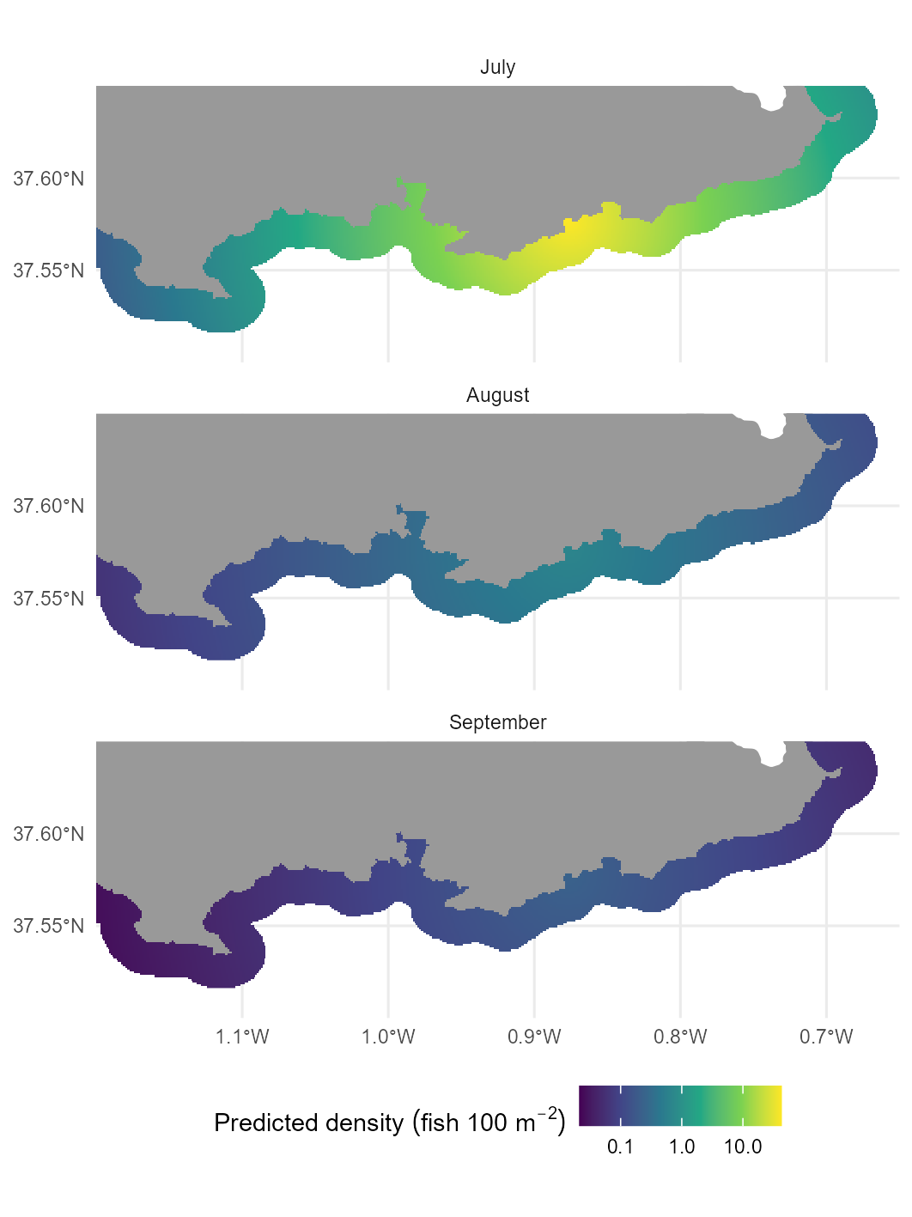

Figure 3

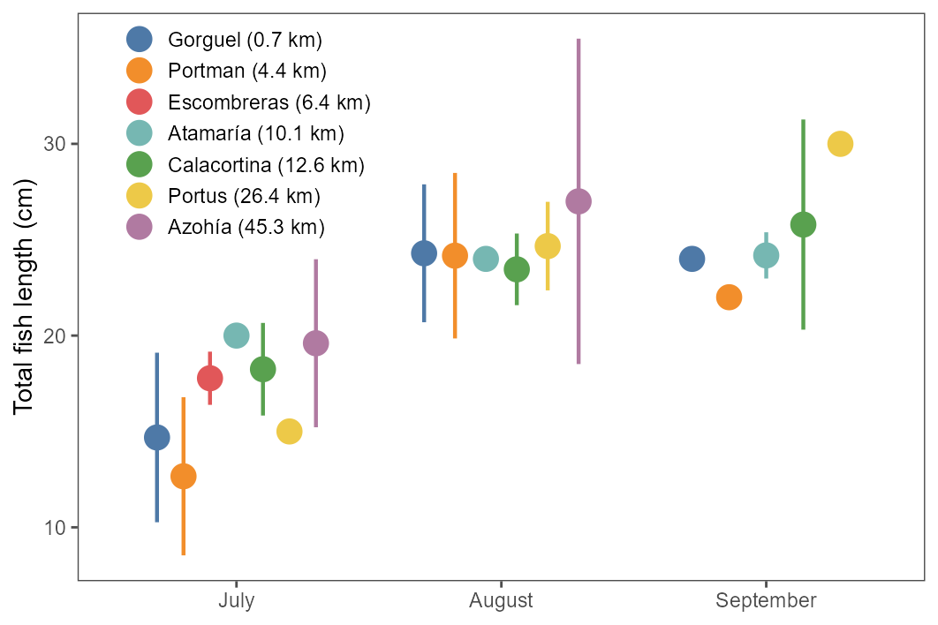

Figure 4