1.repetitive calPriority

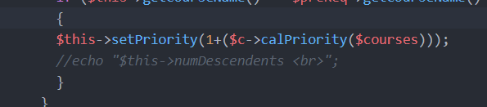

When you want to calPriority ,it will calculate all its coReq,preReq priority

Take soen 490 for example(blue ones are the course will be calculated in calPriority(490))

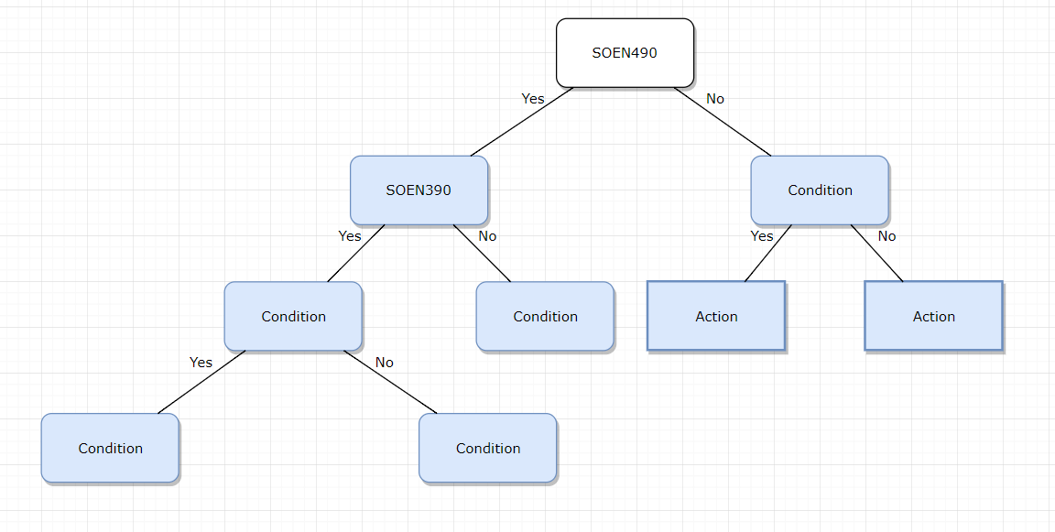

and then we calculate soen 390

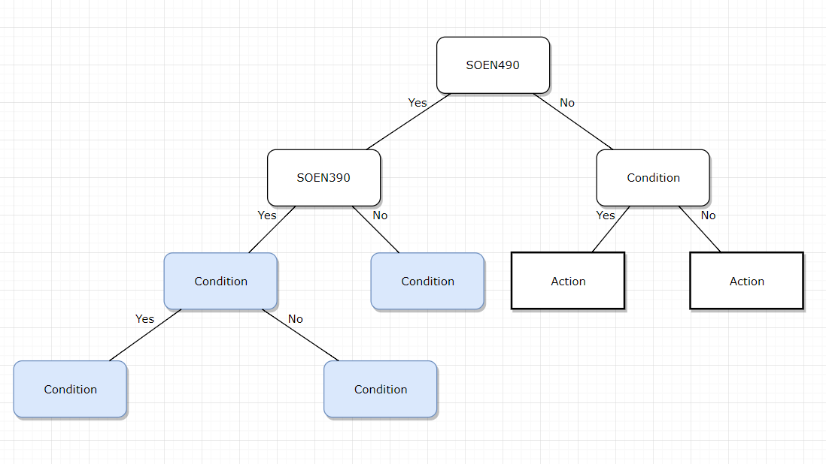

we can see 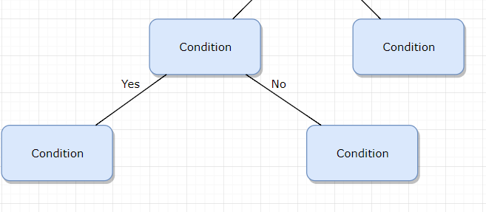this part are calculated repetitively.

Solution: don’t update all priority, just update the root course(SOEN 490,ENGR 392…..) ,then every basic course like comp248,249 will be calculated when you calculate root course

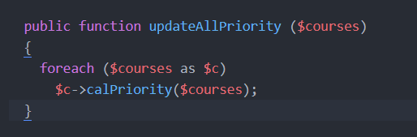

2.Why it overtime even in one calPriority,

because when you calPriority of root course like SOEN490, in fact all SOEN courses will be caculated in one call.

And it is not calculated from top to bottom in fact.

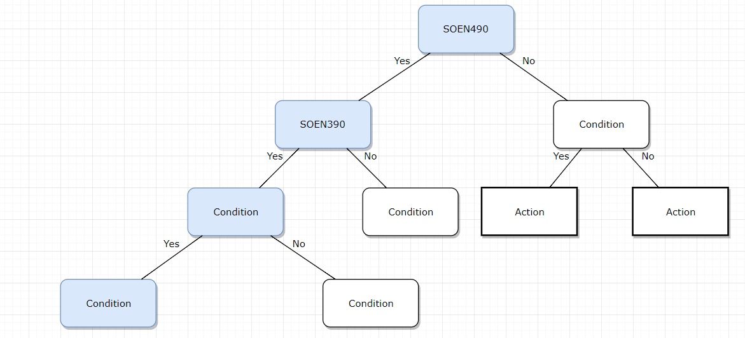

it will calpriority recursively until reach bottom(basic course like comp248 math 203),

So my function construct the tree from bottom to top

1.set every course’s priority to 1

level 0:find all courses that have no coReq,preReq ,and set them to level 0



level1:for rest courses ，its priority equals its coReq priority+preReq priority +1(just add its direct coReq instead of all tree)

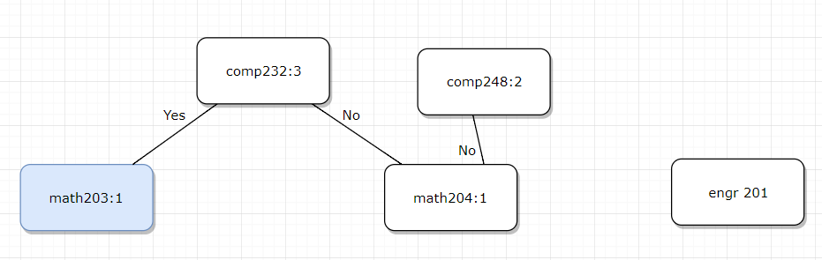

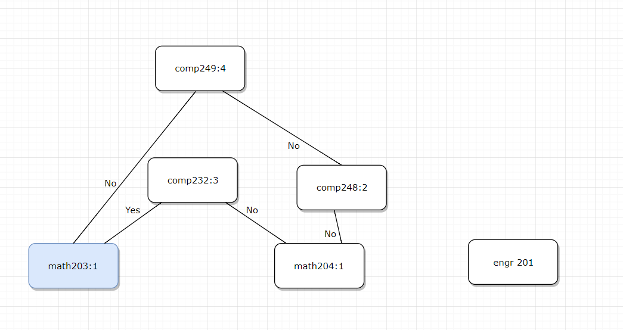

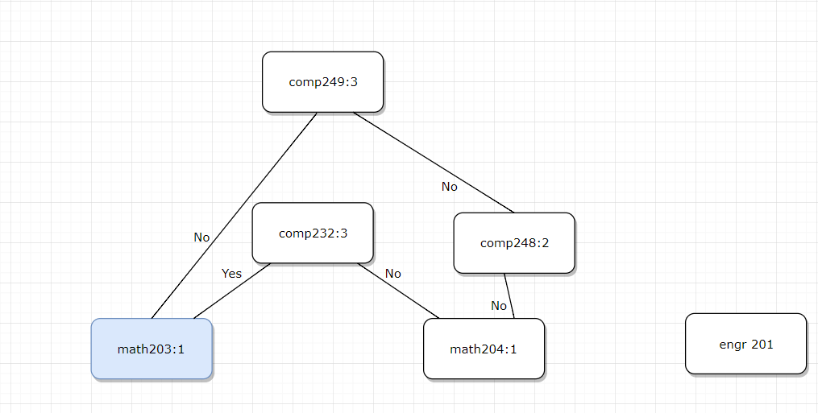

3. 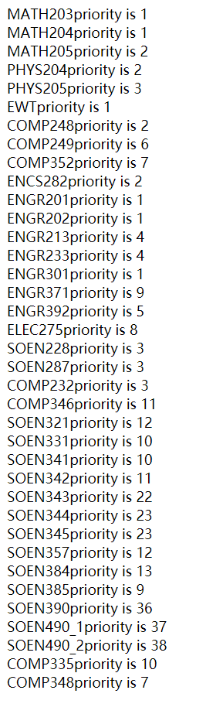

my way will also cause a problem,(and I think this problem will also appear in your way)

For most courses, using number of coReq/preReq to decide priority is feasible, but for some courses like engr 201 engr 202 engr 301, they have no prereq or coreq

In my way,they are level0 so that their priority is 1, student will need first year to pass engr 201 202,math 203…

And then important courses like comp248 will be taken in year 2,which may delay graduation//too early

In your way, engr201 202 encs282 are only preReq of engr392,which means that their priority will be very low, so student will use a year to finish them(third year or fourth year).//too late

However, the ideal way is that engr 201 202 encs 282 should be evenly distributed among different semesters over four years. With my way or your way, these courses will occurred in one semester because they have same priority.