**Software Engineering Assignment**

**MODULE: 1**

**SE – Overview of IT Industry**

1. **What is software? What is software engineering?**

• Software is a set of instructions, data or programs used to operate computers and execute specific tasks. It is the opposite of hardware, which describes the physical aspects of a computer. Software is a generic term used to refer to applications, scripts and programs that run on a device.

• software engineering is a systematic, disciplined, and quantifiable approach to the development, operation, and maintenance of software. It applies engineering principles to software creation to ensure that it is reliable, efficient, maintainable, and scalable.

1. **Explain types of software.**

System Software

• System software refers to the collection of software programs that coordinate and manage the hardware and software resources of a computer system. It provides a platform for other software applications to run smoothly.

• System software is a type of computer software designed to provide a platform for other software and manage hardware components. It acts as an intermediary between the user, application software, and the computer hardware, ensuring that all components of the system function together effectively.

• System software is essential for the overall functionality, performance, and user experience of a computer system. It forms the backbone that supports and optimizes the use of application software and hardware resources.

Application Software

• Application software is a type of computer program designed to help users perform specific tasks or activities. Unlike system software, which manages the hardware and provides a platform for applications, application software directly assists users in achieving their objectives, whether for productivity, entertainment, education, or other purposes.

• Application software is essential in modern computing, providing the tools and capabilities needed to perform everyday tasks and specialized activities across various domains.

1. **What is SDLC? Explain each phase of SDLC**

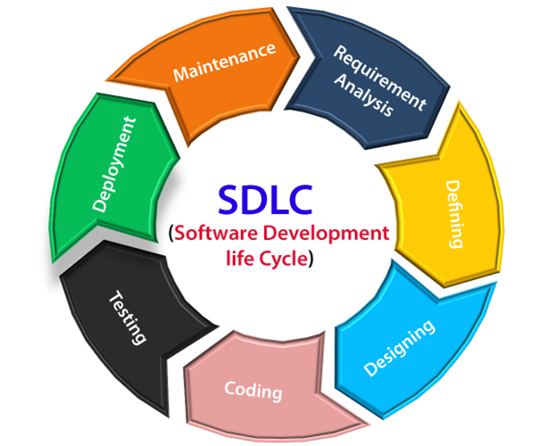

• **Requirements gathering and analysis**: This phase involves gathering information about the software requirements from stakeholders, such as customers, end-users, and business analysts.

• **Design:** In this phase, the software design is created, which includes the overall architecture of the software, data structures, and interfaces.

It has two steps:

High-level design (HLD): It gives the architecture of software products.

Low-level design (LLD): It describes how each and every feature in the product should work and every component.

**• Implementation or coding**: The design is then implemented in code, usually in several iterations, and this phase is also called as Development.

**things you need to know about this phase:**

This is the longest phase in SDLC model.

This phase consists of Front end + Middleware + Back-end.

In front-end: Development of coding is done even SEO settings are done.

In Middleware: They connect both the front end and back end.

In the back-end: A database is created.

**• Testing:** The software is thoroughly tested to ensure that it meets the requirements and works correctly.

* **Deployment:** After successful testing, The software is deployed to a production environment and made available to end-users.

**• Maintenance:** This phase includes ongoing support, bug fixes, and updates to the software.

1. **What is DFD? Create a DFD diagram on Flipkart**

* Data Flow Diagram (DFD) represents the flow of data within information systems.
* Data Flow Diagrams (DFD) provide a graphical representation of the data flow of a system that can be understood by both technical and non-technical users.
* The models enable software engineers, customers, and users to work together effectively during the analysis and specification of requirements.

**Context level DFD – 0 level**

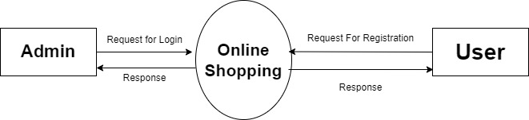

**1st Level Admin Side DFD**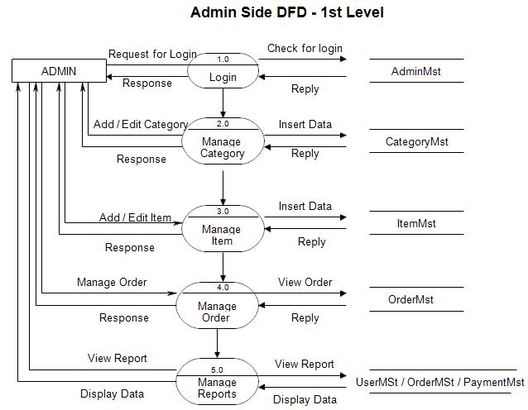

**2nd Level – Admin side DFD (3.0)**

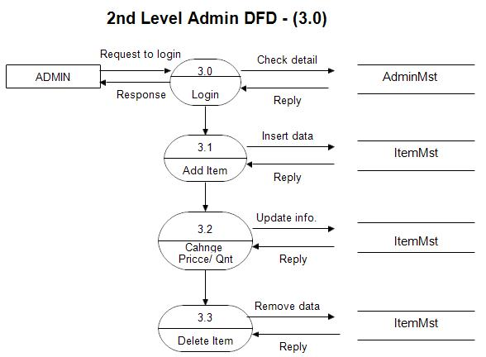

**2nd Level – Admin side DFD (4.0)**

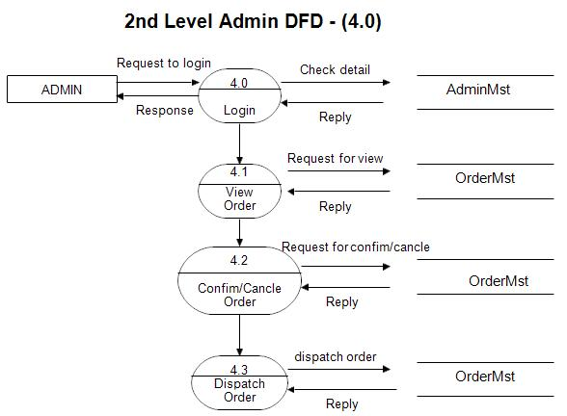

1. **What is Flow chart?** **Create a flowchart to make addition of two numbers**

* Flowchart is a graphical representation of an algorithm.
* Programmers often use it as a program-planning tool to solve a problem.
* It makes use of symbols which are connected among them to indicate the flow of information and processing.
* The process of drawing a flowchart for an algorithm is known as “flowcharting”.
* A flowchart can be helpful for both writing programs and explaining the program to others.

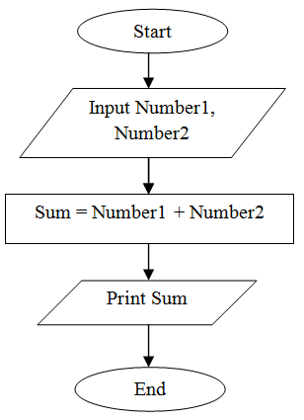

1. **What is Use case Diagram? Create a use-case on bill payment on paytm.**

* A use case diagram is used to represent the dynamic behavior of a system.
* It encapsulates the system's functionality by incorporating use cases, actors, and their relationships.
* It models the tasks, services, and functions required by a system/subsystem of an application.
* It depicts the high-level functionality of a system and also tells how the user handles a system.

