**Ex 5 Package Management System**

**Date: 29.08.20**

**Aim:**

To study and implement the package management system

**Description:**

**Samba :**

Samba is a free and open-source re-implementation of the SMB/CIFS network file sharing protocol that allows end users to access files, printers, and other shared resources.

This tutorial explains how to install Samba on Ubuntu 18.04 and configure it as a standalone server to provide file sharing across different operating systems over a network.

We’ll create the following Samba shares and users.

Users:

* **sadmin** - An administrative user with read and write access to all shares.
* **josh** - A regular user with its own private file share

Shares:

* **users** - This share will be accessible with read/write permissions by all users.
* **josh** - This share will be accessible with read/write permissions only by users josh and sadmin.

The file shares will be accessible from all devices on your network. Later in this tutorial, we will also provide detailed instructions on how to connect to the Samba server from Linux, Windows and macOS clients.

**Exercise**

**1. Install (Samba) free software re-implementation of the SMB/CIFS networking protocol.**

Installing samba using terminal

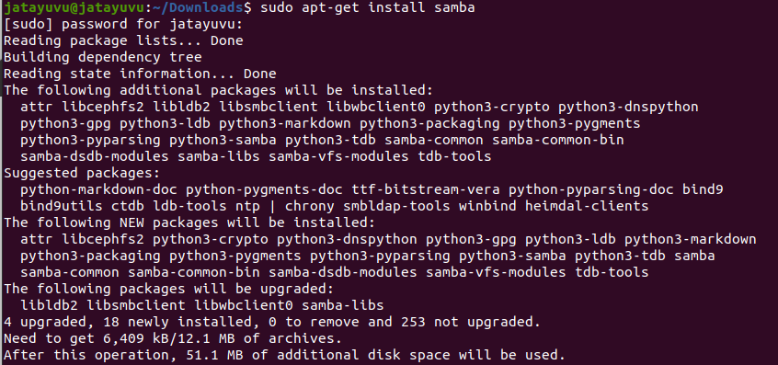

Checking the status of Samba service

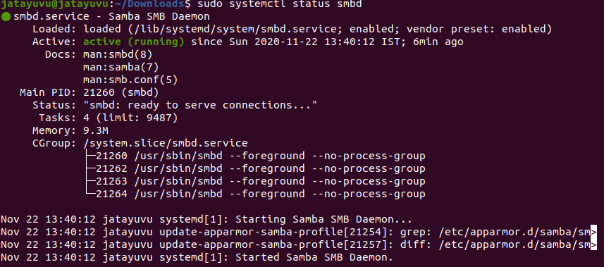

Starting Samba using start smbd

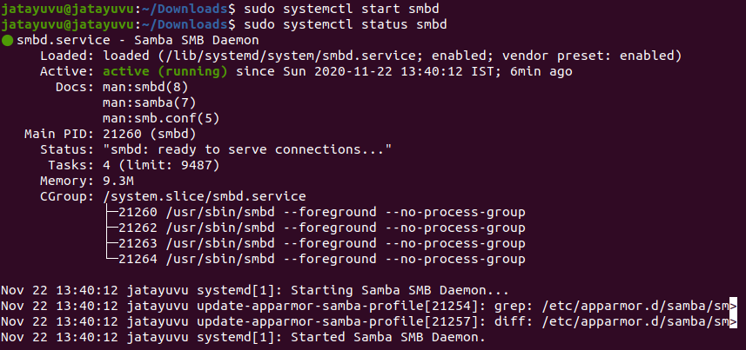

Restart Samba using restart smbd



Allow Samba service from firewall

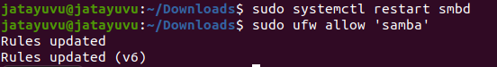

Enforce Permissive State





Creating a normal user named venu & admin and setting up the Password

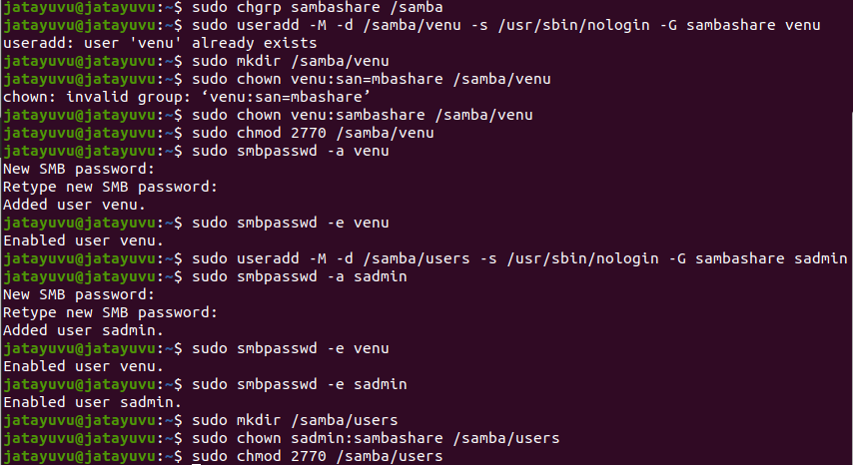

Installing smbclient from terminal to access localhost

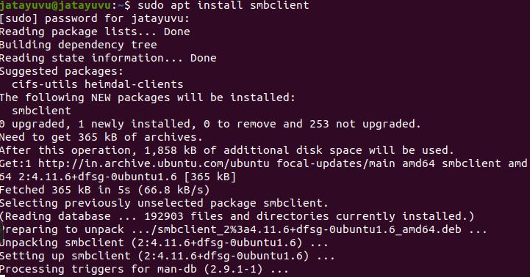

Login into smbclient and listing number of documents

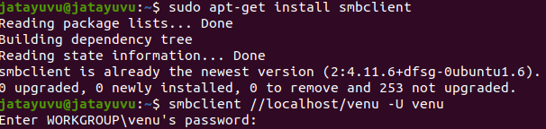

**Results:**

The package management system is studied and executed.

**Video : https://youtu.be/Plr-Hs76YZo**