**Ex 7 Basic Python Programming**

**Date: 06.10.2020**

**Aim:**

To study and implement the basic python programming.

**Exercise**

**1. Design and implement a basic calculator.**

**Source Code :**

a = int(input("enter the first number :"))

b = int(input("enter the second number :"))

c = int(input("enter the operation you want :\n 1.Add \n 2.Sub \n 3.Mul \n 4.Div \n"))

if c==1:

print(a+b)

elif c==2:

print(a-b)

elif c==3:

print(a*b)

elif c==4:

print(a/b)

else:

print("choose the correct operation _ ")

**Output :**

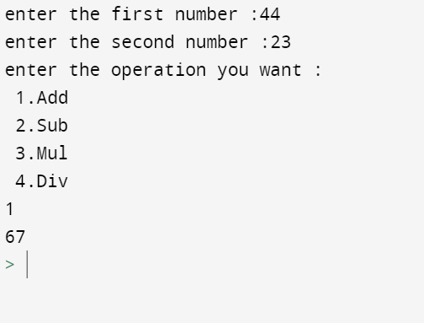

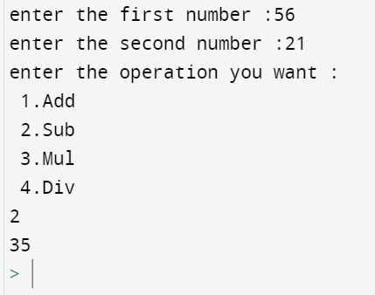

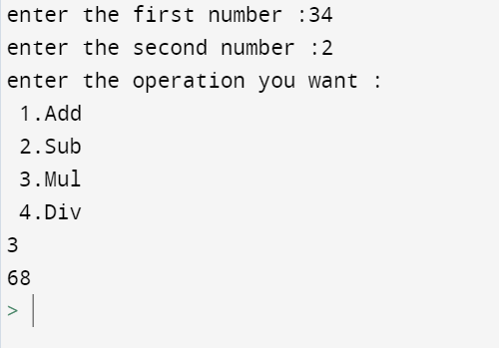

**2. Find whether the given number is perfect or not.**

**Source Code :**

Number = int(input(" Please Enter any Number: "))

Sum = 0

for i in range(1, Number):

if(Number % i == 0):

Sum = Sum + i

if (Sum == Number):

print(" %d is a Perfect Number" %Number)

else:

print(" %d is not a Perfect Number" %Number)

**Output :**

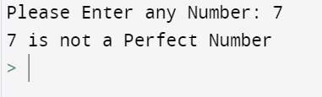

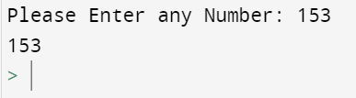

**3. Find whether the given number is Adam’s number or not.**

**Source Code :**

def isAdam(num):

n = num

rev = 0

while n != 0:

rev = rev * 10 + n % 10

n = n // 10

sn = num ** 2

sr = rev ** 2

n = sr

rev = 0

while n != 0:

rev = rev * 10 + n % 10

n = n // 10

return sn == rev

num = int(input("Enter the number: "))

if isAdam(num):

print(str(num) + " is an Adam Number.")

else:

print(str(num) + " is NOT an Adam Number.")

**Output :**

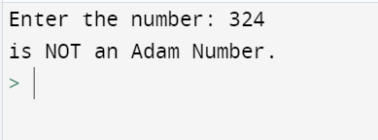

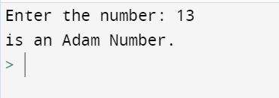

**4. Write a program to check whether the given number is Armstrong or not.**

**Source Code :**

num = int(input("Enter a number: "))

sum = 0

temp = num

while temp > 0:

digit = temp % 10

sum += digit ** 3

temp //= 10

if num == sum:

print(num,"is an Armstrong number")

else:

print(num,"is not an Armstrong number")

**Output :**

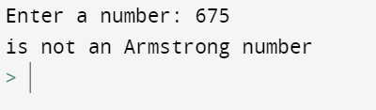

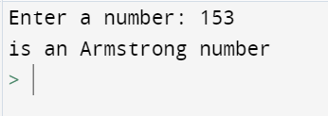

**Results:**

The study and implementation of the basic python programming are studied and executed.

**Video :**