Josh Atchley

CS 340

4/21/17

Assignment 1b

1a)

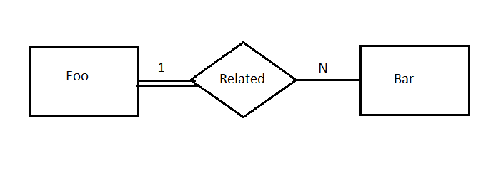

1b)

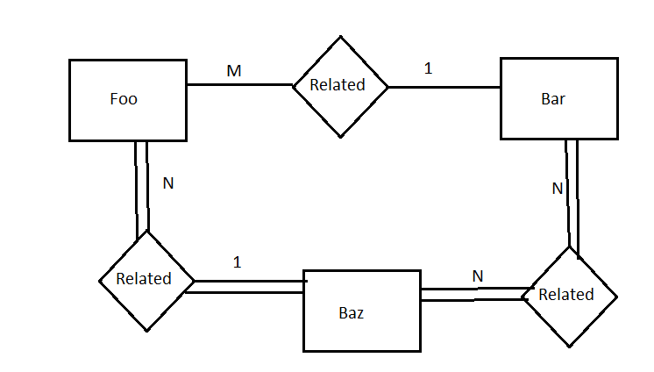

2)

**Aisle** (

ID,

Name

)

**Department** (

ID,

Name

)

**Product** (

ID,

Name,

Weight,

Price,

SKU

)

**Coupon** (

ID,

SalePrice,

Expires

)

3)

