# 3.0: Final Design Overview

An overview of the NovoGrip design is provided in this section. Specifically, this section includes a summary of the mechanical assembly, a block diagram of the system dynamics and a high level explanation of the virtual manipulator environment. Additionally, deviations and modifications made to the MTE 481 final design are highlighted in this section.

## 3.1: NovoGrip Design Summary

NovoGrip is an electro-mechanical device that consists of mechanical, hardware and software design aspects. It has three feedback channels, which provide force feedback on the operator’s forearm, index finger and thumb. A visual representation of the NovoGrip model is shown in Figure 1.

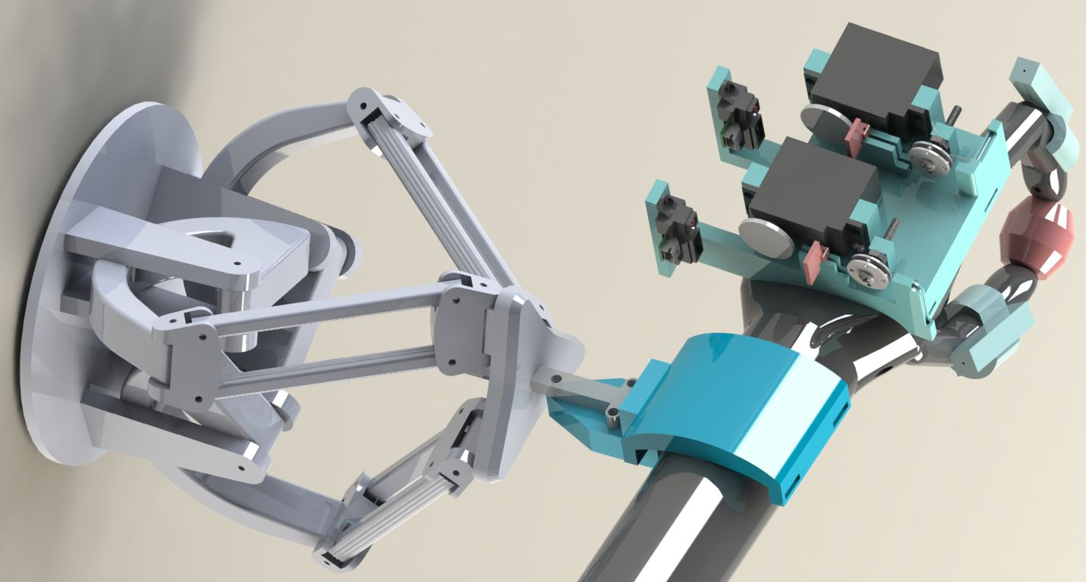

Figure 1: NovoGrip Model

As seen in Figure X, NovoGrip consists of a hand exoskeleton that is attached to the end effector of a delta robot. The delta robot allows the operator three translational DOF and one rotational DOF. Furthermore, the delta robot exerts a normal force on the operator’s forearm. The hand exoskeleton is attached to the delta robot with a custom-made wristband. The wristband assembly is semi-elliptical component that the operator fits their forearm into. A more detailed view of the wristband assembly can be seen in Figure 2.

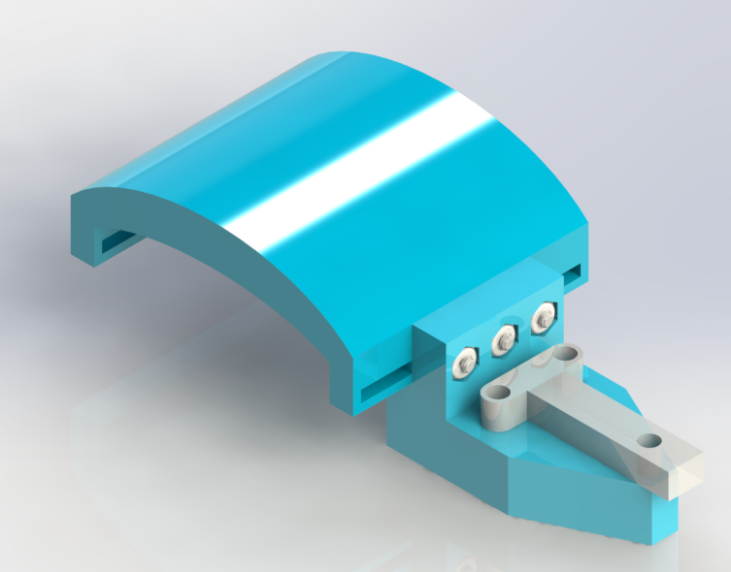

Figure 2: Wristband Assembly

Figure 2 reveals that the wristband attaches to the delta robot end effector via an intermediary connector part. The connector fastens onto the flat vertical surface of the wristband and then is bolted through the three holes on the connector.

The hand exoskeleton acts as a mounting surface for two servo motor actuators. The servo motor actuators are used in combination with a cabling system to provide resistive force feedback on the operator’s index finger and thumb. The hand-exoskeleton sub-assembly is shown in Figure 3.

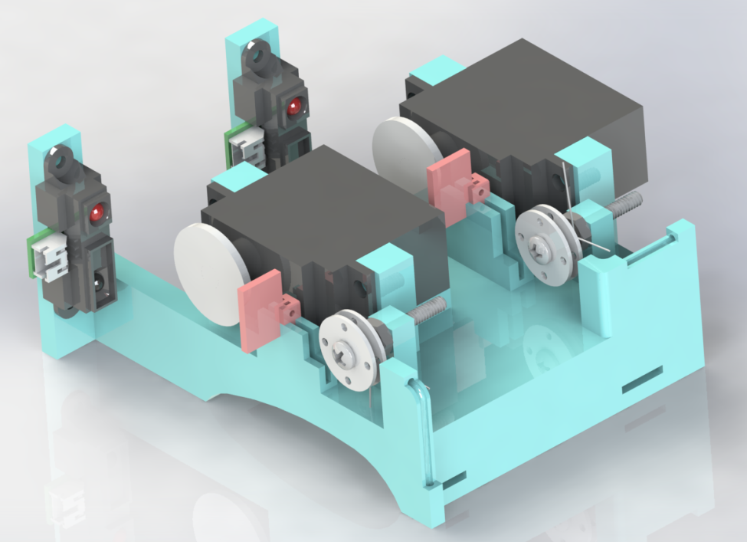

Figure 3: Hand Exoskeleton Assembly

Figure 3 shows that two infrared (IR) sensors are fixed vertically on the hand-exoskeleton. When the user flexes their finger downwards, the red markers seen in Figure 3 are displaced forwards. These IR sensors are used to track the displacement of the red markers; this position information is then used to update the remote manipulator position.

NovoGrip allows a human operator to interact with a remote manipulator. It has both human-machine and machine-human information channels. For the purposes of this project, the remote robot will be simulated in software using CHAI 3D. CHAI 3D is an open source software platform that can simulate haptic environments. The system dynamics for both interfaces are displayed in Figure 4.

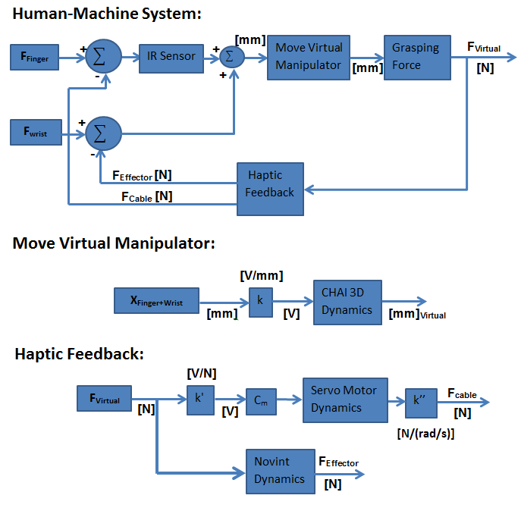

Figure 4: Control Scheme Overview

The control scheme in Figure 4 consists of capturing finger and forearm motion and transferring that to a virtual manipulator in CHAI 3D. The virtual manipulator is programmed to pick up objects. The virtual manipulator's grasping force is recorded by CHAI 3D and sent to the hand exoskeleton and delta robot controllers. The controller uses the virtual force reading to engage the servo motors of the hand exoskeleton and delta robot.

Infrared (IR) sensors are used to record the motion of the finger and thumb. When the operator flexes or extends their finger, the IR sensor measures the displacement of the cable marker. CHAI 3D uses this displacement information to update the position of the virtual manipulator. Accelerometers embedded in the delta robot effector measure the position of the operator's forearm.

The rotational speed of the hand exoskeleton servo motors is determined by the virtual force input. The rotation of the servo motor pulls on the cable, which in turn exerts a tension force on the operator's finger.

Overall, the NovoGrip design can be organised into the following categories:

Mechanical

Delta Robot

Wristband Design

Hand Exoskeleton Design

Hardware

Servo Motor Drive Design

IR Sensor Implementation

Arduino Interfacing

Software

Virtual Manipulator Environment

Virtual Manipulator – NovoGrip interfacing

## 3.2: Deviations & Modifications from Original Design

Design deviations are actions that are taken to drastically change a design’s intention. In contrast, modifications can be classified as changes that improve a design without altering its original focus. Several changes have been to the MTE 482 prototype that have both altered and modified the final MTE 481 design. The proceeding sections highlight and rationalize the changes made for the mechanical, hardware and software design aspects.

### 3.2.1: Mechanical Changes

Several changes have been made to the mechanical design of NovoGrip. Specifically, the design emphasis of NovoGrip has been shifted from the delta robot to the hand exoskeleton. A list of mechanical design changes is displayed in .

Table 1: Mechanical Design Changes

|  |  |  |
| --- | --- | --- |
| Change | Description | Deviation / Modification |
| Delta Robot | Purchased from vendor instead of custom-designed | Deviation |
| Delta Robot Orientation | Oriented horizontally instead of vertically | Modification |
| # of Feedback Channels | Increased to three channels; the thumb is the third feedback channel | Deviation |
| Index Finger Actuation | Actuation provided by servo motor & cable system combination | Modification |

From Table 1, it can be seen that the role of the delta robot has been significantly changed in the design phase. It has been decided that it is better to purchase a commercial delta robot versus custom-designing and manufacturing one. The time constraints of this project would prohibit a custom-designed delta robot from being prototyped within the designated six month project period. Additionally, it is believed that since there are no intellectual property rights to be gained from a custom delta robot, it is better to devote resources and time to the hand exoskeleton design. Furthermore, the orientation of the delta robot has been modified so that it is oriented horizontally instead of vertically. The advantage of this modifying the orientation is that a custom fixture does not need to be designed and manufactured to support the weight of the delta robot, as it can now rest on the top of a table surface.

Additionally, two changes have been made to the hand exoskeleton design. First, it is desired that NovoGrip provide force feedback for pinching finger gestures; the thumb motion is an integral part of any pinching gesture. Therefore, the thumb along with the index finger needs to be actuated. The actuation method has also been modified from the original MTE 481 design. A cable system that is connected to the shaft of a servo motor is now used to provide resistive force feedback on the operator’s finger and thumb. A cable system allows simple force transmission to occur between the actuation source and destination. Unlike a linkage structure, a cable system is not limited by geometrical constraints and limiting positions.

### 3.2.2: Hardware Changes

Hardware changes:

Instead of designing custom controller for motor, decided to use servo motor with inbuilt controller

2. sensor?

3. arranging cables and stuff

4. flag and sensor combo for motion capture

Describe what was planned in me481, why design had to be changed, what the new design is, why it works (better).

### 3.2.3: Software Changes

## 3.3: Final Design Details

# 5.0: Testing and Commissioning

## 5.1: Testing Equipment

## 5.2: Commissioning Components

## 5.3: Performance Review

# 6.0: Schedule and Budgeting

## 6.1: Schedule

## 6.2: Budget and expected vs actual cost

# Appendix D: Arduino Code