BatDetailControl. *See* BatDetailControl

BatListControl. *See* MainWindow

BatRecordingsListDetailControl. *See* BatRecordingListDetailControl

ImageScrollerControl. *See* RecordingSessionListDetailControl, SessionsAndRecordingsControl, BatRecordingsListDetailControl, BatDetailControl

MainWindow, 2

RecordingsDetailListControl. *See* RecordingSessionListDetailControl

RecordingSessionListDetailControl. *See* MainWindow

RecordingSessionViewControl

RecordingSessionListDetailControl. *See*

SessionsAndRecordingsControl. *See* BatRecordingListDetailControl

MainWindow

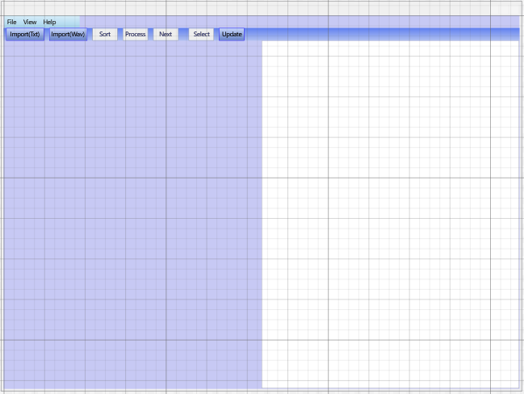

RecordingSessionListDetailControl

(displayed in MainWindow)

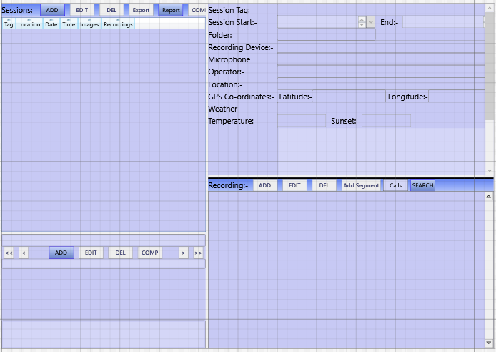

RecordingSessionViewControl (displayed in RecordingSessionListDetailControl)

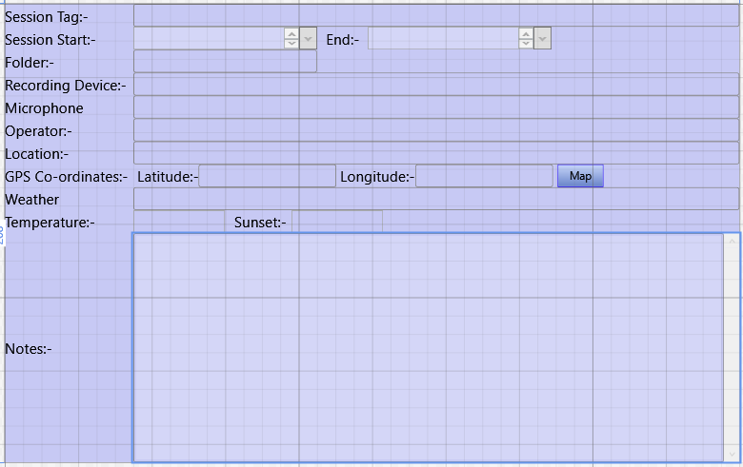

RecordingsDetailListControl (displayed in RecordingSessionListDetailControl)

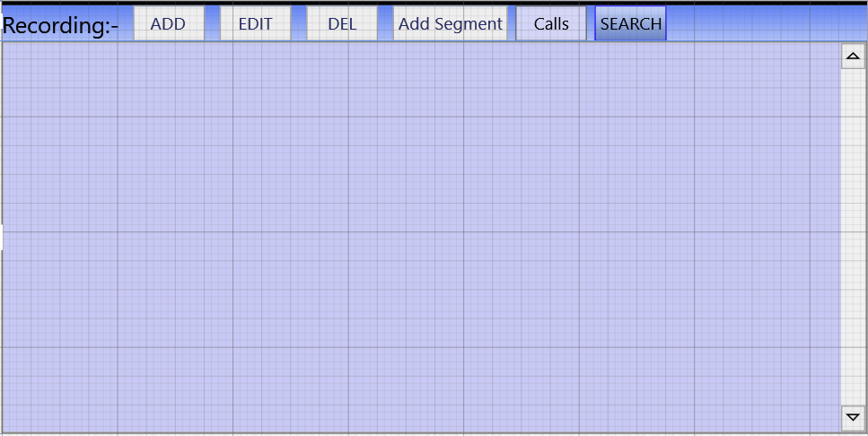

ImageScrollerControl (displayed in

RecordingSessionListDetailControl

SessionsAndRecordingsControl

BatRecordingsListDetailControl {as BatAndCallImageScroller}

BatDetailControl {as BatAndCallImageScroller} )



BatRecordingsListDetailControl (displayed in MainWindow)

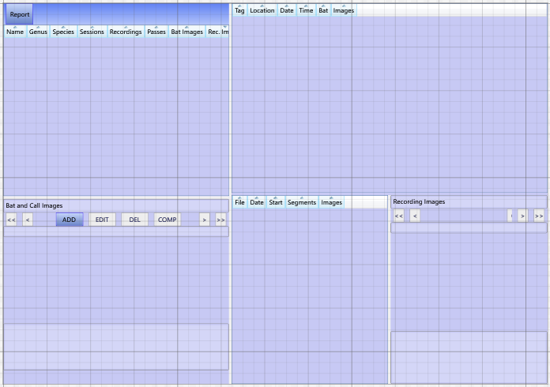

SessionsAndRecordingsControl (displayed in BatRecordingListDetailControl)

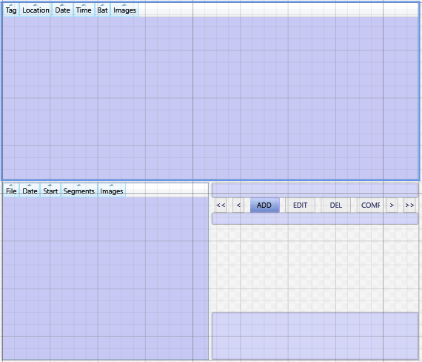

BatListControl (displayed in MainWindow)

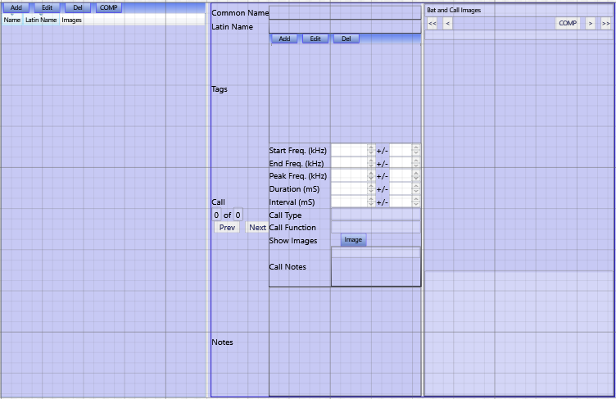

BatDetailControl (displayed in BatListControl)

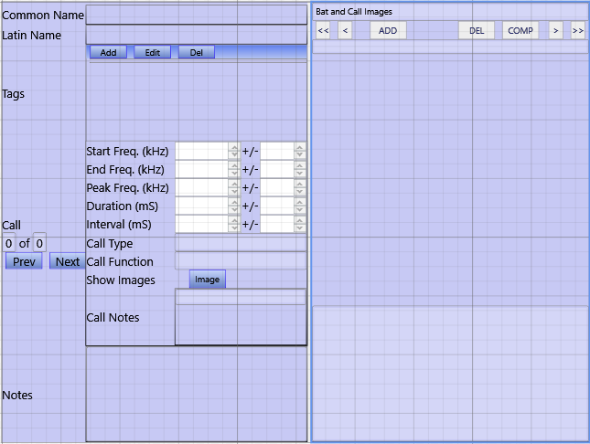

BatCallControl (displayed in BatDetailControl)

