AI GOVERNMENT SCHEME ELIGIBILITY

A Profile-Based, Explainable Rule-and-Retrieval Framework for Identifying Potentially Applicable Government Schemes
A Student-Centered Integrated Learning Platform Using React, Supabase and Server-Side AI
JATHIN CHOWDARY C H 240701209
Department of Information Technology, Rajalakshmi Engineering College
Under the Guidance of Mrs B. Deepa, Assistant Professor (SG), Dept of CSE
Abstract
India’s central and state governments operate a very large number of welfare, education, health, agricultural and entrepreneurship schemes, yet citizens often find it difficult to know which of them they may qualify for. Eligibility conditions are usually written in natural-language guidelines and combine several criteria such as age, income, occupation, place of residence and social category. AI Government Scheme Eligibility is a proposed web-based system that helps a citizen identify schemes for which they may be eligible. The citizen supplies a small, structured profile; the system shortlists candidate schemes using semantic retrieval and then evaluates the profile against human-curated, machine-readable eligibility rules using a three-valued (satisfied, violated, unknown) logic. Each scheme is classified as Likely Eligible, Needs More Information or Not Eligible, accompanied by a rule-level explanation, a list of documents and a link to the official source. Language-model components, where used, are restricted to understanding free-text input and rewording explanations; they never decide eligibility. The paper also sets out fairness, privacy, security and explainability requirements and insists that all results are indicative and must be verified against official scheme rules. This paper presents the design, methodology and a planned evaluation protocol. No experimental results are reported, and every module described is a proposed feature unless stated otherwise.
Keywords: Artificial Intelligence; Government Schemes; Eligibility Assessment; Rule-Based Reasoning; Semantic Retrieval; Explainable AI; Fairness; Data Privacy; E-Governance; Citizen Services.

1. Introduction
Government schemes are a principal instrument through which public policy reaches citizens, covering scholarships, pensions, health coverage, agricultural support, housing, skill development and credit. The benefit of a scheme, however, depends on whether the intended beneficiary knows that it exists, understands its conditions and is able to apply. The national scheme-discovery platform myScheme was introduced precisely because citizens otherwise have to search many separate departmental websites and study multiple sets of guidelines to check their eligibility. [1][2]
Research on public programmes has long observed that eligibility does not automatically translate into participation. Reviews of benefit take-up identify administrative barriers, limited awareness and transaction costs as important reasons why eligible people do not claim support. [3] An assistive tool that reduces the effort of finding and understanding relevant schemes therefore addresses a real and well-documented problem.
This paper proposes AI Government Scheme Eligibility, a decision-support system that accepts details such as age, annual household income, occupation, state and district, and other relevant attributes, and returns a transparent, explainable list of potentially applicable schemes. The system is deliberately designed as an advisor, not an authority: the final decision on eligibility is always taken by the competent government department.
The central research question is: how can a citizen-facing AI system use a limited set of self-reported details to identify potentially applicable government schemes in a manner that is transparent, privacy-preserving, fair and verifiable against official rules? The proposed answer combines curated symbolic rules for the eligibility decision with semantic retrieval for discovery, and treats explanation and official verification as core features rather than optional additions.

1.1 Scope, Assumptions and Status of this Paper
Because the project is at the design and planning stage, the following assumptions are stated explicitly rather than presented as established facts:
- A1 – Geography. The system targets Indian citizens and considers central-government and selected state-government schemes.
- A2 – Knowledge base. The prototype knowledge base is assumed to contain a limited, curated set of schemes whose criteria are taken from official sources and encoded by people; it does not claim to cover all schemes.
- A3 – Self-reported data. All user inputs are self-reported and unverified. The system does not access government databases.
- A4 – Advisory output. Results are indicative. They are not an application, an approval or a legal determination.
- A5 – Technology choices. The technologies named in Section 9 are proposed design choices that can be substituted without changing the method.
- A6 – No experiments yet. No experiments, datasets or performance measurements are reported. Statements about performance describe design goals or expected behaviour, and Section 12 describes how they will be tested.

2. Problem Statement and Motivation
Information about government schemes is distributed across ministries, state departments, notifications and application portals. A citizen who wishes to find suitable schemes must first know which schemes exist, then locate the relevant guidelines, and finally interpret criteria that combine several conditions, for example an age band, an income ceiling, a residence requirement and an occupational category. The difficulty lies less in any single scheme than in the number of schemes and the effort of reading each one. [1][3]
Eligibility questionnaires that are specific to a single scheme, such as the Yes/No scheme-specific questions offered by the national platform, reduce this effort once the citizen has chosen a scheme. [4] They are less suited to a citizen who does not know which schemes to ask about. A profile-driven approach, in which one set of personal details is evaluated against many schemes, can reverse the direction of the search from scheme to citizen to citizen to schemes.
The two possible errors of an eligibility tool are not equally costly. Wrongly telling a citizen that they are eligible may waste time and travel, while wrongly telling them that they are not eligible may cause a legitimate benefit to be missed. Additionally, a user may not supply every attribute needed by a scheme, so a binary Yes/No output would force the system to guess. The problem addressed in this paper is therefore formulated as follows.
Problem formulation. Given a citizen profile u and a set of schemes S, where each scheme s ∈ S has an encoded rule set R(s) derived from official sources, partition S into three sets: Likely Eligible, Needs More Information and Not Eligible. Each assignment must be accompanied by a human-readable explanation, the source of the rule, and an instruction to verify the result with the official authority.

3. Objectives
- Design a profile-based system that evaluates one citizen profile against many government schemes.
- Represent scheme eligibility criteria in a structured, versioned and human-reviewable form linked to official sources.
- Classify each scheme using three-valued logic so that missing information is reported rather than guessed.
- Use semantic retrieval to help users discover relevant schemes from free-text needs, without letting it decide eligibility.
- Generate rule-level explanations that show which criteria were met, not met or unknown.
- Ask only the follow-up questions that are needed to resolve uncertain schemes.
- Incorporate fairness, privacy, security and accountability requirements into the design from the start.
- Define a rigorous evaluation protocol, clearly separating proposed functionality from tested functionality.

4. Literature Review
This section reviews work in six areas that bear on the proposed system. Only sources that could be verified are cited; the review is selective and does not claim to be a systematic survey.

4.1 Benefit Take-Up and Information Barriers
Currie’s review of the take-up of social programmes in the United States and the United Kingdom concludes that take-up is raised by automatic or default enrolment and reduced by administrative barriers, and that concrete transaction costs are likely to matter more than stigma. The review also notes that economists have paid little attention to eligibility rules and to how those rules are made known to eligible people. [3] These findings motivate tools that lower the cost of discovering and understanding eligibility, although a discovery tool alone does not remove other barriers.

4.2 Digital Scheme-Discovery Platforms in India
myScheme, developed and operated by the National e-Governance Division with support from MeitY and DARPG, was dedicated to the nation on 4 July 2022 as a one-stop search and discovery platform for central and state schemes. [1][2] It provides information on benefits, eligibility criteria, the application process and required documents, and is multilingual. [2] According to the Digital India Corporation, a citizen can check eligibility for a particular scheme by answering scheme-specific Yes/No questions, and can apply through GovForms with DigiLocker integration. [4] The platform shows that centralised scheme discovery is feasible at national scale, and it provides the authoritative source against which the present work is to be checked.

4.3 Machine-Readable Rules
The OECD working paper on Rules as Code by Mohun and Roberts describes the idea that governments create an official, machine-consumable version of rules alongside the human-readable text, so that computer systems can interpret and act on them consistently. [5] Where such official encodings do not yet exist, third parties must interpret and encode the rules themselves, which introduces a risk of interpretation errors. This is the situation assumed here, and it motivates versioned, human-reviewed rule encoding with explicit source references.

4.4 Retrieval and Language-Model Techniques
Lewis et al. introduced retrieval-augmented generation (RAG), which combines a pre-trained generator with an explicit, non-parametric memory and notes that providing provenance and updating knowledge are open problems for purely parametric language models. [6] Sentence-BERT provides a method for producing sentence embeddings that can be compared with cosine similarity, which makes semantic search over short documents efficient. [7] Together these works support a design in which retrieved, source-linked scheme text grounds any generated output. They do not, by themselves, make a language model a reliable judge of legal eligibility, which is why the proposed system confines such models to non-decisive roles.

4.5 Fairness in Automated Decision Support
Mehrabi et al. survey sources of bias in machine-learning systems, including bias in data, in algorithms and in user interaction, and review definitions and mitigation approaches for fairness. [8] Eubanks examines automated eligibility and decision tools used in public services in the United States and argues that such systems can harm already disadvantaged people when they are poorly designed or poorly governed. [9] These works justify a conservative design in which the decision logic is inspectable, uncertainty is surfaced, and group-wise error analysis is part of the evaluation.

4.6 Explainability, Governance and Data Protection
Doshi-Velez and Kim argue for a rigorous science of interpretability and discuss how explanations should be evaluated according to their purpose. [10] Ribeiro et al. propose LIME, a technique for explaining the predictions of an arbitrary classifier, and stress the role of explanation in building appropriate trust. [11] For the proposed system, a rule trace is a more direct form of explanation than a post-hoc approximation, because the decision itself is made by explicit rules. At the governance level, the NIST AI Risk Management Framework offers a voluntary structure for identifying and managing AI risks. [12] In India, the Digital Personal Data Protection Act, 2023 governs the processing of digital personal data, and its provisions on consent, purpose and children’s data are relevant to any system that collects citizen details. [13]

4.7 Research Gap
The sources above indicate that (i) eligible citizens often fail to obtain benefits, (ii) national discovery platforms exist, (iii) machine-readable rules improve consistency, (iv) retrieval can ground language-model output, and (v) fairness, explainability and data-protection obligations apply to any automated tool in this area. What this paper adds is a design synthesis: a conservative three-valued rule engine at the core, semantic retrieval and optional language-model assistance at the edges, and explicit fairness, privacy and verification controls, together with an evaluation protocol that can be carried out and reported honestly.

5. Existing System

5.1 National Discovery Platform
The principal existing system is the myScheme portal. It is described by its operators as a one-stop platform to discover government schemes according to citizen eligibility, with guidance on how to apply. [1] Schemes are grouped by categories such as social welfare, health, agriculture and entrepreneurship, and the platform reported more than 1,000 schemes in September 2023. [2] The platform offers an eligibility check using criteria and personal attributes, a filter-based scheme finder and detailed scheme pages. [1]

5.2 Departmental Portals and Manual Processes
Beyond the national platform, scheme information also exists in departmental portals, official guidelines and offices. The need to “visit multiple Government websites” is the very problem the national platform was designed to reduce. [1] In practice, many citizens still depend on intermediaries, local officials or informal sources, which can lead to incomplete or outdated information. This observation is general and is not drawn from a measured study.

5.3 Comparison with the Proposed Design
Table 1 compares the existing platform, as publicly described, with the design goals of the proposed system. The comparison is based on the cited public descriptions and not on a hands-on evaluation; where those sources are silent, the table says so instead of assuming a limitation. The proposed system is intended to complement the official platform, not to replace it.
Table 1. Existing platform (as publicly described) versus proposed design goals.
Dimension | Existing platform (public descriptions [1]–[4]) | Proposed system (design goal)
Discovery | Eligibility check, filter-based finder, categories [1] | Profile-driven evaluation plus free-text semantic search
Eligibility questions | Scheme-specific Yes/No questions [4] | One reusable profile; follow-up questions only for unresolved criteria
Handling of missing data | Not documented in the sources reviewed | Explicit “Needs More Information” state
Explanation of result | Not documented in the sources reviewed | Criterion-by-criterion rule trace with source and date
Official verification | Links to scheme pages and application guidance [1][2] | Mandatory verification notice, source link and rule version on every result
Status in this project | Operational national service | Proposed; not yet implemented or evaluated

6. Proposed System

6.1 Overview
The proposed system is a layered web application. A citizen enters a limited profile through a web interface. The backend validates and normalises the data, retrieves candidate schemes from a curated knowledge base, evaluates each candidate against structured eligibility rules, asks follow-up questions for unresolved criteria, and presents ranked and explained results with links to the official source.

6.2 Design Principles
- Conservative by design. Missing information produces a request for clarification, never a guess.
- Symbolic decision, statistical assistance. The eligibility status is determined only by explicit rules. Machine-learning components assist discovery and presentation.
- Human-curated knowledge. Every rule is linked to an official source and a retrieval date, and reviewed by a person before publication.
- Data minimisation. Only attributes required by at least one scheme rule are requested. Identity numbers and bank details are not collected.
- Verifiability. Every result carries a notice that eligibility must be confirmed with the official authority.

6.3 Operating Modes
Two modes are proposed. In quick-check mode the profile exists only for the duration of the session and is not stored. In saved-profile mode, an optional account lets a citizen keep their profile and be notified when a rule they depend on changes; this mode requires explicit consent and a deletion option. Quick-check mode is the default.

6.4 Input Attributes
Table 2 lists the proposed profile attributes. Sensitive attributes are optional and are requested only when a scheme in the knowledge base actually uses them, and the interface explains why they are asked.
Table 2. Proposed profile attributes and their use.
Attribute | Type / format | Typical use in rules | Sensitivity
Age | Integer or date of birth | Minimum / maximum age; age as on a reference date | Low
Annual household income | Amount in ₹ (per year) | Income ceiling thresholds | Medium
Occupation | Controlled list (student, farmer, artisan, …) | Target-group membership | Low
State and district | Standard codes | Residence-based eligibility; state schemes | Low
Rural / urban | Category | Area-specific schemes | Low
Gender | Category (optional) | Women-specific schemes | Medium
Social category | Category (optional) | Category-specific schemes | High
Disability status | Yes / No (optional) | Disability-specific schemes | High
Education level | Controlled list | Scholarship and training criteria | Low
Family size / dependants | Integer | Household-based criteria | Medium

7. System Architecture
The architecture has three layers (Figure 1). The presentation layer contains the citizen’s browser and a React web interface. The application layer is a backend service that validates input and orchestrates the profile validator, the semantic retrieval module, the rule-based eligibility engine and the explanation generator. The data layer holds the scheme knowledge base, a vector index of scheme descriptions, a minimal consent and audit log, and an administrative curation panel through which authorised staff encode and review rules.
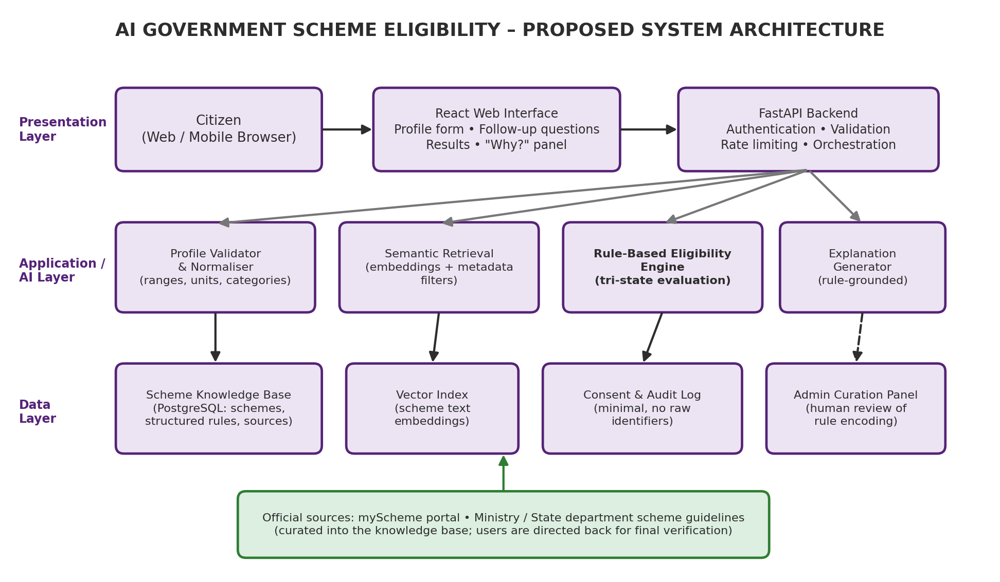
Figure 1. Proposed system architecture of AI Government Scheme Eligibility (design, not a deployed system).

7.1 Scheme Knowledge Base
Each scheme is stored as a record that combines descriptive text, structured rules and provenance (Table 3). Separating the rules from the descriptive text allows the semantic module to work on language while the eligibility engine works only on structured data.
Table 3. Proposed scheme record schema.
Field | Description
scheme_id, name | Unique identifier and official name of the scheme
level, state_code | Central or state scheme; applicable state or UT
category, benefit_summary | Domain (education, health, agriculture, …) and short description of the benefit
mandatory_rules | List of predicates that must all be satisfied (attribute, operator, value)
exclusion_rules | Predicates that, if true, make the applicant ineligible (for example, an existing benefit)
optional_rules, weights | Preference criteria used only for ordering results
documents_required | Documents the applicant is expected to provide, as listed by the source
source_url, retrieved_on | Official source and date on which it was read
rule_version, reviewed_by | Version number and identity of the reviewer who approved the encoding

7.2 User Interface
The interface follows three screens (Figure 2). Screen 1 collects the profile and the user’s consent. Screen 2 asks follow-up questions one at a time, with an explanation of why each question is asked and the option to skip. Screen 3 lists schemes grouped by status, with a short “Why?” explanation, the documents list and a link to the official source, together with a persistent notice that the results are indicative. The design should follow accessibility practice, support regional languages, and remain usable on low-bandwidth mobile connections; these are design requirements that remain to be tested.
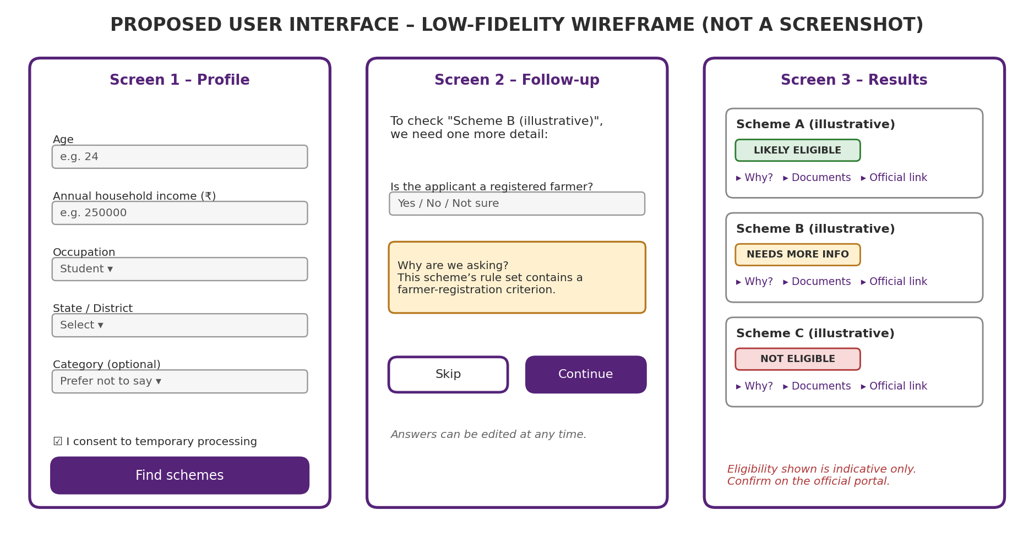
Figure 2. Low-fidelity wireframe of the proposed interface. Scheme names are illustrative placeholders.

8. Methodology

8.1 Development Approach
The project follows an iterative approach: (i) select a small set of schemes from official sources, (ii) encode their criteria, (iii) build the evaluation engine and a minimal interface, (iv) test against reviewer-labelled profiles, and (v) extend the knowledge base and refine the interface. The selection of the initial schemes is left to the project team and should favour schemes with clearly stated, objective criteria.

8.2 Rule Acquisition and Encoding
For every scheme, the encoder reads the official guidelines or portal page, identifies each criterion and writes it as a predicate over a profile attribute. Ambiguous wording is not silently resolved; it is recorded in a note and the predicate is marked for review. A second reviewer independently verifies each encoding against the source, and the record stores the source address, the date it was read and a version number. When a source changes, the scheme is re-encoded as a new version, and older versions are retained for audit.

8.3 Data Processing
Incoming data passes through the following stages before evaluation: (1) validation, which rejects impossible values such as negative income or age above a plausible limit; (2) normalisation, which converts monthly income to annual income, derives age from date of birth on the scheme’s reference date, and maps free-text occupation or location to controlled codes; (3) missing-value marking, in which any attribute the user skipped or answered “not sure” is stored as unknown rather than imputed; and (4) minimisation, in which attributes not used by any candidate scheme are discarded after evaluation. Normalisation rules, such as how income is annualised, should be documented because they affect outcomes.

8.4 Workflow
The end-to-end workflow is shown in Figure 3. After consent and profile entry, the system validates the data, retrieves candidate schemes and evaluates rules. If any candidate has unresolved criteria, the system asks targeted follow-up questions and re-evaluates. Finally it classifies and ranks the schemes, presents explanations, and directs the user to the official source for verification.
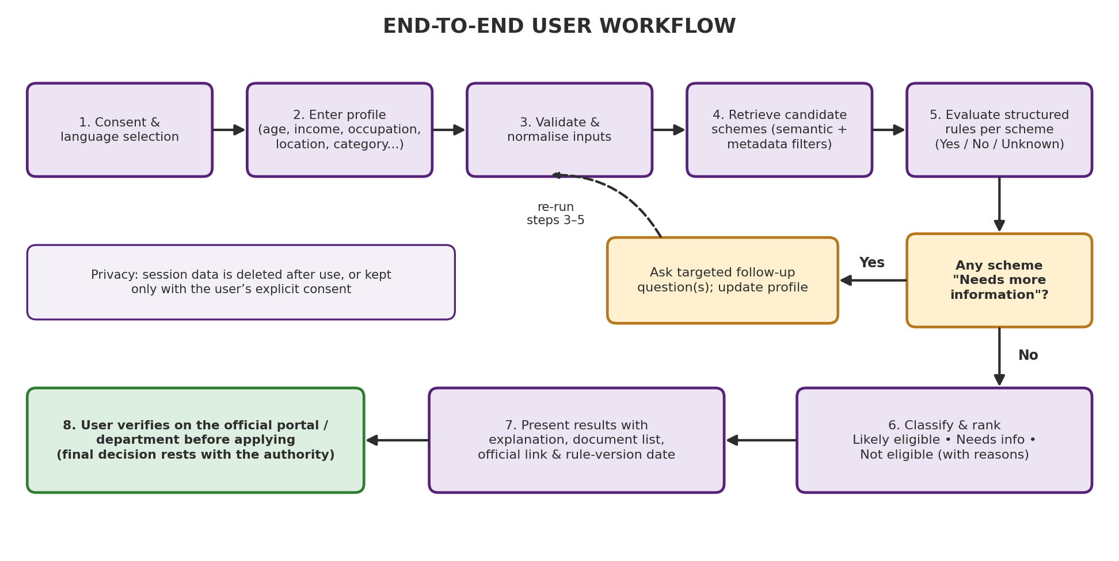
Figure 3. End-to-end workflow of the proposed system.

9. AI Techniques and Technologies Used

9.1 Rule-Based Symbolic Reasoning
The eligibility decision is made by an explicit rule engine. This choice is deliberate. Eligibility rules are defined by official documents rather than learned from data, no labelled dataset of citizen–scheme outcomes is assumed to be available, and rule-based decisions can be traced, audited and corrected when a scheme changes. A statistical classifier trained on historical applications would also risk reproducing past biases and could not justify its output with reference to the official text.

9.2 Semantic Retrieval
To help users who describe a need in their own words, such as “financial help for my daughter’s college fees”, the system embeds scheme descriptions and the query with a sentence-embedding model and ranks schemes by cosine similarity. [7] Metadata filters on state and category narrow the candidate set. Retrieval is used only to shortlist candidates; a retrieved scheme still has to pass the rule engine.
sim(q, d) = (q · d) / (‖q‖ · ‖d‖) (1)
Here q is the embedding of the user’s query and d is the embedding of a scheme description.

9.3 Optional Language-Model Assistance
A large language model may be used for two tasks: converting a free-text self-description into structured fields that the user then confirms, and rewording rule-derived explanations in simple language. Following the retrieval-augmented pattern, the model receives only the retrieved scheme text and the rule trace as context. [6] Safeguards include: the model never sets the eligibility status; its structured output is validated against the attribute schema; the user must confirm any extracted value; user-supplied text is treated as untrusted input to reduce prompt-injection risk; and a template-based explanation is used when the model is unavailable. Any use of an external language-model service must be consistent with the privacy controls in Section 11.

9.4 Follow-Up Question Selection
When several schemes are in the Needs More Information state, the system should ask the question that resolves the most uncertainty. A simple heuristic is to score each missing attribute a by the number of candidate schemes whose status depends on it:
score(a) = | { s ∈ C : ∃ p ∈ M(s), attr(p) = a, p(u) = ⊥ } | (2)
where C is the candidate set, M(s) the mandatory predicates of scheme s, and ⊥ denotes an unknown predicate value. The attribute with the highest score is asked first, with ties broken in favour of less sensitive attributes.

9.5 Proposed Technology Stack
Table 4 lists the technologies proposed for a prototype. They are design suggestions based on common practice; none of them is claimed to be implemented in this paper.
Table 4. Proposed technology stack (design choices).
Component | Proposed technology | Purpose
Frontend | React [16] | Component-based responsive web interface
Backend API | Python with FastAPI [14] | Validation, orchestration and REST endpoints
Database | PostgreSQL [15] | Scheme records, rules, versions and audit log
Embeddings | Sentence-embedding model [7] | Semantic retrieval of scheme descriptions
Rule engine | Custom predicate evaluator | Three-valued evaluation of structured rules
Language model (optional) | Hosted or local LLM [6] | Input structuring and explanation wording only

10. Eligibility Assessment Process

10.1 Formal Model
Let a citizen profile be u = (a₁, …, aₙ), where each attribute may take a value or be unknown. For a scheme s, the mandatory rule set M(s) is a set of predicates p (such as age between 18 and 35, or income not above a threshold). Each predicate evaluates to one of three values:
p(u) ∈ { 1 (satisfied), 0 (violated), ⊥ (unknown) } (3)
Exclusion criteria are modelled as predicates that must evaluate to 0 for the citizen to qualify. The status of scheme s for profile u is then:
Status(u, s) = NOT ELIGIBLE if ∃ p ∈ M(s) : p(u) = 0
NEEDS INFO if no such p, and ∃ p ∈ M(s) : p(u) = ⊥
LIKELY ELIGIBLE otherwise (4)
Optional criteria O(s), with configurable weights wₚ, influence only the ranking. A combined ordering score for schemes of equal status may be defined as:
ρ(u, s) = α · sim(q, dₛ) + β · ( Σₚ∈O(s) wₚ · 1[p(u) = 1] ) / ( Σₚ∈O(s) wₚ ), α + β = 1 (5)
The parameters α and β are design parameters to be set during development; no values are claimed here. Because ρ is used only for ordering, it can never turn a Not Eligible scheme into a Likely Eligible one.
The term Likely Eligible is used instead of Eligible because the system can only check the criteria it has encoded, on the basis of unverified self-reported data. Requirements such as document authenticity, scheme budgets, application windows or administrative discretion may also determine the outcome.
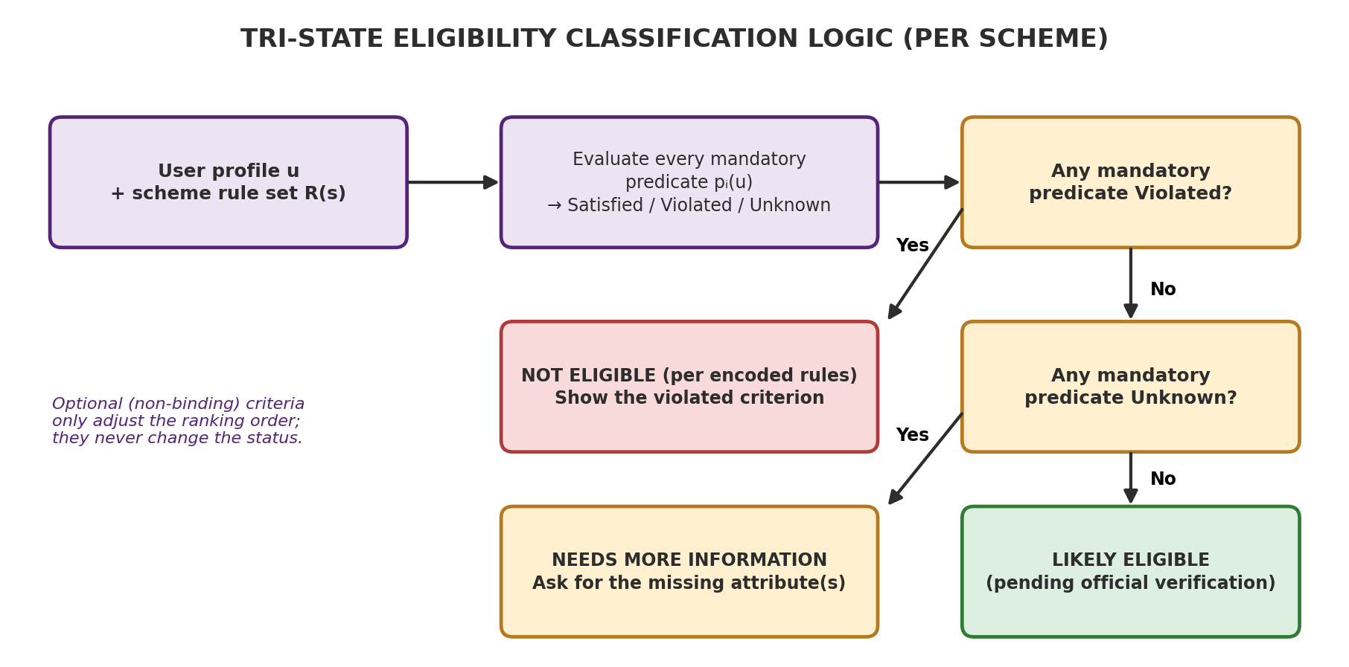
Figure 4. Tri-state classification logic applied to each candidate scheme.

10.2 Algorithm
Algorithm 1 summarises the evaluation procedure for one profile.
Algorithm 1: EvaluateSchemes(u, S, q)
Input : validated profile u (unknown values allowed),
scheme set S, optional free-text query q
Output: schemes grouped by status, each with a rule trace

1 C <- RetrieveCandidates(S, q, filters(u)) // semantic + metadata
2 for each scheme s in C do
3 trace <- empty list; violated <- false; unknown <- false
4 for each predicate p in mandatory(s) + exclusion(s) do
5 v <- Evaluate(p, u) // 1, 0 or UNKNOWN
6 append (p, value(u), v, source(s)) to trace
7 if v = 0 then violated <- true
8 else if v = UNKNOWN then unknown <- true
9 if violated then status(s) <- NOT_ELIGIBLE
10 else if unknown then status(s) <- NEEDS_INFO
11 else status(s) <- LIKELY_ELIGIBLE
12 end for
13 rank schemes within each status group using rho(u, s)
14 return grouped schemes with traces, rule_version, source_url

10.3 Illustrative Worked Example
The following example uses a hypothetical scheme with invented criteria purely to demonstrate the logic. It does not describe any real government scheme, and the profile is fictional.
Table 5. Hypothetical example of rule evaluation (not a real scheme and not an experimental result).
Criterion of hypothetical Scheme X | Profile value | Predicate result | Effect
Age between 18 and 25 years | Age = 21 | Satisfied | Continue
Annual family income ≤ ₹ 3,00,000 | Income = ₹ 2,40,000 | Satisfied | Continue
Resident of the state offering the scheme | State = matches | Satisfied | Continue
Currently enrolled as a student | Not provided | Unknown | Ask follow-up
Result: no mandatory predicate is violated, but one is unknown, so Scheme X is classified as Needs More Information, and the user is asked whether they are currently enrolled. If the answer is “Yes”, the status becomes Likely Eligible; if “No”, it becomes Not Eligible, and the explanation names the unmet criterion. In every case the result is accompanied by the notice to verify with the official source.

10.4 Special Cases
- Date-dependent criteria. Age and income are evaluated as on the date specified by the scheme, which the rule must record.
- Mutually exclusive benefits. Where a scheme excludes people who already receive another benefit, the system asks about this explicitly instead of inferring it.
- Ambiguous or discretionary criteria. Criteria that cannot be reduced to an objective predicate are displayed as text for the user to read and are not used to rule a scheme out.
- Rule changes. If the source of a rule changes, the previous version is retained, and results are labelled with the version used.

11. Fairness, Privacy, Security and Explainability

11.1 Fairness
Fairness risks arise less from a learned model than from the system’s coverage and accessibility. If the knowledge base contains many schemes for one state or one language community and few for others, citizens from the latter group will receive fewer results. Digital access, literacy and language can also affect who can use the system at all. Mehrabi et al. emphasise that bias can arise in data, algorithms and user interaction alike, and the same applies here. [8] Mitigations include publishing the coverage of the knowledge base by state and category, supporting several languages, allowing assisted use through community service centres, treating sensitive attributes as optional, and reporting evaluation errors by group (Section 12). Eubanks’s analysis of automated public-service systems is a reminder that the most vulnerable users bear the greatest cost of errors, which is a further reason for the conservative three-state design and for the mandatory verification notice. [9]

11.2 Privacy
The profile contains personal data, some of it potentially sensitive. The design therefore applies purpose limitation, data minimisation and storage limitation. Consent is obtained before processing, and quick-check mode stores nothing after the session. Identity numbers, bank details and contact information are not required for eligibility screening and are not collected. The Digital Personal Data Protection Act, 2023 regulates digital personal data processing in India, including consent and the protection of children’s data, and the final deployment must be reviewed against the Act and the rules framed under it, whose commencement and status should be checked at the time of deployment. [13] If an external language-model service is used, personal data must not be sent to it unless a legal basis and suitable contractual safeguards exist; otherwise the optional component should be disabled or replaced with a locally hosted model.

11.3 Security
Proposed security measures include encrypted transport, strict input validation, rate limiting, authenticated and role-based access to the curation panel, secret management for any external service keys, logging of rule changes, regular dependency updates, and protection against prompt injection in language-model components. The audit log should record events such as rule publication and administrative access, and should not store raw profile data.

11.4 Explainability
Every result is accompanied by a rule trace listing each criterion, the value that the user supplied, the outcome, the official source and the rule version. This follows the principle that explanations should serve the purpose for which they are given: here, to let a citizen understand a result and to let a reviewer detect an encoding error. [10] Since the decision logic is explicit, a post-hoc approximation method such as LIME is unnecessary for the eligibility decision itself, although such techniques remain relevant for any future learned component. [11]

11.5 Official Verification and Accountability
The system is an advisory tool. It displays a visible statement that eligibility is indicative and must be confirmed with the competent department, shows the date on which each rule was last checked, and provides a way for users to report incorrect results. Governance should follow a recognised risk-management approach, such as the NIST AI Risk Management Framework, which organises activities into governing, mapping, measuring and managing risks. [12] Table 6 summarises the main risks and proposed controls.
Table 6. Risks and proposed mitigations.
Risk | Possible consequence | Proposed mitigation
Outdated or wrongly encoded rule | Incorrect advice to the citizen | Versioning, dual review, source date shown, user error reporting
Unequal coverage of schemes | Unequal benefit to different regions or groups | Publish coverage, prioritise gaps, multilingual access
Over-collection of personal data | Privacy harm and legal non-compliance | Minimisation, consent, no identity numbers, session-only default
Language-model error or injection | Misleading text or manipulated output | Model cannot set status; schema validation; user confirmation; templates
Over-reliance on the tool | Citizens skip official verification | Mandatory notice, official link, “Likely” wording
Unauthorised rule changes | Corrupted knowledge base | Role-based access, audit log, review before publication

12. Results and Discussion

12.1 Implementation Status
At the time of writing, this paper is a design document. No quantitative experiments have been carried out, and no dataset or performance figure is reported. Table 7 therefore marks every module as proposed. If parts of the system are implemented before submission, the status column should be updated to reflect only what has actually been built and tested.
Table 7. Status of modules (to be updated by the project team).
Module | Description | Status
Profile intake and validation | Form, range checks, normalisation | Proposed
Scheme knowledge base | Curated records with structured rules | Proposed
Rule-based eligibility engine | Three-valued evaluation, rule trace | Proposed
Semantic retrieval | Embedding-based candidate selection | Proposed
Follow-up question selection | Heuristic of Equation (2) | Proposed
Explanation generator | Rule-trace and templated text | Proposed
Language-model assistance | Input structuring, wording | Proposed (optional)
Admin curation panel | Rule encoding and review workflow | Proposed

12.2 Planned Evaluation Method
The evaluation is designed to answer whether the system classifies schemes correctly, whether its explanations are useful and whether its behaviour is consistent across user groups. The planned procedure is as follows.
- Test profiles. The team prepares a set of fictional citizen profiles covering typical and boundary cases, such as a value exactly at an income threshold, missing attributes and conflicting criteria. The number of profiles is to be decided and reported.
- Ground truth. Two reviewers independently determine the expected status of each profile–scheme pair from the official guidelines. Disagreements are resolved by discussion, and the agreement between reviewers is reported.
- Execution. The system is run on every profile and its outputs are compared with the ground truth.
- User study. A small group of volunteers completes realistic tasks and answers a usability and trust questionnaire. Participant selection and consent procedures are to be defined.
Table 8 lists the proposed metrics. With TP, FP and FN counted for the class Likely Eligible, precision and recall are:
Precision = TP / (TP + FP), Recall = TP / (TP + FN) (6)
Because wrongly assuring a user of eligibility is a serious error, the false-eligible rate, that is, the share of truly ineligible profile–scheme pairs classified as Likely Eligible, will be reported separately. Target thresholds are intentionally not stated, since they should be set with the reviewers before testing.
Table 8. Proposed evaluation metrics.
Metric | Definition / procedure | Compared against | Status
Status accuracy | Share of pairs with the correct three-way status | Reviewer ground truth | Planned
Precision and recall | Per Equation (6) for Likely Eligible | Reviewer ground truth | Planned
False-eligible rate | Ineligible pairs labelled Likely Eligible | Reviewer ground truth | Planned
Group-wise error analysis | Error rates compared across state, language, gender, area type | Same metrics by subgroup | Planned
Explanation quality | Reviewer rating of correctness and clarity of rule traces | Rating scale | Planned
Usability and trust | Task completion and questionnaire responses | Volunteer study | Planned
Retrieval relevance | Whether relevant schemes appear in the shortlist | Reviewer judgement | Planned

12.3 Expected Outcomes and Discussion
Based on the design, the following behaviours are expected; they are hypotheses to be tested, not findings. First, because the decision is made by explicit rules, errors should arise mainly from mistakes in rule encoding or normalisation rather than from model uncertainty, and the rule trace should make such errors easy to locate. Second, the three-state design is expected to reduce incorrect assurances compared with a binary approach, because missing data is surfaced. Third, semantic retrieval is expected to help users who cannot name a scheme, but its usefulness depends on the quality of scheme descriptions and must be measured. Fourth, the system’s value depends heavily on the completeness and currency of the knowledge base, which is an organisational and maintenance problem as much as a technical one.

12.4 Threats to Validity
Evaluation with fictional profiles may not represent real citizens. Reviewers may interpret ambiguous criteria differently. A small knowledge base limits generalisation to the full range of schemes. Self-reported inputs may be incorrect. A usability study with volunteers, often students, may not represent those most in need of the system. These limitations should be reported alongside any results.

13. Advantages and Limitations

13.1 Expected Advantages
- A single profile is evaluated against many schemes, reducing repeated data entry and scheme-by-scheme searching.
- Missing information is made visible and requested, not guessed.
- Rule traces make the reasoning transparent and let reviewers detect encoding errors.
- Source links, retrieval dates and rule versions support accountability and verification.
- Data minimisation and a session-only default reduce privacy exposure.
- The modular design allows retrieval, language-model and interface components to be replaced independently.

13.2 Limitations
- The system is at the design stage and has not been implemented or evaluated; all benefits above are expected, not demonstrated.
- Results depend on manually curated rules, which require continuous maintenance as schemes change.
- Coverage is limited to the schemes in the knowledge base and may be uneven across states and categories.
- Self-reported inputs cannot be verified, and the output is only indicative.
- Some criteria are discretionary, ambiguous or require documents that the system cannot assess.
- Access depends on devices, connectivity, language support and digital literacy.
- The optional language-model component, if used, may introduce privacy and reliability concerns.

14. Future Enhancements
Several extensions are possible once a baseline prototype has been evaluated. First, the knowledge base should be expanded to more schemes and states, with a published coverage report. Second, multilingual and voice-based interaction would help citizens with limited literacy; the national platform itself is described as multilingual, which underlines its importance. [2] Third, if official interfaces become available, the system could integrate with them, for example for document checklists or application hand-off, subject to the applicable legal and consent requirements. The national platform already links applications with DigiLocker. [4]
Fourth, language models could assist in proposing draft rule encodings from official text, provided that every proposal is reviewed by a person before publication. Fifth, wherever official machine-readable rules are published, the system should consume them directly in line with the Rules-as-Code approach. [5] Sixth, notification of rule changes, assisted-use modes for community centres, and periodic fairness audits can be added. Finally, a formal risk assessment aligned with a recognised framework would be appropriate before any public deployment. [12]

15. Conclusion
This paper presented AI Government Scheme Eligibility, a proposed system that lets citizens enter a limited profile and receive an explained, source-linked list of government schemes for which they may be eligible. Its central design decision is to separate discovery from decision: semantic retrieval and optional language-model assistance help users find and understand schemes, while a conservative, three-valued rule engine determines the eligibility status. Treating missing information as an explicit state, providing rule-level explanations and requiring official verification are intended to make the tool useful without overstating its authority.
The contribution at this stage is a design and an evaluation protocol, not an experimental result. The system has not yet been implemented or tested, and its expected benefits are hypotheses to be examined through the planned evaluation. The principal challenges for realising it are maintaining an accurate and current rule base, ensuring equitable coverage and access, and protecting citizens’ personal data. Addressing these challenges in a transparent and accountable way is as important as the underlying algorithms.

References
[1] myScheme. About Us – myScheme: National Platform for Government Schemes. National e-Governance Division, MeitY, Government of India. https://www.myscheme.gov.in/about
[2] National e-Governance Division. myScheme. Ministry of Electronics and Information Technology, Government of India. https://negd.gov.in/myscheme/
[3] J. Currie. The Take-Up of Social Benefits. In A. Auerbach, D. Card and J. Quigley (eds.), Public Policy and the Income Distribution, Russell Sage Foundation, New York, 2006, pp. 80–148 (earlier version: IZA Discussion Paper No. 1103, 2004). https://www.nber.org/papers/w10488
[4] Digital India Corporation. myScheme. Ministry of Electronics and Information Technology, Government of India. https://dic.gov.in/my-scheme/
[5] J. Mohun and A. Roberts. Cracking the Code: Rulemaking for Humans and Machines. OECD Working Papers on Public Governance, No. 42, OECD Publishing, Paris, 2020. https://doi.org/10.1787/3afe6ba5-en
[6] P. Lewis, E. Perez, A. Piktus, F. Petroni, V. Karpukhin, N. Goyal, H. Küttler, M. Lewis, W. Yih, T. Rocktäschel, S. Riedel and D. Kiela. Retrieval-Augmented Generation for Knowledge-Intensive NLP Tasks. Advances in Neural Information Processing Systems 33 (NeurIPS 2020). https://arxiv.org/abs/2005.11401
[7] N. Reimers and I. Gurevych. Sentence-BERT: Sentence Embeddings using Siamese BERT-Networks. Proc. EMNLP-IJCNLP 2019, pp. 3982–3992. https://arxiv.org/abs/1908.10084
[8] N. Mehrabi, F. Morstatter, N. Saxena, K. Lerman and A. Galstyan. A Survey on Bias and Fairness in Machine Learning. ACM Computing Surveys, 54(6), Article 115, 2021. https://doi.org/10.1145/3457607
[9] V. Eubanks. Automating Inequality: How High-Tech Tools Profile, Police, and Punish the Poor. St. Martin’s Press, New York, 2018.
[10] F. Doshi-Velez and B. Kim. Towards A Rigorous Science of Interpretable Machine Learning. arXiv:1702.08608, 2017. https://arxiv.org/abs/1702.08608
[11] M. T. Ribeiro, S. Singh and C. Guestrin. “Why Should I Trust You?”: Explaining the Predictions of Any Classifier. Proc. 22nd ACM SIGKDD International Conference on Knowledge Discovery and Data Mining, 2016, pp. 1135–1144. https://doi.org/10.1145/2939672.2939778
[12] National Institute of Standards and Technology. Artificial Intelligence Risk Management Framework (AI RMF 1.0). NIST AI 100-1, January 2023. https://doi.org/10.6028/NIST.AI.100-1
[13] Ministry of Electronics and Information Technology, Government of India. Digital Personal Data Protection Act, 2023 and Data Protection Framework. https://www.meity.gov.in/data-protection-framework
[14] FastAPI Documentation. FastAPI – Modern Python web framework. https://fastapi.tiangolo.com/
[15] PostgreSQL Global Development Group. PostgreSQL Documentation. https://www.postgresql.org/docs/
[16] React Documentation. React – A JavaScript library for building user interfaces. https://react.dev/

