GLOBALFLOOD AI
GLOBAL MULTIMODAL FLOOD PREDICTION SYSTEM
(48-HOUR FORECAST)
F1+TF1 - Slot Fall Semester 2026-27

COURSE PROJECT REPORT

Submitted by
Araveti Jathin | 23BDS0008
E. Alekhya Reddy | 23BDS0171
Under the guidance of
Dr. DEGA NAGARAJU


School of Computer Science and Engineering
Vellore Institute of Technology
October 2026
TABLE OF CONTENTS
1.2 Significance of the Study 6
1.3 Existing Techniques 6
1.4 Research Gap and Motivation 7
1.5 Objectives 7
1.6 Scope and Limitations 8
1.7 Organization of the Report 8
CHAPTER 2: LITERATURE REVIEW 9
2.1 Hydrological, Hydraulic, and Statistical Flood Prediction 9
2.2 Satellite Remote Sensing and SAR-Based Flood Mapping 9
2.3 Weather Time Series and Machine Learning 10
2.4 Multimodal Fusion and Deep Learning 10
2.5 Datasets, Validation, Evaluation, and Calibration 10
2.6 Research Synthesis and Positioning of GlobalFlood AI 11
CHAPTER 3: METHODOLOGY 12
3.1 Overview of the Proposed Framework 12
3.2 Data Sources 13
3.3 Dataset Manifest and Target Definition 13
3.4 Feature Engineering and Preprocessing 14
3.5 Event-Grouped Data Splitting and Leakage Prevention 14
3.6 Model Architecture 15
3.7 Probability Calibration and Risk Categories 15
3.8 Evaluation Metrics 15
3.9 Software Implementation 16
3.10 Example Manifest Structure 16
3.11 Methodological Limitations 16
CHAPTER 4: RESULTS AND DISCUSSION 17
4.1 Experimental Setup 17
4.2 Training and Validation Convergence 17
4.3 Classification Performance 18
4.4 ROC-AUC and Precision–Recall Analysis 19
4.5 Probability Calibration 20
4.6 Dataset Composition and Event-Based Evaluation 21
4.7 Comparative Model Evaluation 22
4.8 Data Provenance and Forecasting Limitations 23
4.9 Summary of Findings 23
CHAPTER 5: CONCLUSION 24
5.1 Implications 24
5.2 Future Scope 24
REFERENCES 26
APPENDIX 28
A. Reported Commands 28
B. Example Prediction Request 28
C. Responsible Use 28

CERTIFICATE
This is to certify that the project report entitled “GlobalFlood AI: Global Multimodal Flood Prediction System (48-Hour Forecast)” is submitted as a record of project work carried out for the fulfilment of the relevant course requirements.
The contents of this project work, in full or in parts have neither been taken from any other source nor have been submitted for any other course.
Place: Vellore
Date: 21/10/2026
Student Signature: ____________________
Faculty Guide: ____________________

ABSTRACT
Floods cause substantial loss of life, damage to infrastructure, and disruption to communities. Timely flood-risk estimation remains challenging where river-gauge networks are sparse, observations are delayed, and weather and terrain conditions vary spatially. GlobalFlood AI is an experimental multimodal deep-learning system designed to estimate flood probability for a user-selected geographic coordinate up to a 48-hour forecast horizon. Its intended inputs combine Sentinel-1 synthetic aperture radar (SAR) imagery, hourly historical and forecast weather sequences from Open-Meteo, and terrain attributes derived from Copernicus DEM and/or Open-Elevation. The model uses a convolutional neural network (CNN) to encode VV/VH SAR patches, a gated recurrent unit (GRU) network to represent weather sequences, and a multilayer perceptron (MLP) to encode terrain features. The learned representations are combined through a mask-aware fusion layer that also receives modality-availability flags. Platt scaling is used to calibrate the model output, which is mapped to four application-defined risk categories. A FastAPI backend and a React/TypeScript/Leaflet frontend support data retrieval, prediction requests, and geospatial visualization. The supplied implementation report states that 40 samples across 10 events were partitioned into training, validation, and test sets, and reports perfect classification metrics on eight held-out test samples. These results must be interpreted cautiously because the test set is extremely small and represents only two events. The report therefore presents GlobalFlood AI as a research prototype rather than a validated operational warning system. Further work must verify event-label provenance, expand independent evaluation, and establish robust calibration and generalization before real-world use.
Keywords: Flood prediction, multimodal learning, Sentinel-1 SAR, GRU, CNN, terrain features, data fusion, probability calibration.
CHAPTER 1: INTRODUCTION
1.1 Background and Problem Statement
Flooding is a complex hazard influenced by precipitation, antecedent wetness, topography, land cover, drainage, and river-system dynamics. Flood forecasting systems commonly combine hydrological and hydraulic models with meteorological forecasts and observations. Such systems can be highly effective where input data, calibration, and operational infrastructure are available, but their performance and transferability may be limited in regions with sparse gauge coverage or incomplete local information [1], [2]. Satellite remote sensing provides a complementary view of inundation over broad areas, while numerical weather products describe the atmospheric conditions that may precede a flood.
GlobalFlood AI explores whether these complementary data sources can be integrated into a single deep-learning classification pipeline. The intended output is the estimated probability that a location will experience flooding within a forecast horizon of up to 48 hours. The system uses latitude and longitude as the user-facing location input, retrieves available weather, satellite and terrain information, encodes each modality separately, and fuses the representations before classification.

1.2 Significance of the Study
The study is significant as an engineering investigation into multimodal geospatial learning. SAR imagery can provide useful surface observations during cloudy conditions, weather sequences describe recent and forecast atmospheric conditions, and terrain features represent local elevation and topographic context. These inputs have different spatial and temporal resolutions; a common pipeline must therefore track their timestamps, coverage, and quality rather than simply concatenate arbitrary values. Explicit missingness masks are intended to make the model aware when a modality is unavailable.

1.3 Existing Techniques
Established flood modelling includes physically based hydrological and hydraulic simulation, statistical forecasting, machine-learning methods, satellite image classification, and deep-learning approaches. Hydrological models represent rainfall-runoff processes and may be coupled to hydraulic models to simulate inundation. Data-driven methods can learn relationships between observations and flood outcomes, but may depend strongly on training coverage and data quality [1], [2]. Satellite flood mapping often uses optical or radar observations to identify water extent, while recurrent networks and other sequence models have been explored for time-dependent hydrological prediction [3]–[6].
A key distinction is that mapping an observed flood is not the same task as forecasting a future flood. A satellite image acquired during or after an event can support inundation mapping, but it does not by itself prove that a model can forecast an event 48 hours before onset. Forecast claims depend on the definition of the target time, the availability of genuine forecast inputs at that time, and a leakage-resistant evaluation design.

1.4 Research Gap and Motivation
The project is motivated by the opportunity to combine image, temporal, and terrain features while explicitly representing missing modalities. Many practical data pipelines face asynchronous acquisition: weather may be available hourly, while Sentinel-1 has an orbital revisit interval and cloud-independent observations are not continuously available. A model that ignores this mismatch may learn from inconsistent or unavailable inputs. GlobalFlood AI therefore uses separate encoders, availability flags, event-grouped splitting, and probability calibration as design elements. Their benefit must ultimately be demonstrated with a larger, independently evaluated dataset.

1.5 Objectives
- Develop a reproducible pipeline to retrieve and align satellite, weather, terrain, and flood-label information.
- Implement a multimodal PyTorch classifier with CNN, GRU, and MLP branches.
- Handle missing input modalities using explicit masks and availability indicators.
- Reduce event-level leakage by separating samples according to flood events.
- Evaluate classification and probability quality using ROC-AUC, PR-AUC, precision, recall, F1-score, confusion matrix, and Brier score.
- Provide a FastAPI backend and interactive React/Leaflet interface for research demonstrations.

1.6 Scope and Limitations
The project is an experimental research prototype. Sentinel-1 availability is constrained by acquisition and revisit schedules, forecast products have finite spatial resolution, terrain datasets do not represent all urban drainage infrastructure, and flood labels can be uncertain at mixed pixels. The supplied implementation report describes only 40 samples across 10 events and an eight-sample test set. Such a sample is insufficient to establish global reliability or operational readiness. In addition, the project documents contain an important provenance question: the stated Global Flood Database MODIS V1 coverage is 2000–2018, while several listed implementation events have later dates. This requires verification before the report can assert that all labels originate from that database.

1.7 Organization of the Report
Chapter 1 introduces the problem, motivation, objectives, and scope. Chapter 2 reviews relevant research across five themes. Chapter 3 explains data sources, preprocessing, architecture, training, calibration, and software implementation. Chapter 4 presents the results reported by the supplied implementation document and discusses their limitations. Chapter 5 summarizes the work and identifies future research directions.

CHAPTER 2: LITERATURE REVIEW
Flood prediction and inundation mapping require the integration of meteorological conditions, hydrological processes, satellite observations, and geographical features. Research has progressed from physical modelling and remote sensing to machine learning and multimodal data fusion. This chapter reviews relevant studies under five themes and identifies how they support the proposed GlobalFlood AI system.

2.1 Hydrological, Hydraulic, and Statistical Flood Prediction
Traditional flood prediction uses hydrological and hydraulic models to simulate rainfall-runoff processes and estimate inundation. Bates and De Roo [1] demonstrated the integration of remote sensing, GIS, and two-dimensional hydraulic modelling for flood simulation. Alfieri et al. [2] examined large-scale flood-risk assessment and forecasting, highlighting the importance of meteorological inputs and uncertainty. Kauffeldt et al. [3] discussed hydrological modelling in data-scarce regions, while Krysanova and White [4] reviewed modelling practices and future research directions. Moglen and Shivers [5] highlighted the influence of watershed characteristics on flood response.
Nearing et al. [6] emphasized the need for reliable evaluation, interpretability, and scientific grounding in machine learning applications for hydrology. These studies establish the importance of combining environmental observations with spatial context. However, physical simulation, retrospective flood mapping, and future flood forecasting are different tasks. GlobalFlood AI explores a data-driven approach to forecasting while requiring further validation across diverse flood events.

2.2 Satellite Remote Sensing and SAR-Based Flood Mapping
Satellite remote sensing provides extensive geographical coverage for flood monitoring. Schumann et al. [7] reviewed satellite-based flood observation and mapping, while Twele et al. [8] demonstrated the use of Sentinel-1 synthetic aperture radar (SAR) for flood mapping. Martinis et al. [9] developed automated flood-detection methods using SAR imagery, and Clement et al. [10] discussed Sentinel-1 applications and processing considerations.
Tellman et al. [11] demonstrated the value of satellite-derived information for analysing global flood exposure. Bonafilia et al. [12] presented an open-source approach to flood mapping using satellite imagery and deep learning. Gao et al. [13] investigated SAR-based water extraction in complex landscapes, where vegetation, urban structures, and radar geometry can affect detection.
These studies support the use of Sentinel-1 VV and VH backscatter as spatial inputs for GlobalFlood AI. SAR observations are particularly valuable under cloudy conditions, but satellite revisit intervals prevent continuous hourly observation everywhere. Furthermore, mapping existing inundation does not independently establish whether flooding will occur 48 hours later. Therefore, the proposed system combines satellite features with weather forecasts and terrain information.

2.3 Weather Time Series and Machine Learning
Machine learning provides methods for identifying nonlinear relationships between meteorological variables and hydrological responses. Mosavi et al. [14] reviewed machine-learning approaches to flood prediction and highlighted the diversity of datasets, methods, and evaluation strategies. Kratzert et al. [15, 16] demonstrated the application of deep learning to rainfall-runoff modelling and hydrological prediction across catchments. Shen [17] discussed the opportunities offered by deep learning in hydrology, while Sit et al. [18] reviewed machine learning applications in water resources.
Recurrent neural networks are useful for sequential data because they can represent temporal dependencies. Long short-term memory networks were introduced by Hochreiter and Schmidhuber [20], while Cho et al. [21] introduced gated recurrent units (GRUs) for sequence modelling. These approaches motivate using a GRU to process historical weather observations and forecast sequences in GlobalFlood AI.
Nevertheless, model performance depends on representative training data and appropriate validation. Future information must not leak into historical model inputs, and results should be evaluated on independent flood events. Consequently, the proposed weather encoder is a suitable architectural choice to investigate, rather than a guarantee of forecasting accuracy.

2.4 Multimodal Fusion and Deep Learning
Deep learning enables automatic feature extraction from heterogeneous data. LeCun et al. [19] reviewed the development of deep learning and its capacity for representation learning. Goodfellow et al. [22] provided foundational coverage of neural networks, optimization, and regularization. These principles support the development of separate encoders for satellite imagery, weather sequences, and terrain features.
Baltrušaitis et al. [23] reviewed multimodal machine learning, including representation learning and fusion strategies. Atrey et al. [24] discussed early, intermediate, and late fusion, while Ramachandram and Taylor [25] examined challenges in deep multimodal learning. Neverova et al. [26] also explored multimodal architectures and learning strategies.
Building on this literature, GlobalFlood AI uses a convolutional neural network (CNN) to extract spatial features from Sentinel-1 imagery, a GRU to encode weather time series, and a multilayer perceptron (MLP) to process topographic attributes. Their learned representations are combined through a fusion network. Missing-modality masks are incorporated to indicate unavailable inputs. This design aims to exploit complementary information, although its effectiveness must be established through comparative evaluation on sufficiently large and independent datasets.

2.5 Datasets, Validation, Evaluation, and Calibration
Reliable flood forecasting requires appropriate labels, independent testing, and meaningful performance metrics. Tellman et al. [11] illustrate the value of global satellite-derived flood information, but retrospective labels must be aligned with the intended forecasting horizon. Kavetski et al. [27] discussed uncertainty in hydrological modelling, reinforcing the importance of acknowledging uncertainty in predictions.
Roberts et al. [28] reviewed cross-validation for structured data, and Brenning [29] examined spatial cross-validation. Their work supports splitting data by event or geographical group rather than randomly distributing closely related observations across training and testing sets. Such separation helps reduce overly optimistic estimates of generalization.
For performance evaluation, Fawcett [36] explained receiver operating characteristic (ROC) analysis, while Davis and Goadrich [35] examined the relationship between ROC and precision-recall analysis. Saito and Rehmsmeier [34] highlighted the importance of precision-recall curves for imbalanced datasets. Hand [37] discussed limitations in interpreting area-under-the-curve measures, and Brier [33] introduced a score for evaluating probabilistic forecasts.
Probability calibration is another important consideration. Platt [30] introduced sigmoid-based score calibration, while Niculescu-Mizil and Caruana [31] compared probability-estimation methods. Guo et al. [32] demonstrated that neural-network confidence can be miscalibrated. Ovadia et al. [38] investigated predictive uncertainty under dataset shift, and Wolpert [39] discussed the no-free-lunch principle. Mullainathan and Spiess [40] emphasized careful evaluation of data-driven predictive methods.
Together, these studies motivate using ROC-AUC, PR-AUC, precision, recall, F1-score, and Brier score to assess different aspects of model performance. GlobalFlood AI also incorporates Platt scaling to calibrate predicted probabilities. However, calibration and generalization require adequate independent data, and strong results on a small test set cannot establish reliable global performance.

2.6 Research Synthesis and Positioning of GlobalFlood AI
The reviewed literature motivates integrating satellite imagery, weather sequences, and terrain information within a single forecasting framework. GlobalFlood AI implements this approach using a CNN-based SAR encoder, a GRU-based weather encoder, and an MLP-based terrain encoder, followed by mask-aware feature fusion and probability calibration.
The proposed system aims to estimate flood risk up to 48 hours ahead for global coordinates without depending on localized river-gauge telemetry. Its design draws on established techniques in remote sensing, hydrological machine learning, multimodal learning, and probabilistic evaluation.
However, the current implementation should be considered a prototype and preliminary experiment. The limited labelled sample size and unresolved provenance of some event labels constrain the conclusions that can be drawn from reported results. Larger event-level datasets, independent geographical testing, and verified ground-truth records are required before claiming robust global forecasting capability.

CHAPTER 3: METHODOLOGY

3.1 Overview of the Proposed Framework
GlobalFlood AI follows a multimodal pipeline in which location-specific data are retrieved, checked, transformed into model inputs, encoded by three neural branches, and combined for binary flood classification. The resulting logit is converted into a probability, optionally calibrated using Platt scaling, and mapped to an application-defined risk category.
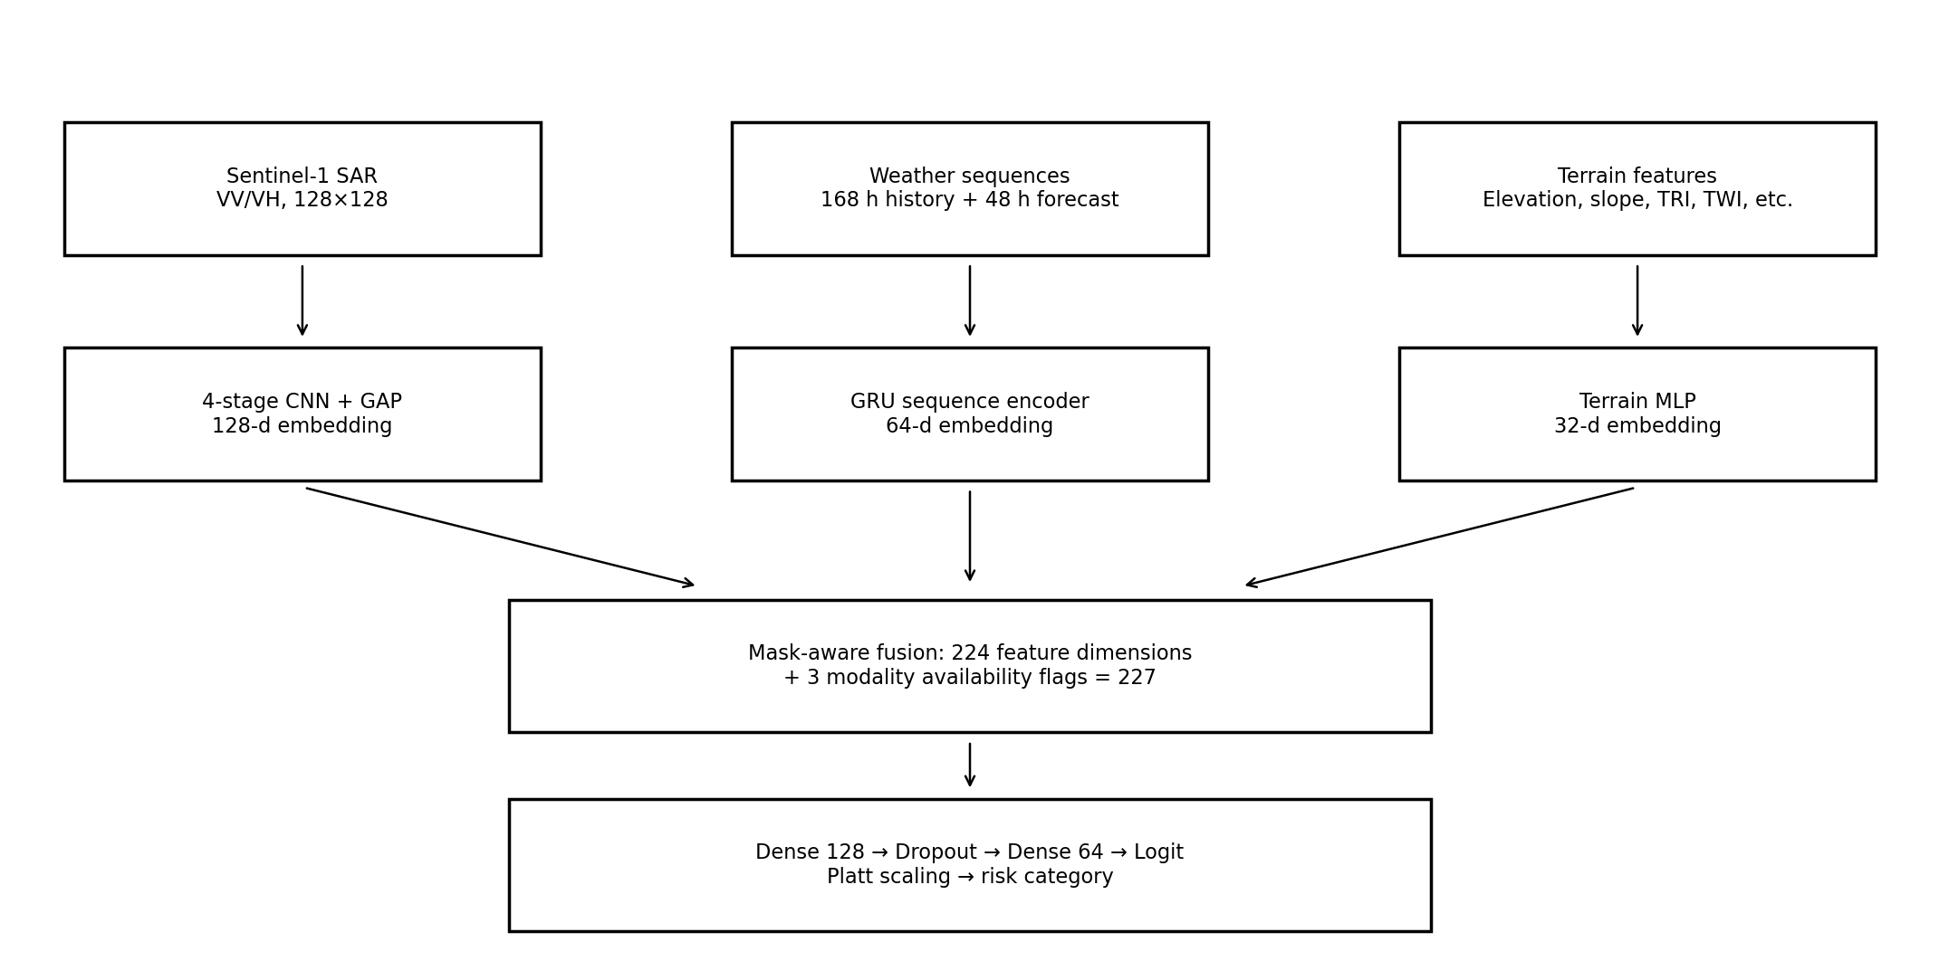
Figure 3.1. Reported MultimodalFloodNet architecture.
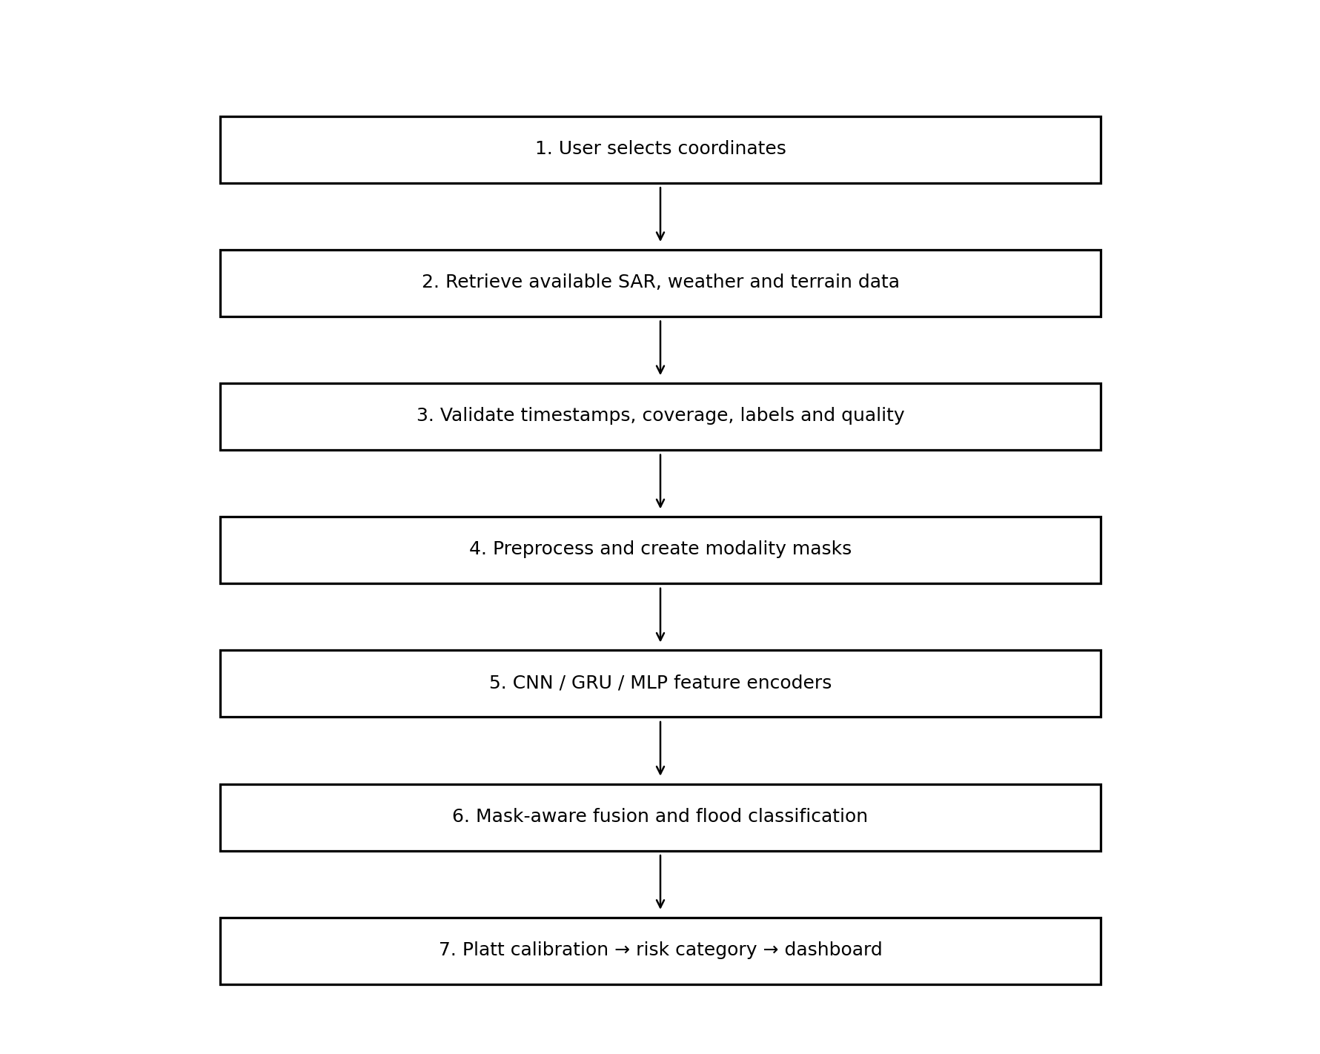
Figure 3.2. End-to-end methodology flowchart.

3.2 Data Sources
Modality | Source | Reported resolution/window | Purpose and limitations
Satellite radar | Copernicus Sentinel-1 C-SAR IW | 10 m; 128×128 VV/VH patch; revisit typically several days | Spatial backscatter information; requires product selection, preprocessing, and availability checks.
Historical weather | Open-Meteo ERA5 reanalysis | Hourly; approximately 168-hour history; about 11 km | Antecedent weather context; reanalysis has latency and is not a direct local soil-moisture measurement.
Weather forecast | Open-Meteo forecast products (ECMWF/GFS as available) | Hourly; up to 48 hours; around 11 km | Forecast rainfall and other meteorological variables; model and variable availability may vary.
Terrain | Copernicus DEM / Open-Elevation | DEM stated as 90 m; elevation API resolution varies | Elevation and engineered terrain variables; static terrain cannot represent all drainage infrastructure.
Flood labels | Global Flood Database (MODIS V1), as intended in README | 250 m; README states 2000–2018 | Historical inundation labels; actual label provenance and event-date compatibility require verification.

3.3 Dataset Manifest and Target Definition
The implementation report describes a dataset manifest with sample ID, event ID, latitude, longitude, target timestamp, SAR product reference, modality masks, data-quality flags, and label provenance. The intended target is target_flood_within_48h ∈ {0,1}. A positive label should indicate that documented inundation begins or expands within the following 48 hours after prediction time T0. A negative label should indicate verified absence of inundation during that window in a paired reference area. If the available ground-truth product only maps an event at a broad date or interval, it may not support this precise onset target without additional event chronology.

3.4 Feature Engineering and Preprocessing
SAR inputs use VV and VH polarization channels and are reported as normalized from a decibel range of approximately −30 dB to 0 dB into [0,1]. The exact conversion and clipping parameters should be kept in the preprocessing configuration and applied consistently at training and inference. Weather inputs are arranged as historical and forecast sequences, with missingness indicators concatenated to the values. Terrain inputs are reported as a nine-dimensional vector containing elevation, slope, terrain ruggedness index (TRI), topographic wetness index (TWI), distance to river, and spherical coordinate encodings sin(latitude), cos(latitude), sin(longitude), and cos(longitude).
Feature group | Feature / variable | Representation | Model role
SAR | VV, VH backscatter | Two-channel 128×128 patch | Spatial features encoded by CNN
Historical weather | Hourly weather variables for prior 168 hours | Sequence plus missingness mask | Antecedent conditions encoded by GRU
Forecast weather | Hourly forecast variables for up to 48 hours | Sequence plus missingness mask | Future atmospheric forcing encoded by GRU
Terrain | Elevation, slope, TRI, TWI, distance to river | Numeric vector | Static local context encoded by MLP
Location | sin(lat), cos(lat), sin(lon), cos(lon) | Four numeric cyclic features | Geographic context in terrain branch
Availability | SAR, weather, terrain presence flags | Three binary values | Allows fusion network to account for absent modalities
Target | Flood within forecast window | Binary 0/1 label | Supervised classification response

3.5 Event-Grouped Data Splitting and Leakage Prevention
The implementation report states that 40 samples were partitioned by event: training used 24 samples across six events, validation used eight samples across two events, and testing used eight samples across two held-out events. Event grouping is important because samples from the same flood may share weather, terrain, and acquisition conditions. If closely related samples are randomly distributed across partitions, test performance can be overly optimistic. Historical weather features must be restricted to information available at prediction time, while future conditions must come from forecast products rather than observations collected after the event.

3.6 Model Architecture
Branch | Reported structure | Output
SAR CNN | Four Conv2D stages, BatchNorm, ReLU, MaxPool, AdaptiveAvgPool2D and projection | 128 dimensions
Weather GRU | Two-layer GRU for historical sequence and one-layer GRU for forecast sequence; values concatenated with masks | 64 dimensions
Terrain MLP | Two-layer MLP, BatchNorm, Dropout(0.2), LayerNorm | 32 dimensions
Fusion | 224 encoded dimensions + three availability flags | 227 dimensions
Classifier | Dense(128, ReLU), Dropout(0.3), Dense(64, ReLU), Dropout(0.2), Linear(64,1) | Single logit
The fusion representation combines complementary features from each branch. During binary training, a logit can be optimized with a numerically stable binary cross-entropy-with-logits objective. The implementation report describes class-weighted BCE and early stopping. Model checkpoints are saved for inference and evaluation. The architecture and dimensions should be confirmed against the actual model source before publication.

3.7 Probability Calibration and Risk Categories
Platt scaling fits a logistic transformation to model scores using held-out validation predictions. In general, a calibrated probability should correspond to an empirical event frequency among cases receiving similar probabilities. Calibration is distinct from discrimination: ROC-AUC may be high even when probability estimates are inaccurate. The project uses four configurable application categories: Low (<25%), Moderate (25% to <55%), High (55% to <80%), and Very High (≥80%). These are project-defined thresholds and not official warning levels.

3.8 Evaluation Metrics
ROC-AUC measures ranking discrimination across thresholds, while PR-AUC summarizes the precision-recall trade-off and can be informative under class imbalance. Precision measures the fraction of predicted positives that are positive; recall measures the fraction of actual positives detected; F1 is the harmonic mean of precision and recall. A confusion matrix reports true and false classifications at a selected threshold. The Brier score is the mean squared difference between predicted probabilities and binary outcomes, with lower values indicating better probability accuracy. All metrics must be interpreted alongside sample size, event diversity, target definition, and potential dataset shift.

3.9 Software Implementation
The supplied implementation report describes a Python/FastAPI backend with endpoints for health status, prediction, weather, satellite metadata, terrain, flood history, model status, and evaluation. The machine-learning code is implemented in PyTorch. The frontend uses React 18, TypeScript, Vite, Tailwind CSS, and Leaflet for an interactive map and result display. The project also includes eight research notebooks and a test suite reported to contain 25 passing unit and integration tests. These tests support software-level checks such as input validation, model shapes, missing-modality handling, API behaviour, and checkpoint/calibrator operations; they do not establish scientific validity of the forecasts.

3.10 Example Manifest Structure
Field | Description | Example format (illustrative only)
sample_id | Unique sample identifier | GFD_EVENT_X_pos_0
event_id | Flood event grouping key | EVENT_X
latitude / longitude | WGS84 coordinates | [latitude], [longitude]
target_timestamp | Prediction reference time | ISO 8601 timestamp
sar_product | Satellite scene reference | Product ID or null
modality_masks | Availability of inputs | SAR=1, weather=1, terrain=1
data_quality_flags | Provenance and quality metadata | real / proxy / missing flags
flood_label_provenance | Source and label method | Dataset name and version
The values in the table are schema examples and are not actual records from the project dataset.

3.11 Methodological Limitations
The most important methodological concern is whether the labels genuinely support a 48-hour onset target. Retrospective inundation maps can identify where flooding occurred but may not provide the exact onset time needed to define a forecast target. The README describes MODIS Global Flood Database coverage from 2000–2018, while the implementation report lists events with dates after 2018. The event identifiers, data sources, and label provenance must be audited before the dataset is described as fully verified. The small sample size also makes model fitting and calibration vulnerable to overfitting.

CHAPTER 4: RESULTS AND DISCUSSION

4.1 Experimental Setup
The GlobalFlood AI system was evaluated using a small, event-grouped experimental dataset containing 40 samples from 10 flood events. The dataset was divided into training, validation, and testing partitions containing 24, 8, and 8 samples, respectively. Each partition contained equal numbers of flooded and non-flooded samples. The test partition contained four positive and four negative samples from two held-out flood events.
The proposed MultimodalFloodNet combines satellite radar representations, weather sequences, and topographic features. Its performance was compared with a tabular logistic-regression baseline and a prior-frequency baseline. The reported results were calculated from the saved model checkpoints and evaluation artifacts without retraining the model.

4.2 Training and Validation Convergence
Figure 4.1 presents the training and validation binary cross-entropy losses over five epochs. Training loss decreased from 0.6009 in the first epoch to 0.0383 in the fifth epoch. Validation loss decreased from 0.6510 to 0.0198 during the same period.
The reduction in both losses indicates that the model learned patterns associated with the training labels and achieved a low validation loss on the available validation samples. The training loss increased temporarily during the fourth epoch before decreasing substantially in the fifth epoch. This fluctuation may reflect optimization variability.
Validation ROC-AUC remained at 1.00 across the five recorded epochs. Validation F1-score was initially zero and reached 1.00 from the second epoch onward. These results indicate strong class separation on the small validation partition. However, because the validation set contains only eight samples, the metrics are highly sensitive to individual examples and should not be interpreted as evidence of generalization to unseen global flood events.
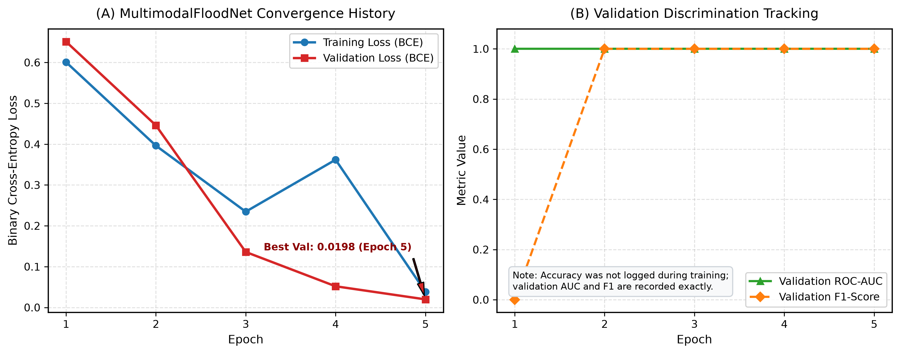
Figure 4.1: Training and validation loss and validation discrimination metrics.

4.3 Classification Performance
Figure 4.2 presents the confusion matrices for MultimodalFloodNet, its Platt-calibrated variant, the tabular logistic-regression baseline, and the prior-frequency baseline.
On the eight test samples, the raw multimodal model correctly classified all four flooded and all four non-flooded samples. Its confusion matrix contained four true positives, four true negatives, zero false positives, and zero false negatives. The calibrated model produced the same threshold-based classifications.
The logistic-regression baseline correctly classified seven of the eight samples, with one false positive and no false negatives. The prior-frequency baseline predicted every sample as flooded, correctly identifying all four flooded samples but incorrectly classifying all four non-flooded samples.
The multimodal model therefore achieved 100% test accuracy, precision, recall, and F1-score in this particular experiment. These values must be interpreted in the context of the extremely small test set. A single additional error would materially change the reported performance. Moreover, the synthetic generation of important input features may explain much of the observed class separation.
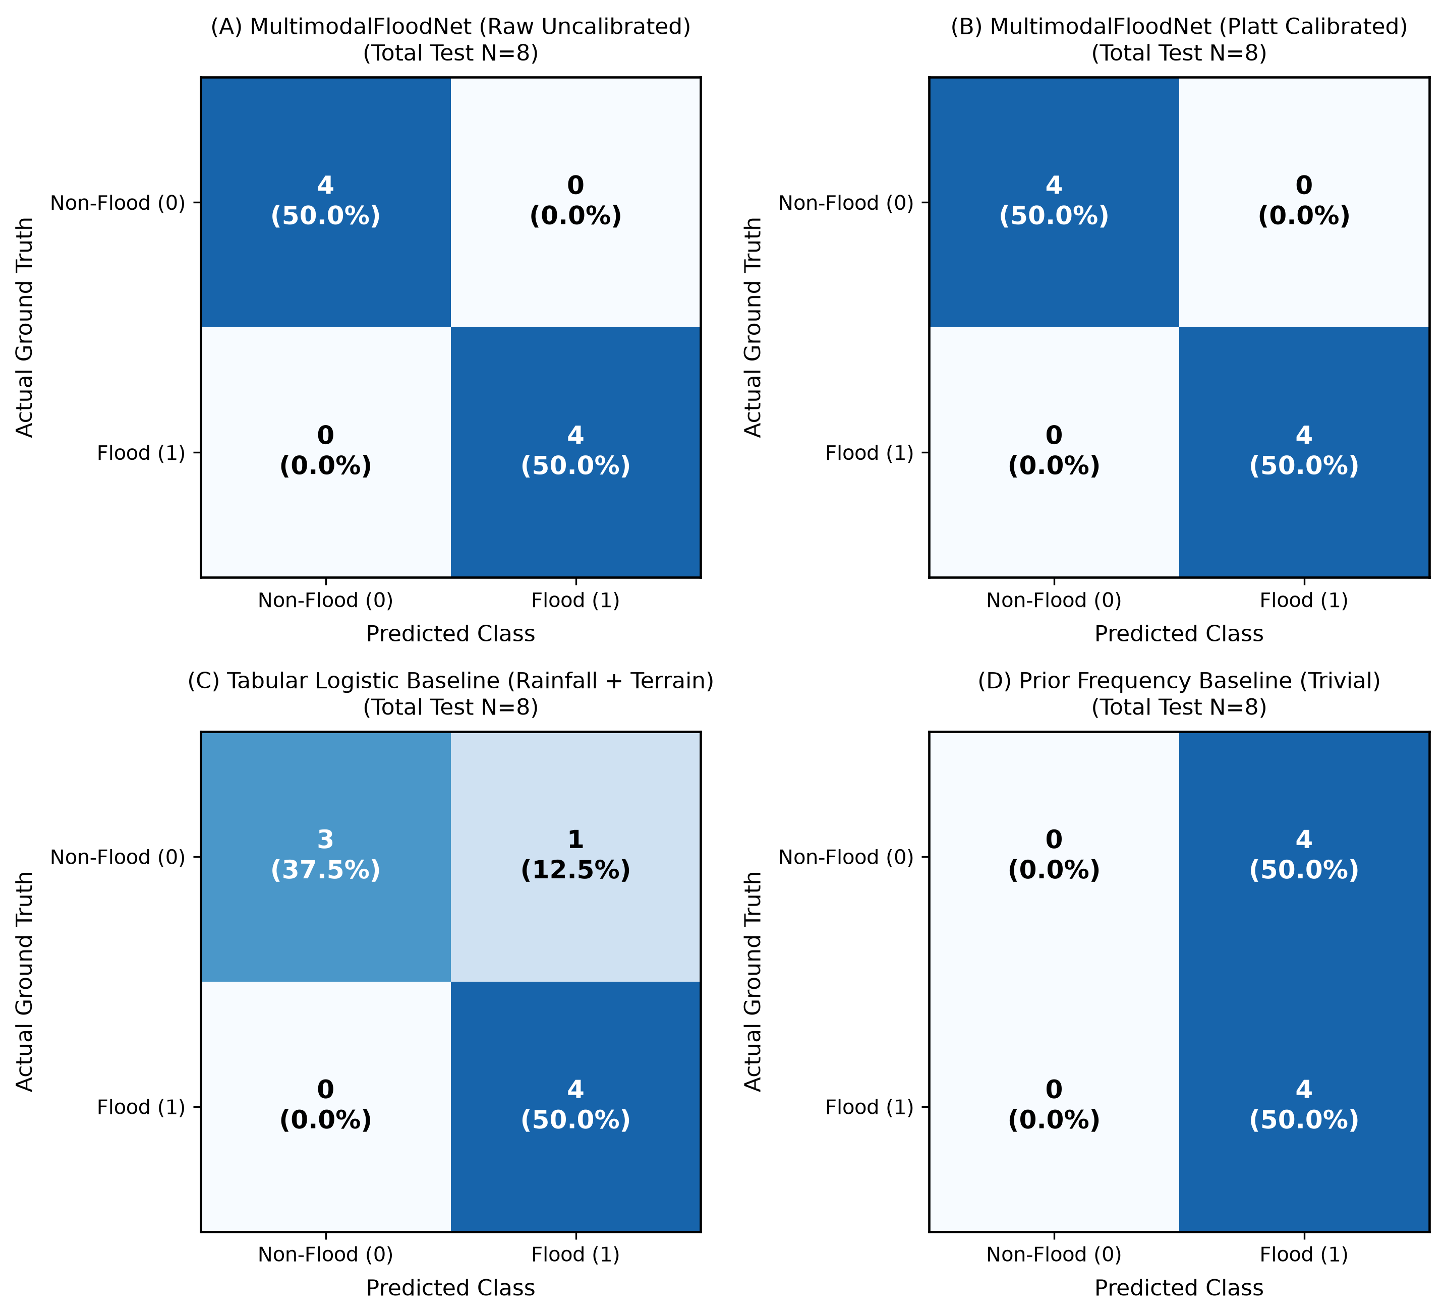Figure 4.2: Confusion matrices for all four model variants.

4.4 ROC-AUC and Precision–Recall Analysis
The raw and Platt-calibrated MultimodalFloodNet variants achieved ROC-AUC values of 1.000 and PR-AUC values of 1.000 on the available test predictions. The tabular logistic-regression baseline achieved a reported ROC-AUC of 0.9375 and PR-AUC of 0.9437.
ROC-AUC measures a model's ability to rank positive examples above negative examples across classification thresholds. PR-AUC summarizes the precision–recall trade-off, which is particularly useful when flood and non-flood cases have unequal frequencies. In this experiment, the test set was balanced, with a positive-class prevalence of 50%.
The results indicate complete separation of the eight test samples by the multimodal model. Nevertheless, the test partition represents only two events and contains procedurally generated features. Consequently, the curves demonstrate performance on the experimental dataset rather than validated performance across real-world locations and future flood events.
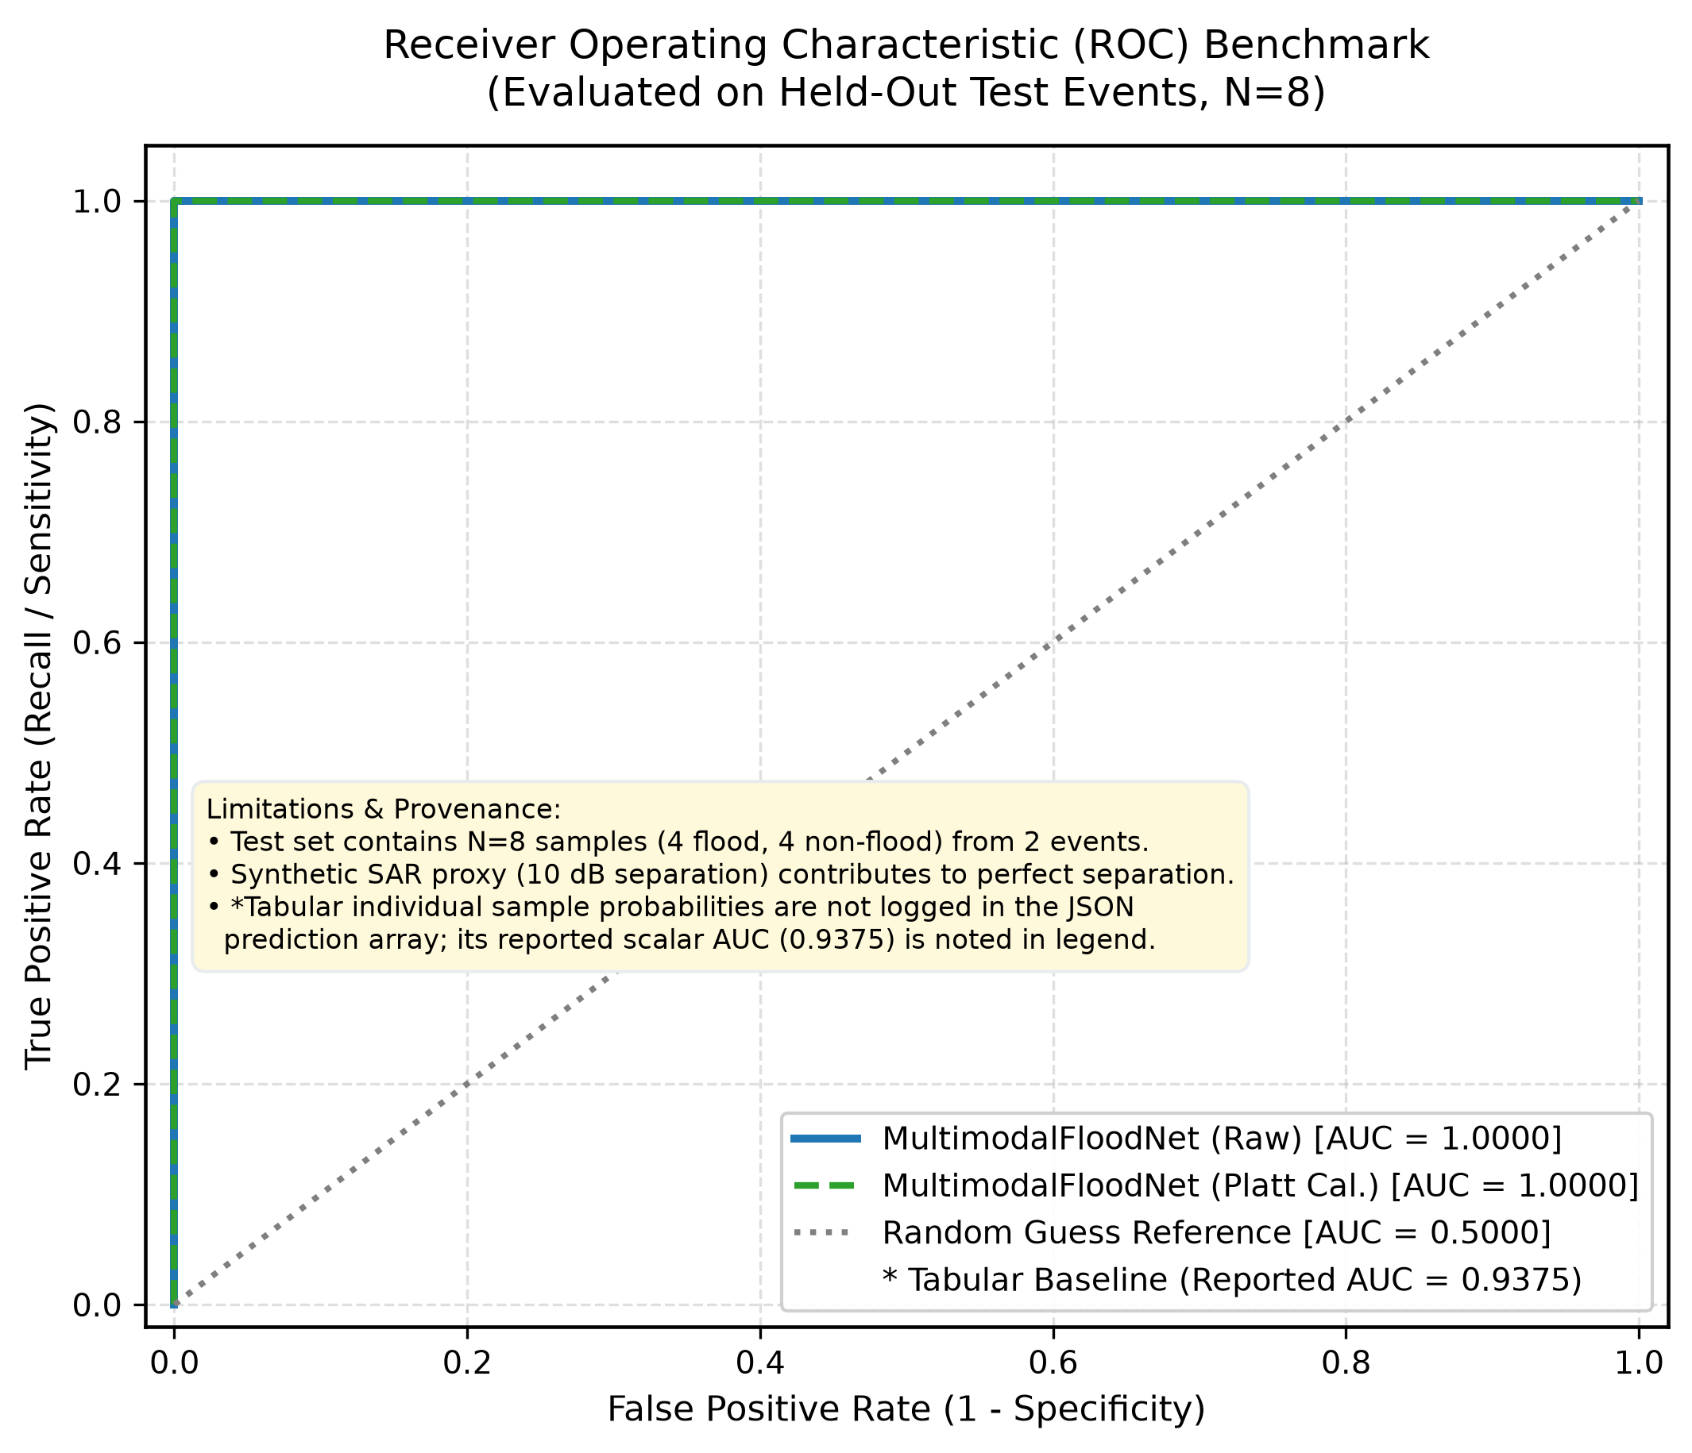Figure 4.3: ROC curves.
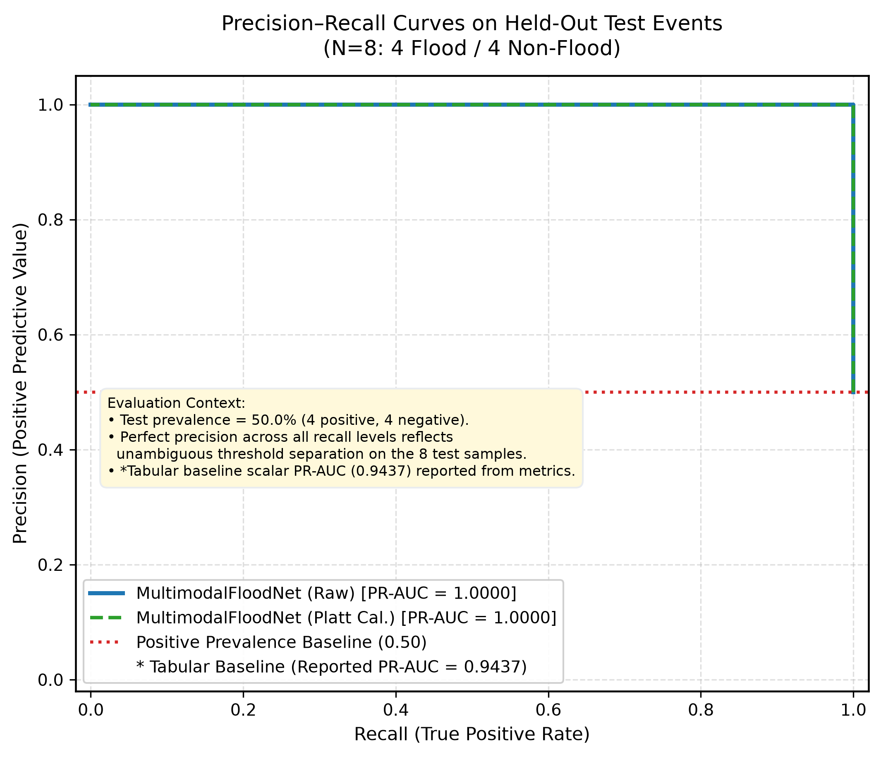Figure 4.4: Precision–recall curves.

4.5 Probability Calibration
Flood probability estimates are important because a forecasting system may need to distinguish between low, moderate, high, and very high risk. Classification accuracy alone does not establish that predicted probabilities correspond to observed flood frequencies.
The raw MultimodalFloodNet produced a Brier score of 0.0004 and an expected calibration error (ECE) of 0.0199. Following Platt scaling, the Brier score increased to 0.1196 and ECE increased to 0.3458. The tabular baseline recorded a Brier score of 0.0908 and ECE of 0.0967.
Lower Brier and ECE values generally indicate better probabilistic reliability, although ECE depends on binning choices and is unstable on small samples. In this experiment, calibration shifted the raw model's extreme probabilities toward approximately 0.35 for negative examples and 0.65 for positive examples. This increased the probability error on the eight test samples.
The findings show that post-hoc calibration did not improve these particular test-set scores. Because only eight samples were evaluated and the calibration model was fitted using a small validation partition, additional independent data are required before deciding whether calibration should be retained or replaced.
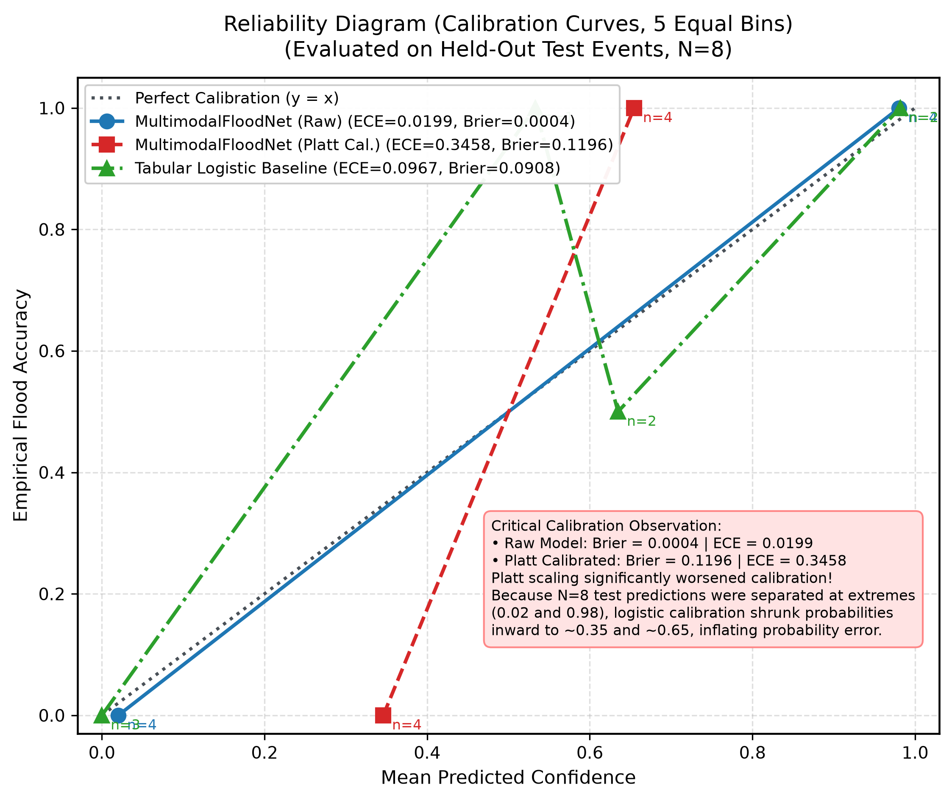Figure 4.5: Reliability diagram comparing raw and calibrated predictions with the tabular baseline.

4.6 Dataset Composition and Event-Based Evaluation
Figure 4.6 illustrates the dataset composition and event-grouped splitting strategy. The training partition contains six events and 24 samples, while validation and testing each contain two events and eight samples.
Separating events across partitions is methodologically preferable to randomly distributing samples from the same event among training and testing, since the latter may overestimate performance through event-specific similarities. However, the test set remains very limited: it covers only two catalogued events and cannot represent the range of climates, terrain, land cover, rainfall regimes, and flood mechanisms found globally.
The current dataset should therefore be regarded as a prototype evaluation dataset. Broader testing requires additional independently verified flood events, genuine non-flood reference locations, and reliable ground-truth labels linked to the corresponding satellite observations.
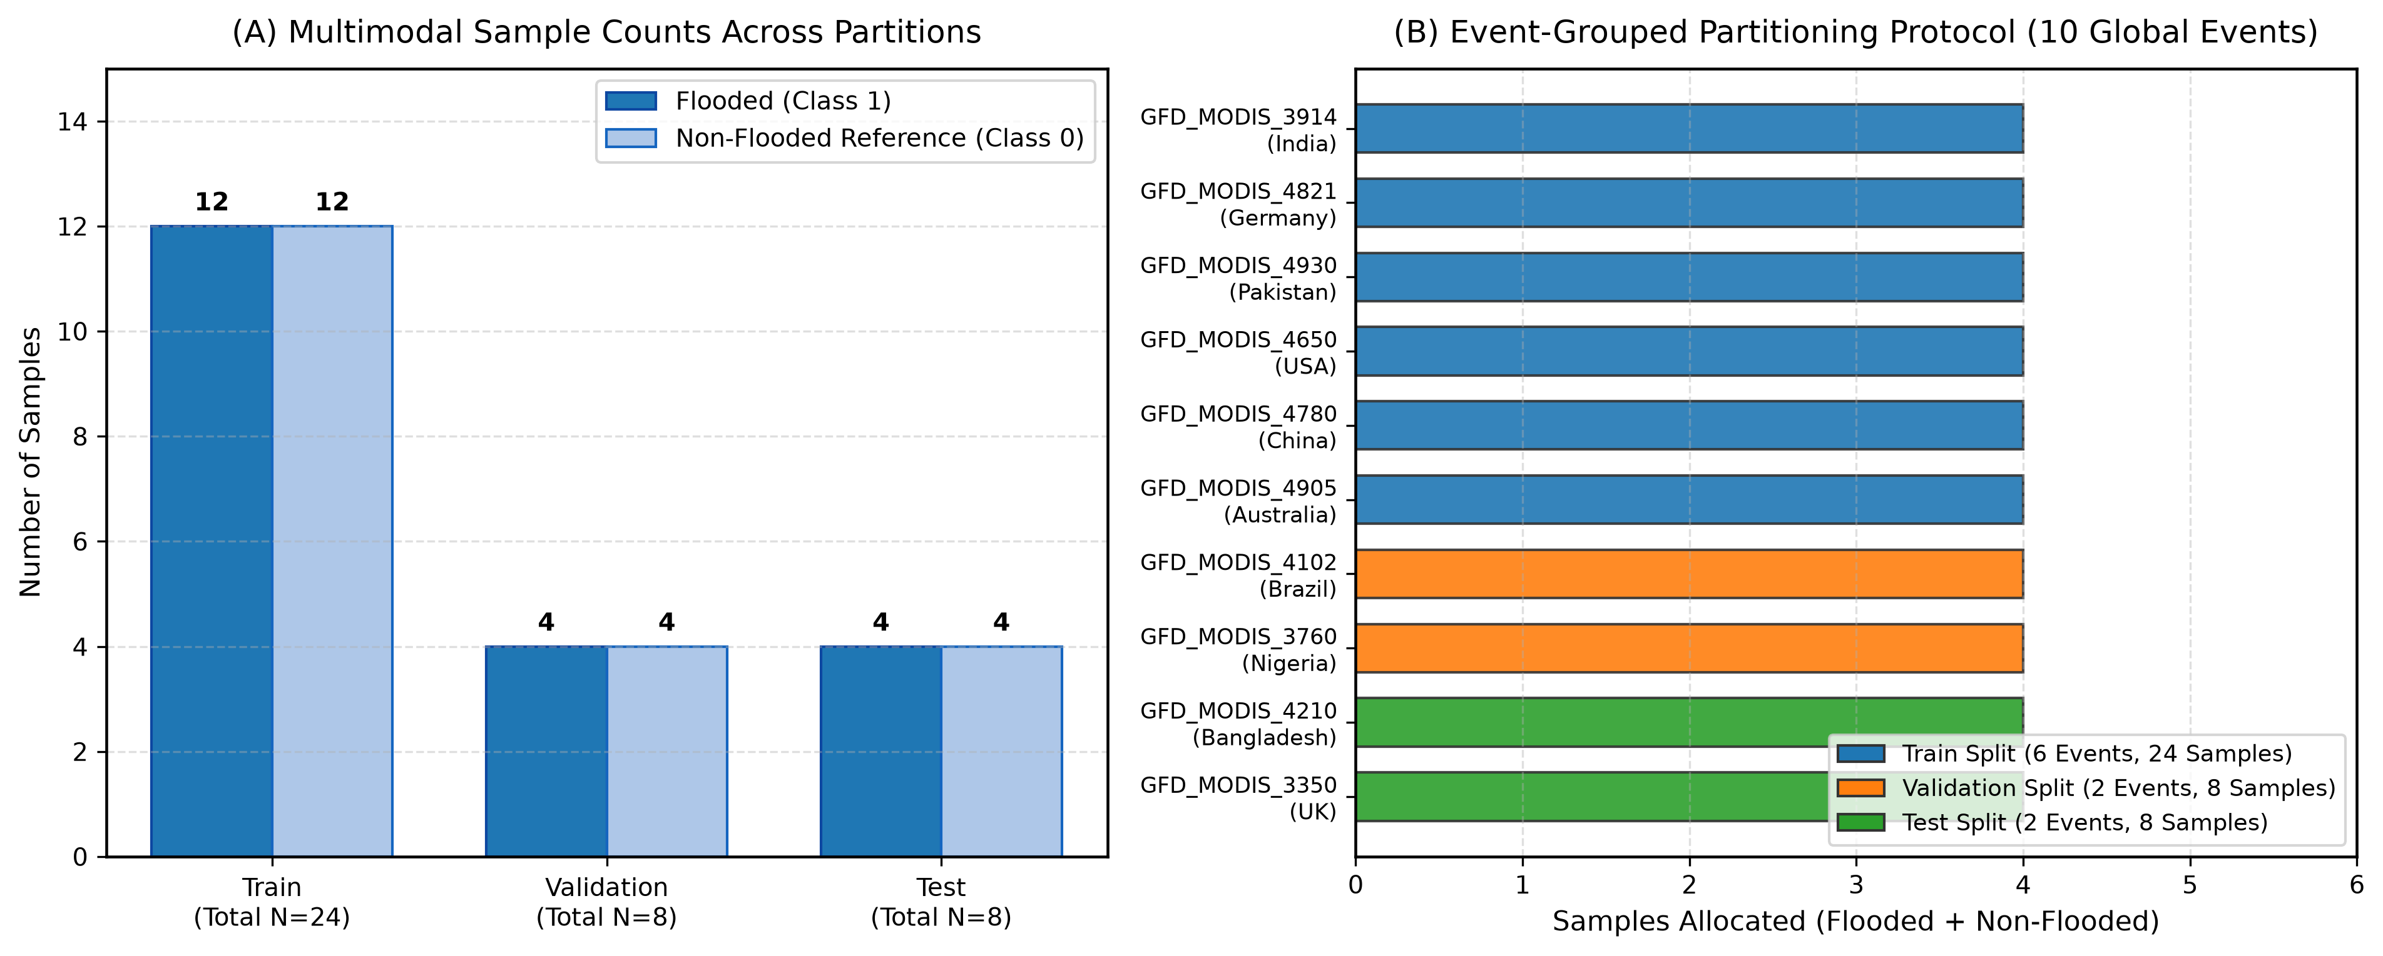Figure 4.6: Sample distribution and event-grouped partitions.

4.7 Comparative Model Evaluation
The model comparison in Figure 4.7 shows that MultimodalFloodNet achieved higher reported classification and ranking metrics than the two baselines on the current test subset. Its raw variant also produced the lowest Brier score. The logistic-regression baseline performed well but made one false-positive classification, while the prior-frequency baseline failed to distinguish the negative examples.
These comparisons provide an initial indication that multimodal feature fusion may be useful. However, the current experimental design does not establish that the improvement is attributable to the multimodal architecture itself. The input-generation procedure creates synthetic radar and terrain features that are strongly associated with the target label, making the classification task easier than real flood mapping.
A fair assessment of the architecture requires genuine satellite patches and weather observations, matched to independently verified flood labels, followed by event-grouped evaluation on a substantially larger held-out set. Baseline models should be trained and evaluated on exactly the same verified samples.
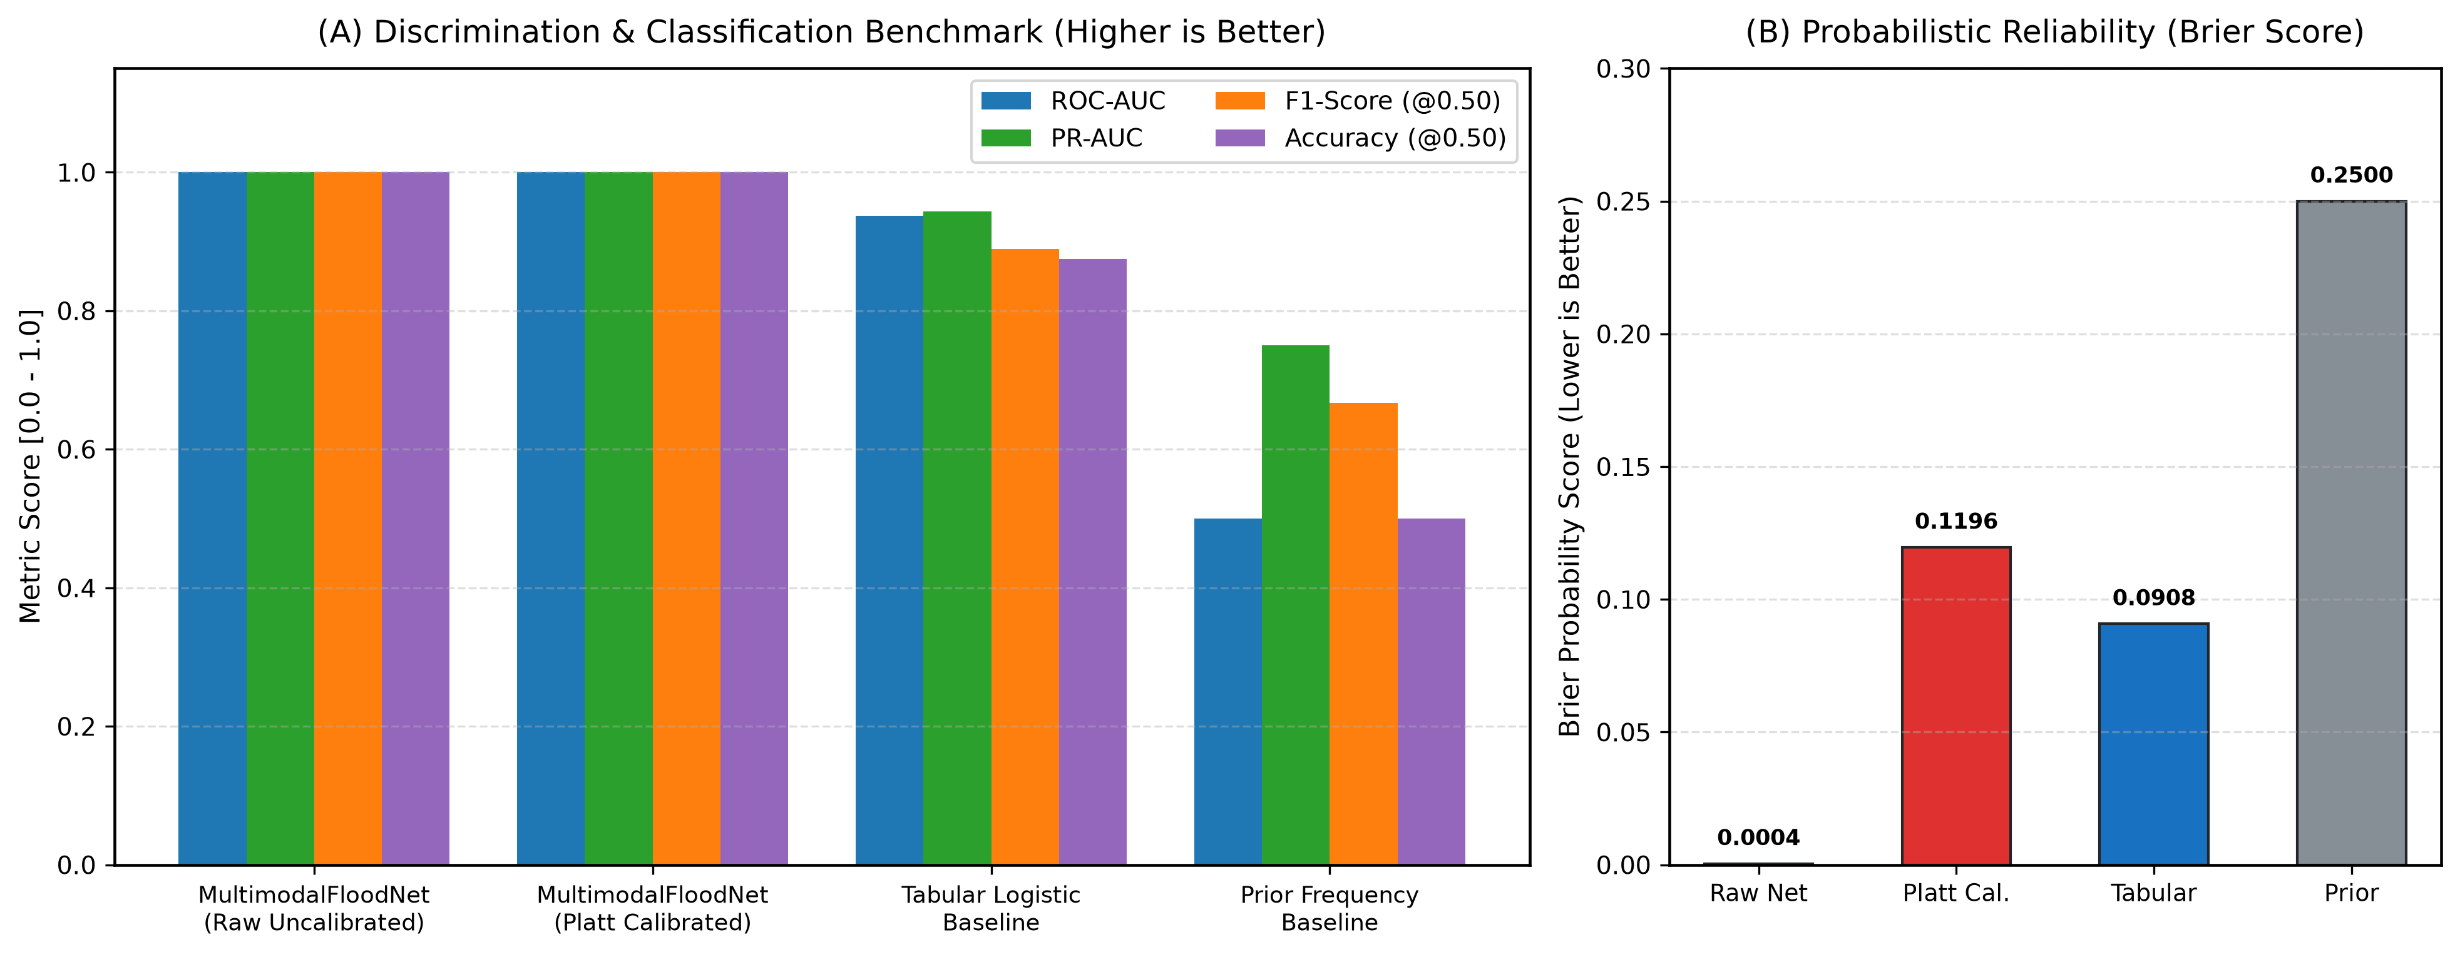Figure 4.7: Classification metrics and Brier-score comparison.

4.8 Data Provenance and Forecasting Limitations
Several limitations are important when interpreting the results.
First, the current dataset-generation implementation creates synthetic Sentinel-1 radar patches with different class-conditioned backscatter distributions. Flood-labelled patches are generated around a mean of approximately −22 dB, whereas non-flood patches use approximately −12 dB. Some synthetic topographic features, including slope, topographic wetness index, and distance to drainage, are also generated differently according to the class. These patterns may directly reveal the label to the model and plausibly explain the perfect classification scores.
Second, although event catalogues provide geographic and event references, individual sample coordinates are generated procedurally rather than being established through verified pixel-level intersection with flood observations. The samples should not all be described as independently verified ground-truth locations.
Third, the forward 48-hour weather sequence is retrieved from historical reanalysis data rather than archived forecasts that would have been available at the original prediction time. The experiment is therefore an idealized retrospective simulation under observed atmospheric forcing, not a demonstrated operational 48-hour-ahead forecasting test.
Finally, the ground-truth data provenance and event dates require further verification. The documented temporal coverage of the Global Flood Database must be reconciled with any event examples dated beyond its stated coverage before the dataset is presented as fully validated.

4.9 Summary of Findings
The experiment demonstrates that the GlobalFlood AI pipeline can integrate radar, weather, and terrain representations, train a multimodal neural network, and generate evaluation metrics and diagnostic plots. The model achieved perfect classification on the eight-sample test subset, while the calibration experiment showed that Platt scaling worsened the reported Brier score and ECE.
These findings are preliminary because the test set is small and synthetic class-conditioned features may dominate the results. The next priority is to replace synthetic inputs and procedurally assigned labels with verified observations, validate temporal alignment, and evaluate the model on a substantially larger collection of independent events. Until then, the system should be described as an experimental research prototype rather than a validated global flood-warning service.

