Student Management Portal Sprint Report

Sprint 1 10/04/2023

Sprint 2 24/04/2023

Context
First Day of Sprint 1: 27/03/2023
Last Day of Sprint 1: 10/04/2023
First Day of Sprint 2: 10/04/2023
Last Day of Sprint 2: 24/04/2023
Working Days in Sprint 1: <<14>>
Working Days in Sprint 2: <<14>>

Team Members
The following cross-functionality team members participated in the sprint. Also listed are the days they were expected to work and the number of days they did work.
Name | Role in the Sprint | Planned Days | Worked Days
PSN Jathin | Scrum Master | 14 | 10
Suraj Gopinath | Developer | 14 | 10
Shubham Garg | Developer | 14 | 10
Sharvaani T | Developer | 14 | 10
Udith S | Product Owner | 14 | 10

Sprint 1 and Sprint 2 Sprint 1 and Sprint 2
Internal Assessor Product Owner

User Stories
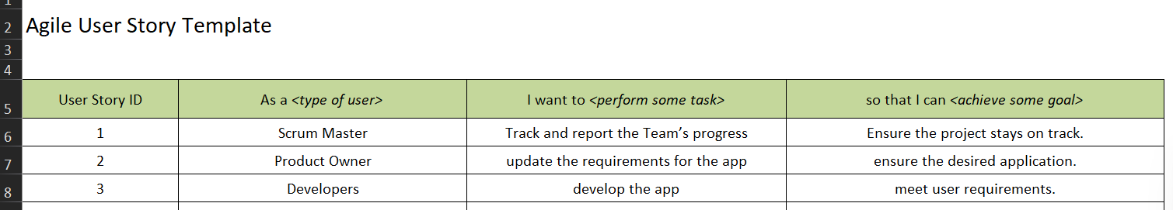

Product Backlogs

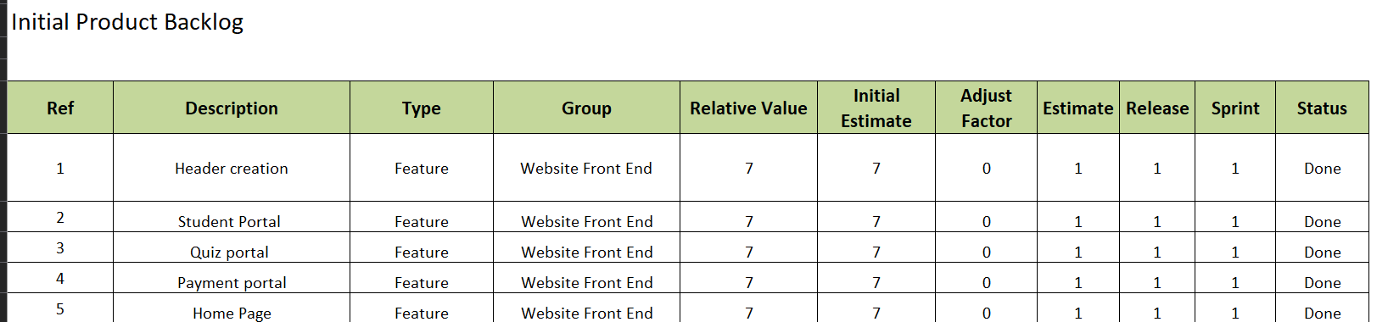

Iteration Planning
You have to write and insert the Iteration plan for each module of Sprints based on the template provided to you.
Iteration Planning done with the Product Owner
Select from the following activities. Note why you have or have not chosen an activity:
Introduction
- Introduce team members and stakeholders
- Review agenda and objectives of the meeting
Vision and Roadmap
- Review the overall vision and goals of the Student Dashboard project
- Discuss progress towards the roadmap and any changes to be made for this iteration
Number of User Stories Fit
- Review the number of user stories that the team can realistically commit to completing during the iteration
- Discuss any concerns or challenges that may impact the team's ability to complete the work
Current Status
- Review the current status of the project and any updates on previously completed work or outstanding issues
Iteration Theme / Name
- Determine a theme or name for the iteration that captures the main goals and focus areas
Prior Data
- Review any relevant data or feedback from users that can inform the team's work for this iteration
Dates
- Confirm the start and end dates for the iteration
- Discuss any potential scheduling conflicts or holidays that may impact the team's availability
Capacity
- Discuss the team's capacity and availability for the upcoming iteration
- Determine if any adjustments need to be made to the team's workload or priorities
Issues / Logistics
- Review any logistical issues or concerns that may impact the team's ability to complete the work
DOD (Definition of Done)
- Review and confirm the team's definition of done for the iteration
- Discuss any changes or updates that may be needed
Backlog Extract
- Review the user stories in the backlog and prioritize them for the upcoming iteration
- Discuss any dependencies or issues that may impact the team's ability to complete the work
Tasking
- Break down the user stories into individual tasks and assign them to team members
- Discuss any concerns or challenges that may arise during the tasking process
Issues and Risks
- Discuss any known issues or risks that may impact the team's ability to complete the work
- Identify potential mitigation strategies or contingency plans
Dependencies and Assumptions
- Review any dependencies or assumptions that the team is working with for the iteration
- Discuss any potential impact on the team's ability to complete the work
"Commitment"
- Confirm the team's commitment to completing the user stories and tasks assigned for the iteration
Actions
- Assign any action items or follow-up tasks that arise from the meeting
- Determine who is responsible for each task and the deadline for completion
Retrospect
- Plan a retrospective for the end of the iteration to review progress and identify areas for improvement
Extra Activities
- Include any additional activities specific to the team or process as needed
Estimated Time
- Total estimated time for the meeting: 2 hours
Are there any extra activities specific to your team or process that you need?
No.
_____________________________________________________________________
Provide a range estimate for how long each selected activity will take for your team.
Total : 3-5 hrs

Daily Scrum Report

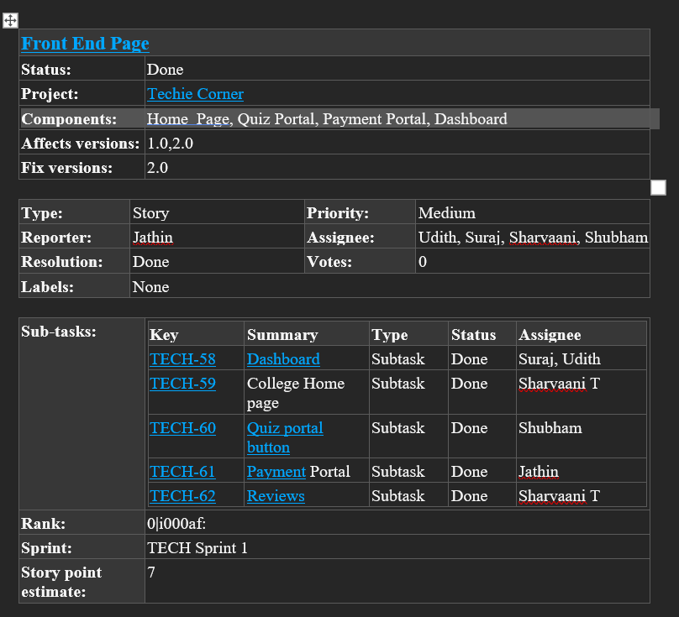

Contents and Assessment
Points Planned: 7
Points Earned: 7
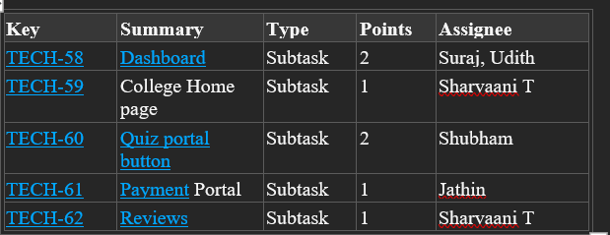

Sprint 1 Implementation

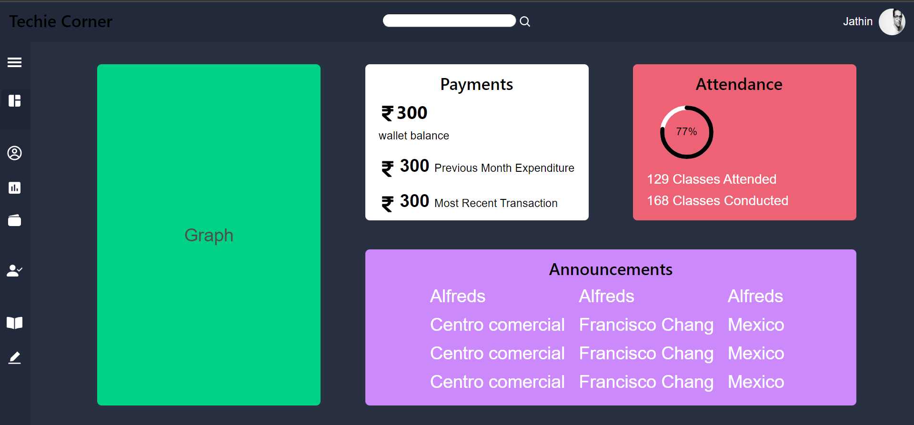

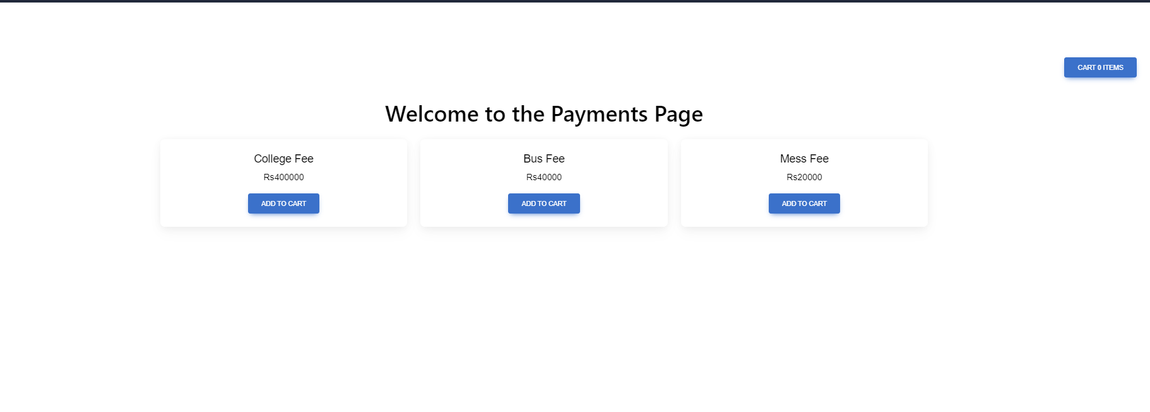

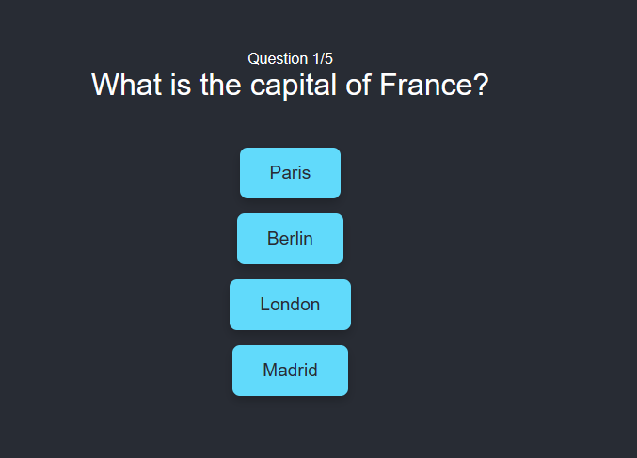

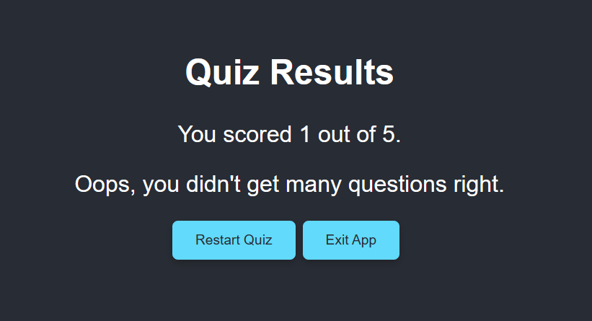






Sprint Review
The sprint review was held on 09/04/23 and attended by Jathin, Suraj, Shubham, Sharvaani, Udith. Before approving or rejecting product backlog items as noted above, key decisions from the review were:
- Increasing the burn up chart ‘s graph
- Adapt to Backlogs

Sprint Retrospective
The team held a sprint retrospective on 10/04/23. It was attended by Jathin, Suraj, Shubham, Sharvaani, Udith. Key decisions were:
- Enhancing styling of webpage
- Integration with backend and apis

