VISVESVARAYA TECHNOLOGICAL UNIVERSITY
“JnanaNangama”, Belgaum -590014, Karnataka.



LAB REPORT on

Machine Learning

Submitted by

Jathin SN(1BM19CS066)

in partial fulfilment for the award of the degree of
BACHELOR OF ENGINEERING
in
COMPUTER SCIENCE AND ENGINEERING


B.M.S. COLLEGE OF ENGINEERING
BENGALURU-560019 May-2022 to July-2022
(Autonomous Institution under VTU)

Department of Computer Science and Engineering

CERTIFICATE
This is to certify that the Lab work entitled “Machine Learning” carried out by Jathin SN
(1BM19CS066), who is bonafide student of B. M. S. College of Engineering. It is in partial fullfillment for the award of Bachelor of Engineering in Computer Science and Engineering of the Visvesvaraya Technological University, Belgaum during the year 2022. The Lab report has been approved as it satisfies the academic requirements in respect of a Machine Learning - (20CS6PCMAL) work prescribed for the said degree.

Dr G R Asha Dr. Jyothi S Nayak
Assistant Professor Professor and Head
Department of CSE Department of CSE BMSCE, Bengaluru BMSCE,Bengaluru

Index Sheet
Sl.  No  . | Experiment Title | Page No.
1 | Find-S | 4
2 | Candidate Elimination | 7
3 | Decision Tree | 9
4 | Naïve Bayes | 16
5 | Linear Regression | 20
6 | Bayesian network | 24
7 | k-Means algorithm | 28
8 | EM algorithm | 34
9 | k-Nearest Neighbour algorithm | 36
10 | Non-Parametric Locally Weighted Regression algorithm | 38
Course Outcome
CO1 | Ability to apply the different learning algorithms.
CO2 | Ability to analyse the learning techniques for given dataset
CO3 | Ability to design a model using machine learning to solve a problem.
CO4 | Ability to conduct practical experiments to solve problems using appropriate machine learning Techniques.

1) Implement and demonstrate the FIND-S algorithm for finding the most specific hypothesis based on a given set of training data samples. a) Using CSV as input:
import csv
def updateHypothesis(x,h): if h==[]: return x
for i in range(0,len(h)): if x[i].upper()!=h[i].upper(): h[i] = '?'
return h
if __name__ == "__main__":
data = [] h = []
# reading csv file with open('Desktop/FindS.csv', 'r') as file: reader = csv.reader(file)
print("Data: ") for row in reader: data.append(row)
print(row) if data: for x in data: if x[-1].upper()=="YES":
x.pop() # removing last field h = updateHypothesis(x,h) print("\nHypothesis: ",h)
Output:
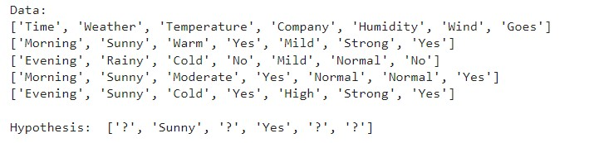
B) Using user Input:
import numpy as np import pandas as pd
n=int(input("Enter the number of attributes ")) l=int(input("Enter the number of rows "))
print("Enter the ",n,"ättributes") attributes=[] for i in range(1,n+1): print("Enter the name of ",i," attribute ")
name=input()

for i in range(1,l+1): print("Ënter the values of ",i," row") print("Enter the values of attributes")
res=[] for j in range(1,l+1): res.append(input()) attributes.append(res)
print("Enter the target values") target=[] for i in range(1,l+1): print("Enter the value of ",i," target") x=input() target.append(x)
def findS(c,t):
for i, val in enumerate(t): if val == "Yes": specific_hypothesis = c[i].copy()
break

for i, val in enumerate(c): if t[i] == "Yes": for x in range(len(specific_hypothesis)): if val[x] != specific_hypothesis[x]: specific_hypothesis[x] = '?' else: pass

return specific_hypothesis print("\n The final hypothesis is:",findS(attributes,target))
Output:
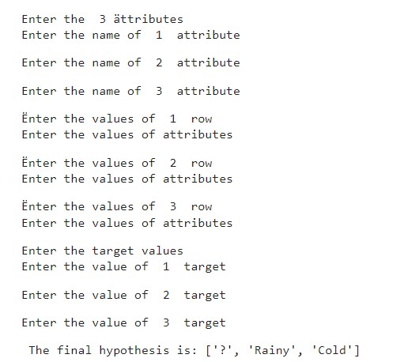

2) For a given set of training data examples stored in a .CSV file, implement and demonstrate the Candidate-Elimination algorithm to output a description of the set of all hypotheses consistent with the training examples

import numpy as np import pandas as pd
#to read the data in the csv file
data = pd.DataFrame(data=pd.read_csv('/content/drive/MyDrive/enjoysport.csv')) print(data,"\n")
#making an array of all the attributes concepts = np.array(data.iloc[:,0:-1]) print("The attributes are: ",concepts)
#segregating the target that has positive and negative examples target = np.array(data.iloc[:,-1]) print("\n The target is: ",target)
#training function to implement candidate_elimination algorithm def learn(concepts, target):
specific_h = concepts[0].copy()
print("\n Initialization of specific_h and general_h") print(specific_h)
general_h = [["?" for i in range(len(specific_h))] for i in range(len(specific_h))] print(general_h) for i, h in enumerate(concepts): if target[i] == "yes": for x in range(len(specific_h)): if h[x]!= specific_h[x]: specific_h[x] ='?' general_h[x][x] ='?' # print(specific_h) if target[i] == "no": for x in range(len(specific_h)): if h[x]!= specific_h[x]: general_h[x][x] = specific_h[x] else: general_h[x][x] = '?'
print("\n Steps of Candidate Elimination Algorithm",i+1) print(specific_h) print(general_h)
indices = [i for i, val in enumerate(general_h) if val ==
['?', '?', '?', '?', '?', '?']] for i in indices: general_h.remove(['?', '?', '?', '?', '?', '?']) return specific_h, general_h s_final, g_final = learn(concepts, target)
#obtaining the final hypothesis
print("\nFinal Specific_h:", s_final, sep="\n") print("\nFinal General_h:", g_final, sep="\n") Output:
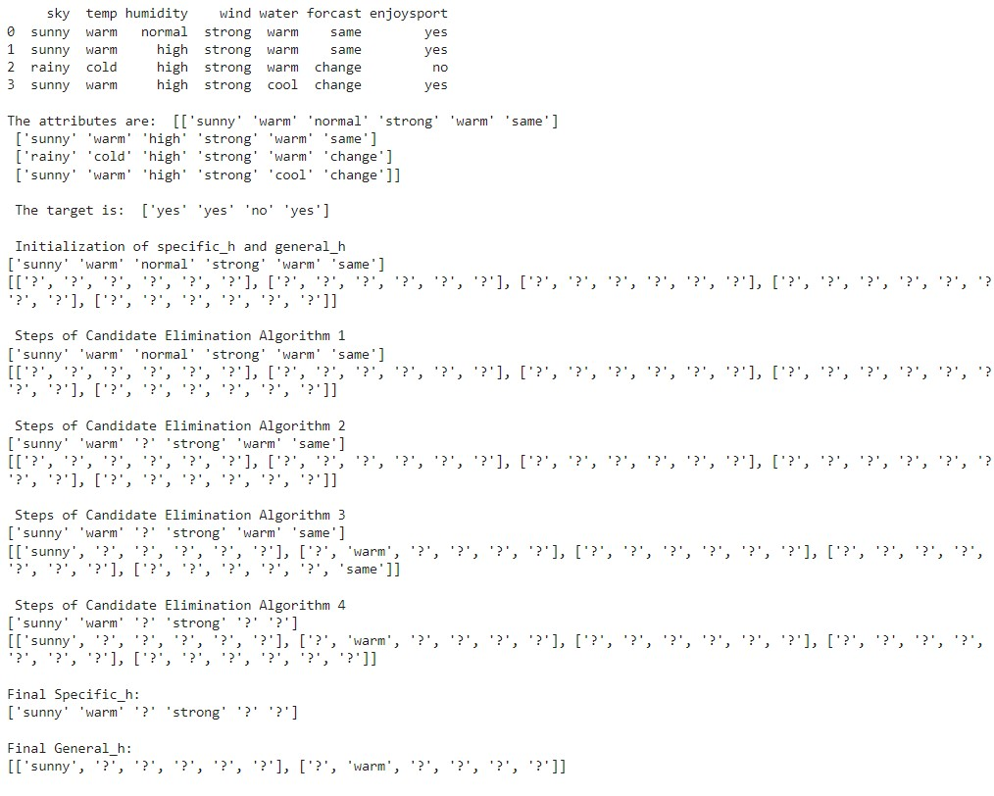

3)Write a program to demonstrate the working of the decision tree based ID3 algorithm. Use an appropriate data set for building the decision tree and apply this knowledge to classify a new sample.
a)ID3 :
import math import csv def load_csv(filename): lines=csv.reader(open(filename,"r"));
dataset = list(lines) headers = dataset.pop(0) return dataset,headers
class Node: def __init__(self,attribute): self.attribute=attribute self.children=[]
self.answer=""

def subtables(data,col,delete): dic={}
coldata=[row[col] for row in data]
attr=list(set(coldata))

counts=[0]*len(attr) r=len(data) c=len(data[0]) for x in range(len(attr)): for y in range(r): if data[y][col]==attr[x]: counts[x]+=1

for x in range(len(attr)): dic[attr[x]]=[[0 for i in range(c)] for j in range(counts[x])] pos=0 for y in range(r):
if data[y][col]==attr[x]: if delete: del data[y][col] dic[attr[x]][pos]=data[y] pos+=1
return attr,dic

def entropy(S): attr=list(set(S)) if len(attr)==1:
return 0

counts=[0,0]
for i in range(2): counts[i]=sum([1 for x in S if attr[i]==x])/(len(S)*1.0)

sums=0 for cnt in counts: sums+=-1*cnt*math.log(cnt,2) return sums
def compute_gain(data,col):
attr,dic = subtables(data,col,delete=False)

total_size=len(data) entropies=[0]*len(attr)
ratio=[0]*len(attr)

total_entropy=entropy([row[-1] for row in data]) for x in range(len(attr)):
ratio[x]=len(dic[attr[x]])/(total_size*1.0) entropies[x]=entropy([row[-1] for row in dic[attr[x]]]) total_entropy-=ratio[x]*entropies[x] return total_entropy
def build_tree(data,features): lastcol=[row[-1] for row in data] if(len(set(lastcol)))==1: node=Node("") node.answer=lastcol[0]
return node

n=len(data[0])-1 gains=[0]*n for col in range(n): gains[col]=compute_gain(data,col) split=gains.index(max(gains)) node=Node(features[split]) fea = features[:split]+features[split+1:]

attr,dic=subtables(data,split,delete=True)

for x in range(len(attr)):
child=build_tree(dic[attr[x]],fea) node.children.append((attr[x],child)) return node
def print_tree(node,level): if node.answer!="":
print(" "*level,node.answer)
return

print(" "*level,node.attribute) for value,n in node.children: print(" "*(level+1),value) print_tree(n,level+2)

def classify(node,x_test,features): if node.answer!="": print(node.answer) return pos=features.index(node.attribute) for value, n in node.children: if x_test[pos]==value:
classify(n,x_test,features)

'''Main program''' dataset,features=load_csv("id3.csv") node1=build_tree(dataset,features)
print("The decision tree for the dataset using ID3 algorithm is") print_tree(node1,0) testdata,features=load_csv("id3.csv")
for xtest in testdata: print("The test instance:",xtest) print("The label for test instance:",end=" ") classify(node1,xtest,features)
Output:
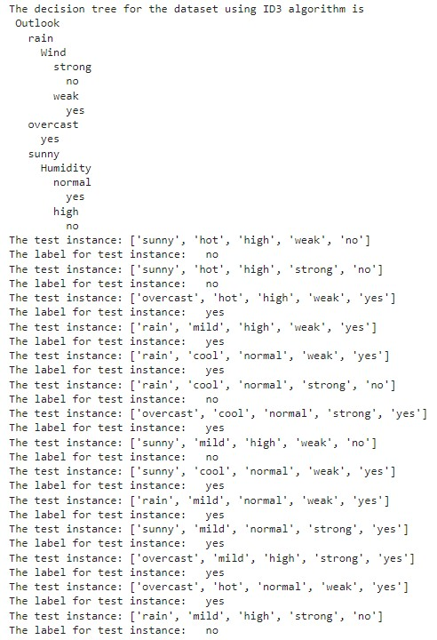
b) Using SKlearn:
import pandas as pd import numpy as np from sklearn.datasets import load_iris
data = load_iris()
In [2]:
df = pd.DataFrame(data.data, columns = data.feature_names)
In [3]: df.head() df['Species'] = data.target
#replace this with the actual names target = np.unique(data.target) target_names = np.unique(data.target_names) targets = dict(zip(target, target_names))
df['Species'] = df['Species'].replace(targets)
In [5]: x = df.drop(columns="Species")
y = df["Species"]
In [6]: feature_names = x.columns labels = y.unique()
In [7]: from sklearn.model_selection import train_test_split
X_train, test_x, y_train, test_lab = train_test_split(x,y,test_size = 0.4,random_state = 42)
In [8]: from sklearn.tree import DecisionTreeClassifier
clf = DecisionTreeClassifier(max_depth =4, random_state = 42)
In [9]: clf.fit(X_train, y_train) test_pred = clf.predict(test_x)
In [11]: from sklearn import metrics import seaborn as sns import matplotlib.pyplot as plt
confusion_matrix = metrics.confusion_matrix(test_lab,test_pred)
In [12]: confusion_matrix matrix_df = pd.DataFrame(confusion_matrix) ax = plt.axes() sns.set(font_scale=1.3) plt.figure(figsize=(10,7))
sns.heatmap(matrix_df, annot=True, fmt="g", ax=ax, cmap="magma")
ax.set_title('Confusion Matrix - Decision Tree') ax.set_xlabel("Predicted label", fontsize =15) ax.set_xticklabels(['']+labels) ax.set_ylabel("True Label", fontsize=15) ax.set_yticklabels(list(labels), rotation = 0) plt.show() clf.score(test_x,test_lab)
from sklearn import tree fig = plt.figure(figsize=(25,20))
_ = tree.plot_tree(clf, feature_names=data.feature_names,
class_names=data.target_names, filled=True)
Output:
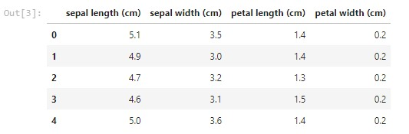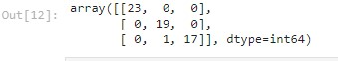

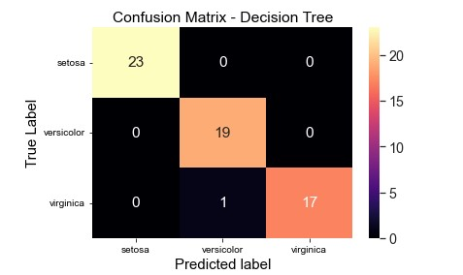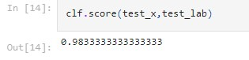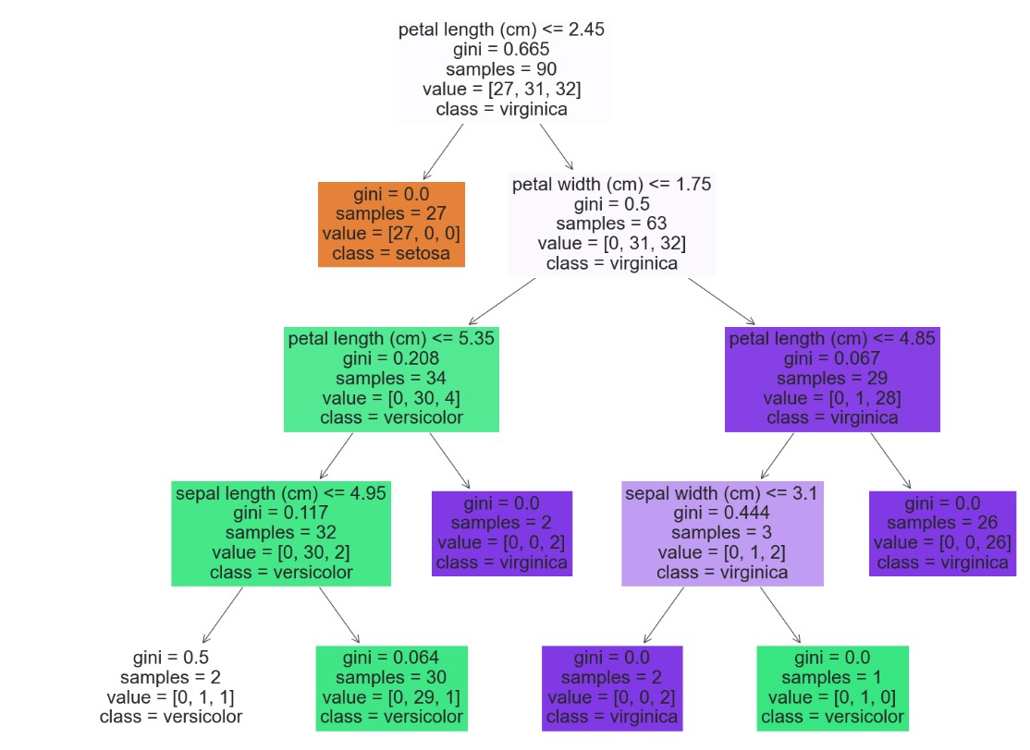

4)Write a program to implement the naïve Bayesian classifier for a sample training data set stored as a .CSV file. Compute the accuracy of the classifier, considering few test data sets
a) Without using SKlearn:
import numpy as np import pandas as pd data = pd.read_csv('/content/dataset.csv') data.head()
y = list(data['PlayTennis'].values) X = data.iloc[:,1:].values print(f'Target Values: {y}') print(f'Features: \n{X}') y_train = y[:8] y_val = y[8:] X_train = X[:8] X_val = X[8:] print(f"Number of instances in training set: {len(X_train)}") print(f"Number of instances in testing set: {len(X_val)}") class NaiveBayesClassifier: def __init__(self, X, y): self.X, self.y = X, y self.N = len(self.X) self.dim = len(self.X[0])
self.attrs = [[] for _ in range(self.dim)] self.output_dom = {} self.data = [] for i in range(len(self.X)): for j in range(self.dim): if not self.X[i][j] in self.attrs[j]: self.attrs[j].append(self.X[i][j]) if not self.y[i] in self.output_dom.keys(): self.output_dom[self.y[i]] = 1 else:
self.output_dom[self.y[i]] += 1 self.data.append([self.X[i], self.y[i]]) def classify(self, entry): solve = None max_arg = -1 for y in self.output_dom.keys():
prob = self.output_dom[y]/self.N for i in range(self.dim): cases = [x for x in self.data if x[0][i] == entry[i] and x[1] == y] n = len(cases) prob *= n/self.N if prob > max_arg: max_arg = prob
solve = y return solve
nbc = NaiveBayesClassifier(X_train, y_train) total_cases = len(y_val)
good = 0 bad = 0 predictions = [] for i in range(total_cases): predict = nbc.classify(X_val[i]) predictions.append(predict) if y_val[i] == predict: good += 1 else: bad += 1
print('Predicted values:', predictions) print('Actual values:', y_val)
print()
print('Total number of testing instances in the dataset:', total_cases) print('Number of correct predictions:', good) print('Number of wrong predictions:', bad) print() print('Accuracy of Bayes Classifier:', good/total_cases) Output:
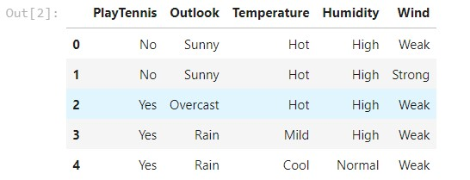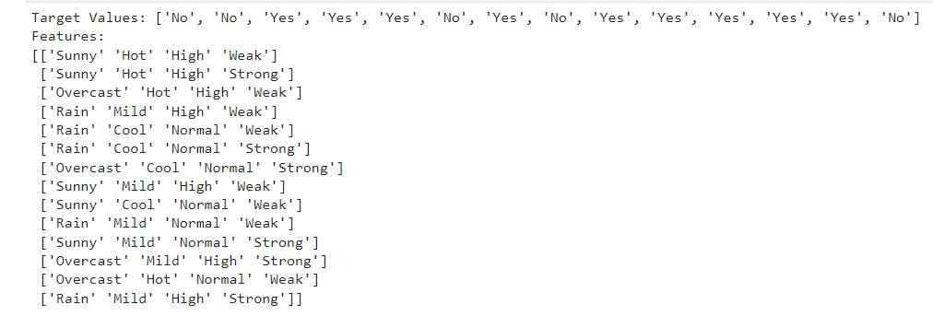

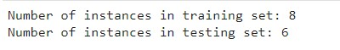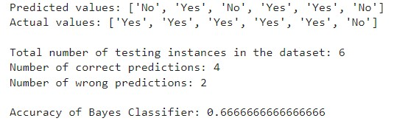 b)Using SKlearn:

import numpy as np # linear algebra
import pandas as pd # data processing, CSV file I/O (e.g. pd.read_csv) from sklearn.model_selection import train_test_split from sklearn.naive_bayes import GaussianNB from sklearn import metrics
df = pd.read_csv("/content/pima_indian.csv")
feature_col_names = ['num_preg', 'glucose_conc', 'diastolic_bp', 'thickness', 'insulin', 'bmi', 'diab_pred', 'age'] predicted_class_names = ['diabetes'] X = df[feature_col_names].values y = df[predicted_class_names].values
print(df.head) xtrain,xtest,ytrain,ytest=train_test_split(X,y,test_size=0.33) print ('\nThe total number of Training Data:',ytrain.shape) print ('The total number of Test Data:',ytest.shape) clf = GaussianNB().fit(xtrain,ytrain.ravel()) predicted = clf.predict(xtest)
predictTestData= clf.predict([[6,148,72,35,0,33.6,0.627,50]]) print('\nConfusion matrix')
print(metrics.confusion_matrix(ytest,predicted)) print('\nAccuracy of the classifier:',metrics.accuracy_score(ytest,predicted)) print('The value of Precision:', metrics.precision_score(ytest,predicted)) print('The value of Recall:', metrics.recall_score(ytest,predicted)) print("Predicted Value for individual Test Data:", predictTestData)

Output:
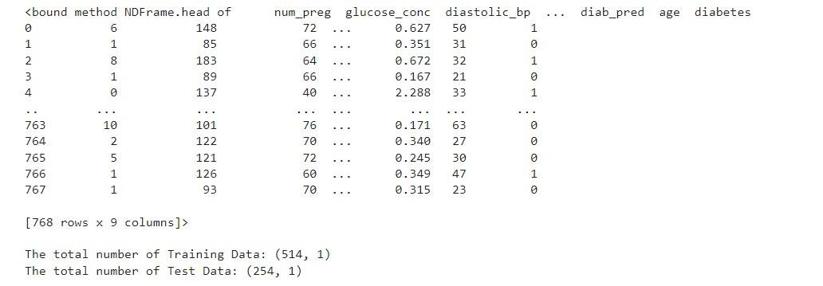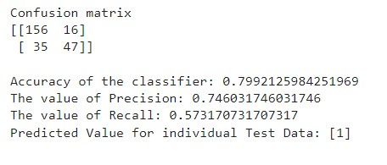

5)Implement the Linear Regression algorithm in order to fit data points. Select appropriate data set for your experiment and draw graphs. a)Using SKlearn:
import numpy as np import matplotlib.pyplot as plt import pandas as pd
# Importing the dataset
dataset = pd.read_csv('salary_data.csv')
X = dataset.iloc[:, :-1].values #get a copy of dataset exclude last column y = dataset.iloc[:, 1].values #get array of dataset in column 1st:
# Splitting the dataset into the Training set and Test set from sklearn.model_selection import train_test_split
X_train, X_test, y_train, y_test = train_test_split(X, y, test_size=1/3, random_state=0)
# Fitting Simple Linear Regression to the Training set from sklearn.linear_model import LinearRegression regressor = LinearRegression() regressor.fit(X_train, y_train)
# Visualizing the Training set results
viz_train = plt
viz_train.scatter(X_train, y_train, color='red')
viz_train.plot(X_train, regressor.predict(X_train), color='blue') viz_train.title('Salary VS Experience (Training set)') viz_train.xlabel('Year of Experience') viz_train.ylabel('Salary') viz_train.show()
# Visualizing the Test set results viz_test = plt
viz_test.scatter(X_test, y_test, color='red')
viz_test.plot(X_train, regressor.predict(X_train), color='blue') viz_test.title('Salary VS Experience (Test set)') viz_test.xlabel('Year of Experience') viz_test.ylabel('Salary') viz_test.show()
# Predicting the Test set results y_pred = regressor.predict(X_test) print(y_pred)
Output:
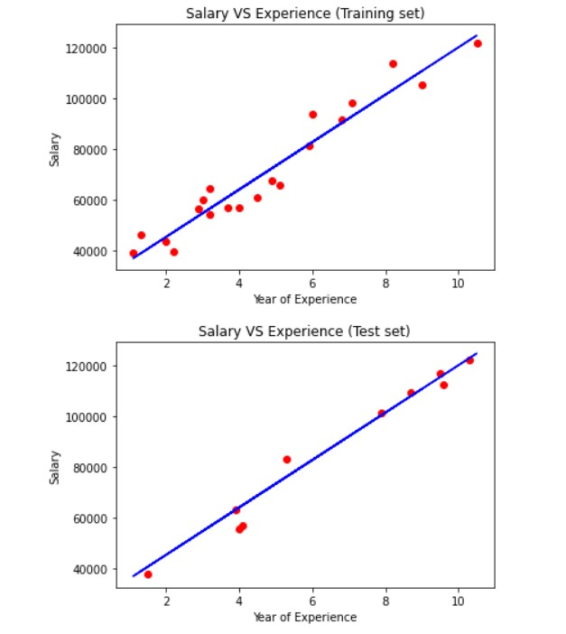

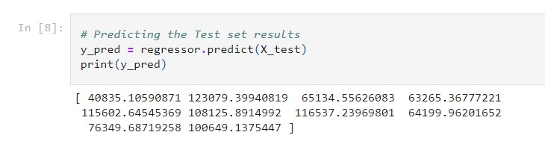

b) Without using SKlearn:
import pandas as pd import numpy as np class LR(): def __init__(self):
self.w = [] def fit(self, X, y): self.w = np.linalg.solve(X.T@X, X.T@y) def predict(self, X): return X@self.w def score(self, X, y):
SS_reg = np.sum((X@self.w - y)**2) SS_tot = np.sum((y - np.mean(y))**2) return (1 - (SS_reg/SS_tot))

from sklearn.model_selection import train_test_split from sklearn.datasets import fetch_california_housing fetch_california_housing data, labels = fetch_california_housing(return_X_y = True) data.shape, labels.shape one = np.ones(data.shape[0]) data = np.column_stack((one, data))
X_train,X_test, y_train, y_test = train_test_split(data, labels, train_size = 0.75, random_state = 42) lro = LR()
lro.fit(X_train, y_train) lro.w lro.predict(X_test) lro.score(X_test, y_test)
Output:
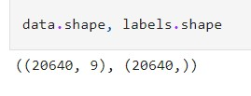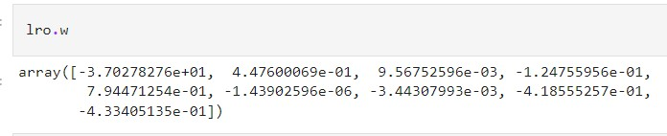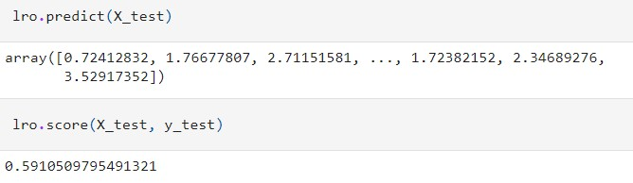

6) Write a program to construct a Bayesian network considering training data. Use this model to make predicFons. a) Using built-in:
!pip install pgmpy import numpy as np import pandas as pd
import csv
from pgmpy.estimators import MaximumLikelihoodEstimator from pgmpy.models import BayesianModel from pgmpy.inference import VariableElimination heartDisease = pd.read_csv('heart_disease.csv') heartDisease = heartDisease.replace('?',np.nan)
print('Sample instances from the dataset are given below') print(heartDisease.head())
print('\n Attributes and datatypes') print(heartDisease.dtypes)
model= BayesianModel([('age','Heartdisease'),('sex','Heartdisease'),('exang','Heartdisease'),
('cp','Heartdisease'),('Heartdisease','restecg'),('Heartdisease','chol')]) print('\nLearning CPD using Maximum likelihood estimators') model.fit(heartDisease,estimator=MaximumLikelihoodEstimator)
print('\n Inferencing with Bayesian Network:') HeartDiseasetest_infer = VariableElimination(model)
print('\n 1. Probability of HeartDisease given evidence= restecg')
q1=HeartDiseasetest_infer.query(variables=['Heartdisease'],evidence={'restecg':1}) print(q1)
print('\n 2. Probability of HeartDisease given evidence= cp ')
q2=HeartDiseasetest_infer.query(variables=['Heartdisease'],evidence={'cp':2}) print(q2)

Output:
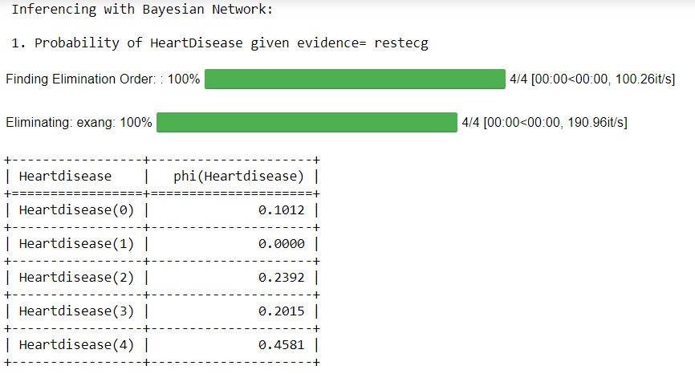
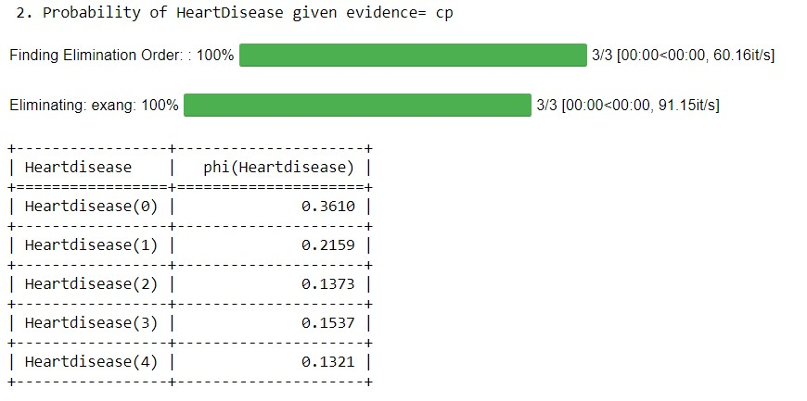
b) Without using built-in: import

bayespy as bp import numpy as np import csv from colorama import init from colorama import Fore, Back, Style
init()
# Define Parameter Enum values
# Age ageEnum = {'SuperSeniorCitizen': 0, 'SeniorCitizen': 1,
'MiddleAged': 2, 'Youth': 3, 'Teen': 4}
# Gender genderEnum = {'Male': 0, 'Female': 1}
# FamilyHistory familyHistoryEnum = {'Yes': 0, 'No': 1}
# Diet(Calorie Intake) dietEnum = {'High': 0, 'Medium': 1, 'Low': 2}
# LifeStyle lifeStyleEnum = {'Athlete': 0, 'Active': 1, 'Moderate': 2, 'Sedetary': 3}
# Cholesterol cholesterolEnum = {'High': 0, 'BorderLine': 1, 'Normal': 2}
# HeartDisease heartDiseaseEnum = {'Yes': 0, 'No': 1} import pandas as pd data = pd.read_csv("heart_disease_data.csv") data =np.array(data, dtype='int8')
N = len(data)
# Input data column assignment p_age = bp.nodes.Dirichlet(1.0*np.ones(5)) age = bp.nodes.Categorical(p_age, plates=(N,)) age.observe(data[:, 0])
p_gender = bp.nodes.Dirichlet(1.0*np.ones(2)) gender = bp.nodes.Categorical(p_gender, plates=(N,)) gender.observe(data[:, 1])
p_familyhistory = bp.nodes.Dirichlet(1.0*np.ones(2)) familyhistory = bp.nodes.Categorical(p_familyhistory, plates=(N,)) familyhistory.observe(data[:, 2])
p_diet = bp.nodes.Dirichlet(1.0*np.ones(3)) diet = bp.nodes.Categorical(p_diet, plates=(N,)) diet.observe(data[:, 3])
p_lifestyle = bp.nodes.Dirichlet(1.0*np.ones(4)) lifestyle = bp.nodes.Categorical(p_lifestyle, plates=(N,)) lifestyle.observe(data[:, 4])
p_cholesterol = bp.nodes.Dirichlet(1.0*np.ones(3)) cholesterol = bp.nodes.Categorical(p_cholesterol, plates=(N,)) cholesterol.observe(data[:, 5]) p_heartdisease = bp.nodes.Dirichlet(np.ones(2), plates=(5, 2, 2, 3, 4, 3)) heartdisease = bp.nodes.MultiMixture(
[age, gender, familyhistory, diet, lifestyle, cholesterol], bp.nodes.Categorical, p_heartdisease) heartdisease.observe(data[:, 6]) p_heartdisease.update() m = 0 while m == 0:
print("\n") res = bp.nodes.MultiMixture([int(input('Enter Age: ' + str(ageEnum))), int(input('Enter Gender: ' + str(genderEnum))), int(input('Enter FamilyHistory: ' + str(familyHistoryEnum))), int(input('Enter dietEnum: ' + str( dietEnum))), int(input('Enter LifeStyle: ' + str(lifeStyleEnum))), int(input('Enter Cholesterol: ' + str(cholesterolEnum)))], bp.nodes.Categorical, p_heartdisease).get_moments()[0][heartDiseaseEnum['Yes']] print("Probability(HeartDisease) = " + str(res))
# print(Style.RESET_ALL)
m = int(input("Enter for Continue:0, Exit :1 "))

Output:
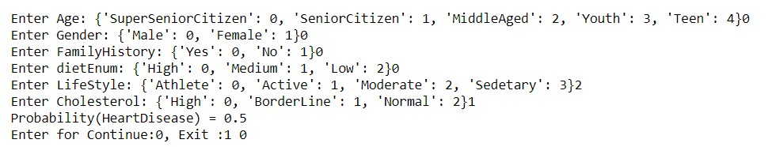

7) Apply k-Means algorithm to cluster a set of data stored in a .CSV file
a) Using built-in: import pandas as pd from sklearn.cluster import KMeans from sklearn.preprocessing import MinMaxScaler from matplotlib import pyplot as plt
%matplotlib inline df = pd.read_csv('income.csv') df.head(10) scaler = MinMaxScaler()
scaler.fit(df[['Age']]) df[['Age']] = scaler.transform(df[['Age']])
scaler.fit(df[['Income($)']]) df[['Income($)']] = scaler.transform(df[['Income($)']]) df.head(10) plt.scatter(df['Age'], df['Income($)'])
k_range = range(1, 11) sse = [] for k in k_range:
kmc = KMeans(n_clusters=k) kmc.fit(df[['Age', 'Income($)']]) sse.append(kmc.inertia_) plt.xlabel = 'Number of Clusters' plt.ylabel = 'Sum of Squared Errors' plt.plot(k_range, sse)
km = KMeans(n_clusters=3) km
df0 = df[df.cluster == 0] df0 df1 = df[df.cluster == 1] df1 df2 = df[df.cluster == 2] df2
p1 = plt.scatter(df0['Age'], df0['Income($)'], marker='+', color='red') p2 = plt.scatter(df1['Age'], df1['Income($)'], marker='*', color='blue') p3 = plt.scatter(df2['Age'], df2['Income($)'], marker='^', color='green') c = plt.scatter(km.cluster_centers_[:,0], km.cluster_centers_[:,1], color='black') plt.xlabel('Age') plt.ylabel('Income($)') plt.legend((p1, p2, p3, c),
('Cluster 1', 'Cluster 2', 'Cluster 3', 'Centroid'))

Output:
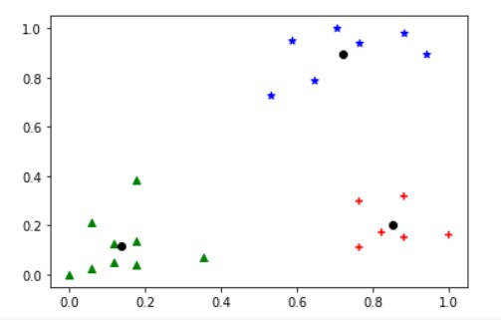

b) Without using built-in:

import math; import sys; import pandas as pd import numpy as np from random import choice from matplotlib import pyplot from random import shuffle, uniform; def ReadData(fileName): f = open(fileName,'r') lines = f.read().splitlines()
f.close()
items = [] for i in range(1,len(lines)): line = lines[i].split(',') itemFeatures = [] for j in range(len(line)-1): v = float(line[j]) itemFeatures.append(v) items.append(itemFeatures) shuffle(items) return items def FindColMinMax(items):
n = len(items[0]) minima = [float('inf') for i in range(n)] maxima = [float('-inf') -1 for i in range(n)] for item in items: for f in range(len(item)): if(item[f] < minima[f]): minima[f] = item[f] if(item[f] > maxima[f]): maxima[f] = item[f] return minima,maxima
def EuclideanDistance(x,y): S = 0 for i in range(len(x)): S += math.pow(x[i]-y[i],2) return math.sqrt(S) def InitializeMeans(items,k,cMin,cMax):
f = len(items[0]) means = [[0 for i in range(f)] for j in range(k)] for mean in means: for i in range(len(mean)): mean[i] = uniform(cMin[i]+1,cMax[i]-1)
return means
def UpdateMean(n,mean,item): for i in range(len(mean)):
m = mean[i] m = (m*(n-1)+item[i])/float(n) mean[i] = round(m,3) return mean def FindClusters(means,items):
clusters = [[] for i in range(len(means))] for item in items:
index = Classify(means,item) clusters[index].append(item) return clusters
def Classify(means,item): minimum = float('inf'); index = -1 for i in range(len(means)):
dis = EuclideanDistance(item,means[i]) if(dis < minimum): minimum = dis index = i return index def CalculateMeans(k,items,maxIterations=100000): cMin, cMax = FindColMinMax(items) means = InitializeMeans(items,k,cMin,cMax) clusterSizes = [0 for i in range(len(means))] belongsTo = [0 for i in range(len(items))] for e in range(maxIterations):
noChange = True; for i in range(len(items)):
item = items[i]; index = Classify(means,item) clusterSizes[index] += 1 cSize = clusterSizes[index] means[index] = UpdateMean(cSize,means[index],item) if(index != belongsTo[i]): noChange = False belongsTo[i] = index

if (noChange): break return means
def CutToTwoFeatures(items,indexA,indexB):
n = len(items) X = [] for i in range(n): item = items[i] newItem = [item[indexA],item[indexB]] X.append(newItem) return X

def PlotClusters(clusters): n = len(clusters) X = [[] for i in range(n)] for i in range(n): cluster = clusters[i] for item in cluster: X[i].append(item) colors = ['r','b','g','c','m','y'] for x in X:
c = choice(colors) colors.remove(c)
Xa = [] Xb = [] for item in x:
Xa.append(item[0]) Xb.append(item[1]) pyplot.plot(Xa,Xb,'o',color=c) pyplot.show()
def main(): items = ReadData('data.txt') k = 3 items = CutToTwoFeatures(items,2,3) print(items) means = CalculateMeans(k,items) print("\nMeans = ", means) clusters = FindClusters(means,items) PlotClusters(clusters) newItem = [1.5,0.2] print(Classify(means,newItem))
if __name__ == "__main__": main()
Output:
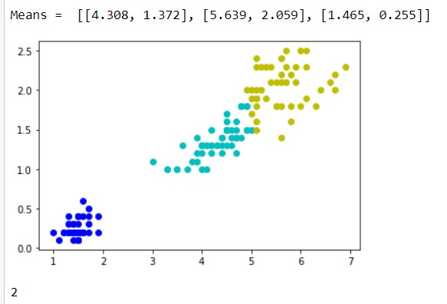

8) Apply EM algorithm to cluster a set of data stored in a .CSV file. Compare the results of k-Means algorithm and EM algorithm.
import matplotlib.pyplot as plt from sklearn import datasets from sklearn.cluster import KMeans import sklearn.metrics as sm import pandas as pd import numpy as np iris = datasets.load_iris()
X = pd.DataFrame(iris.data)
X.columns = ['Sepal_Length','Sepal_Width','Petal_Length','Petal_Width'] y = pd.DataFrame(iris.target) y.columns = ['Targets'] model = KMeans(n_clusters=3) model.fit(X) plt.figure(figsize=(14,7)) colormap = np.array(['red', 'lime', 'black']) # Plot the Original Classifications plt.subplot(1, 2, 1) plt.scatter(X.Petal_Length, X.Petal_Width, c=colormap[y.Targets], s=40) plt.title('Real Classification') plt.xlabel('Petal Length') plt.ylabel('Petal Width')
# Plot the Models Classifications plt.subplot(1, 2, 2) plt.scatter(X.Petal_Length, X.Petal_Width, c=colormap[model.labels_], s=40) plt.title('K Mean Classification') plt.xlabel('Petal Length') plt.ylabel('Petal Width') print('The accuracy score of K-Mean: ',sm.accuracy_score(y, model.labels_)) print('The Confusion matrixof K-Mean: ',sm.confusion_matrix(y, model.labels_))
from sklearn import preprocessing scaler = preprocessing.StandardScaler() scaler.fit(X) xsa = scaler.transform(X) xs = pd.DataFrame(xsa, columns = X.columns) #xs.sample(5)
from sklearn.mixture import GaussianMixture gmm = GaussianMixture(n_components=3) gmm.fit(xs)
y_gmm = gmm.predict(xs)
#y_cluster_gmm
plt.subplot(2, 2, 3) plt.scatter(X.Petal_Length, X.Petal_Width, c=colormap[y_gmm], s=40) plt.title('GMM Classification') plt.xlabel('Petal Length') plt.ylabel('Petal Width') print('The accuracy score of EM: ',sm.accuracy_score(y, y_gmm)) print('The Confusion matrix of EM: ',sm.confusion_matrix(y, y_gmm)) Output:
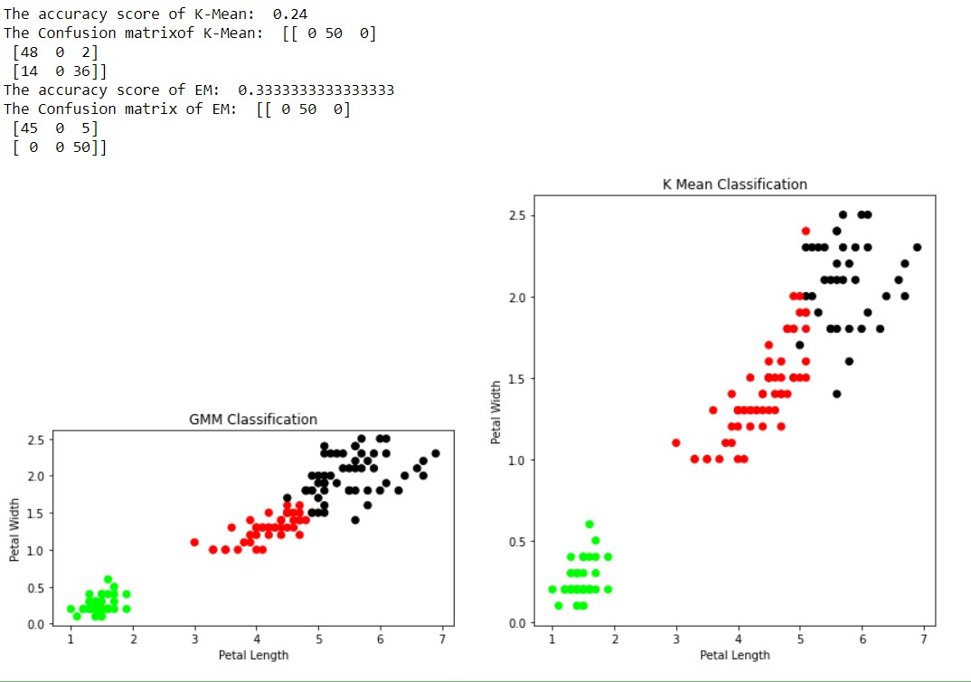
9) Write a program to implement k-Nearest Neighbour algorithm to classify the iris data set. Print both correct and wrong predicFons.

from sklearn.model_selection import train_test_split from sklearn.neighbors import KNeighborsClassifier from sklearn.metrics import classification_report, confusion_matrix from sklearn import datasets
iris=datasets.load_iris()
x = iris.data y = iris.target print ('sepal-length', 'sepal-width', 'petal-length', 'petal-width') print(x) print('class: 0-Iris-Setosa, 1- Iris-Versicolour, 2- Iris-Virginica') print(y) x_train, x_test, y_train, y_test = train_test_split(x,y,test_size=0.3)
#To Training the model and Nearest nighbors K=5 classifier = KNeighborsClassifier(n_neighbors=5) classifier.fit(x_train, y_train)
#To make predictions on our test data y_pred=classifier.predict(x_test) print('Confusion Matrix') print(confusion_matrix(y_test,y_pred)) print('Accuracy Metrics') print(classification_report(y_test,y_pred))
Output:
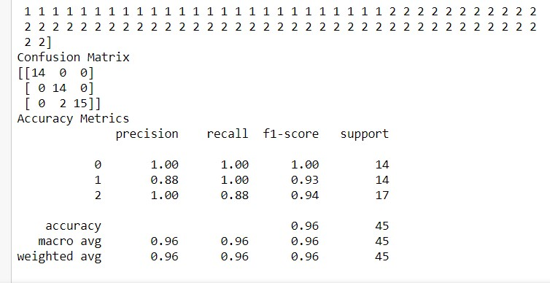
10) Implement the non-parametric Locally Weighted Regression algorithm in order to fit data points. Select appropriate data set for your experiment and draw graphs.
a) Using built-in: import numpy as np from bokeh.plotting import figure, show, output_notebook from bokeh.layouts import gridplot from bokeh.io import push_notebook
def local_regression(x0, X, Y, tau):# add bias term x0 = np.r_[1, x0] # Add one to avoid the loss in information X = np.c_[np.ones(len(X)), X]
# fit model: normal equations with kernel xw = X.T * radial_kernel(x0, X, tau) # XTranspose * W
beta = np.linalg.pinv(xw @ X) @ xw @ Y #@ Matrix Multiplication or Dot Product
# predict value return x0 @ beta # @ Matrix Multiplication or Dot Product for prediction def radial_kernel(x0, X, tau):
return np.exp(np.sum((X - x0) ** 2, axis=1) / (-2 * tau * tau))
# Weight or Radial Kernal Bias Function
n = 1000 # generate dataset X = np.linspace(-3, 3, num=n) print("The Data Set ( 10 Samples) X :\n",X[1:10]) Y = np.log(np.abs(X ** 2 - 1) + .5) print("The Fitting Curve Data Set (10 Samples) Y :\n",Y[1:10])
# jitter X
X += np.random.normal(scale=.1, size=n) print("Normalised (10 Samples) X :\n",X[1:10])
domain = np.linspace(-3, 3, num=300) print(" Xo Domain Space(10 Samples) :\n",domain[1:10])
def plot_lwr(tau):
# prediction through regression prediction = [local_regression(x0, X, Y, tau) for x0 in domain] plot = figure(plot_width=400, plot_height=400) plot.title.text='tau=%g' % tau plot.scatter(X, Y, alpha=.3) plot.line(domain, prediction, line_width=2, color='red') return plot
show(gridplot([
[plot_lwr(10.), plot_lwr(1.)], [plot_lwr(0.1), plot_lwr(0.01)]]))
Output:
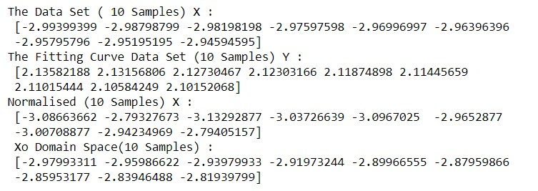 b) Without using built-in:
import matplotlib.pyplot as plt import pandas as pd import numpy as np
def kernel(point, xmat, k): m,n = np.shape(xmat) weights = np.mat(np.eye((m))) for j in range(m): diff = point - X[j] weights[j,j] = np.exp(diff*diff.T/(-2.0*k**2)) return weights
def localWeight(point, xmat, ymat, k):
wei = kernel(point,xmat,k)
W = (X.T*(wei*X)).I*(X.T*(wei*ymat.T)) return W

def localWeightRegression(xmat, ymat, k):
m,n = np.shape(xmat) ypred = np.zeros(m) for i in range(m): ypred[i] = xmat[i]*localWeight(xmat[i],xmat,ymat,k) return ypred data = pd.read_csv('10-dataset.csv') bill = np.array(data.total_bill)
tip = np.array(data.tip)

#preparing and add 1 in bill mbill = np.mat(bill) mtip = np.mat(tip) m= np.shape(mbill)[1] one = np.mat(np.ones(m)) X = np.hstack((one.T,mbill.T)) ypred = localWeightRegression(X,mtip,0.5) SortIndex = X[:,1].argsort(0) xsort = X[SortIndex][:,0] fig = plt.figure() ax = fig.add_subplot(1,1,1) ax.scatter(bill,tip, color='green') ax.plot(xsort[:,1],ypred[SortIndex], color = 'red', linewidth=5) plt.xlabel('Total bill') plt.ylabel('Tip') plt.show();
Output:
