# **Frontend Mentor - Social links profile solution**

This is a solution to the [Social links profile challenge on Frontend Mentor] (https://www.frontendmentor.io/challenges/social-links-profile-UG32l9m6dQ). Frontend Mentor challenges help you improve your coding skills by building realistic projects.

## Overview

### The challenge:

To design Responsive Social Link Profile Card.

Users should be able to:

- See hover and focus states for all interactive elements on the page

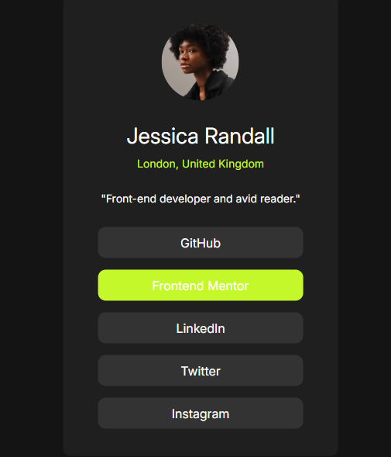**### Screenshot**

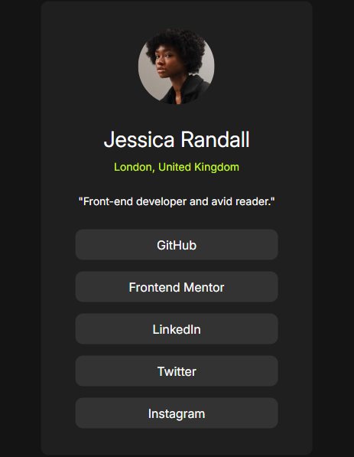

**### Links**

- Solution URL: https://github.com/jathinyenike/social-links-card

- Live Site URL: [**https://jathinyenike.github.io/social-links-card/**](https://jathinyenike.github.io/social-links-card/)

## My process

First wrote html content and then styled it

**### Built with**

- Semantic HTML5 markup

- CSS custom properties

- Flexbox

- CSS Grid

- Mobile-first workflow

**### What I learned**

Mobile-first design approach.

- Frontend Mentor - https://www.frontendmentor.io/profile/jathin54

## Acknowledgments

Designing through mobile first approach is a better way to design applications.