**4.5.2 :**

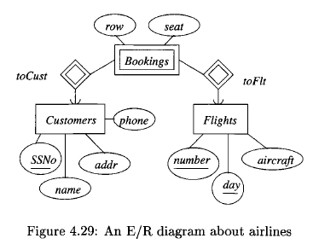

**! Exercise 4 .5 .2 : There is another E /R diagram that could describe the weak**

**entity set Bookings in Fig. 4.29. Notice that a booking can be identified uniquely**

**by the flight number, day of the flight, the row, and the seat; the customer is**

**not then necessary to help identify the booking.**

**a) Revise the diagram of Fig. 4.29 to reflect this new viewpoint.**

**b) Convert your diagram from (a) into relations. Do you get the same**

**database schema as in Exercise 4.5.1?**

**a)**

Bookings

Flights

toFlt

row

seat

number

aircraft

day

**b)**

Flights (number, day, aircraft)

Bookings (number, day, row, seat)

(no need to represent toFlt as it is a supporting relationship)

The relational schema presented here is different from what it would have been representing Figure 2.49 because that schema would have also included an entry for the Customers entity set and the key attributes of the Bookings entity set would not have included row and seat.

**4.6.2 :**

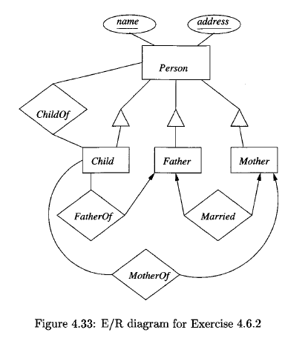

**! Exercise 4.6 .2 : Convert the E /R diagram of Fig. 4.33 to a relational database**

**schema, using:**

**a) The straight-E/R method**

Person(name, address, personType)

Child(name, address)

Mother(name, address)

Father(name, address)

Married(FatherName, MotherName)

FatherOf(FatherName, ChildName)

MotherOf(MotherName, ChildName)

ChildOf(ChildName, PersonName)

**b) The object-oriented method**

Person(name, address)

PersonChild(name, address, personType)

PersonMother(name, address, personType)

PersonFather(name, address, personType)

Married(FatherName, MotherName)

FatherOf(FatherName, ChildName)

MotherOf(MotherName, ChildName)

ChildOf(ChildName, PersonName)

**c) The nulls method.**

Person(name, address, personType, classType)

Married(FatherName, MotherName)

FatherOf(FatherName, ChildName)

MotherOf(MoherName, ChildName)

ChildOf(ChildName, PersonName)

I, Justin Anthony Timberlake, declare that I have completed this assignment completely and entirely on my own, without any consultation with others.  I understand that any breach of the UAB Academic Honor Code may result in severe penalties.