**Statements used to create trigger and associated function :**

CREATE OR REPLACE FUNCTION addtototalfunc()

RETURNS TRIGGER AS $addtototalfunc$

BEGIN

IF (TG_OP = 'INSERT') THEN

UPDATE Total_Expense

SET total_amount = total_amount + NEW.amount;

ELSEIF (TG_OP = 'DELETE') THEN

UPDATE Total_Expense

SET total_amount = total_amount - OLD.amount;

ELSE

UPDATE Total_Expense

SET total_amount = total_amount - OLD.amount + NEW.amount;

END IF;

RETURN NULL;

END;

$addtototalfunc$ LANGUAGE plpgsql;

CREATE TRIGGER AddToTotal

AFTER INSERT OR DELETE OR UPDATE ON Purchases

FOR EACH ROW

EXECUTE PROCEDURE AddToTotalfunc();

**TESTING :**

**Before and after insertion of two values into the Purchases table :**

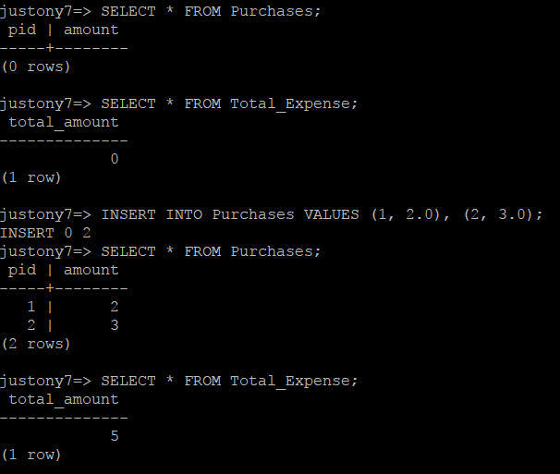

**Deletion of the value with PID = 2 :**

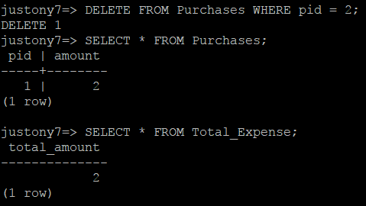

**Updating the amount to 4 for the Purchases tuple with PID = 1 :**

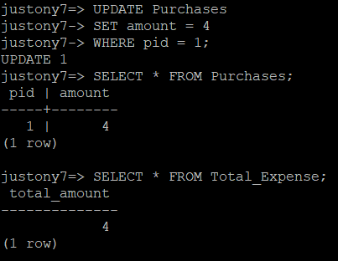

**I, Justin Anthony Timberlake, declare that I have completed this assignment completely and entirely on my own,**

**without any consultation with others. I understand that any breach of the UAB Academic Honor Code may result in**

**severe penalties.**