**Assignment 6**

1.

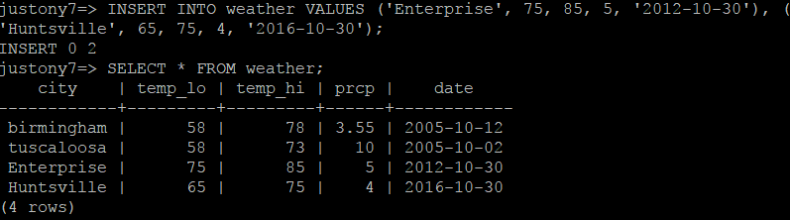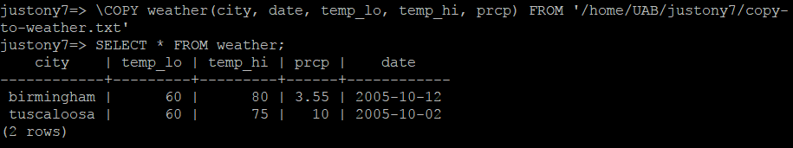

2.

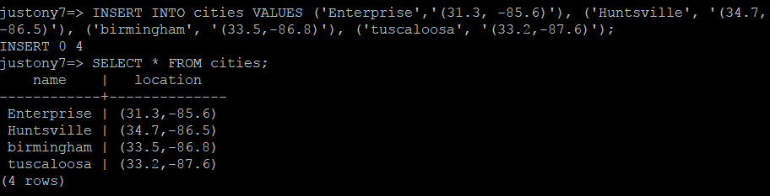

3.

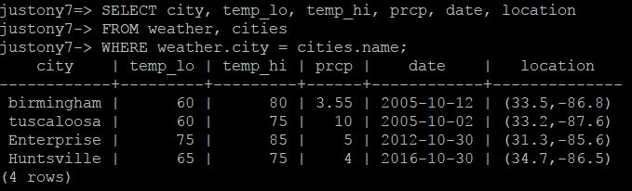

4.

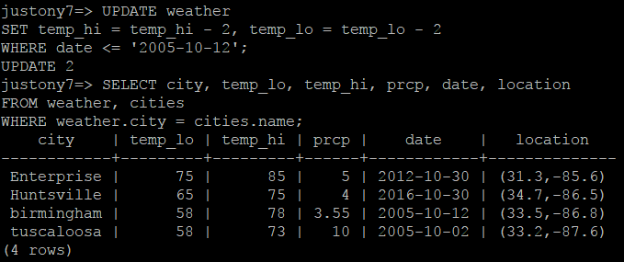

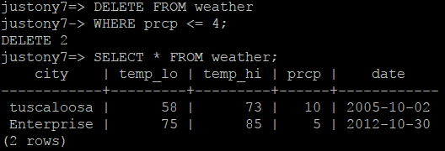

5.

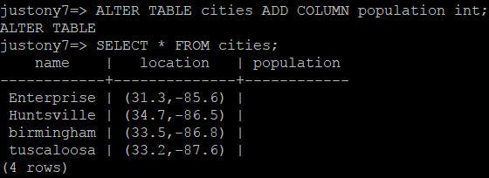

6.

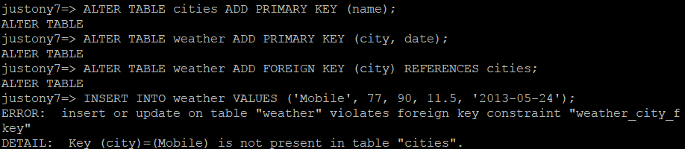

I, Justin Anthony Timberlake, declare that I have completed this assignment completely and entirely on my own, without any consultation with others. I understand that any breach of the UAB Academic Honor Code may result in severe penalties.