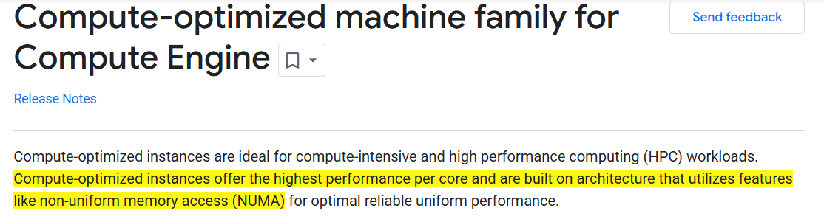

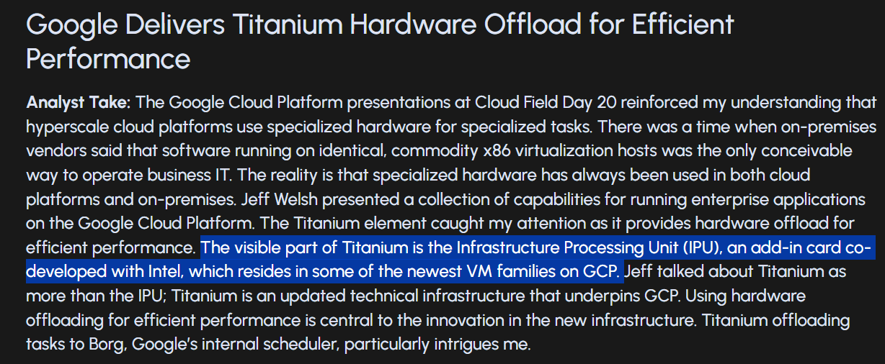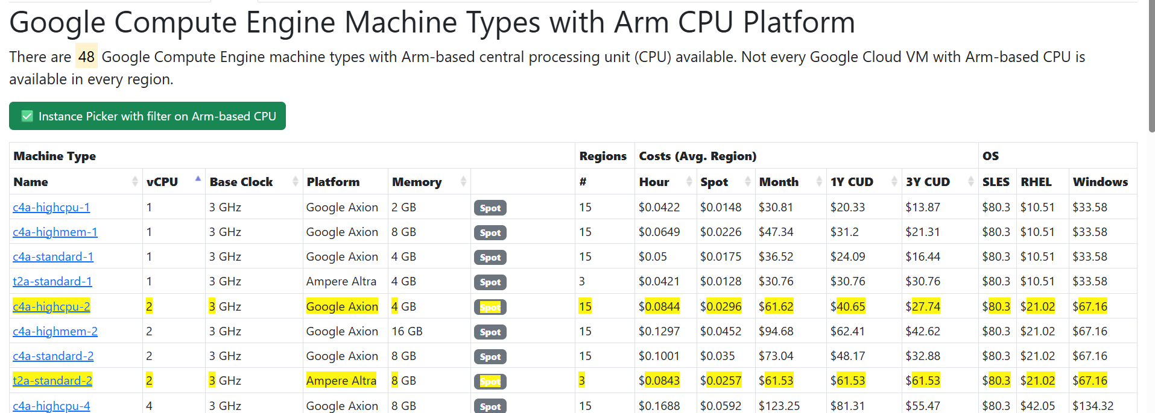

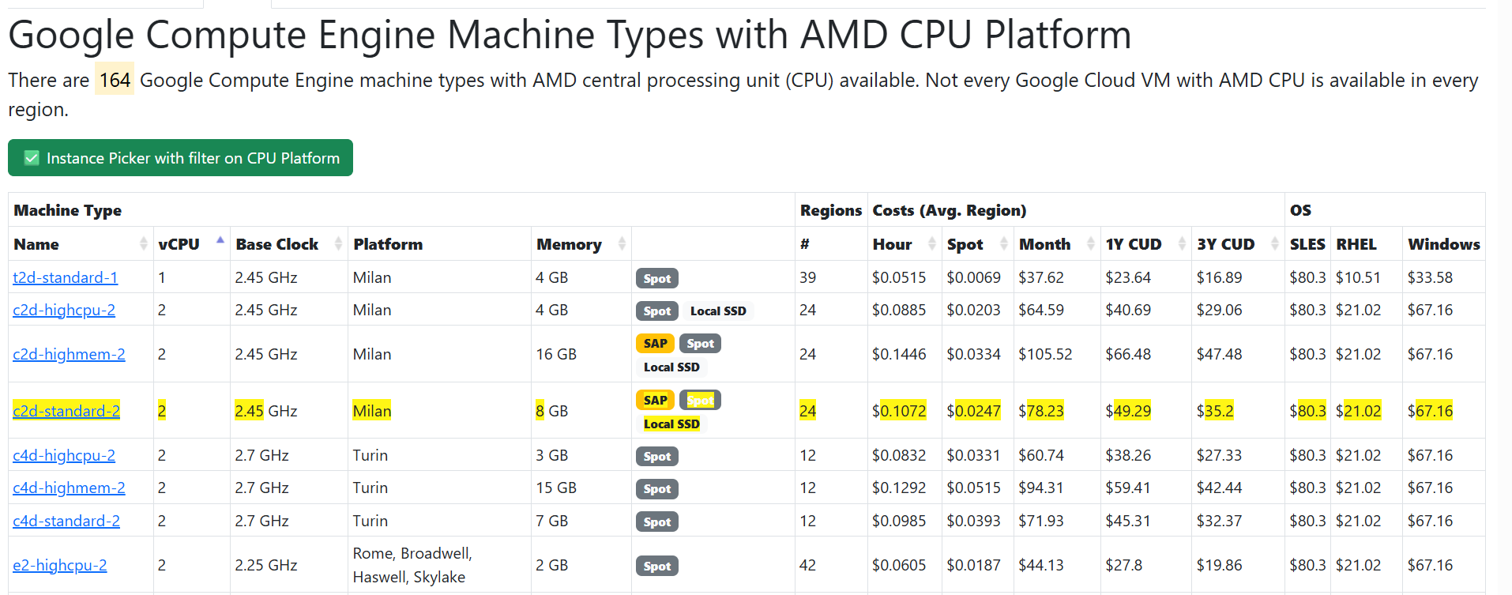

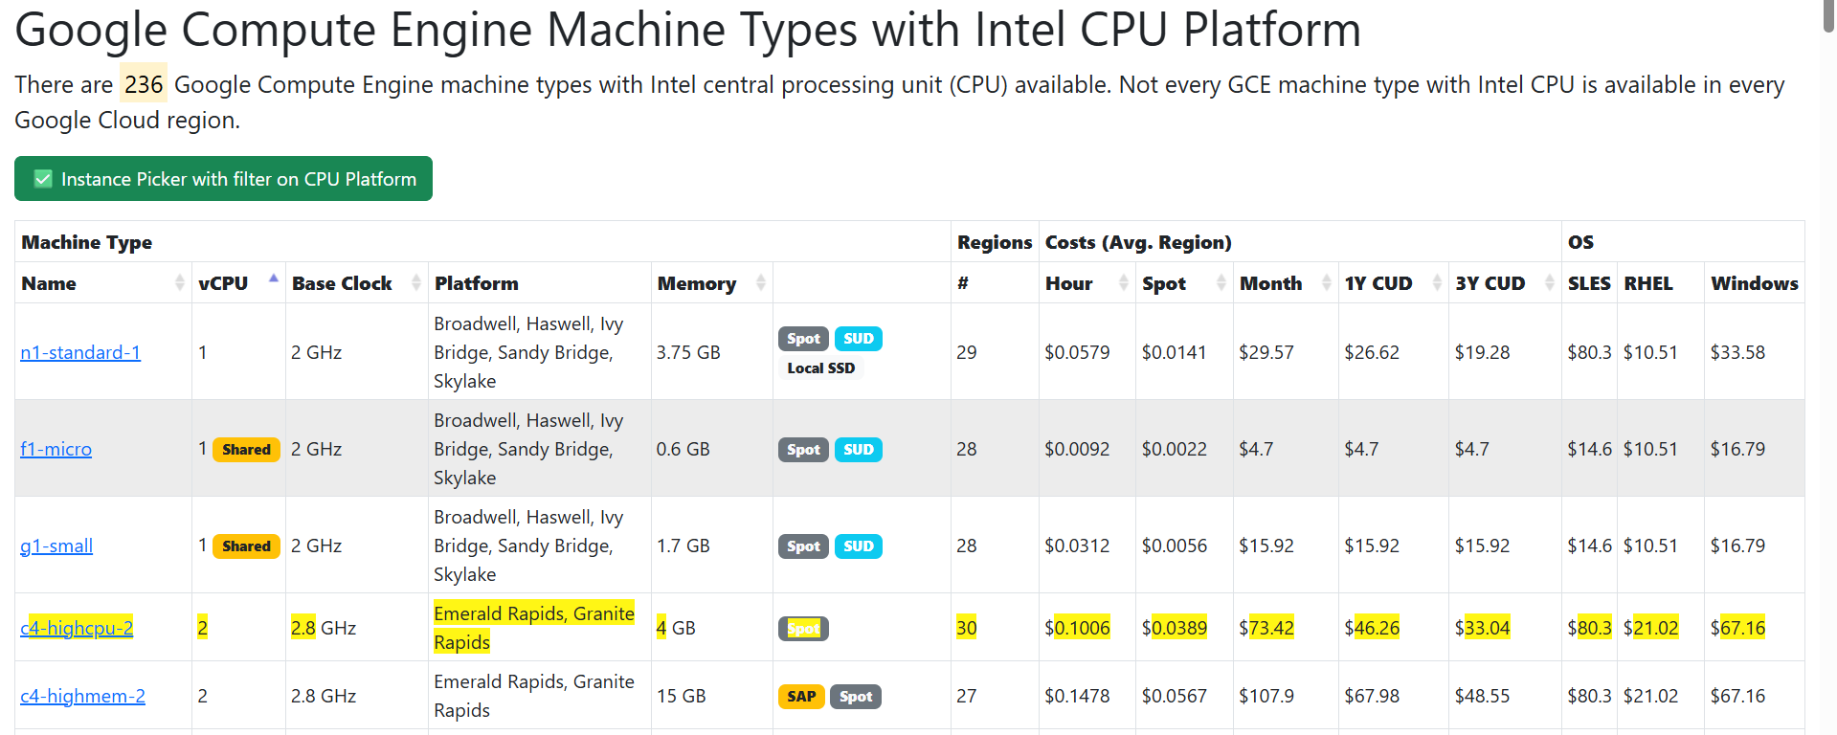

AWS Sapphire Rapids – 1 month.



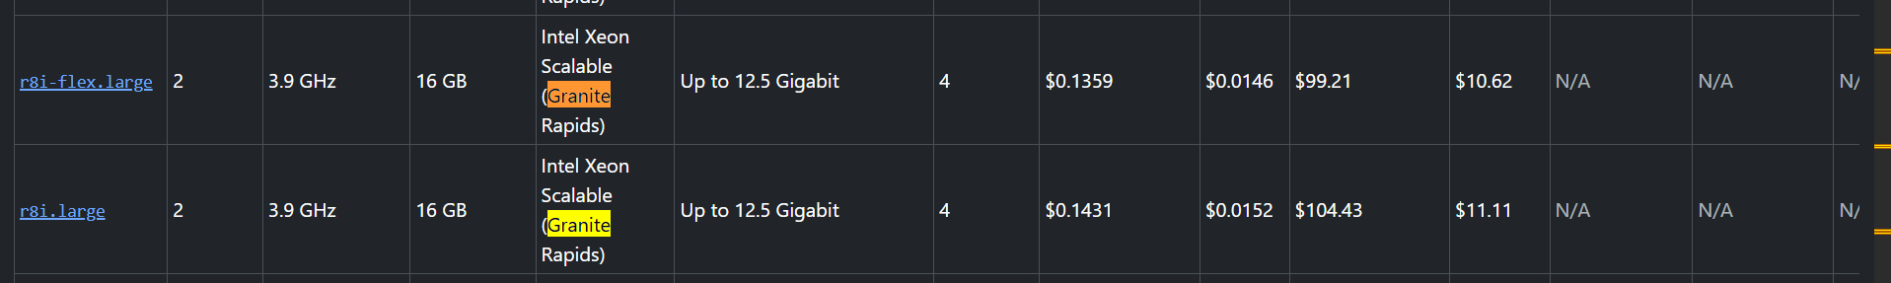

Granite Rapids AWS – 3.9 GHz 104.43 vs GCP Emerald / Granite Rapids – 2.8 GHz monthly cost

<https://gcloud-compute.com/>

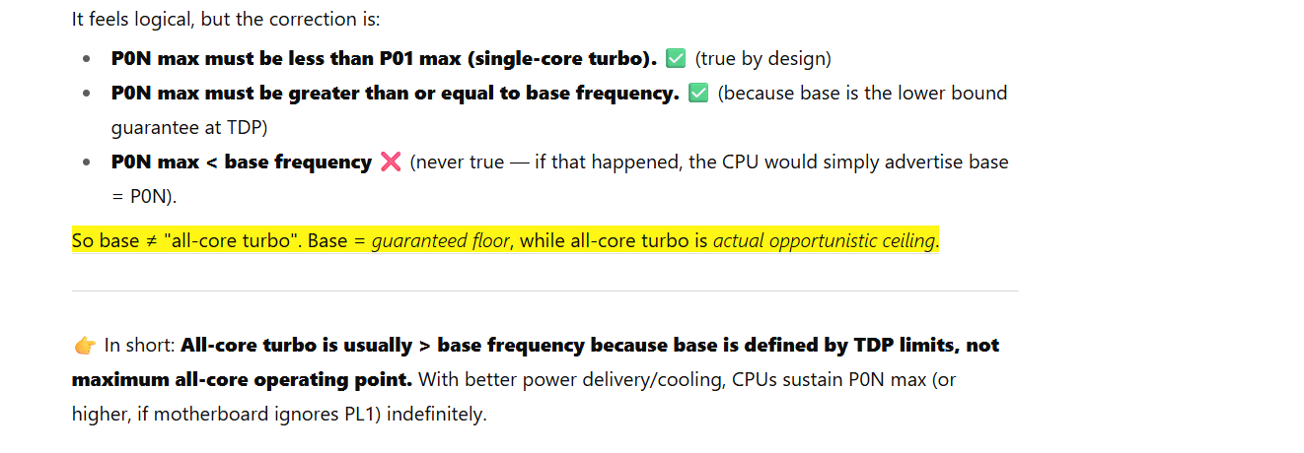

[https://cloud.google.com/compute/docs/cpu-platforms?hl=en&_gl=1*1ylz8nh*_ga*NjU3MTQ4Nzc5LjE3NTYxMDUzNDU.*_ga_WH2QY8WWF5*czE3NTYxMDUzNDQkbzEkZzEkdDE3NTYxMDk1NDEkajEwJGwwJGgw#frequency_behavior:~:text=3.3-,Frequency%20behavior,-The%20previous%20tables](https://cloud.google.com/compute/docs/cpu-platforms?hl=en&_gl=1*1ylz8nh*_ga*NjU3MTQ4Nzc5LjE3NTYxMDUzNDU.*_ga_WH2QY8WWF5*czE3NTYxMDUzNDQkbzEkZzEkdDE3NTYxMDk1NDEkajEwJGwwJGgw#frequency_behavior:~:text=3.3-,Frequency%20behavior,-The%20previous%20tables)

So GCP is using Base Frequency in its VCPU listings while AWS is using P0N max (all-core turbo) both GCP and AWS uses same Granite rapids SKU (unless customized by Intel for a specific CSP).

JVM consider a system as a server class machine if its has atleast 2 CPU and 2GB RAM…

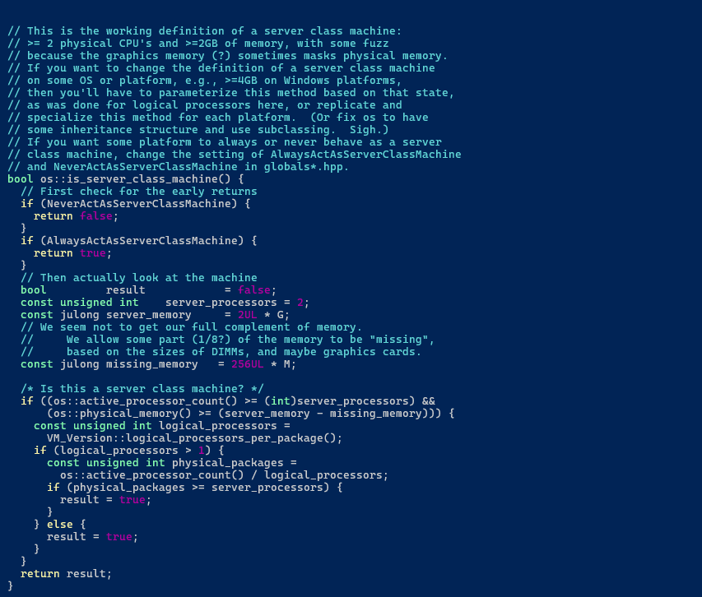

By default, a machine which is not a server class always uses Serial GC collector.

Following JVM flags can be used to change the ERGO settings.

