**GRAAL DEEP DIVE**

1. **Building and running an application using the Graal compiler**

Steps:-

1/ Checkout https://github.com/oracle/graal.git

2/ Checkout https://github.com/graalvm/mx.git

3/ set <dir>/mx to PATH

4/ cd <dir>/graal/compiler

mx --java-home <JDK-26> build

mx --java-home <JDK-26> archive // optional

cd ../<dir>/vm

mx --java-home <JDK-26> build

5/ export GRAAL_HOME=<dir>/graal/sdk/latest_graalvm_home

Run - Graal compiler using JVMCI

$GRAAL_HOME/bin/java -XX:+UnlockExperimentalVMOptions -XX:+EnableJVMCI --add-exports=java.base/jdk.internal.misc=jdk.graal.compiler -XX:-JVMCIPrintProperties -Djdk.graal.PrintPropertiesAll=false -Dgraalvm.locatorDisabled=true -XX:+UseJVMCICompiler -Djdk.graal.PrintCompilation=true -cp . test_pea 100000 10000 0

1. **Debugging the Graal compiler**

Given that Graal itself is written in Java best way to debug it is by developing a Java test and then set the Java Runtime to the latest_graalvm_home directory under <dir>/graal/sdk/

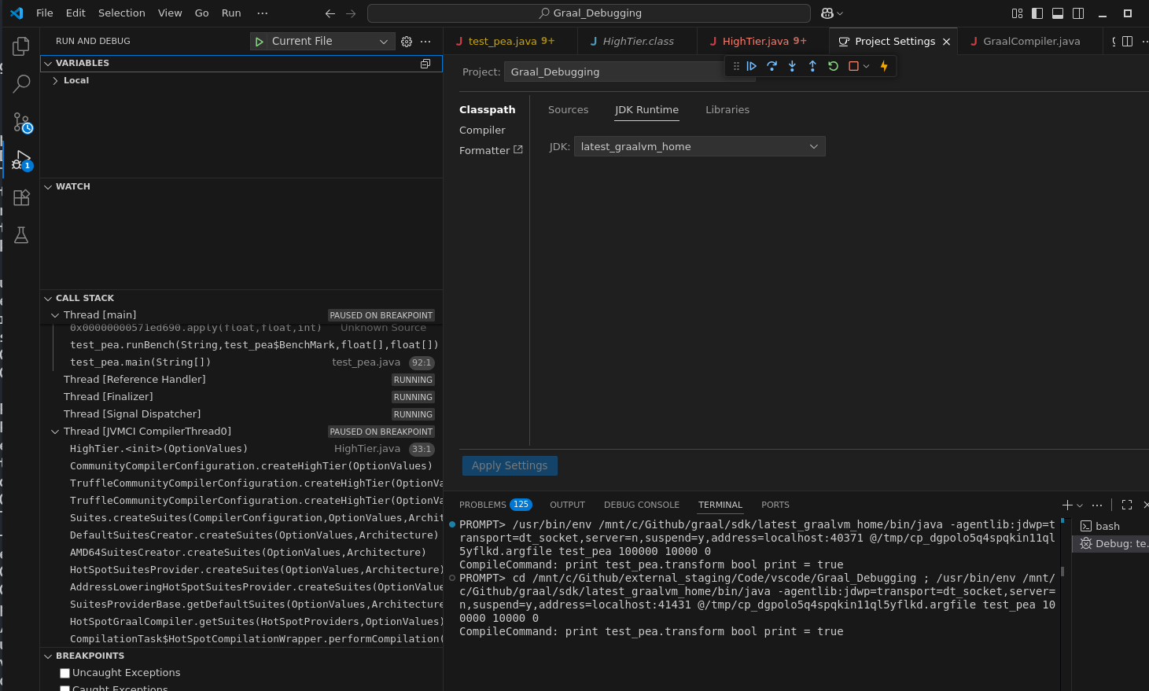

Set correct sourcePath, vmArgs and args in launch.json

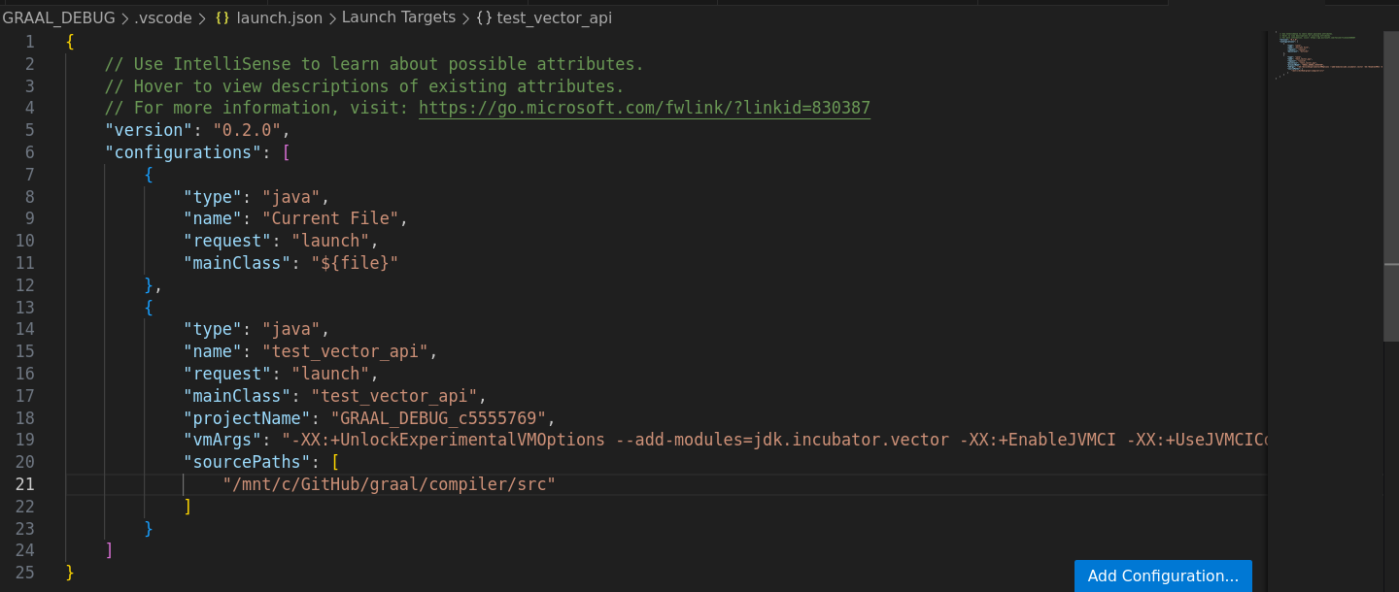

{

// Use IntelliSense to learn about possible attributes.

// Hover to view descriptions of existing attributes.

// For more information, visit: https://go.microsoft.com/fwlink/?linkid=830387

"version": "0.2.0",

"configurations": [

{

"type": "java",

"name": "Current File",

"request": "launch",

"mainClass": "${file}"

},

{

"type": "java",

"name": "test_vector_api",

"request": "launch",

"mainClass": "test_vector_api",

"projectName": "GRAAL_DEBUG_c5555769",

"vmArgs": "-XX:+UnlockExperimentalVMOptions --add-modules=jdk.incubator.vector -XX:+EnableJVMCI -XX:+UseJVMCICompiler -XX:-TieredCompilation -XX:CompileOnly=test_vector_api::kernel",

"sourcePaths": [

"/mnt/c/GitHub/graal/compiler/src"

]

}

]

}

That’s it, launch the debugger after putting the breakpoint in the appropriate Graal compiler method:-

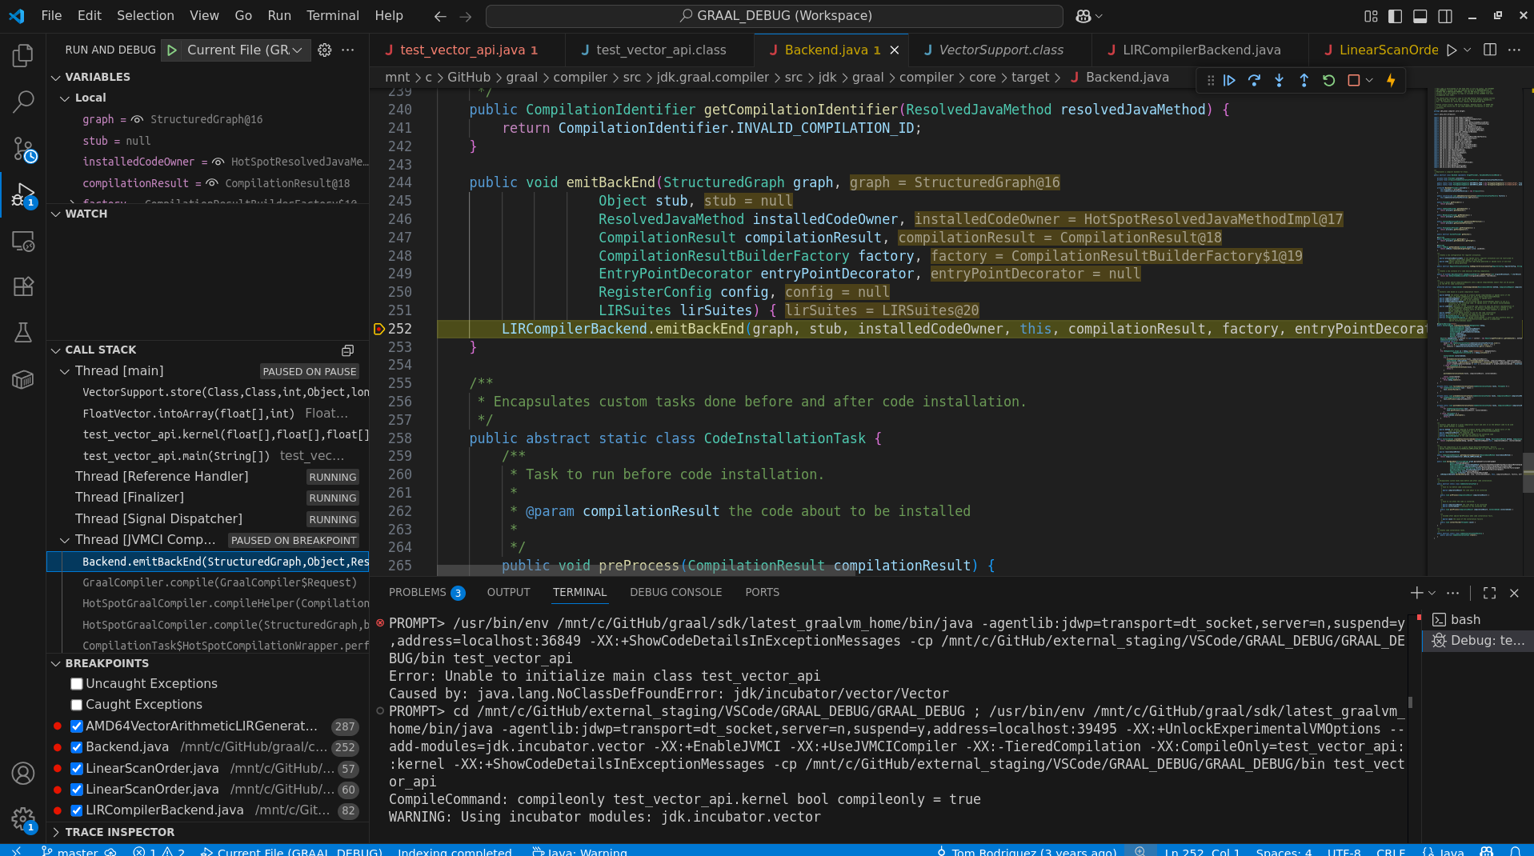

Check in the call stack, the new JVMCI Thread corresponds to the Graal compiler.

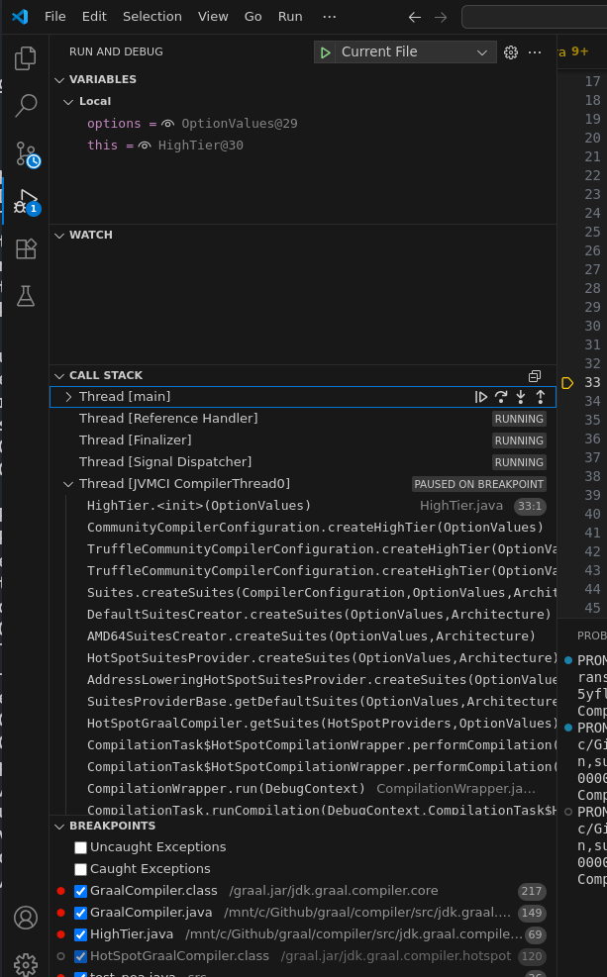

For hassle-free debugging, it's better to use -Xbatch, so that the compilation requests are blocking; otherwise, the interpreter may continue executing the code in the background.

Another alternative is to explicitly pause the execution of the application thread by clicking on the pause execution icon in the call stack

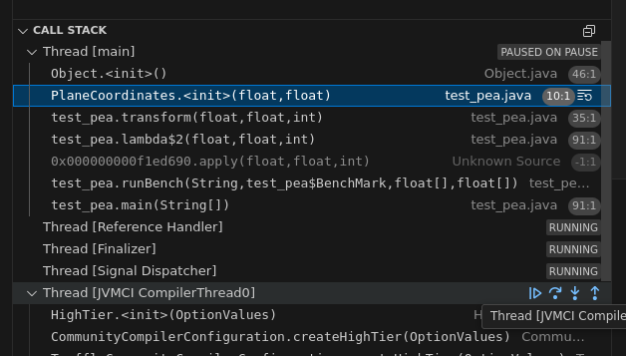

**Java and native parallel debugging**

After copying *debuginfo from <debug_jdk>/build/*slowdebug/bin/ and <debug_jdk>/build/*slowdebug/lib/ and <debug_jdk>/build/*slowdebug/lib/server into <graal_build>/sdk/latest_graalvm_home/bin lib and lib/server.

Graal VM should be built with debug_jdk as its java-home

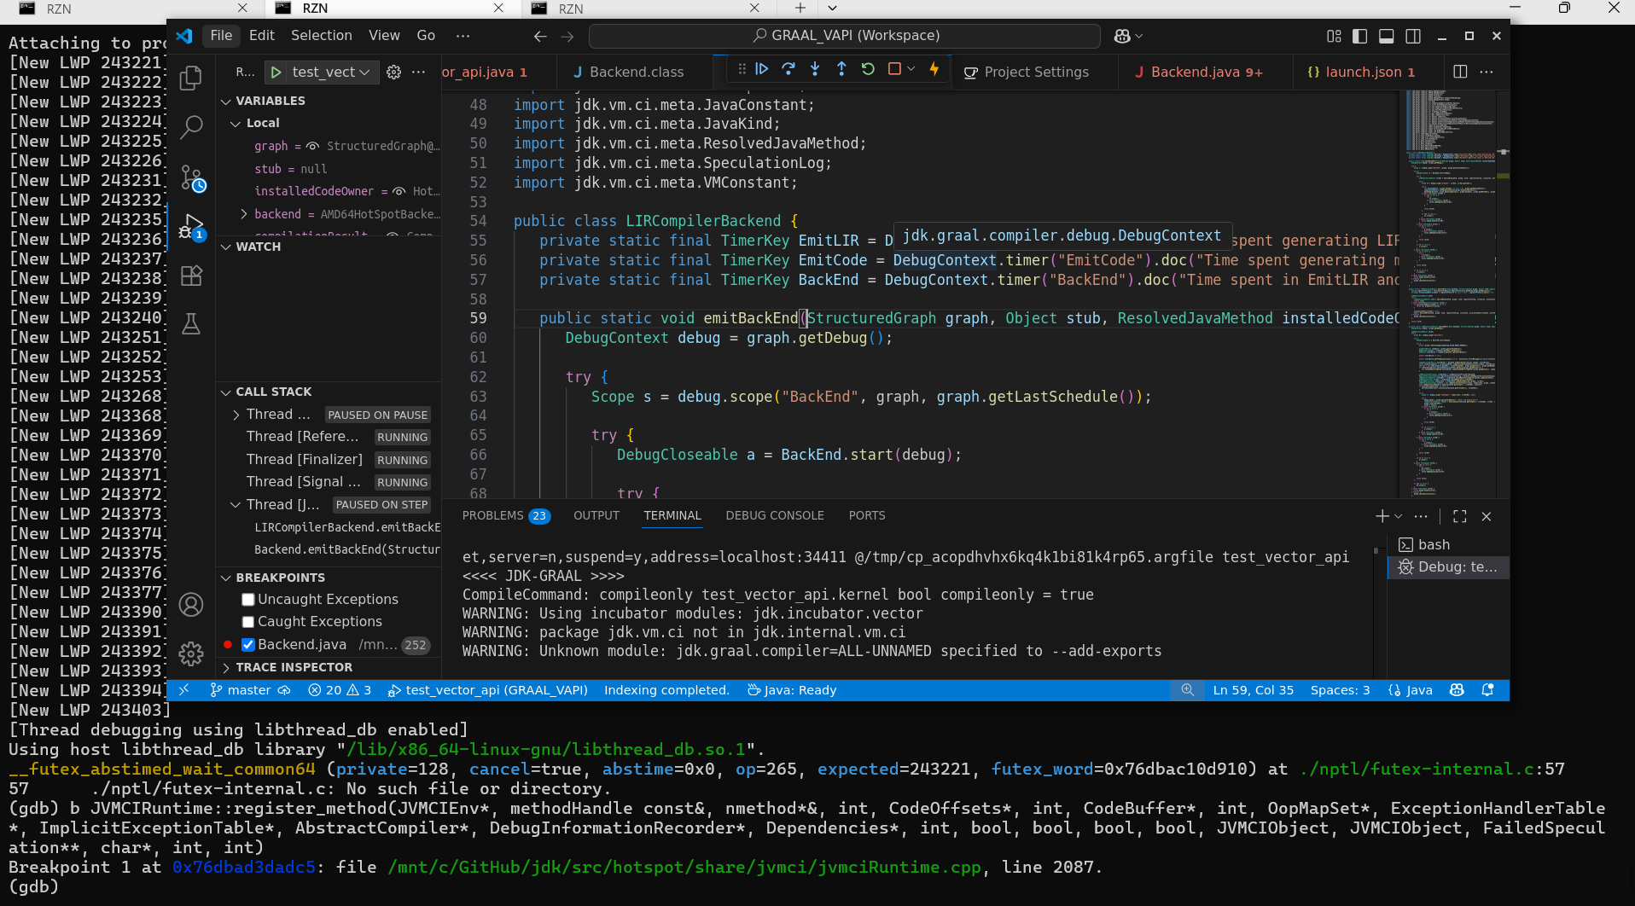

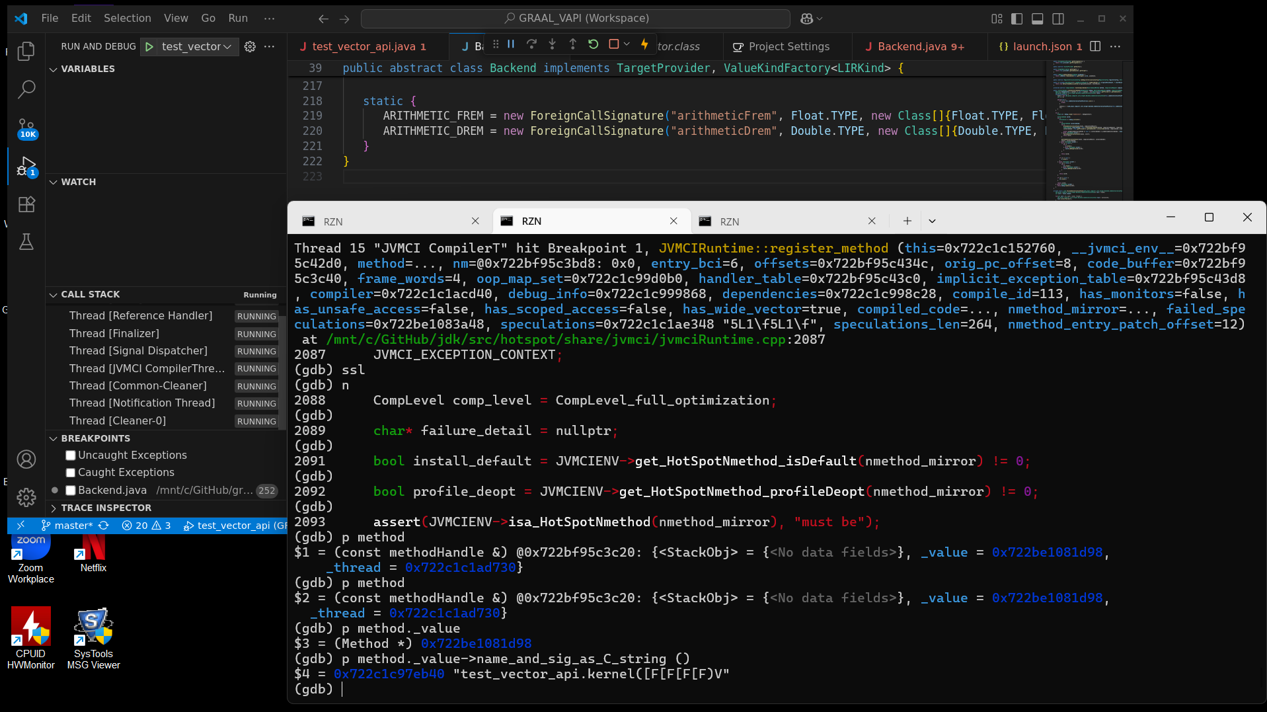

1. **Flow and important code pointers**

HotSpot VM (native ) -> JVMCI (Java interface to Graal compiler)

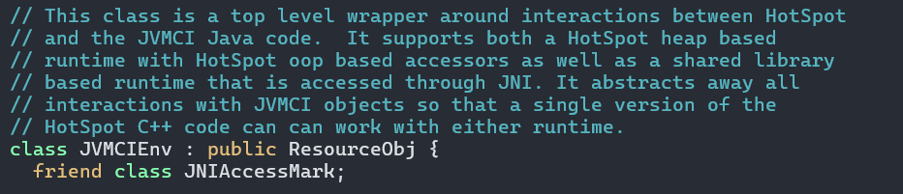

The Native Hotspot VM uses JavaCalls::call_special to invoke a Java method directly, in this case JVMCI’s compileMethod, which generates a HotSpotCompilationRequest to be processed by the JVMCI compiler thread running the Graal compiler.

File: jdk/src/jdk.internal.vm.ci/share/classes/jdk/vm/ci/hotspot/HotSpotJVMCIRuntime.java

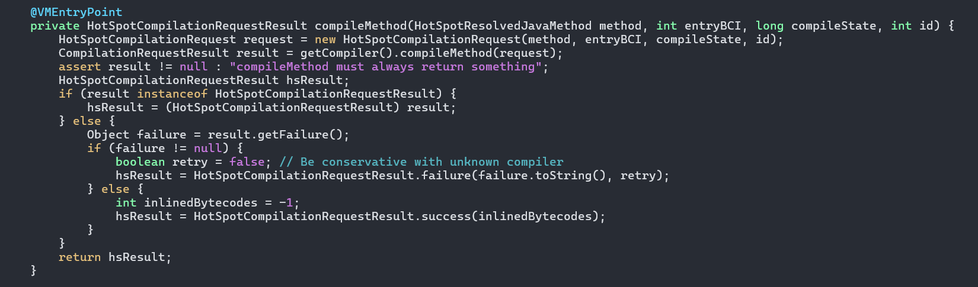

This compile request is received by HotSpotGraalCompiler thread

File: graal/compiler/src/jdk.graal.compiler/src/jdk/graal/compiler/hotspot/HotSpotGraalCompiler.java 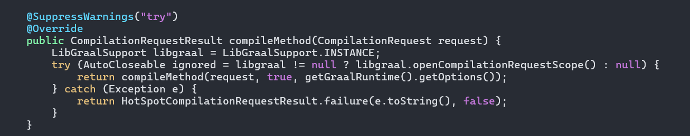

Here is the call stack of interest

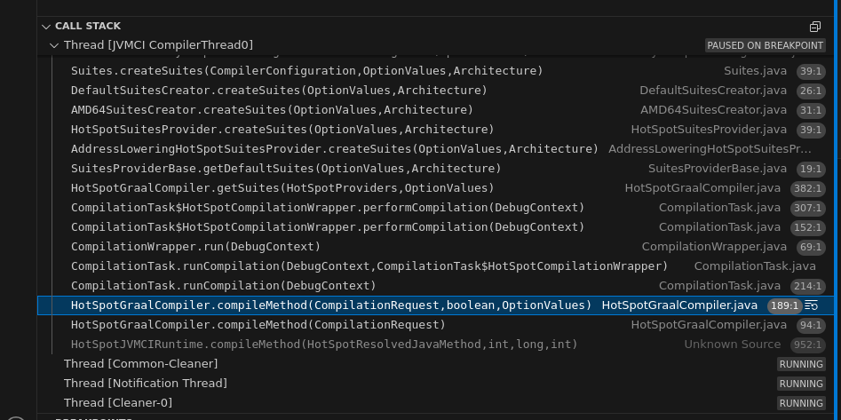

The following file contains various compiler tuning options:-

*graal/compiler/src/jdk.graal.compiler/src/jdk/graal/compiler/core/common/GraalOptions.java*

All the options listed in above page can be invoked using -Djdk.graal.<OPTION>=<VALUE>

e.g.

**PROMPT>$GRAAL_HOME/bin/java -XX:+UnlockExperimentalVMOptions -XX:+EnableJVMCI -XX:+UseJVMCICompiler -Djdk.graal.PrintCompilation=false -XX:+JVMCIPrintProperties -Djdk.graal.TargetVectorLowering=false -Djdk.graal.PrintPropertiesAll=true -cp . test_pea 1000000 10000 0 | grep Vector**

**jdk.graal.OptimizeVectorAPI = true [community edition] [Boolean]**

**Expand Vector API operations to optimized machine instructions**

**jdk.graal.TargetVectorLowering := false [community edition] [Boolean]**

**PROMPT>**

**Phases are divided into multiple tiers: High, Mid, and Low. Phase ordering within a respective tier is captured by AbstractCompilationPlan**

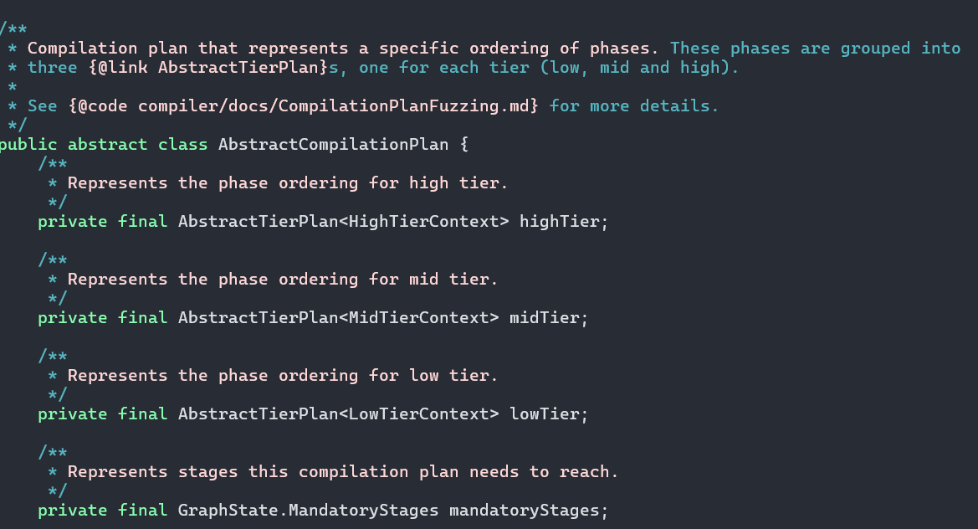

**Phases are organized into multiple Suites**

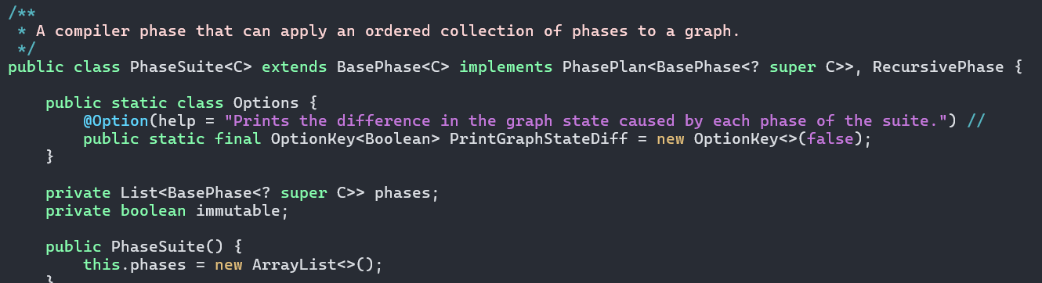

**Abstract BasePhase has an instance-specific method run, which is overridden by different concrete optimization phases. This method receives a StructuredGraph and Context as parameters.**

**protected abstract void run(StructuredGraph graph, C context);**

**In the context of VectorAPI, AMD64VectorLoweringPhase is of interest.**

**Another interesting option in context of VectorAPI is**

**jdk.graal.OptimizeVectorAPI = true [community edition] [Boolean]**

**Expand Vector API operations to optimized machine instructions**

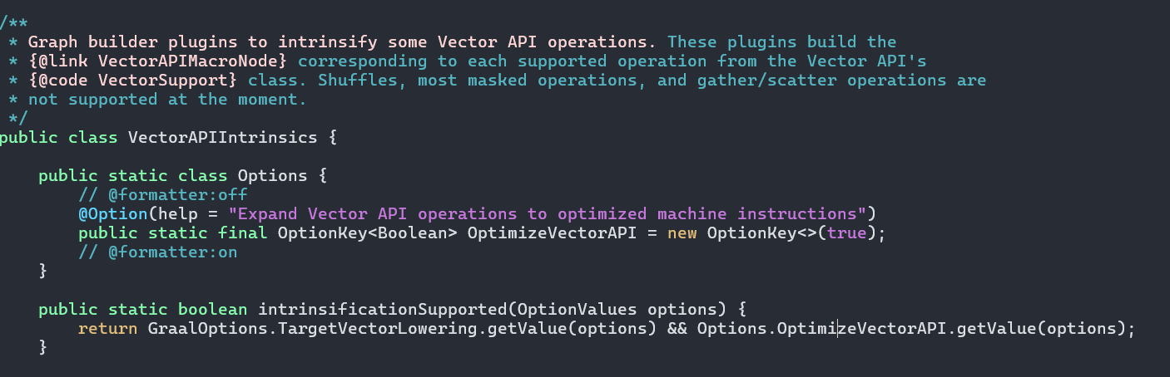

**Here is an execution stack of method compilation.**

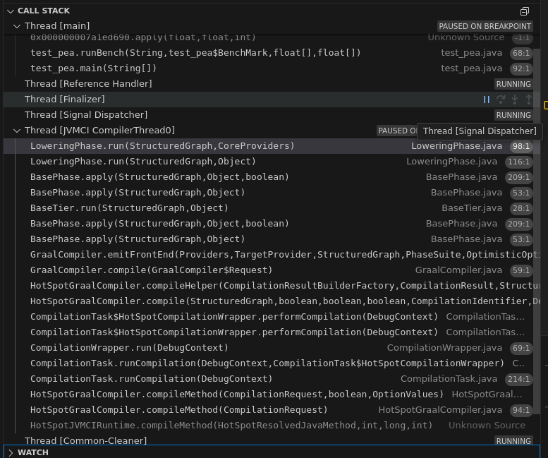

**Optimization Log printer**

**PROMPT>$GRAAL_HOME/bin/java -XX:+EnableJVMCI -XX:+UseJVMCICompiler -XX:-JVMCIPrintProperties -Djdk.graal.PrintPropertiesAll=false -Djdk.graal.OptimizationLog=Directory -Djdk.graal.OptimizationLogPath=optimization_report -XX:CompileOnly=test_pea::transform -cp . test_pea 100000 10000 0**

**PROMPT>jq -C < optimization_report/0_19**

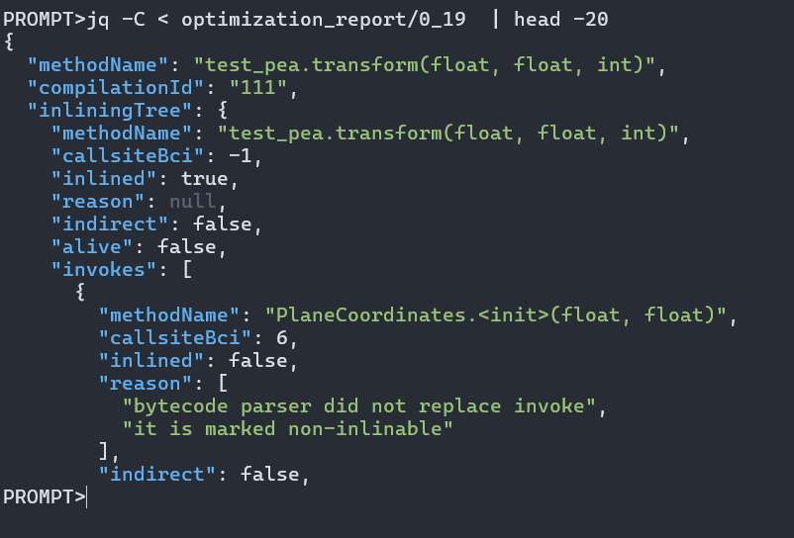

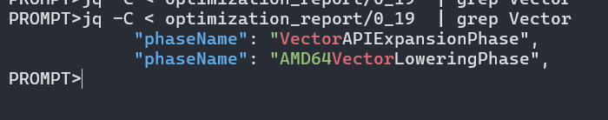

PROMPT>jq -C < optimization_report/0_19

{

"methodName": "test_pea.transform(float, float, int)",

"compilationId": "111",

"inliningTree": {

"methodName": "test_pea.transform(float, float, int)",

"callsiteBci": -1,

"inlined": true,

"reason": null,

"indirect": false,

"alive": false,

"invokes": [

{

"methodName": "PlaneCoordinates.<init>(float, float)",

"callsiteBci": 6,

"inlined": false,

"reason": [

"bytecode parser did not replace invoke",

"it is marked non-inlinable"

],

"indirect": false,

"alive": true

},

{

"methodName": "PlaneCoordinates.affine_transform(float, float)",

"callsiteBci": 29,

"inlined": false,

"reason": [

"bytecode parser did not replace invoke",

"it is marked non-inlinable"

],

"indirect": false,

"alive": true

},

{

"methodName": "PlaneCoordinates.getX()",

"callsiteBci": 33,

"inlined": true,

"reason": [

"inline accessor method (bytecode parsing)"

],

"indirect": false,

"alive": false

},

{

"methodName": "PlaneCoordinates.getY()",

"callsiteBci": 37,

"inlined": true,

"reason": [

"inline accessor method (bytecode parsing)"

],

"indirect": false,

"alive": false

}

]

},

"optimizationTree": {

"phaseName": "RootPhase",

"optimizations": [

{

"phaseName": "PhaseSuite",

"optimizations": [

{

"phaseName": "HotSpotGraphBuilderPhase",

"optimizations": []

}

]

},

{

"phaseName": "DeadCodeEliminationPhase",

"optimizations": []

},

{

"phaseName": "HighTier",

"optimizations": [

{

"phaseName": "CanonicalizerPhase",

"optimizations": [

{

"optimizationName": "Canonicalizer",

"eventName": "UnusedNodeRemoval",

"position": null

}

]

},

{

"phaseName": "HostInliningPhase",

"optimizations": []

},

{

"phaseName": "InliningPhase",

"optimizations": []

},

{

"phaseName": "DeadCodeEliminationPhase",

"optimizations": []

},

{

"phaseName": "ConvertDeoptimizeToGuardPhase",

"optimizations": [

{

"phaseName": "DeadCodeEliminationPhase",

"optimizations": []

}

]

},

{

"phaseName": "IterativeConditionalEliminationPhase",

"optimizations": [

{

"phaseName": "ConditionalEliminationPhase",

"optimizations": []

}

]

},

{

"phaseName": "DominatorBasedGlobalValueNumberingPhase",

"optimizations": []

},

{

"phaseName": "BoxNodeIdentityPhase",

"optimizations": []

},

{

"phaseName": "FinalPartialEscapePhase",

"optimizations": [

{

"phaseName": "IncrementalCanonicalizerPhase",

"optimizations": []

},

{

"phaseName": "SchedulePhase",

"optimizations": []

},

{

"phaseName": "DeadCodeEliminationPhase",

"optimizations": [

{

"optimizationName": "DeadCodeElimination",

"eventName": "NodeRemoval",

"position": null

}

]

},

{

"phaseName": "IncrementalCanonicalizerPhase",

"optimizations": []

},

{

"phaseName": "IncrementalCanonicalizerPhase",

"optimizations": []

},

{

"phaseName": "SchedulePhase",

"optimizations": []

},

{

"optimizationName": "PartialEscapeLog",

"eventName": "AllocationVirtualization",

"position": null,

"materializations": 1

}

]

},

{

"phaseName": "VectorAPIExpansionPhase",

"optimizations": []

},

{

"phaseName": "ReadEliminationPhase",

"optimizations": [

{

"phaseName": "IncrementalCanonicalizerPhase",

"optimizations": []

},

{

"phaseName": "DeadCodeEliminationPhase",

"optimizations": []

},

{

"phaseName": "IncrementalCanonicalizerPhase",

"optimizations": []

},

{

"phaseName": "IncrementalCanonicalizerPhase",

"optimizations": []

}

]

},

{

"phaseName": "BoxNodeOptimizationPhase",

"optimizations": []

},

{

"phaseName": "HighTierLoweringPhase",

"optimizations": [

{

"phaseName": "SchedulePhase",

"optimizations": []

},

{

"phaseName": "IncrementalCanonicalizerPhase",

"optimizations": []

}

]

}

]

},

{

"phaseName": "MidTier",

"optimizations": [

{

"phaseName": "LockEliminationPhase",

"optimizations": []

},

{

"phaseName": "FloatingReadPhase",

"optimizations": [

{

"optimizationName": "FloatingRead",

"eventName": "FixedWithFloatingReplacement",

"position": null

},

{

"optimizationName": "FloatingRead",

"eventName": "FixedWithFloatingReplacement",

"position": null

},

{

"phaseName": "IncrementalCanonicalizerPhase",

"optimizations": []

}

]

},

{

"phaseName": "IterativeConditionalEliminationPhase",

"optimizations": [

{

"phaseName": "ConditionalEliminationPhase",

"optimizations": []

}

]

},

{

"phaseName": "LoopSafepointEliminationPhase",

"optimizations": []

},

{

"phaseName": "SpeculativeGuardMovementPhase",

"optimizations": []

},

{

"phaseName": "RemoveValueProxyPhase",

"optimizations": []

},

{

"phaseName": "LoopSafepointInsertionPhase",

"optimizations": []

},

{

"phaseName": "MidTierLoweringPhase",

"optimizations": [

{

"phaseName": "SchedulePhase",

"optimizations": []

},

{

"phaseName": "IncrementalCanonicalizerPhase",

"optimizations": [

{

"optimizationName": "Canonicalizer",

"eventName": "UnusedNodeRemoval",

"position": null

}

]

}

]

},

{

"phaseName": "IterativeConditionalEliminationPhase",

"optimizations": [

{

"phaseName": "ConditionalEliminationPhase",

"optimizations": []

}

]

},

{

"phaseName": "OptimizeDivPhase",

"optimizations": []

},

{

"phaseName": "FrameStateAssignmentPhase",

"optimizations": []

},

{

"phaseName": "ReassociationPhase",

"optimizations": [

{

"phaseName": "IncrementalCanonicalizerPhase",

"optimizations": []

}

]

},

{

"phaseName": "DeoptimizationGroupingPhase",

"optimizations": []

},

{

"phaseName": "CanonicalizerPhase",

"optimizations": []

},

{

"phaseName": "WriteBarrierAdditionPhase",

"optimizations": []

}

]

},

{

"phaseName": "LowTier",

"optimizations": [

{

"phaseName": "InitMemoryVerificationPhase",

"optimizations": []

},

{

"phaseName": "LowTierLoweringPhase",

"optimizations": [

{

"phaseName": "SchedulePhase",

"optimizations": []

},

{

"phaseName": "IncrementalCanonicalizerPhase",

"optimizations": [

{

"optimizationName": "Canonicalizer",

"eventName": "CanonicalReplacement",

"position": null,

"replacedNodeClass": "HotSpotCompression",

"canonicalNodeClass": "Constant"

},

{

"optimizationName": "Canonicalizer",

"eventName": "UnusedNodeRemoval",

"position": null

},

{

"optimizationName": "Canonicalizer",

"eventName": "UnusedNodeRemoval",

"position": null

},

{

"optimizationName": "Canonicalizer",

"eventName": "UnusedNodeRemoval",

"position": null

},

{

"optimizationName": "Canonicalizer",

"eventName": "UnusedNodeRemoval",

"position": null

}

]

}

]

},

{

"phaseName": "ExpandLogicPhase",

"optimizations": []

},

{

"phaseName": "OptimizeOffsetAddressPhase",

"optimizations": []

},

{

"phaseName": "FixReadsPhase",

"optimizations": [

{

"phaseName": "SchedulePhase",

"optimizations": []

}

]

},

{

"phaseName": "CanonicalizerPhase",

"optimizations": [

{

"optimizationName": "Canonicalizer",

"eventName": "CanonicalReplacement",

"position": null,

"replacedNodeClass": "HotSpotCompression",

"canonicalNodeClass": "PublishWrites"

}

]

},

{

"phaseName": "UseTrappingNullChecksPhase",

"optimizations": [

{

"optimizationName": "UseTrappingNullChecks",

"eventName": "NullCheckInsertion",

"position": null

}

]

},

{

"phaseName": "AddressLoweringByNodePhase",

"optimizations": []

},

{

"phaseName": "FinalCanonicalizerPhase",

"optimizations": [

{

"optimizationName": "Canonicalizer",

"eventName": "UnusedNodeRemoval",

"position": null

}

]

},

{

"phaseName": "AMD64VectorLoweringPhase",

"optimizations": []

},

{

"phaseName": "DeadCodeEliminationPhase",

"optimizations": []

},

{

"phaseName": "PropagateDeoptimizeProbabilityPhase",

"optimizations": []

},

{

"phaseName": "OptimizeExtendsPhase",

"optimizations": []

},

{

"phaseName": "SchedulePhase$FinalSchedulePhase",

"optimizations": [

{

"phaseName": "SchedulePhase",

"optimizations": []

}

]

},

{

"phaseName": "TransplantGraphsPhase",

"optimizations": []

}

]

}

]

}

}

1. **Exploring Graal’s partial escape analysis**

<https://bugs.openjdk.org/browse/JDK-8366137>

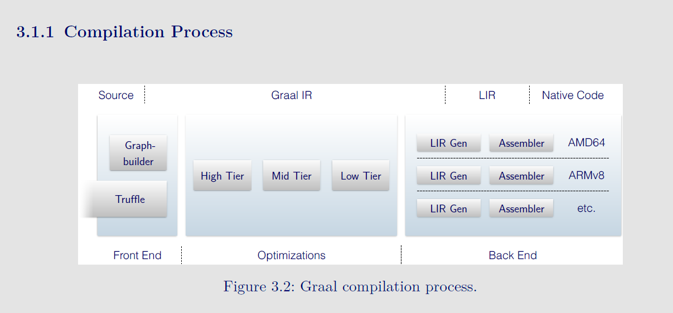

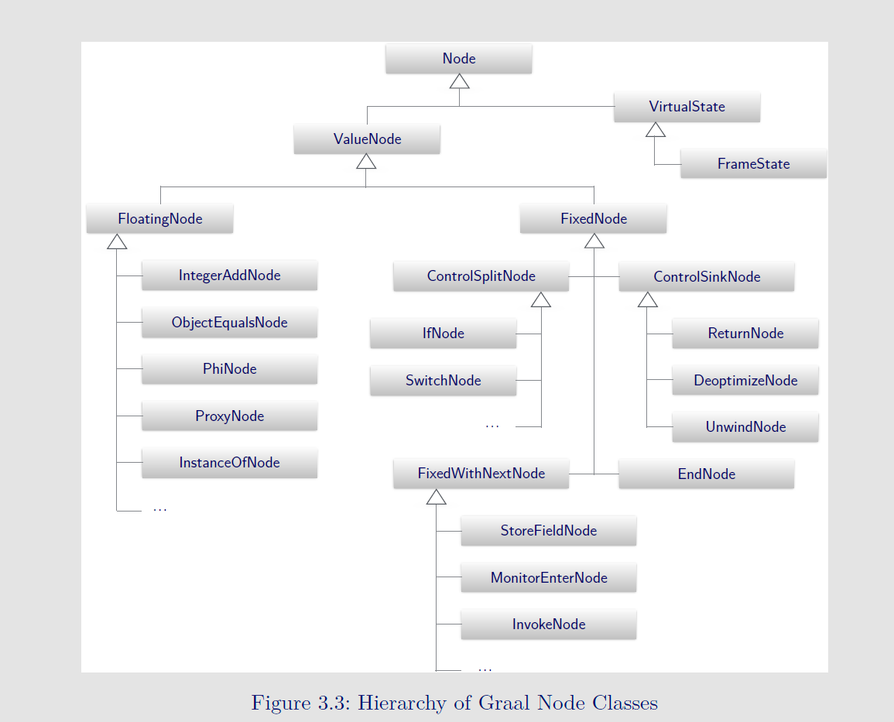

FrameState in Graal compiler is analogous to JVMState in C2

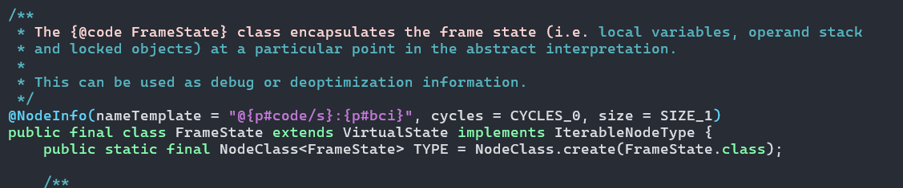

JVMState is associated with various SafePointNodes, around loop back, method return, and at the call site. build_start_state creates initial state of method creation by ParserGenerator. A chain of JVMState is formed if a node is inlined. During code emission, the compiler dumps the stack of frames associated with Safepoints into the debug stream. Multiple VM clients, such as deoptimization, use this to reconstruct the interpreter state. It is also used during root set enumeration, along with OopMaps, to find the location of oops.

Runtime always expects a valid OopMap against each frame; auxiliary structure PCDescriptor maintains this mapping.

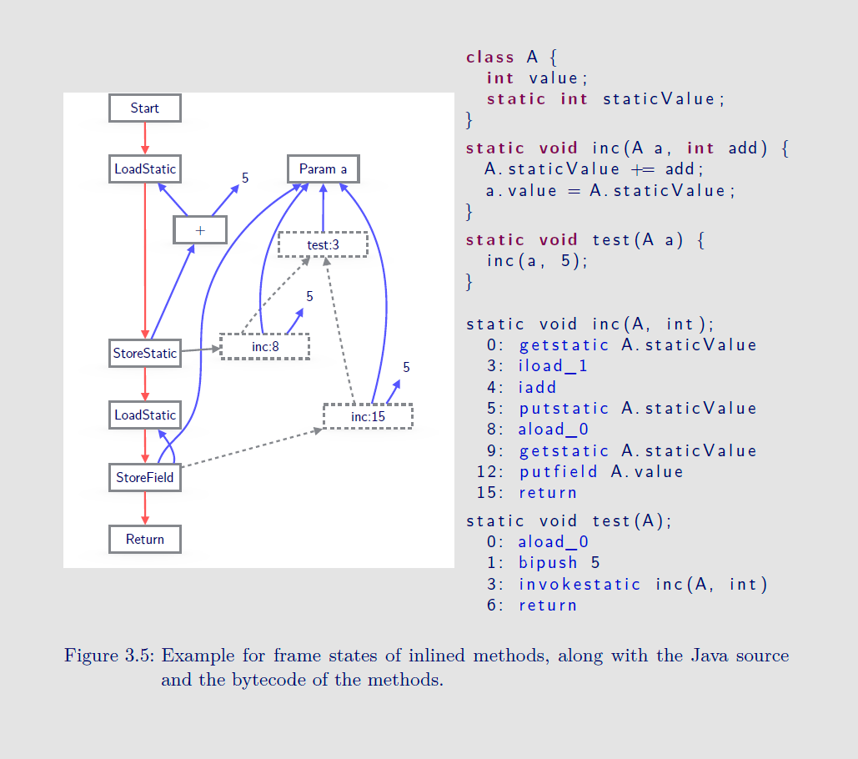

[C2 tip] Useful iterators:-

* OopMapStream
* vframeStream
  + vframeStreamCommon