Java return convention for functions returning value instances as fields.
_{Example:}
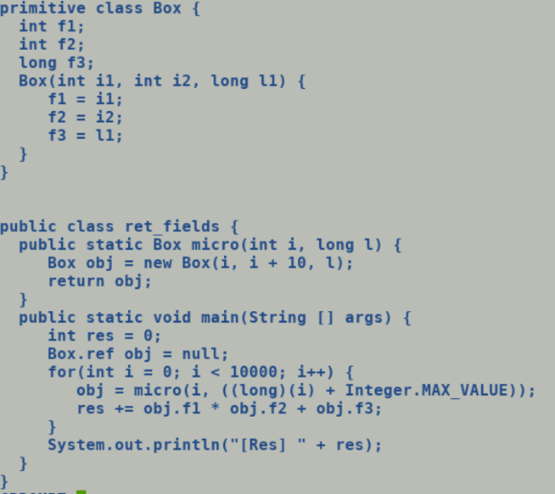
-Xcomp triggers compilation at first invocation and batch option makes compilation request blocking, thus micro does not get inline expanded into main. But it still passes the primitive type instance (Box) as scalarized values, through newly added return calling convention which returns the fields via caller saved registers.
