Data Center and Cloud as a Service

What is a Data Center?

A traditional Data Center is a physical facility which companies use to store their information as well as other applications which are integral to their functioning. While a Data Center is thought to be one thing, in reality, it is often composed of technical equipment depending on what requires to be stored – it can range from routers and security devices to storage systems and application delivery controllers. A data center's design is based on a network of computing and storage resources that enable the delivery of shared applications and data. To keep all the hardware and software updated and running, a Data Center also requires a significant amount of infrastructure. The key components of a data center design include routers, switches, firewalls, storage systems, servers, and application-delivery controllers. These facilities can include ventilation and cooling systems, uninterruptible power supplies, backup generators, and more.

Need for a Data Center in Today’s World

With the growth of population increasing exponentially by the hour, key data that a firm works on, which is used to draw important insights about the audience and potential clients, has reached dimensions of the scale of petabytes. It requires huge data centers in the form of huge data warehouses to store and manage such a humongous amount of data properly. Data is the most critical asset of any organization and businesses are faced with the imminent challenges of managing and governing data while ensuring data compliance. Data management is critical for every company to improve business agility with up-to-date information available anywhere, anytime to the employees who need it most. There are entire ecosystems that grow perennially around Big Data and Data Analytics, which make enterprises aim for significantly critical tools to manage everyday data.

With businesses realizing the dynamism of what can be done with their data, they are moving on from their existing resources to well-equipped Data Centers to aid better data management. Data Centers have become top priority for businesses across the globe to measure up their IT infrastructure requirements. With this shift in addressing information, Data Centers have moved beyond being just an additional storage facility. Infact, they have emerged as a key business parameter.

Role of a Data Center

Data centers are an integral part of the enterprise, designed to support business applications and provide services such as:

* Data storage, management, backup and recovery
* Productivity applications, such as email
* High-volume e-commerce transactions
* Powering online gaming communities
* Big data, machine learning and artificial intelligence

Types of Data Centers

Many types of data centers and service models are available. Their classification depends on whether they are owned by one or many organizations, how they fit (if they fit) into the topology of other data centers, what technologies they use for computing and storage, and even their energy efficiency. There are four main types of data centers:

1. **Colocation data centers** : In colocation ("colo") data centers, a company rents space within a data center owned by others and located off company premises. The colocation data center hosts the infrastructure: building, cooling, bandwidth, security, etc., while the company provides and manages the components, including servers, storage, and firewalls.
2. **Cloud data centers** : A cloud data center is the type of data center in which the cloud company manages and takes care of the actual hardware with the help of a third-party managed services provider. It gives the clients the liberty to run applications and manage websites and data within the ambits of a virtual infrastructure running on the cloud servers.
3. **Managed services data centers** : These data centers are managed by a third party (or a managed services provider) on behalf of a company. The company leases the equipment and infrastructure instead of buying it.
4. **Enterprise data centers** : These are built, owned, and operated by companies and are optimized for their end users. Most often they are housed on the corporate campus.

In-House Data Center Vs. Cloud

Some of the major key differences are mentioned below:

* The major difference between the Data Center and Cloud is that the applications are offered locally and are accessible by users whenever needed without an internet connection. While in the cloud, the applications are online and a network connection is necessary to access the same.
* Data is stored in a public repository in Cloud whereas data is stored in the local repository in the Data Center. The repository is taken care of by service providers in the cloud and those are taken care of by developers in the Data Center.
* Investment is needed in the Data Center to set up and maintain the repository. Small companies and startups may find it hard to find investment. No large investments are needed for clouds as it is a subscription and companies can easily find the money invested for cloud deployment.
* Larger organizations go forth with Data Center. Small companies and startups go with cloud deployment. Less budget and resources force the companies to go with cloud services offered by third party services. Organizations find it easy to fund the repository and target the resources than to risk the security.
* Organizations feel hard and remorseful while recovering the data or application from the Data Center as it takes a long time and the data is not fully recovered. It is not hard to recover data from the Cloud if something goes wrong. Data is distributed in several remote servers and the data is easily recovered when called for once at least.
* The infrastructure of the cloud can be extended whenever needed and hence extra storage is not a burden for companies using Cloud. However, when extra storage is needed in the Data Center, it means extending the local servers, which in turn results in huge investment, again.
* Cloud is faster than the Data Center. This is because all the data is stored in different servers and it will not result in any cacophony while using the application. Data Center’s speed depends on the network of the organization and the amount of data stored in the servers.
* Just as our application is being updated in the mobile phones or systems, cloud updates the software of the company. This does not happen automatically in the Data Center and developers need to take care of the same.
* Security is a concern for larger companies and hence they store the application in-house. This results in the Data Center. Since the applications are stored in Cloud (maybe in public), security cannot be offered as a benefit in Cloud though the service providers offer the same.

Need for Remote Data Centers to be accessible through Cloud

In the remote workplace, data centers play a significant role, businesses that previously did not have in-house data centers or IT departments needed to migrate to cloud-based services quickly. Working with a colocation data center is always a smart option as they will assist you in managing the IT infrastructure.

The most significant aspect of remote work is the data center. They handle the traffic for cloud storage, meetings, VOIP traffic, and web-based applications. They also have access to your mission-critical business systems. It’s critical to safeguard your data center’s environment. Staff will access your network on a daily basis. As a result, they will be utilizing the IT assets housed in colocation data centers. It is critical that this procedure be streamlined and secure.

Workers often prefer remote work, which may inspire loyalty to the company. It is expected that the COVID-19 pandemic has caused a permanent shift in working practices for many people.

Despite these clear advantages, moving from a largely office-based workforce to a remote workforce poses a number of practical obstacles. Business owners may have difficulty accessing data or apps and avoiding security breaches/intrusions to their network infrastructure if they do not have a manned and managed centralized data center on their premises. Fortunately, there are third-party companies that can handle these concerns and ensure that a decentralized company model runs well. These companies are known as colocation data centers, and their popularity has skyrocketed in recent months. Here are a few examples of how a colocation data center could benefit you and your remote workers.

Cloud Data Centers

Cloud storage is a system that provides functions such as data storage and business access. It assembles a large number of different types of storage devices through the application software which are based on the functions of the cluster applications, grid techniques, distributed file systems, etc. Cloud storage can be simply understood as the storage in cloud computing, and also can be considered to be a cloud computing system equipped with large capacity storage. Cloud storage system architecture mainly includes storage layer, basic management layer, application interface layer and access layer .

Cloud storage technology of enterprises

**AWS** Amazon Web Services

**Amazon Web Services** (**AWS**) is a subsidiary of [Amazon](https://en.wikipedia.org/wiki/Amazon.com) that provides [on-demand](https://en.wikipedia.org/wiki/Software_as_a_service) [cloud computing](https://en.wikipedia.org/wiki/Cloud_computing) [platforms](https://en.wikipedia.org/wiki/Computing_platform) and [APIs](https://en.wikipedia.org/wiki/Application_programming_interface) to individuals, companies, and governments, on a metered pay-as-you-go basis. These cloud computing [web services](https://en.wikipedia.org/wiki/Web_services) provide [distributed computing](https://en.wikipedia.org/wiki/Distributed_computing) processing capacity and software tools via AWS [server farms](https://en.wikipedia.org/wiki/Server_farms). One of these services is [Amazon Elastic Compute Cloud](https://en.wikipedia.org/wiki/Amazon_Elastic_Compute_Cloud) (EC2), which allows users to have at their disposal a [virtual](https://en.wikipedia.org/wiki/Virtualization) [cluster of computers](https://en.wikipedia.org/wiki/Computer_cluster), available all the time, through the Internet. AWS's virtual computers emulate most of the attributes of a real computer, including hardware [central processing units](https://en.wikipedia.org/wiki/Central_processing_unit) (CPUs) and [graphics processing units](https://en.wikipedia.org/wiki/Graphics_processing_unit) (GPUs) for processing; local/[RAM](https://en.wikipedia.org/wiki/Random-access_memory) memory; hard-disk/[SSD storage](https://en.wikipedia.org/wiki/Solid-state_drive); a choice of operating systems; networking; and pre-loaded application software such as [web servers](https://en.wikipedia.org/wiki/Web_server), [databases](https://en.wikipedia.org/wiki/Database), and [customer relationship management](https://en.wikipedia.org/wiki/Customer_relationship_management) (CRM).

AWS services are delivered to customers via a network of AWS server farms located throughout the world. Fees are based on a combination of usage (known as a "Pay-as-you-go" model), hardware, operating system, software, or networking features chosen by the subscriber required [availability](https://en.wikipedia.org/wiki/Availability_(system)), [redundancy](https://en.wikipedia.org/wiki/Redundancy_(engineering)), [security](https://en.wikipedia.org/wiki/Computer_security), and service options. Subscribers can pay for a single virtual AWS computer, a dedicated physical computer, or clusters of either. Amazon provides select portions of security for subscribers (e.g. physical security of the data centers) while other aspects of security are the responsibility of the subscriber (e.g. account management, vulnerability scanning, patching).

**Azure**

The Azure Storage platform is Microsoft's cloud storage solution for modern data storage scenarios. Azure Storage offers highly available, massively scalable, durable, and secure storage for a variety of data objects in the cloud. Azure Storage data objects are accessible from anywhere in the world over HTTP or HTTPS via a REST API. Azure Storage also offers client libraries for developers building applications or services with .NET, Java, Python, JavaScript, C++, and Go. Developers and IT professionals can use Azure PowerShell and Azure CLI to write scripts for data management or configuration tasks. The Azure portal and Azure Storage Explorer provide user-interface tools for interacting with Azure Storage.

## Microsoft Azure Architecture : Like other cloud platforms, Microsoft Azure depends on a technology called virtualization, which is the emulation of computer hardware in software. This is made possible by the fact that most computer hardware works by following a set of instructions encoded directly into the silicon. By mapping software instructions to emulate hardware instructions, virtualized hardware can use software to function like “real” hardware. Cloud providers maintain multiple data centers, each one having hundreds (if not thousands) of physical servers that execute virtualized hardware for customers. Microsoft Azure architecture runs on a massive collection of servers and networking hardware, which, in turn, hosts a complex collection of applications that control the operation and configuration of the software and virtualized hardware on these servers. This complex orchestration is what makes Azure so powerful. It ensures that users no longer have to spend their time maintaining and upgrading computer hardware as Azure takes care of it all behind the scenes.

**GFS** google file system

1) System Architecture

A GFS cluster consists of a single master, multiple chunk servers and multiple clients. Each of these is typically a commodity Linux.

• GFS Master: Master manages all file system metadata and the files directory structure. GFS uses a single master policy which means in the same time only one master provides services so that it can avoid extra costs for coordinating between multiple masters synchronously. A client interacts with the master only for metadata, and interacts with the chunk servers directly for all other data.

• Chunkserver: GFS files are divided into fixed-size chunks stored on each chunkserver and the default block size is 64M. Each chunk is identified by an immutable and globally unique 64 bit chunk handle assigned by the master as soon as the chunk is created. Each block is replicated on three chunk servers. Users can set different replication levels for each region of the file namespace. There are four chunk servers and five chunks as C0-C4 Each chunk is saved on three chunk servers.

• Client: GFS client code linked into each application implements the file system API and communicates with the master and chunk servers to read or write the master for metadata operations, but all data-bearing communication goes directly to the chunk servers.

2) Workflow

Thin solid lines represent the control information between clients and master

or between master and chunk servers, thick solid lines represent the data communication between chunk servers and client, dashed lines indicate the control information between clients and chunk servers Firstly, clients compute chunk index from files structure and chunk size, then send file name and

chunk index to master (mark①). Secondly, master sends chunk handle and chunk locations to clients (mark②). Thirdly, clients send chunk handle and byte range to the nearest chunkserver (mark⑤). Finally chunkserver sends data to client (mark⑥).Once clients get chunk locations from master, clients do not

interact with the master any more. Master does not permanently save the mapping from chunkserver to chunk. Instead, it asks each chunkserver about its chunks at master startup or whenever a chunkserver joins the cluster (③④). The master periodically communicates with each chunkserver in HeartBeat message to give it instructions and collect its state (③④)

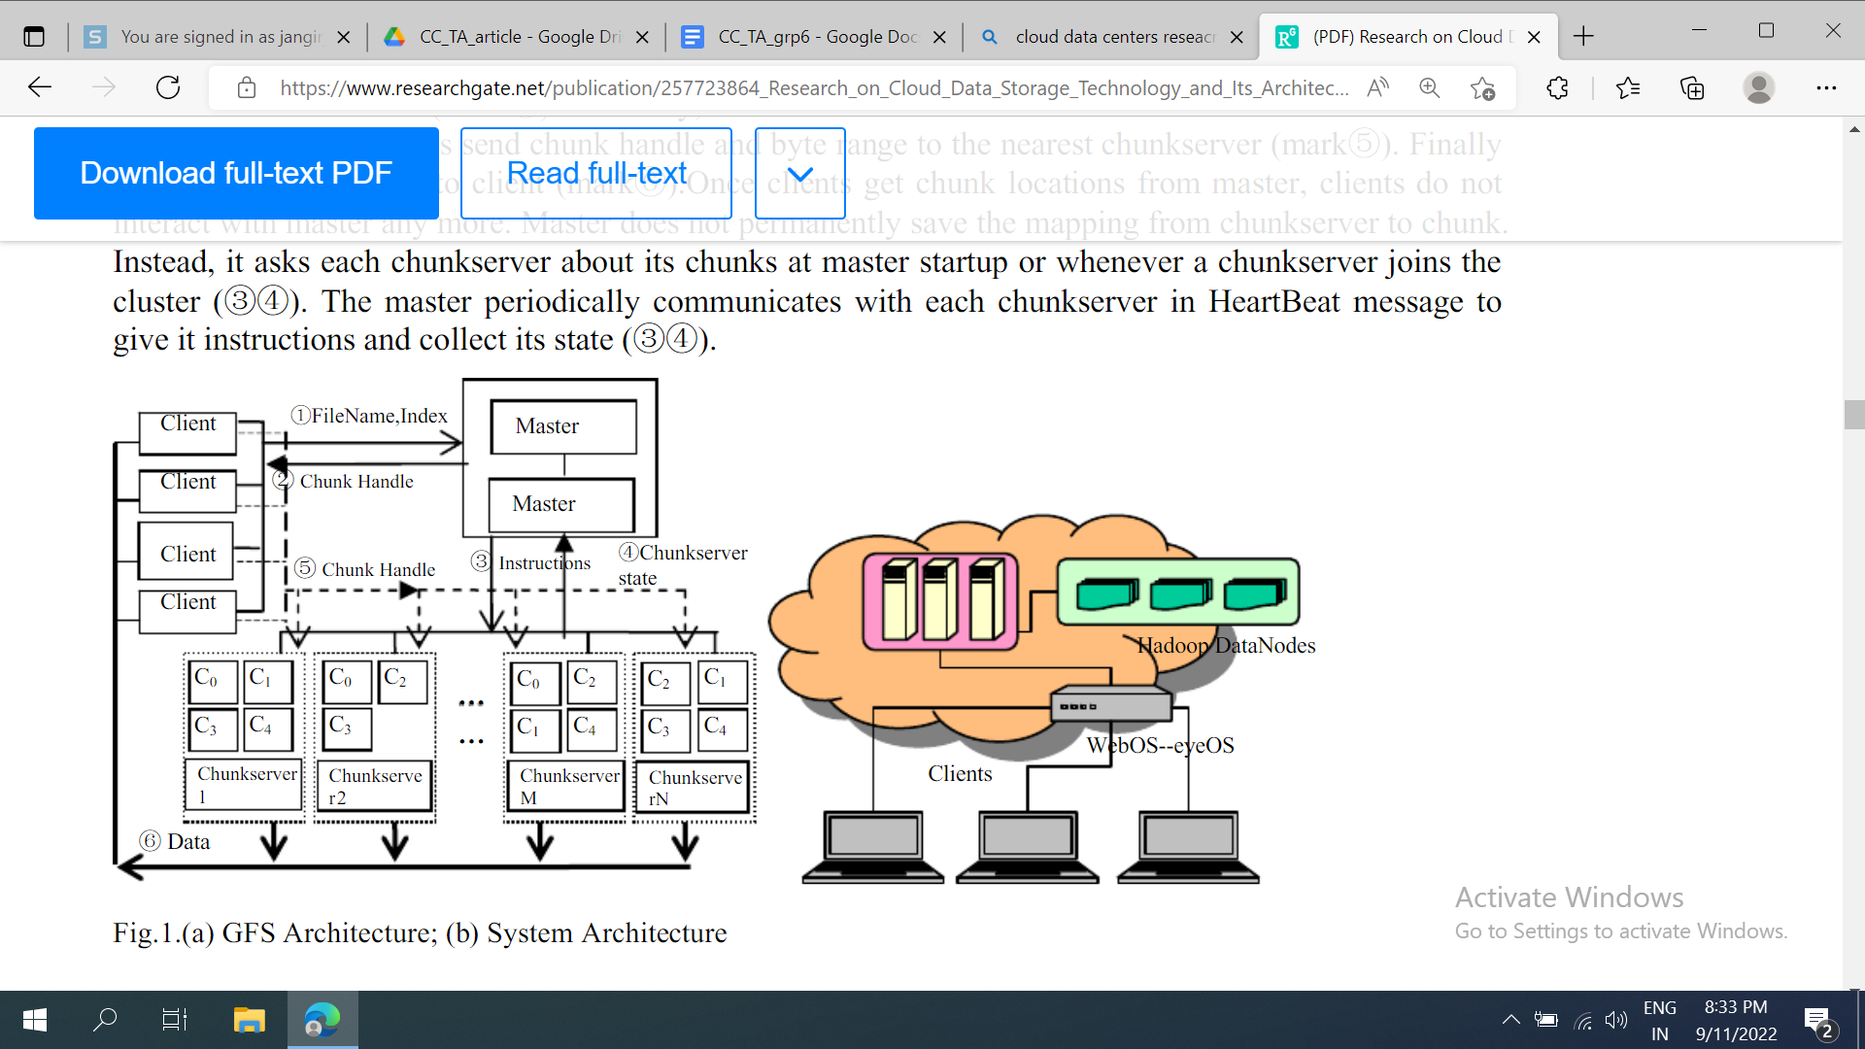

**HDFS** hadoop distributed file system

Hadoop is hosted by the Apache Software Foundation, which provides support for a community of open source software projects. Although Hadoop is best known for MapReduce and its distributed file system (HDFS), the other subprojects provide complementary services, or build on the core to add higher- level abstractions. The detailed contents refer to the document.

The full name of HDFS is Hadoop Distributed File System. HDFS is run on large clusters of commodity hardware and is like GFS of Google. The architecture of HDFS is master/slave and a HDFS cluster has one namenode and multiple datanodes. Namenode is the central server, equivalent to master in GFS. It is responsible for the namespace operation of file systems. Datanode is similar to the chunkserver of GFS which is responsible for managing storage on datanodes, creating blocks, deleting blocks, copying blocks etc. The files in HDFS are divided into one or multiple blocks which are stored in datanodes. Namenode and datanodes can be run on the low-cost Linux computer. HDFS is developed in the Java language.

Difference between Cloud data Centers and normal Data Centers

| features | Traditional data centers | Cloud data centers |
| --- | --- | --- |
| Server | Co-located dependent failure | Integrated Fault-Tolerant |
| Resources | Partitioned Performance Interrelated | Unified performance Isolated |
| Management | Separated manual | Centralized full control with automation |
| Scheduling | Plan ahead overprovisioning | Flexible Scalable |
| Renting | Per Physical machine | Per logical usage |
| Application/  Services | Fixes on designated servers | Runs and move across all VMs |

How does cloud integration of data centers work?

Datacenter management is required to administer many different topics related to the data center, including:

* **Facilities Management**. Management of a physical data center facility may include duties related to the facility's real estate, utilities, access control, and personnel.
* **Datacenter inventory or asset management**. Datacenter features include hardware assets and software licensing, and release management.
* **Datacenter Infrastructure Management**. DCIM lies at the intersection of IT and facility management and is typically accomplished by monitoring data center performance to optimize energy, equipment, and floor use.
* **Technical support**. The data center provides technical services to the organization, and as such, it should also provide technical support to the end-users of the enterprise.
* Datacenter management includes the day-to-day processes and services provided by the data center.

What is Data Center Virtualization and How Does it Work?

Data center virtualization is the transfer of physical data centers into digital data centers using a cloud software platform, so that companies can remotely access information and applications.

In a virtualized data center, a virtual server, also called a software-defined data center (SDDC) is created from traditional, physical servers. This process abstracts physical hardware by imitating its processors, operating system, and other resources with help from a hypervisor. A hypervisor (or virtual machine monitor, VMM, virtualizer) is a software that creates and manages a virtual machine. It treats resources such as CPU, memory, and storage as a pool that can be easily reallocated between existing virtual machines or to new ones.

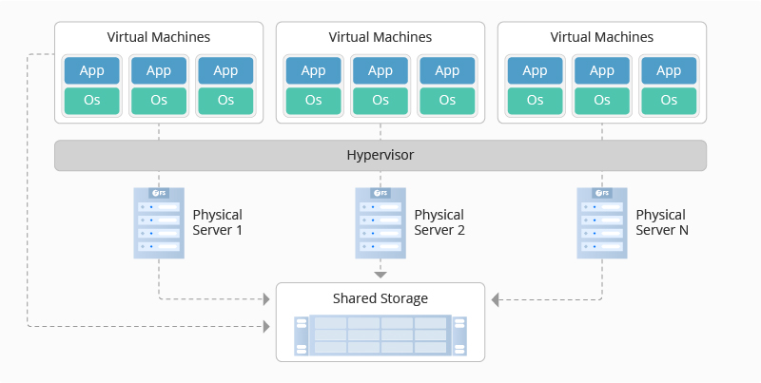

Benefits of Data Center Virtualization

Data center virtualization offers a range of strategic and technological benefits to businesses looking for increased profitability or greater scalability.

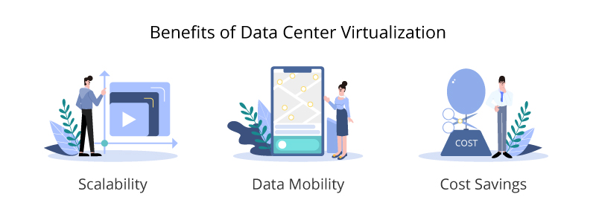

1. **Scalability** : Compared to physical servers, which require extensive and sometimes expensive sourcing and time management, virtual data centers are relatively simpler, quicker, and more economical to set up. Any company that experiences high levels of growth might want to consider implementing a virtualized data center. It’s also a good fit for companies experiencing seasonal increases in business activity. During peak times, virtualized memory, processing power, and storage can be added at a lesser cost and in a faster timeframe than purchasing and installing components on a physical machine. Likewise, when demand slows, virtual resources can be scaled down to remove unnecessary expenses. All of these are not possible with metal servers.
2. **Data Mobility** : Before virtualization, everything from common tasks and daily interactions to in-depth analytics and data storage happened at the server level, meaning they could only be accessed from one location. With a strong enough Internet connection, virtualized resources can be accessed when and where they are needed. For example, employees can access data, applications, and services from remote locations, greatly improving productivity outside the office.

Moreover, with the help of cloud-based applications such as video conferencing,

word processing, and other content creation tools, virtualized servers make

versatile collaboration possible and create more sharing opportunities.\

1. **Cost Savings** : Typically outsourced to third-party providers, physical servers are always associated with high management and maintenance. But they will not be a problem in a virtual data center. Unlike their physical counterparts, virtual servers are often offered as pay-as-you-go subscriptions, meaning companies only pay for what they use. By contrast, whether physical servers are used or not, companies still have to shoulder the costs for their management and maintenance. As a plus, the additional functionality that virtualized data centers offer can reduce other business expenses like travel costs.

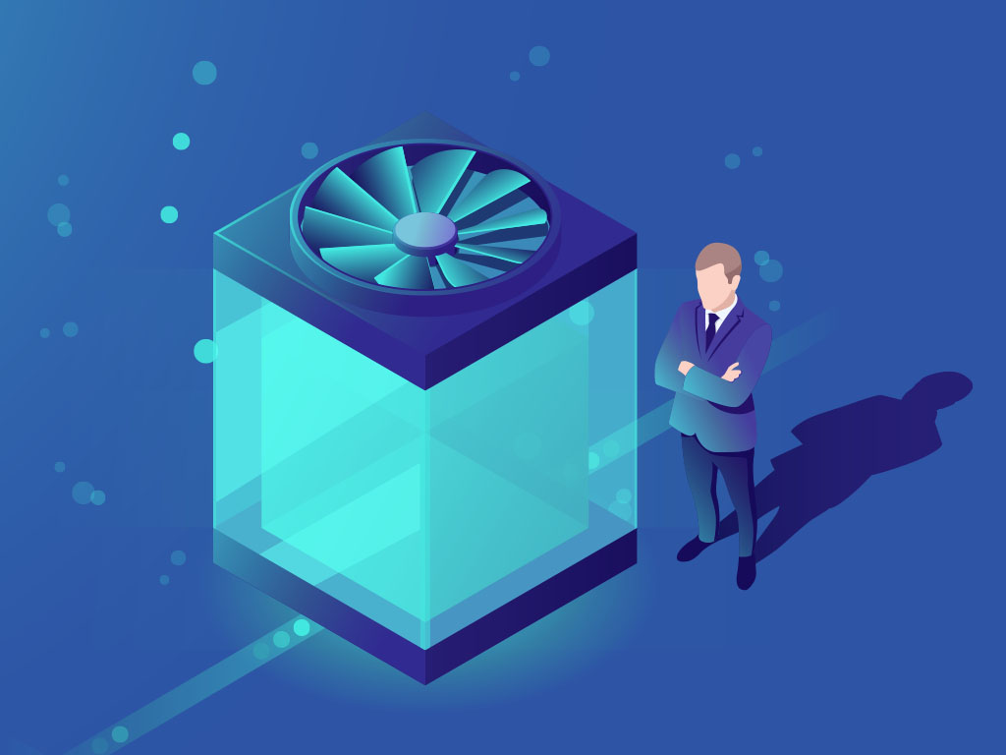

1. **Reduce Cooling System** : The large amount of hardware

that works on data center facilities makes the room heat

fast. Because the more hardware you need, the more

cooling you need to keep the temperature stable.

Virtualization can be used in the data center to reduce

the amount of hardware usage. This will also impact on

reducing air conditioning requirements.

Because of virtualization, besides saving space, reducing

the number of data center coolers, virtualization will also

reduce your operational expenses in terms of electricity costs. So the accumulation of costs can be reduced.

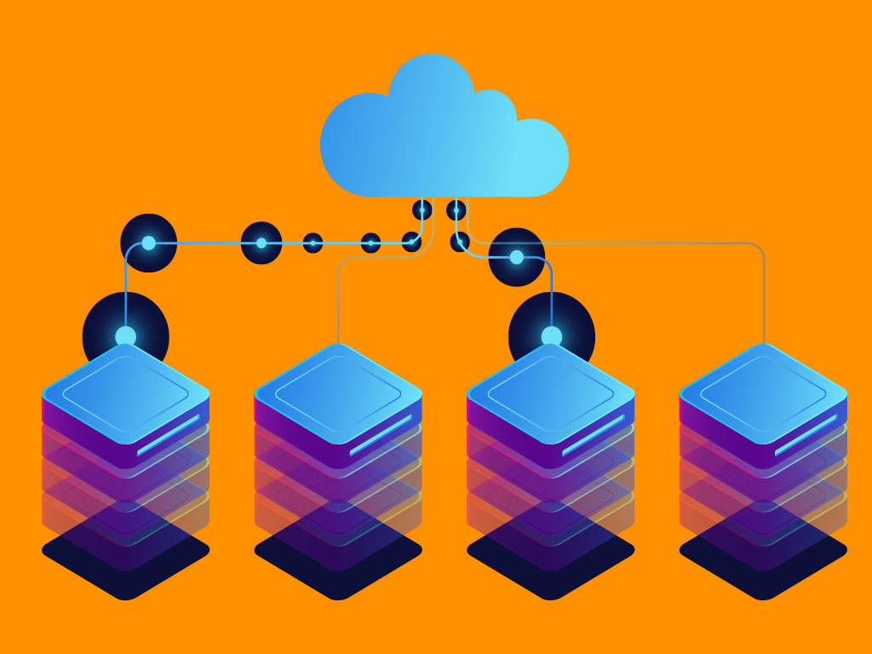

1. **Faster Replacement :** When you use a physical server then the server turns off, the transfer time depends on a number of factors, the availability of a backup server, the image of the server, the data on your current backup server. With virtualization, job switching can occur in a a few minutes. With just a few steps, virtual machine snapshots can be activated. And with a virtual backup tool, image switching will be so fast that your end user won’t feel.
2. **Scalability is Better :** Virtualization in the environment is designed to be scaled. Thus, companies can be more flexible in the growth of their business needs. No need to buy additional infrastructure components, applications and new improvements can be easily implemented with virtualization.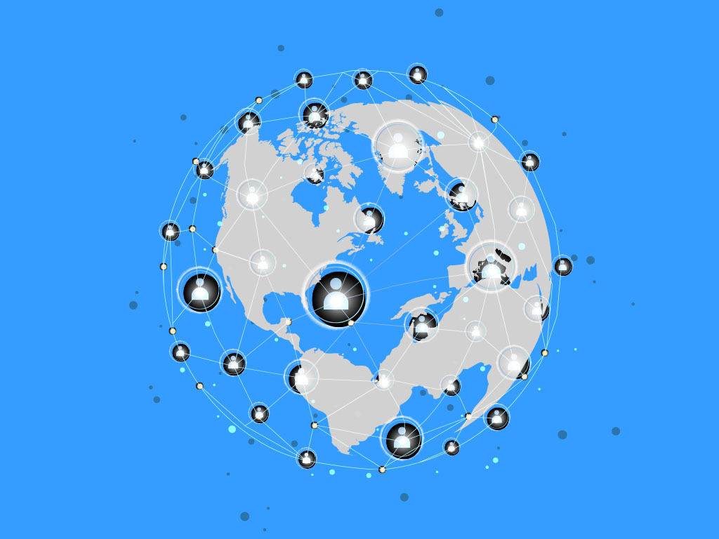

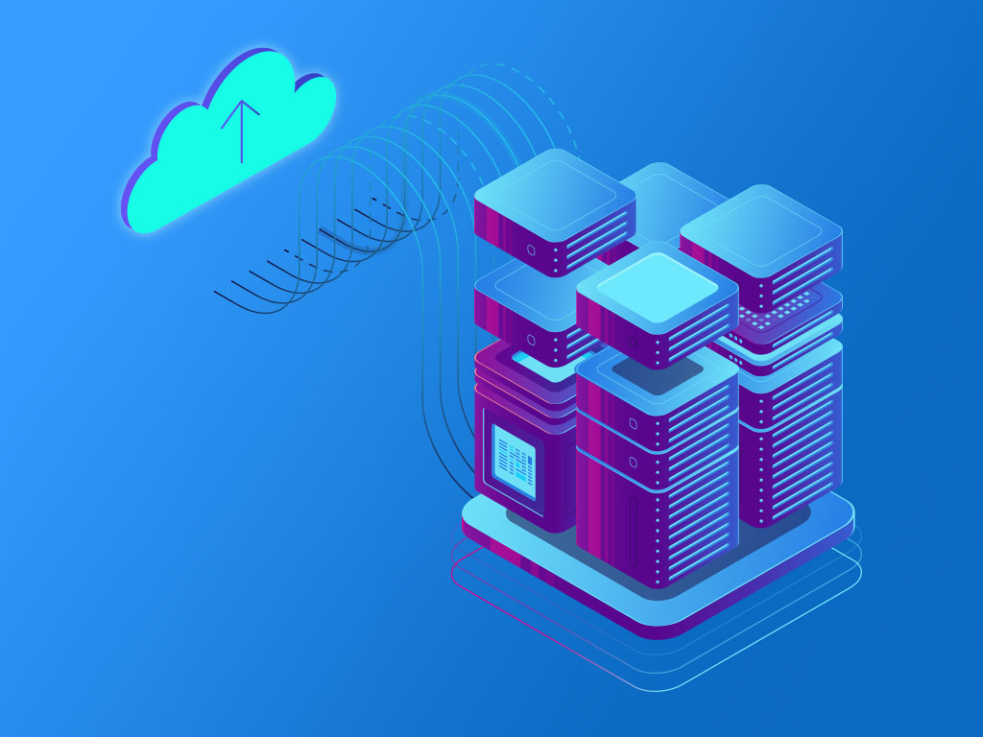

1. **Unbound to One Vendor :** One of the nice things about virtualization is the abstraction between software and hardware. This means you don’t have to be bound to one particular vendor. Meanwhile, virtual machines don’t really care what hardware they run. Therefore, you will not be tied to one vendor, server type, or even platform.
2. **Easier Migration to the Cloud :** 12By moving to a virtual machine, 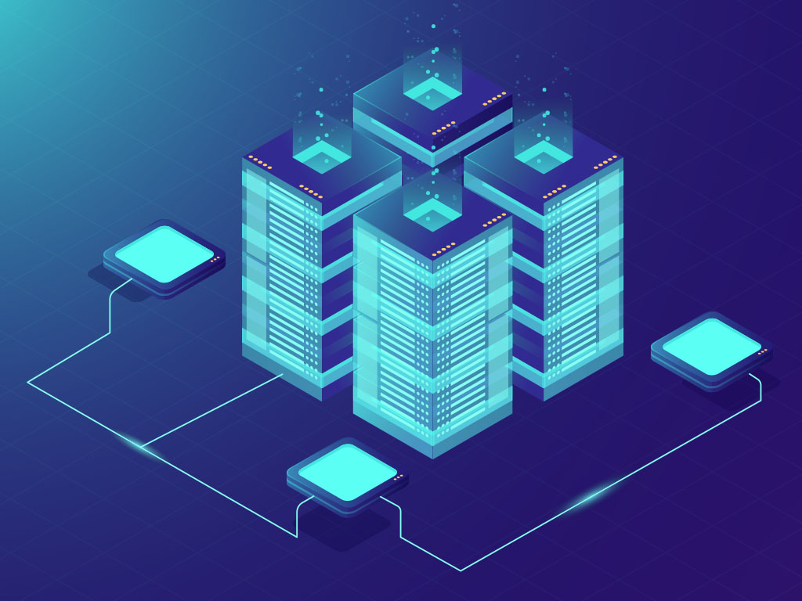you are closer to a cloud environment. You can even reach a point where you can use a VM to and from your data center to create a strong cloud-based infrastructure. But outside the actual virtual machine, virtual technology makes you closer to the cloud-based mindset. This will help you migrate more easily.
3. **Better Disaster Recovery :** Disaster recovery is a little easier when your data center is virtualized. With the latest snapshots of your virtual machine, you can quickly get back up and running. And if a disaster strikes the data center itself, you can always move the virtual machine elsewhere (as long as you can re-create the network addressing scheme and the like). Having this level of flexibility means that your disaster recovery plan will be easier to enforce and will have a much higher success rate.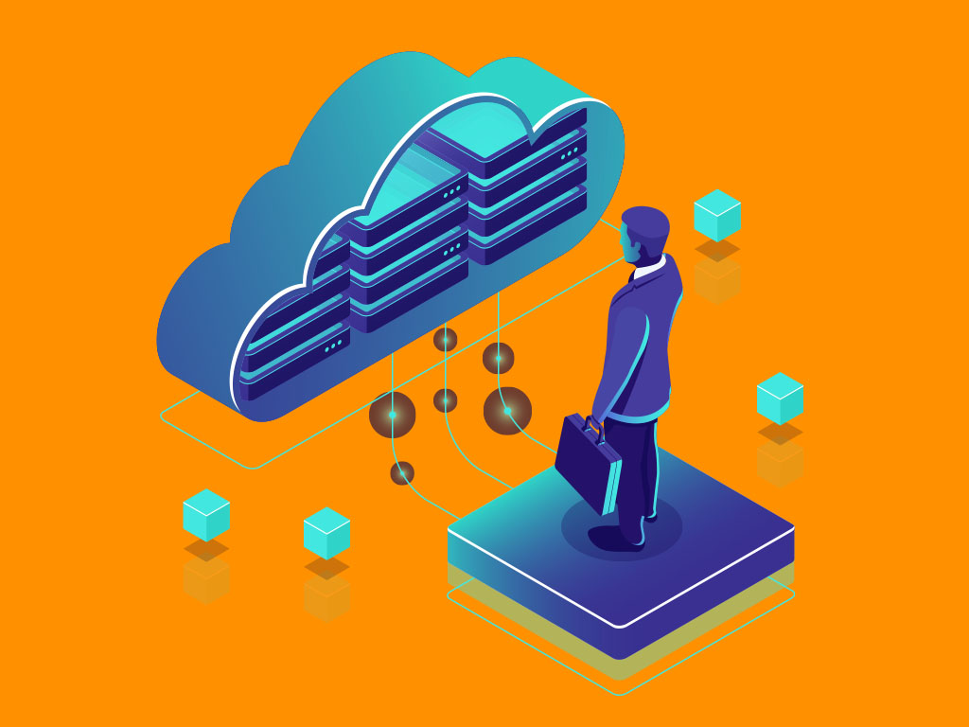
4. **Single-Minded Servers :** The all-in-one service will make the point of failure one point there. You have services that compete with all resources with each other. All things can be bought to save money. With virtualization, you can easily have a cost-effective route to separate your e-mail server, your web server, your database server, etc. By doing this, you will enjoy a much more powerful and reliable data center.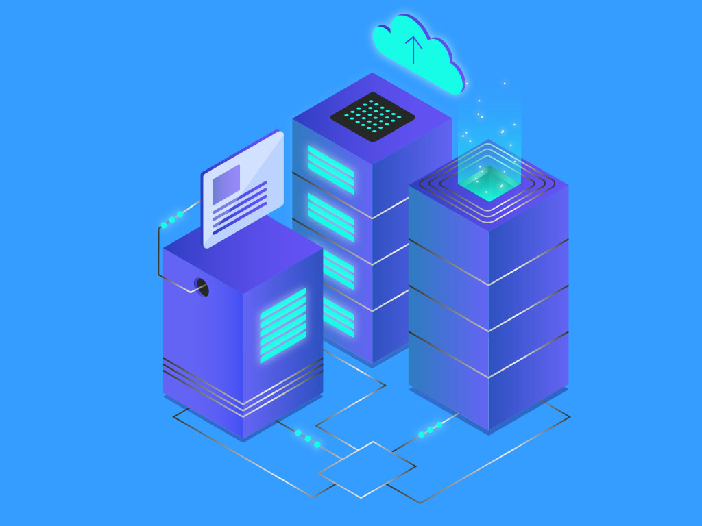

# What is Data Center as a Service (DCaaS)?

Data center as a service is the provisioning of physical data center facilities and infrastructure to a client. Though it sounds very much like cloud computing’s infrastructure as a service (IaaS) and software as a service (SaaS), it is more like renting out a house or an office.

DCaaS infrastructure and facilities are uniquely tailored according to a client’s needs. For example a client can opt to use their own hardware and the DCaaS provider can simply provide the space required. The space can be constructed, even with sensors and controls enabling the client to supervise changes in the computing environment. A major benefit of DCaaS providers is that they can offer expansion for data centers that can no longer do so for various reasons such as lack of physical space, power, cooling or capital. This remotely rented data center is usually controlled remotely via WAN, making WAN downtime or disruption one of the biggest concerns with DCaaS providers, as it interrupts access to services and availability of applications.

## Why do we need a Data Center as a service?

1. DCaaS solves all the problems such as Lack of power, cooling, rack space, capital, bandwidth, and experienced IT staff.
2. DCaaS saves costs compared to building a private data center.
3. DCaaS provides flexibility and a cost-effective solution.
4. DCaaS provides an effective solution for companies using hybrid (Public cloud and Private cloud) and multi-cloud solutions.
5. With DCaaS it is easier to scale up and down resources than an on-site [**Data Center**](https://teceze.com/data-centre).
6. DCaaS offers a Pay as you go service that helps in saving the cost. Moving to the OpEx model from CapEx saves the money for more strategic initiatives.
7. DCaaS can be customized or tailored as per the customer’s requirement.
8. DCaaS also provides backup and redundancies to keep the data up and running
9. A DCaaS provider makes sure of the uptime as per the SLA and also provides security to its clients.
10. DCaaS allows you to get started right away rather than waiting for capital expenditure and then setting that up.
11. DCaaS incorporates compliance assurances into operations and policies.

## Key benefits of DCaaS

Whether a company is facing physical limitations, such as space in a server room, or limitations relating to the time and costs involved in infrastructure upgrades, DCaaS solves the problem. For this reason, many organizations are choosing DCaaS to prepare for the future, particularly if they’ve got big plans to expand into new markets, or they’re starting to introduce more interconnected digital services for their customers.

Efficiency is key for any company looking to compete. As the capabilities of competitors grow, it’s becoming ever more important that brands are able to go one step further, continuously improving their own offering. Opting for DCaaS is a good way of doing this, as it rapidly boosts efficiency in ways that customers will definitely notice.

Cost is another key consideration for the vast majority of companies, and DCaaS offers benefits here too. Compared to the costs involved in setting up and maintaining private IT infrastructure, DCaaS is far more affordable. And with DCaaS, this affordability doesn’t mean compromises in terms of the quality of the services companies have access to.

Unexpected downtime can be a major source of disappointment for both brand owners and their customers. When brands rely on cloud-based services, these periods of downtime can quickly become a problem. But DCaaS services seek to eliminate frustrations like these, by offering continuous uptime that companies can always rely on. The flexibility of these services mean that providers are able to get companies back up and running at a moment’s notice, so customers are never left in the lurch.

DCaaS Advantages & Disadvantages

The three primary advantages of DCaaS include:

* Scalability Pay-as-you-go (SaaS) model allows flexibility to scale up/down based on business needs, only paying for what is used.
* Expandability Data centers experiencing limitations can leverage additional resources.
* ProductivityIn-house IT staff can spend more time focusing on other mission-critical needs.

A few of the biggest concerns with DCaaS providers surround availability and business continuity.

* [WAN](https://www.techguidance.com/tech-guidance-glossary#WAN) disruptions or provider downtime can leave applications inaccessible.
* Although SLAs should address downtime/availability issues, a business should carefully consider the potential ramifications of unexpected downtime.
* Remember that DCaaS providers are still just a business themselves; staffing issues, mergers, and even going out of business are all challenges that could potentially require mitigation in the future.

## What’s the difference between DCaaS and other services?

Data Center as a Service works differently to other popular data center services. This option enables companies to access the full capabilities of their chosen data center, without having to physically visit the center.

Choosing DCaaS is a great way of future proofing, as the services that the chosen data center provides can expand in line with a company’s growth. DCaaS enables companies to avoid both the physical and budgetary limitations of expanding private infrastructure, meaning they can grow quickly as and when they need to.

For companies looking to outsource their IT requirements, DCaaS is a great option. Packages include everything that a company might need, and can be quite flexible depending on the size and budget of the organization in question. DCaaS solutions will usually include a wide range of resources, from data storage and servers to networking.

When a company chooses DCaaS, it benefits from a fast and easy setup process, which is ordinarily handled by the provider in question. There’s therefore very little work involved for the company’s own time-pressed teams, so it’s a good option for companies that are having to expand quickly to meet customers’ demands.

# Data Center as a Service (DCaaS) vs. Infrastructure as a Service (IaaS)

**Data Center as a Service (DCaaS)** also known as Rack Colocation services allow the client to essentially outsource the building, power, cooling, rack space and provision of internet connectivity for its I.T services to the rack colocation provider. The business accesses its computing resources remotely via a wide area network (WAN) link. Systems are maintained and managed remotely or by visiting the colocation site to undertake ongoing backups, moves , adds and changes etc.

The principal advantage of DCaaS is an increased level of ownership as the client deploys and owns the I.T hardware and software assets. Typically, the rack colocation provider is able to support flexible rack space providing full, half, quarter and individual “U” space to suit server count as well as power allocation to meet the client’s individual I.T demands.

Rack colocation space will generally have full infrastructure management and environmental monitoring systems in place. Often colocation providers will offer a range of options to allow clients to implement their own sensors and remote control features that allow the client to monitor and react to changes in the computing environment.

DCaaS / Rack Colocation is suited to those clients who wish to retain control of their I.T assets. Colocation services are also ideal for Systems Integrators who in turn offer managed IaaS services which may include cloud computing, disaster recovery, storage services etc.

**Infrastructure as a Service (IaaS)** is the provision of all of the servers, storage and other networking hardware. Clients simply lease a portion of the provider’s computing resources to run applications or workloads. In addition, an IaaS provider may offer a comprehensive menu of value-added services for the client, including services such as reporting, monitoring and so on. While a DCaaS client is primarily concerned with the provider’s data center infrastructure, an IaaS client is primarily focused on the computing resources that the IaaS provider is delivering.

When an IaaS provider deploys and maintains all of the computing resources, clients have no need to buy, deploy or maintain the data center or computing infrastructure, and resources can easily be adjusted by simply selecting from a menu of available options. The IaaS model can provide improved agility and flexibility for clients.

The IaaS approach works well when it is more important for a company to focus on running workloads rather than installing hardware, but there is a distinct loss of control over the computing environment that may not be suitable for many businesses.

Why is DCaaS the future of Colocation?

1. **Cost effective working**: Running on-premise IT infrastructure is not child’s play, even if the company plans to operate its infra without investing in additional space (squeezing its resources in an existing space) it is quite costly and time consuming to say the least. Also, in-house in-house servers are really not known for their efficiency along with the heavy carbon footprint that they produce. Removing the heavy maintenance of the on-premise IT infrastructures, DCaaS allows for businesses to redirect their funds towards more productive customer engagement activities. Also, businesses only need to pay for the amount of resources they use if a data center offers a pay-as-you-go model. This way businesses can be assured that they don’t have to take the burden of unused resources, while compromising on business profits.
2. **Availability**: ‘Downtime’ is one of the most dreaded scenarios for online businesses, because downtime equals financial loss, customer loss and reputation at stake. This is where the uptime guarantee of colocation data centers comes into play. The uptime of data centers is unmatched, on-premise IT infra simply cannot compete with the uptime guarantee that the data center delivers. The setup in data centers is such that the server hosted will never be out of reach of the audience even if there are catastrophes. With DCaaS hybrid and multi-cloud facilities in colocation data centers there is a combination of backups and redundancies that offer consistent uptime for customers and they never have to be out of business.
3. **Scalability**: In the case of on-premise IT infrastructure it is not possible to upgrade frequently. The limited space that is available in on-premise infrastructures causes hindrance growth. If businesses don’t have the capacity to expand, they cannot do it, it is as simple as that. One cannot adjust complex resources in claustrophobic places. Colocation data centers on the other hand have the space and also the finances required to upgrade servers whenever needed. When partnering with a colocation data center it is easy for businesses to just increase their monthly billing plans and get new improved servers on demand. This is rather simple than investing in heavy resources and later having them outdated to the ever changing IT industry.
4. **Security**: Security of data is a prime concern with small or even large scale companies. Data centers are equipped with top-notch equipment that provides top-notch security. When collocating with data centers a company get all the benefits that the infrastructure offers. Data centers are incorporated with compliance assurances and follow all regulations of security. When hosting with colocation data centers organizations also get access to these benefits. Companies don’t have to worry about fulfilling any kind of compliance requirements.

## **Always-On Service** : Data availability is one of the critical factors for enterprises that rely on the network to deliver services to their customers. Unexpected downtime may result in serious damage in terms of reputation and performance. This is where the unmatched uptime guarantee of DCaaS providers comes into play. With DCaaS multi-cloud and hybrid facilities in colocation data centers, the consolidation of redundancies and backups offers consistent uptime, so the clients never have to be out of reach of the audience.

Future/ Scope of DCaaS

DCaaS is a solution for data centers that are no longer able to expand their internal resources through lack of space, power or capital. Data center skills requirements are also changing, particularly for environments where legacy and cloud applications and services co-exist.

DCaaS can provide those additional, scalable resources on an OPEX basis with no upfront costs required. Clients will have access to the latest data center technologies and infrastructure, with no recurring upgrade costs. And, the service provider manages and maintains the resources, eliminating the skills problem and reducing day-to-day operational requirements on-premise.

## 