Before installing :-

In ReadMails.cs file in solution,

Line 22:- Need to change the Excahnge server version :- if 2010 use ExchangeVersion.Exchange2010

Line 24 :- Need to put the username and password in given specified format

Line 26:- change <https://mail.uhc.com/> in place of https://mail.uhc.com to your company mailserver name

Line 29:- Change your email addree

Line 63 :- Change tha path to fetch the mail attachmets

In service1.cs file

Line 50 change path for log file (C:\Logs)

Installation : --

Run cmd prompt Run as admin

Run these commands in sequence

cd "C:\Windows\Microsoft.NET\Framework\v4.0.30319"

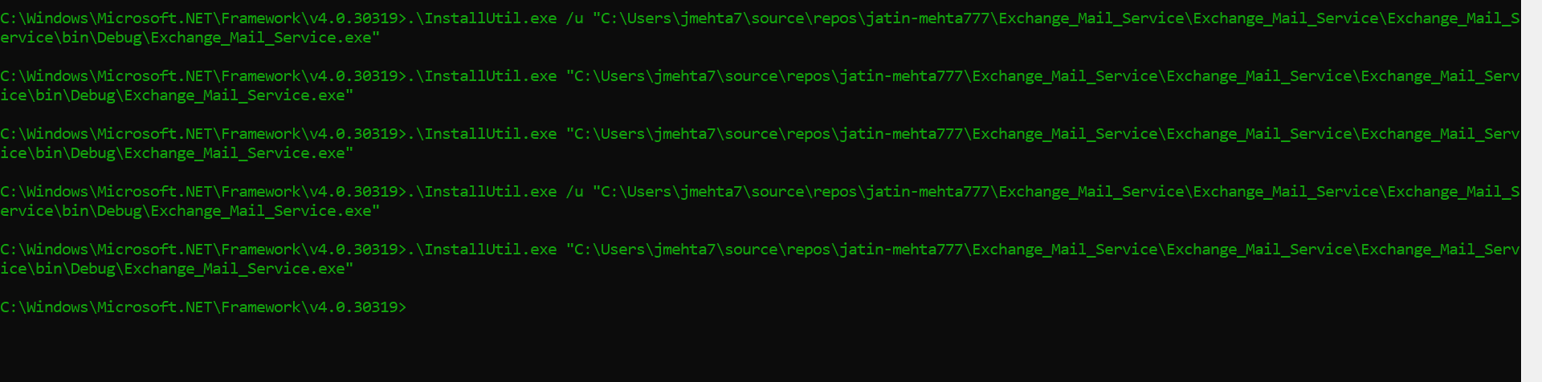

.\InstallUtil.exe " Your service Path\Exchange_Mail_Service.exe"

For unsinatll use /u in between and for delete use /d in between use screenshort for refererence