Name :vjatin sharma

UID: 19bcs3768

Branch: CSE BIG DATA GRP 1

AIM: **Design a system for cars such that, whenever someone walks along its front side, Red LED starts blinking once every 10 ms and if someone walks along its back, Green LED starts blinking once every 20 ms.**

**CIRCUIT DIAGRAM:**

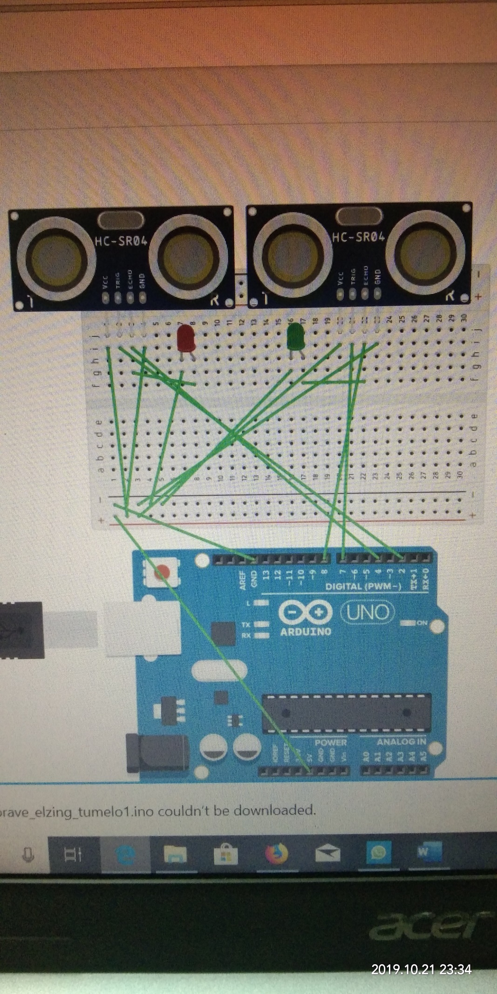

***Code:***

#define trigPin 2

#define echoPin 4

#define btrigPin 7

#define bechoPin 8

#define LED 13

#define LED2 12

void setup() {

Serial.begin (9600);

pinMode(trigPin, OUTPUT);

pinMode(echoPin, INPUT);

pinMode(btrigPin, OUTPUT);

pinMode(bechoPin, INPUT);

pinMode(LED, OUTPUT);

pinMode(LED2, OUTPUT);

}

void loop() {

int duration, distance;

digitalWrite(trigPin, HIGH);

delayMicroseconds(1000);

digitalWrite(trigPin, LOW);

duration = pulseIn(echoPin, HIGH);

distance = (duration/2) / 29.1;

int bduration, bdistance;

digitalWrite(btrigPin, HIGH);

delayMicroseconds(1000);

digitalWrite(btrigPin, LOW);

bduration = pulseIn(bechoPin, HIGH);

bdistance = (bduration/2) / 29.1;

if (distance >= 3 && distance <= 50)

{

Serial.print(distance);

Serial.println(" cm");

digitalWrite(LED, HIGH);

}

if (bdistance >= 3 && bdistance <= 50)

{

digitalWrite(LED2, HIGH);

}

else {

Serial.println("Out of range");

digitalWrite(LED, LOW);

digitalWrite(LED2, LOW);

}

delay(500);

}