**Contents**

Introduction……………………………………………………………………….

Team Members………………………………………………………………….

Roles………………………………………………………………………………….

Work Scheduled table……………………………………………………

Main Work Screenshots…………………………………………………….

Conclusion………………………………………………………………………….

## 

## **INTRODUCTION**

We are creating employee app. In this app Admin can store the employee record. Admin can save, Edit, and delete the record of his employee. He can also view the list of his employees. This application is developed in xamarine with agile and scrum methodology.

# **TEAM MEMBERS**

**jatin kumar**

**inderjeet singh**

**amritpal singh**

**robanpreet singh**

## **ROLES**

**Jatin Kumar**: Client who gives the requirements

**Inderjeet Singh** :uses the agile and scrum methodology

**Amritpal and Roan** : Developers

## **Work Scheduled tables**

|  |  |  |  |
| --- | --- | --- | --- |
| **Week 1** | **Week 2** | **Week 3** | **Week 4** |
| Planning and research |  |  |  |
| Meetings |  |  |  |
|  | Design |  |  |
|  |  | Development and coding |  |
|  |  | Testing |  |
|  |  |  | Documentation |
|  |  |  | Reports |

## **Main Work** **Screenshots**

Splash Screen:

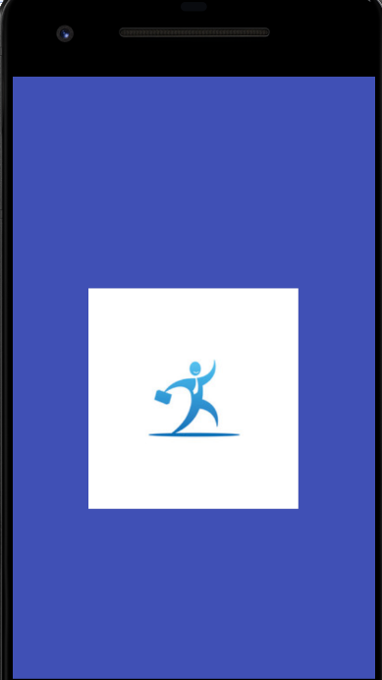

This is splash screen when application starts then it will show. And hide after few seconds. This increases the beauty of application.

Home Screen:

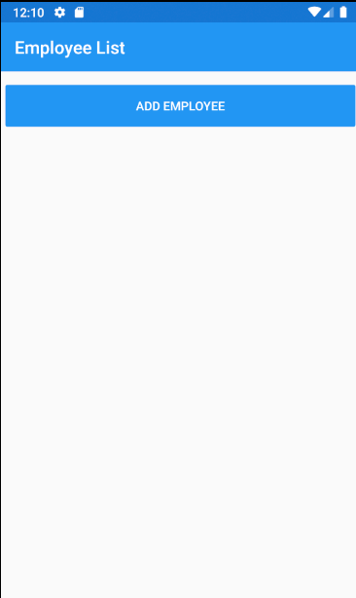

When splash screen hides. Then this home screen will show. Where Add employee button will show. So this project is based on employee record maintence. Next we will add the employee records.

Add Employee Screen:

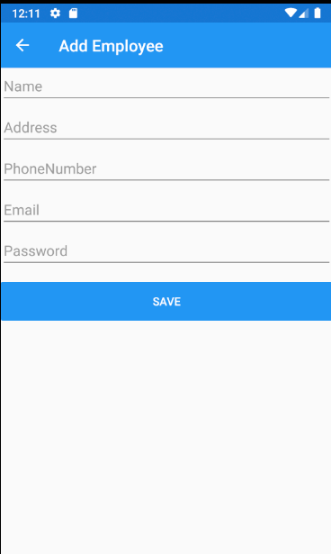

In this screen we can add the details of employee.

Add Employee with data Screen:

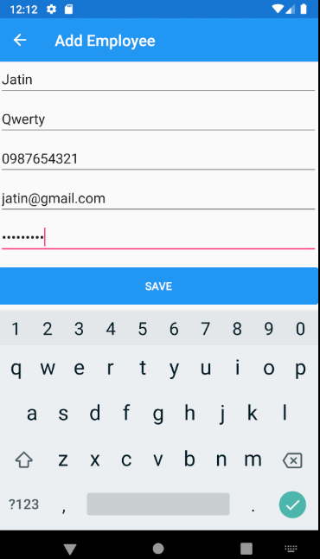

In this screen we have filled the all detail of employee. Then we will click on save button it will save the record in database.

Update Employee:

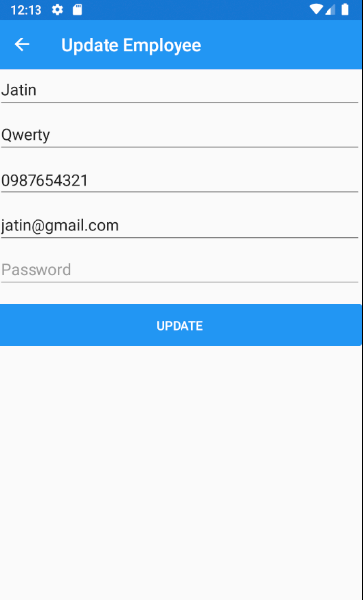

Here we can also update the record. If we enter wrong entry then we can correct it.

View list of Employees:

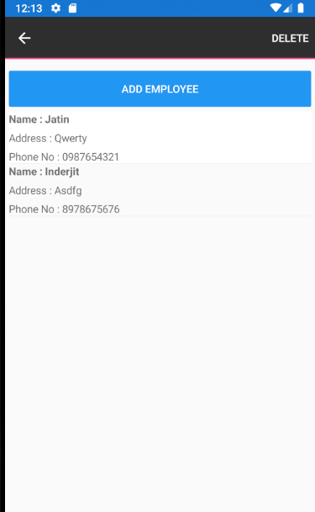

In this screen we can view the records of employees and also delete the records.

**Conclusion**

Agile and Scrum methodologies are used by project managers to track their work. It reacts quickly to change and is more flexible than others.

In summary, this application is for employees to add their records. Here user can add the record of is employees and update delete and view also.