**IT206**



**Dhirubhai Ambani**

**Institute of Information and Communication Technology**

**A project Documentation**

**On**

“**Vaccination Management Portal**”

**For the Course**

**Data Structure and Algorithm (IT206)**

**SUBMITTED BY**

**Patel Harsh Umakant (202001173)**

**Ranpariya Jatin Bharatbhai (202001226)**

**SUBMITTED TO**

**Dr. Archana Nigam**

# Problem Statement

The trending COVID-19 vaccination drive appealed and motivated us to think of designing an optimized and effective vaccination system.

Our main aim to choose this topic as the problem statement was ***to get an experience of working on a real-life problem*** and trying to provide a solution for this.

# Solution of the problem

Our Main focus was to build a neutral and impartial vaccine distribution system for organized distribution of booster injections.

For Doing that we have provided features like choices of booster injections and vaccination centre near to the locality of the user of Surat and Ahmedabad.

(We don’t say our solution is new, we already have good working of **COWIN** **portal**, we don’t want the viewer to think as if you don’t have new solution to it then why do you choose such problem, it’s totally for experience and to make something of what we have learned)

# How we Approach?

1. We started by discussing the basic requirements for a distribution portal and took a deep analysis of the official cowin.com website.
2. After doing an adequate web search about the problem we gathered productive information and started working on creating raw structure with classes and inheritance.
3. We developed a basic version of our proposed solution within few days and demonstrated it to few of our family members which had many limitations as mentioned in the next section.
4. By taking their valuable feedback into consideration, we spotted a scope of improvement by solving the limitations and adding new features like admin portal, 10 centers for vaccination from 2 cities and a display certificate feature.
5. We again did the self-evaluation of the code and after getting satisfactory results, we worked on formatting of the code and added few display features like changing colour for certificate and other sections of the portal.
6. Lastly, we added few data validation like valid Aadhaar Number, Age calculator to verify whether the user is above 18 years or not. We tried to replicate the COWIN vaccination portal to the level best we can with meets and feedbacks in this current pandemic situation.

# Things we learned…

1. Data management system for user
2. Object oriented programming concept
3. Standard template library (STL)
4. File handling to write and read certificate
5. Clock and Time module
6. Data Structure
7. Code reusability using functions.
8. Algorithms like age calculator, date after 84 days calculator, copy to clipboard, random password generator.

# Limitations

***Version – 1,***

We didn’t have Admin Portal, Centre choice for the user.

We didn’t provide Authorized Information about Vaccine while giving choice to customer.

In this version, we were not able to display certificate for first and second doze. Our random generated password is so hard to remember, so we didn’t have function that can copy password in the system clipboard.

In this version, we are not verifying the Aadhar number with our database.

***Version – 2,***

In this version, we have restriction of only two cities (Surat and Ahmedabad)

Our program runs on static run time memory. (we are not storing data in any type of file)

In this version, we are able to display certificate only. (User cannot download)

# Few insights of the portal

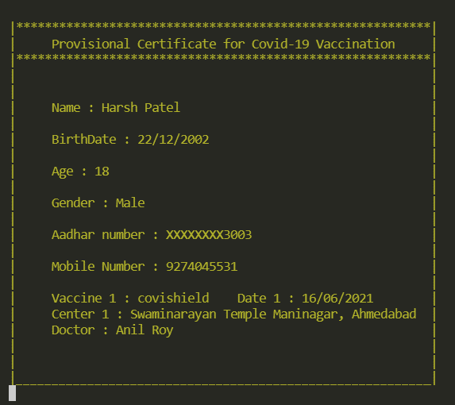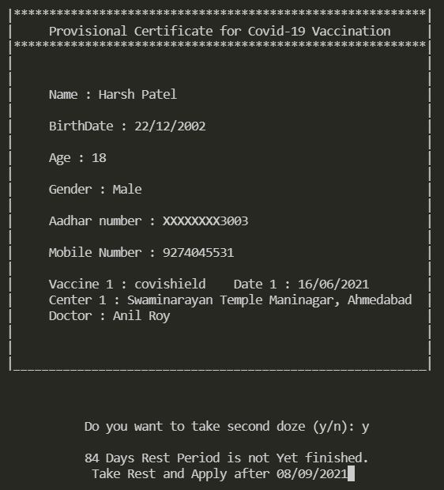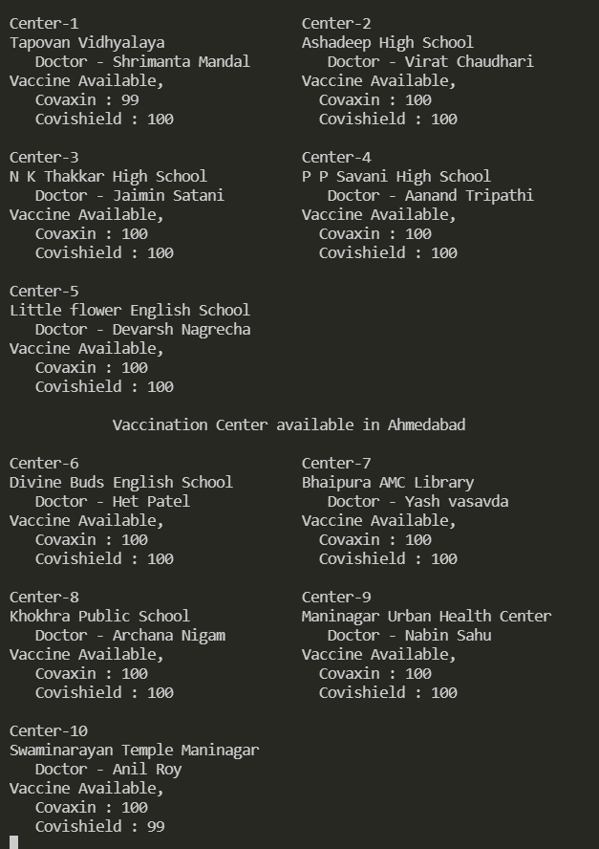

***Thank You***