Git (open source Distributed VCS)
Distributed because connectivity does not block work
Which changes were made?
Who made the change?
When were the changes made?
Why were changes needed?

git branch && git status && git add . && git status && git commit -m “commit” && git push origin main
_____________________________________________________________________________________________________

$ git init (initialize Git repo)
$ git clone (create local copy of project that already exists)
$ git checkout --track origin/branch_3 (How do I clone all remote branches?)
$ git status (show branch & file in which code changes )
$ git diff file-name.html (show changes/modification)

$ git add .
or (un-staged area -> staged area)
$ git add file-name.js

$ git restore –staged file_name.js (staged area -> un-staged area)
$ git restore file_name.js (again do it)
$ git commit -m “message” (code change -> lock )
$ git log (commit history)
$ git log -5 (last 5 commit)
Commit 6f0d8ihu9rn499r4h494h9
Author:
Date:

$ git show commit_id (code changes in this commit)
or
$ git show

$ git branch (branch related information)

$ git branch branch2
or (create new branch)
$ git checkout -b branch2

$ git checkout branch2 (jump to branch2)
$ git log (show same last commit history on branch2 also)
$ git branch -d branch2 (make sure you are not on branch2)
$ git checkout master
$ git merge branch2 (merge branch2 to master)
$ git reset –hard HEAD^ (undo last commit & now code changes not shown)
$ git reset –soft prev_commit_id (undo last commit but code changes still shown)
$ git push (local -> remote)
$ git pull (update all remote tracking branches, and the currently checked out branch)

Make some change
$ git commit –amend (without generating new commit,-m for new commit)
->ESC +W +Q +Enter

$ git remote add origin http
$ git push origin branch_name
&
$ git push origin main

______________________________________________________________________________________________________

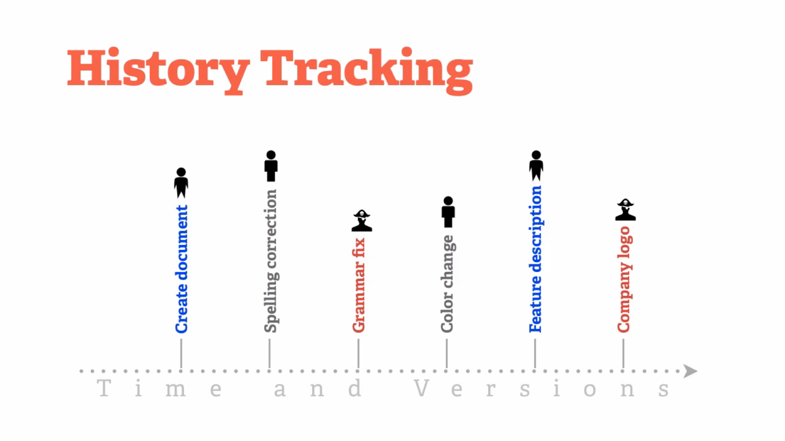

______________________________________________________________________________________________________

Password -> setting->dev setting -> personal access token -> new token(classic)

Error

$ git add .
error: ‘folder/' does not have a commit checked out
fatal: adding files failed

Delete hidden .git folder -> git add .

Focus on what matters instead of fighting with Git
_______________________________________ pending ______________________________________________

git push --set-upstream origin brach_1

