git branch && git status && git add . && git status && git diff --staged && git commit -m "commit" && git push origin main
shift + alt + p

$ tldr # too long; didn’t read
$ tldr man
_____________________________________________________________________________________________________________
$ command1 | command2 # Pass the output of command1 as input to command2
$ command1 && command2 # Run command2 ONLY if command1 succeeds
$ command1 || command2 # Run command2 ONLY if command1 fails
$ command1 ; command2 # Run command2 regardless of whether command1 succeeds or fails

$ ls -l | grep ".txt" # List files and filter only .txt files

| = pipe
_____________________________________________________________________________________________________________
$ cd # change directory
$ cd / # Go to the root directory
$ cd - # Go to the previously chosen directory
_____________________________________________________________________________________________________________
$ ls
$ ls -1 # List files one per line
$ ls -a & $ ls --all # List all files + hidden files

Options/Flag
-h = --human-readable
-r = --reverse
-R = --recursive
-ls = -l -s ************
-a = --all

-l → long listing format
-s → show block size

$ ls -a -1 & $ ls –1a # List all files + hidden files + one per line
$ ls -ls --recursive & $ ls –ls -R # *****List files in Long format, sorted by Size (descending + recursively)
$ ls -ls & $ ls –sl & $ ls –l -s
$ ls -ls –human-readable (………………………...use)
$ ls -ls -r
$ ls -l -s -a
PERMISSIONS | LINKS | OWNER | GROUP | SIZE | DATE | FILENAME
PERMISSIONS LINKS OWNER GROUP SIZE DATE FILENAME
_____________________________________________________________________________________________________________
$ pwd # Print working directory
$ sudo -i # Super user😎️
$ sudo -s & $ sudo --shell # (Super user😎️ + without changing the env )
_____________________________________________________________________________________________________________
$ rm path1/file1 path2/file2 # Remove specific files
$ rmdir # Remove specific empty directories
rm -rf */
rmdir: Only deletes empty directories.
- rm -rf: Deletes directories and their contents, including non-empty ones.

$ rm -r folder
or
$ rm --recursive folder
Flag | Meaning | Example
-r | recursive # delete directories | $ rm -r folder
-f | force (no confirmation, ignore errors) | $ rm -rf folder ❌ (Dangerous
-i | interactive (ask before deleting each file ) | $ rm -ri folder

$ rm -ri folder2 # ✅ Safe Deletion
It will ask:
rm: descend into directory 'folder2'? y
rm: remove regular file 'folder2/file1'? y
$ sudo rm -rf / # ⚠️ Danger Zone && 💀 NEVER run this
It will recursively and forcefully delete everything from the root directory — basically wiping your OS.
_____________________________________________________________________________________________________________
$ history & $ history -10
$ cat ~/.bash_history # bash_history = folder that store the list of commands you’ve typed in the terminal
$ <Space>command # Run a command without adding it to history by adding a leading space

If you want to search for a specific command:
Press Ctrl + R and start typing — it will search your history. *********

You can also
- Clear the commands history list
- Overwrite history file with history of current Bash shell
- Delete the history entry at the specified offset
- Add a command to history without running it
- Run a command without adding it to history by adding a leading space
_____________________________________________________________________________________________________________
$ lsblk # List Block
# or View all storage devices
Unicode | ASCII
= all characters from all languages + symbols + emojis  (Universal Characters  ह 你 ச আ محبت A a Z z ✓ ✔ ✘ ✨ ★ → ← ↑ │ ─ ┼ 😊 😎 ❤️ | = plain English keyboard characters only  (letters, numbers, basic symbols  A a z Z 0 1 9 ! @ # $ % ^ & *- _ + = / ? .
Whereas ASCII is limited to 127 basic English characters | Unicode has over 140,000 characters
Examples  $ lsblk  Uses Unicode characters for pretty tree:  ├─sda1  └─sda2 | $ lsblk --ascii  Uses ASCII (simple characters) : |-sda1 `-sda2
ASCII ⊂ Unicode
ASCII is used because it is 100% safe, compatible, small, fast, and works everywhere.

_____________________________________________________________________________________________________________
$ wc --lines path/ & $ wc -l path/ # Count all lines in a file
$ wc --words path/ & $ wc -w path/ # Count all words in a file
$ wc --char path/ & $ wc -c path/ # Count all characters in a file
$ ls -a | wc -l
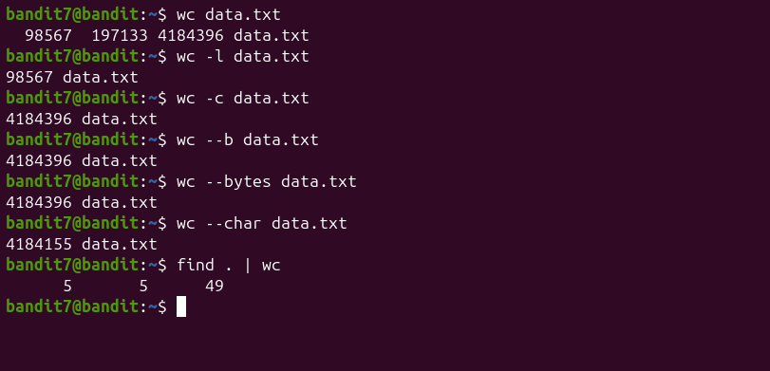

_____________________________________________________________________________________________________________
Situation Correct approach
You KNOW column position $1, $2, $3
Column position UNKNOWN /pattern/
Long Row + Unknown Column/Row + Wanted nth Word $ awk '
{
for (i=1; i<=NF; i++)
if ($i == 32)
print "Found =", $i, "Row =", NR, "Column=", i, "Next value =", $(i+1)
}' data.txt

$1 $2 $3 $4 (not relative fixed and absolute)
11 12 13 14
21 22 23 24
31 32 33 34

$0 → entire line
$1 → first column
$4 → fourth column
NR → row number/line number
NF → number of columns in that row

$ awk '/21/ {print $0}' data.txt # If it match to 21 then print entire Row

$ awk '{print $1}' data.txt
11
21
31

$ awk '{print $2}' data.txt
12
22
32

$ awk '$2=="32" {print $3}' data.txt # In Column 2 if it match to 32 then print Column 3 wrt Row
33
$ awk '$2=="32" {print $0}' data.txt # In Column 2 if it match to 32 then print entire Row
31 32 33 34

$ awk '/32/ {print $0}' data.txt
31 32 33 34

$ awk '
{
for (i=1; i<=NF; i++)
if ($i == 32)
print "Found =", $i, "Row =", NR, "Column=", i, "Next value =", $(i+1)
}' data.txt

////////////////////////////////////////////////Things awk can do that grep CANNOT

1. Apply conditions
$ awk '$3 > 100 {print $1, $3}' data.txt
❌ grep cannot compare numbers

2. Calculations
$ awk '{sum += $3} END {print sum}' data.txt
❌ grep cannot do math

3. Work with columns
$ awk '/millionth/ {print $2, $5}' data.txt
❌ grep cannot extract columns

_____________________________________________________________________________________________________________
xxd -r data.txt > data # create data file contains the binary file
vs
xxd -r data.txt data # data file is not created + just printing on screen
_____________________________________________________________________________________________________________
find → is used to search files and directories, not content inside a file
vs
grep → is used to search lines that contain a pattern
vs
awk → is used to work with columns and structured text
vs
sed → is used for line-based editing / printing

_____________________________________________________________________________________________________________
$ sed -n '1,10p' data.txt # first 10 lines
$ sed -n '830p' data.txt # -n = line number

-n → suppress automatic printing
By default, sed prints every line it processes.
With -n, it only prints lines you explicitly tell it to
_____________________________________________________________________________________________________________
wc -l data.txt
_____________________________________________________________________________________________________________
tldr sort
tldr uniq
example of -nr and sort data.txt
+ adjuscent
can we use uniq directly without sort
sort data.txt
$ sort data.txt | uniq --unique # Display only unique lines
$ sort data.txt | uniq --count # Count occurrences of each line
$ sort data.txt | uniq --count | sort --numeric-sort --reverse # Lines with highest count come first
$ sort data.txt | uniq --count | sort --numeric-sort # Lines with Lowest count come first

or

$ sort data.txt | uniq -u
$ sort data.txt | uniq -c
$ sort data.txt | uniq -c | sort -n
$ sort data.txt | uniq -c | sort -nr

-u --unique
-c --count
_____________________________________________________________________________________________________________
chmod 600 sshkey.private

Filetype Owner permissions Group permissions Others permissions

[0] [1-3] [4-6] [7-9]
- rw- r-- ---

Bit-level meaning of r, w, x
Each permission is 1 bit:

Permission Bit value
r (read) 4 → 100
w (write) 2 → 010
x (execute) 1 → 001
- (none) 0 → 000

Bit breakdown of -rw-r-----
Owner: rw-
r w -
1 1 0 → 110₂ → 6₈

Group: r--
r - -
1 0 0 → 100₂ → 4₈

Others: ---
- - -
0 0 0 → 000₂ → 0₈

✅ Numeric form
-rw-r----- → 640

case : 600

600
│││
││└─ Others
│└── Group
└─── Owner
| Digit | Binary | Permissions |
| ----- | ------ | ----------- |
| 6 | `110` | `rw-` |
| 0 | `000` | `---` |
| 0 | `000` | `---` |

chmod Symbolic Meaning
600 -rw------- Owner read/write only
400 -r-------- Owner read only
700 -rwx------ Owner full access

_____________________________________________________________________________________________________________
$ tr 'A-Za-z' 'N-ZA-Mn-za-m' < data.txt

A-Z a-z
↓ ↓
N-Z A-M n-z a-m

tr = translate characters

a b c d e f g h i j k l m n o p q r s t u v w x y z
↓ ↓ ↓ ↓ ↓ ↓ ↓ ↓ ↓ ↓ ↓ ↓ ↓ ↓ ↓ ↓ ↓ ↓ ↓ ↓ ↓ ↓ ↓ ↓ ↓ ↓
n o p q r s t u v w x y z a b c d e f g h i j k l m
_____________________________________________________________________________________________________________

nc = netcat
nc <host> <port>

You ────text────▶ Port
You ◀───text───── Port

$ nc localhost 30000
MU4VWeTyJk8ROof1qqmcBPaLh7lDCPvS
Correct!
8xCjnmgoKbGLhHFAZlGE5Tmu4M2tKJQo

[bandit14] ──TCP──▶ localhost:30000

1️⃣ What localhost means
localhost means “this same computer”
localhost → IP address 127.0.0.1 + It never leaves your machine + No internet involved

Your computer
├── CPU
├── Memory
├── Disk
└── Network stack
└── 127.0.0.1 (localhost)

When you connect to localhost, you’re talking to your own machine, just through the network system.

2️⃣ What a port is
A port is a number that identifies which program you want to talk to.

IP = which computer
Port = which program on that computer

IP address → Building address
Port number → Apartment number
“Apartment 30000 in this building”

_____________________________________________________________________________________________________________

Level Tool Concept
14 → 15 nc → plain TCP client(❌ encrypted)
15 → 16 openssl s_client → TCP + TLS client(✅ encrypted)

_____________________________________________________
| Tool | Analogy |
| __________________ | ____________________________ |
| `nc` | Talking loudly |
| `openssl s_client` | Talking inside a locked room |
| TLS | The lock |
|____________________|______________________________|

OpenSSL = cryptographic toolkit
SSL = TLS (Modern name) = security layer

You ----password----> Server (Without SSL)
You --encrypted data--> Server (With SSL)

_____________________________________________________________________________________________________________
find <start-path> <tests/filters> <actions>

$ find /folder -maxdepth 1 # look only in /folder, not its subfolders

_______________________________________________________________________________

- Print a sequence from 1 to 10:
seq 10

- Print a sequence from 10 to 20:
seq 10 20

- Print every 3rd number from 5 to 20:
seq 5 3 20

______________________________________________________________

_____________________________________________________________________________________________________________
https://www.cis.rit.edu/class/simg211/unixintro/Access_Permissions.html
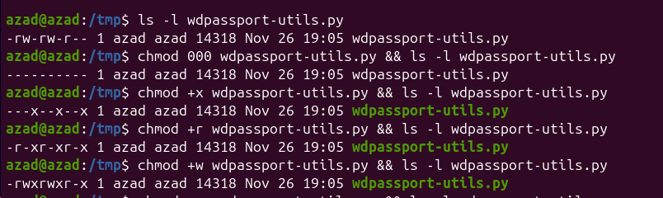

_____________________________________________________________________________________________________________

_______________________________________________ Rarely Used __________________________________________________
$ nslookup google.com # Find the IP Address of a Website
$ uptime # Tell how long the system has been running
$ whoami
_____________________________________________________________________________________________________________

$ mkdir folder_name
$ mkdir path/to/folder_name{1..10} # Create multiple folder with an increasing number
$ touch path/to/file{1..10} # Create multiple files with an increasing number
$ touch 1.txt
_____________________________________________________________________________________________________________
$ stat File_Fodler_name # Display file/folder information
$ nautilus path/path/path
$ nautilus .
$ grep -r "word_find" folder/ *******************************
$ grep -r -n "word_find" folder/

-r recursive
-n line number
-H show filename
-h hide filename

$ tldr command # eg. tldr tldr or tldr man
$ man command
$ cat
$ wget
$ cp
$ mv
$ find
$ chmod
$ nano
$ nautilus
$ n
$ n
$ mv 44.txt .44.txt

CTR +H MV 1.TXT

🧠 Why does mv also rename?
Because renaming is basically “moving” the file within the same directory but with a new name.

ls -la | awk '{if(substr($9,1,1)==".") print}'

apt vs apt-get

ifconfig is deprecated on modern Linux.
Ubuntu uses:
$ ip a

____________________________________________ GK _____________________________________________

/usr/bin
Where most installed developer tools go.
Examples:
- /usr/bin/python3
- /usr/bin/git
- /usr/bin/node

/opt
Where manually installed dev tools go.
Examples:
- /opt/android-studio/
- /opt/vscode/
- /opt/my-tools/

/usr/lib
Libraries used by programming languages and tools.
Examples:
- /usr/lib/python3.10/
- /usr/lib/jvm/ (Java)
- /usr/lib/docker/

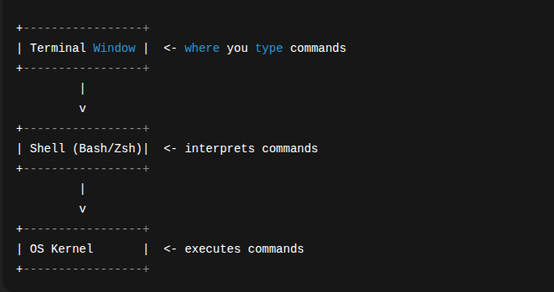
____________________________________________ Development Purpose _____________________________________________
$ nvm ls
$ nvm use 20.17.0 # Find out which versions of Node.js you may have installed and which one of those you're currently using
$ npm install –legacy-peer-deps
__________________________________________________ Swap _____________________________________________________
$ sudo swapoff -a # swap memory off
_____________________________________ 🔑 Unlocking Your WD Passport Drive _____________________________________
$ sudo apt update
$ sudo apt install -y python3-pip git
$ sudo pip3 install pyudev git+https://github.com/crypto-universe/py_sg –break-system-packages
$ lsblk # List connected drives to find your device (e.g., /dev/sdx
$ cd /tmp # Go to temporary folder → will vanish when rebooted

/tmp (Temporary Directory)
- Stores temporary files.
- Files are automatically deleted (on reboot or after some time).
- /tmp = directory named tmp at root (/tmp).
- tmp/ (without leading slash) = a tmp folder in the current directory.
$ wget https://raw.githubusercontent.com/0-duke/wdpassport-utils/master/wdpassport-utils.py -O wdpassport-utils.py # 📥 Download WD Passport unlock script
$ chmod +x wdpassport-utils.py # Make script executable
$ sudo python3 /tmp/wdpassport-utils.py -u -d /dev/sdx* #🔓Unlock your WD Passport drive (replace sdx* with actual device

Flags Used
- -u → Unlock the drive 🔓
- -d /dev/sdx* → Specify the WD Passport device path 💽
- +x → add execute permission ⚙️

lsblk && cd /tmp && wget https://raw.githubusercontent.com/0-duke/wdpassport-utils/master/wdpassport-utils.py -O wdpassport-utils.py && chmod +x wdpassport-utils.py && sudo python3 /tmp/wdpassport-utils.py -u -d /dev/sdc

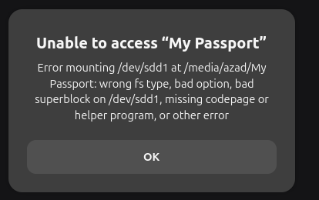

Manual mounting via terminal
Use /mnt – standard place for temporary mounts.
/mnt is a standard directory in Linux used as a temporary mount point for disks, USB drives, or partitions.
- Use your home folder – safer, persistent, no root needed:
mkdir -p ~/WDPassport
sudo mount -t ntfs-3g /dev/sdc1 ~/WDPassport
cd ~/WDPassport
ls
- You specifically tell Linux:
  - Mount device /dev/sdc1
  - Use filesystem type ntfs-3g
  - Mount at a directory you created (~/WDPassport)
- ntfs-3g handles NTFS properly and ignores automount defaults that sometimes fail.

lsblk && \
cd /tmp && \
wget -q https://raw.githubusercontent.com/0-duke/wdpassport-utils/master/wdpassport-utils.py -O wdpassport-utils.py && \
chmod +x wdpassport-utils.py && \
sudo python3 /tmp/wdpassport-utils.py -u -d /dev/sdc && \
mkdir -p ~/WDPassport && \
sudo mount -t ntfs-3g /dev/sdc1 ~/WDPassport && \
cd ~/WDPassport && ls

____________________________________________ Fan Mode Commands ____________________________________________

0 -> Super Silent Mode 🔇
1 -> Standard Mode ⚙️
2 -> Dust Cleaning 🧹
4 -> Efficient Thermal Dissipation Mode 🌡️

$ echo 0 | sudo tee /sys/bus/platform/drivers/ideapad_acpi/VPC2004:00/fan_mode
$ echo 1 | sudo tee /sys/bus/platform/drivers/ideapad_acpi/VPC2004:00/fan_mode
$ echo 2 | sudo tee /sys/bus/platform/drivers/ideapad_acpi/VPC2004:00/fan_mode
$ echo 4 | sudo tee /sys/bus/platform/drivers/ideapad_acpi/VPC2004:00/fan_mode

____________________________________________________________________________________________________________

# used to broadcast important notifications or announcements to all users currently logged into the system.
$ wall "we will be going down for maintenance for one hour sharply at 03:30 pm"
#combines the functionality of both the ‘uptime‘ and ‘who‘ commands,
# w
encryption

tum ek den bohot badi star bano ge or vo den dur nahi hai bohoot dur hai
Bengal Files

