GST No.: 07AADFY0637Q1ZN



Maldives Package
Date of Travel: Aug 2025
Duration: 04 Night & 05 Days
No of Adults: 02 Adults + 01 Kid (05 years)
No of Rooms: 01 Double Room + 01 Child without bed
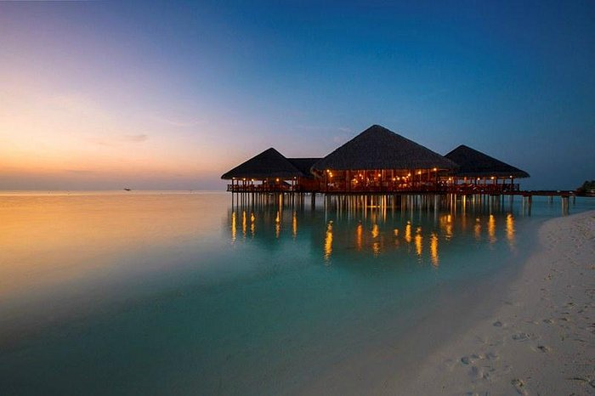
PROGRAM DETAIL
Day 1: Arrival and Check-In
- Arrival at Malé International Airport: Upon arrival, you'll be greeted and transferred to Medhufushi Island Resort via speedboat
- Check-In: Settle into your chosen accommodation, such as a Beach Villa or Water Villa.
- Meals: Enjoy lunch and dinner at the resort's restaurants, offering a variety of international and local cuisines.
Days 2: Leisure and Activities
- Breakfast: Start your day with a hearty breakfast at the resort.
- Leisure Time: Relax on the pristine beaches, swim in the crystal-clear waters, or unwind in your villa.
- Optional Activities: Engage in water sports such as snorkeling, scuba diving, windsurfing, or canoeing. Some packages include complimentary activities, while others may require additional fees.
- Meals: Continue to enjoy lunch and dinner at the resort.
Days 3: Leisure and Activities
- Breakfast: Start your day with a hearty breakfast at the resort.
- Leisure Time: Relax on the pristine beaches, swim in the crystal-clear waters, or unwind in your villa.
- Optional Activities: Engage in water sports such as snorkeling, scuba diving, windsurfing, or canoeing. Some packages include complimentary activities, while others may require additional fees.
- Meals: Continue to enjoy lunch and dinner at the resort.
Days 4: Leisure and Activities
- Breakfast: Start your day with a hearty breakfast at the resort.
- Leisure Time: Relax on the pristine beaches, swim in the crystal-clear waters, or unwind in your villa.
- Optional Activities: Engage in water sports such as snorkeling, scuba diving, windsurfing, or canoeing. Some packages include complimentary activities, while others may require additional fees.
- Meals: Continue to enjoy lunch and dinner at the resort.
Day 5: Departure
- Breakfast: Enjoy your final breakfast at the resort.
- Check-Out: Complete the check-out process and transfer back to Malé International Airport for your onward journey back to home.
Hotels Envisaged: 01
Overnight | Hotel/ Resort | Room Category
02 Maldives | Medhufushi Island Resort | Beach Villa
02 Maldives | Medhufushi Island Resort | Water Villa
Package cost is INR 1,37,000/- for 02 adults + 01 kid
Hotels Envisaged: 02
Overnight | Hotel/ Resort | Room Category
02 Maldives | Holiday Inn Kandooma Maldives | Beach Villa
02 Maldives | Holiday Inn Kandooma Maldives | Overwater Villa Island View
Package cost is INR 1,40,500/- for 02 adults + 01 kid
The Above Cost Includes: -
- 04 Night’s accommodation with breakfast
- Daily breakfast and Dinner at the main restaurant
- Bottled Drinks and water served by the glass (including soft drinks, beer, house wine and pouring spirits*) Beverages to be served between 1000hrs and 0000hrs only.
- After midnight all consumed drinks will be charged at the normal price. (*Pouring spirits include: Gin, Vodka, Whiskey, Brandy, Tequila, Rum, Arrack and Martini)
- 20% discount on A la carte restaurant if bill exceeds US$50
- 20% discount on special dinners
- 10% discount on spa treatments
- Return airport transfers by Speedboat
- Green Tax Included
The Above Cost Does Not Include: -
- TCS will be extra
- Items of personal nature like tips, laundry, telephone,
- Cost for supplementary service, optional Tours, Up-gradation Charges, Guide charges.
- Cost for Insurance Premiums, Water Sports Charges.
- Cost for service provided on a personal request.
- Cost for personal expenses such as laundry, bottled water, soft drinks, incidentals, porter charges, tips etc.
- Activity charges, Scuba, Jet Ski, Snorkeling etc., until and unless mentioned in the inclusions
- Cost for any other service not mentioned under the “Cost Includes” head.
- Difference in cost arising due to change in Taxes by the Government which will have to be collected directly ON ARRIVAL.
- Difference in cost arising due to extra usage of vehicle, other than scheduled & mentioned in the itinerary.
- Difference in cost arising due to mishaps, political unrest, natural calamities like - landslides, road blockage, etc. In such cases extra will have to be paid on the spot by the guest directly.
- Camera Fee (Still or Movie)
Ground Package Cancellation Policy :-
- If cancelled 45 days or more before departure: 20% of the package price would be retained as cancellation fee
- If cancelled 30 to 44 days before departure: 50% of the package price would be retained as cancellation fee
- If cancelled 15 to 30 days before departure: 70% of the package price would be retained as cancellation fee
- If cancelled 14 days or less before departure: 100% of the package price would be retained as cancellation fee
- No shows: 100% of the package price would be retained as cancellation fees
QUOTATION TERMS & CONDITIONS: -
- This is just a quote, no reservations held yet or booking is not proceeded yet.
- The rooms & rates are subject to availability at the time of booking / confirmation.
- Hotel, Sightseeing, Meals, Transfers rate might change without any prior notice until & unless it been booked/ confirmed from your end.
- The change in dates will attract re-quote.
- Normal Hotel check-in time is from 14.00 hrs. onwards. & check-out time is at 12.00 hrs.
- The above cost does not include any kind of surcharge if applicable during the given travel period.
- At check in all guests will be required to present a Major Credit Card for incidentals. "No Show" is subject to Full Booking Charges
- Quotation might change due to currencies ROE fluctuation during confirmation & booking process.
TOUR ENDS!
Please Compare:
You may get equal or better rates of similar packages, but we request you to compare apple to apple and check the below points:
- Please compare the categories of hotels offered to you. We try to offer best possible available option as per your budget. Most of the hotels are inspected by our own operation team.
- We provide updated and new transportation with guided drivers. We keep complete data of all the drivers. Drivers are well familiar with the destination.
- We provide 24X7 customer assistance. Our emergency numbers are always operational for your assistance round the clock. We try to provide every possible assistance in case of any emergency or problem.
- Please compare the inclusions and highlights of the tour in detail.
For booking confirmation, please follow the instructions mentioned below:
Payment Schedule For Tours:
- Booking Amount - 30% Advanced
- After Booking Confirmation - 40% amount of your tour cost should be collected
- Rest Amount - 30% before 15 days of trip
- Air fare / Train charges / Volvo Charges - To be paid at time of booking in addition

Our Bank Details: -
Account Holder's Name: YOUR TRAVEL MATE
Account Number: 10104626775
IFSC: IDFB 0020 128
SWIFT code: IDFB IN BB MUM
Bank name: IDFC FIRST
Branch: Janak Puri Branch
HAVE A SAFE AND PROSPEROUS TRAVEL AHEAD!!!!!!!

Hope all above is in order & clear to you, for any further assistance / clarification you can contact me at below: -
With Best Regards,
Kapil Bari
Sr Travel Sales Executive | yourtravelmate.in/
M: +91 98181 47625
E: kapil@yourtravelmate.in
A: Your Travel Mate, NORTHERN SIDE, FIRST FLOOR, RZ-344A, SADH NAGAR,, Street Number 6, AND 7, Palam, Delhi 110045
Air Tickets | Volvo| Bus Tickets | Holiday Packages | Hotels | Car Rentals |Holiday Packages | Hotel Bookings | Educational Tours | Adventure Packages | MICE |



