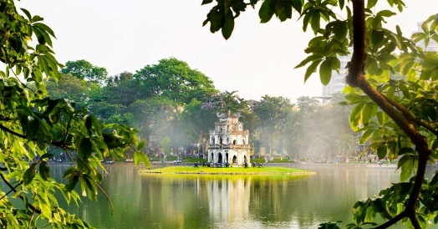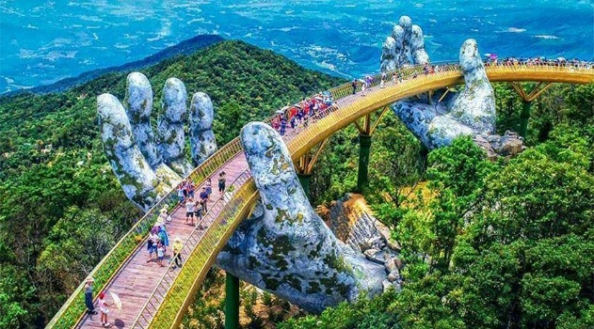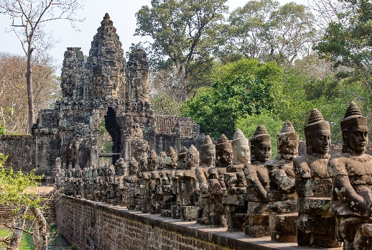

WONDERFUL VIETNAM NORTH TO SOUTH
Highlights: Ha Noi – Halong Bay – Da Nang - Hochiminh
Duration: 08Days/07Nights

BRIEF ITINERARY:
DAY | ITINERARY | MEAL | OVERNIGHT
DAY 1 | HANOI ARRIVAL – HALF DAY CITY TOUR AFTERNOON (PVT) | - | HA NOI
DAY 2 | HANOI - HALONG BAY - OVERNIGHT ON CRUISE – BY SIC LIMOU BUS | B,L,D | HALONG BAY
DAY 3 | HALONG BAY - HANOI BY SIC LIMOU BUS – FLIGHT TO DANANG | B,BR | DA NANG
DAY 4 | BANA HILLS – GOLDEN BRIDGE (PVT) | B | DA NANG
DAY 5 | COCONUT JUNGLE – HOIAN ANCIENT TOWN (PVT) | B | DA NANG
DAY 6 | DANANG – FLIGHT TO HOCHIMINH – HALF DAY CITY TOUR (PVT) | B | HO CHI MINH
DAY 7 | CU CHI TUNNELS (PVT) | B | HO CHI MINH
DAY 8 | HOCHIMINH DEPARTURE | B | -

DETAIL PROGRAM:
DAY 01: HANOI ARRIVAL – HALF DAY CITY TOUR AFTERNOON (PVT)
Welcome to Vietnam! Upon arrival at the airport, you will be welcomed by our local driver and private transfer to your hotel for checking in. Your rooms are available from 14:00 – 15:00. Early Check-in is subject to room availability and a surcharge.
Afternoon: Our Tour guide picks up at your hotel to start the tour.
Visit Tran Quoc Pagoda located on Golden Fish Island in West Lake. It is the oldest pagoda in Hanoi built in the 6th century.
Continue to visit Temple of Literature – the first university of Vietnam, The Temple of Literature (Van Mieu Quoc Tu Giam) is one of the most attractive tourist spots in Northern Vietnam. The Temple of Literature was founded in 1070.
Keep going to visit Hoa Lo Prison, the prison was built by the French, from 1886 to 1901, when Vietnam was still a part of French Indochina. The French called the prison Maison Centrale. The prison was called “A Hell on Earth” and now the prison is like a war museum for those who want to understand more about the war against France of Vietnamese people.
Our driver take you back to the Hotel. We finish the trip!

Meals: No
Overnight at hotel in Hanoi

DAY 02: HANOI - HALONG BAY - OVERNIGHT ON CRUISE – BY SIC LIMOU BUS
Morning, our bus pickup from your hotel to Ha Long Bay, which is about 160 km or 3.5-hour drive away. On the way, you will see some rural areas of the Red River Delta with plenty of chances to take photos of Vietnamese farmers working in paddy fields. Stop half way to visit a handicraft workshop of fine clothes and embroidered paintings.
Arrive in Ha Long City at 11:30 AM and check in aboard the booked junk right after the welcome drink is served. Start cruising while having lunch on board and enjoy the mighty bay view. Ha Long Bay meaning Descending Dragon Bay in Vietnamese as legend has it that it was where a holly dragon landed down from sky. The bay, famous as one of the world’s wonders and heritage sites whose formation dates back 500 million years, consists of around 2,000 karst islands and islets scattered over an area of 1,553 km2. The bay cruise will continue with up close sighting of Dinh Huong Island, Ga Choi Island, Dog Island, Sail Island, a visit to Sung Sot Cave and swimming stop at Titov Beach. Relax to enjoy the bay view at sunset, have dinner after, go fishing at 09:00 PM and spend a night on board.
Note: the itinerary of the cruise in Ha Long Bay will be changed following to your chosen cruise and weather.

Meals: Breakfast, lunch, dinner
Overnight on cruise

DAY 03: HALONG BAY - HANOI BY SIC LIMOU BUS – FLIGHT TO DANANG
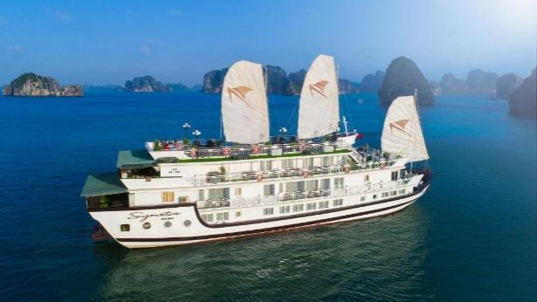
Early risers can enjoy the splendid yet tranquil view of the bay at the crack of dawn. Breathe the sea’s fresh air, feel the morning breeze and hear the sounds of birds above. Have breakfast and cruise to visit the Human head-shaped island and Tortoise Island. Continue to cruise into Bai Tu Long Bay to discover the adjacent bay of “The Little Dragon Bowing to His Mother,” as it is named. Check out and have lunch on board while heading to shore.
Disembark and transfer to your hotel in Hanoi.
Freetime till get on private transfers (with guide) to the airport for flight to Danang.
Upon arrival, our tour guide picks up then transfer to your hotel to do check in.

Meals: Breakfast, Brunch
Overnight at the hotel in Danang

DAY 04: BANA HILLS – GOLDEN BRIDGE (PVT)
07:30 am - 08:00 am: Our driver and tour guide will pick you up at your hotel lobby. Enjoy a scenic ride to Ba Na Hills via cable car.
Spend your time on one of the most modern cable car systems in Southeast Asia. Visit Dream Stream Cable Car Station and admire the breathtaking views of Da Nang’s coastal city.
After completing the first cable car ride, you will visit the Golden Bridge — famous for its exotic design and recognized by The Guardian as one of the world’s most prominent pedestrian bridges — Le Jardin D’amour (consisting of 9 gardens), and Linh Ung Pagoda.
Continue the second cable car to visit the French Village, where you can enjoy street music, admire art statues, Campanile, the Nine-Floor Goddess Shrine, Tombstone Temple, watch carnival performances, and explore Square Du Dome.
Have lunch at a restaurant (by your own expenses)
Take the Lava Train from Sun Kingdom to discover many new attractions for check-in, such as Helios Waterfall, Time Gate, and the Moon Kingdom, etc. Join Fantasy Park by walking through Fairy Forest, discovering Dinosaur Park, playing 5D Wild West, enjoying the 4D Death Race ride, watching 3D Mega 360 Degrees, riding Journey into the Underground, entering Jurassic Park, challenging the Freefall Tower, and participating in adventures at the Horror House, along with over 90 free games.
3:00 pm: Return to the Cable Car for leaving Ba Na Hills
5:00 pm: Our minivan brings you back to your hotel. Tour end.

NOTE: Ticket of Bana Hill NOT include the Wax Museum, Debay Wine Cellar, Games with coin, Alpine Coaster

Meals: Breakfast
Overnight at hotel in Danang

DAY 05: COCONUT JUNGLE – HOIAN ANCIENT TOWN (PVT)
Morning at leisure.
About 1:00 pm: The van and tour guide will pick you up at your hotel
Start your adventure with Cam Thanh Coconut Village. Immerse yourself in the peaceful atmosphere of Cam Thanh Village. Enjoy a relaxing boat trip through the beautiful coconut forest. Learn to paddle the unique Vietnamese bamboo basket boat and join in a basket boat rowing. Besides that, you will see the basket-boat performance.
About 3.00 pm: Visit to the next destination to Hoi An Old Town - a UNESCO World Heritage Site renowned for its timeless charm and rich cultural heritage.
- Enjoy a traditional art performance at the Hoi An Traditional Performing Arts House, offering an authentic glimpse into local folklore, music, and cultural expressions.
- Continue your walking tour with visits to the Museum of Trade Ceramics, showcasing Hoi An’s long history as a major trading port through a rich collection of ceramics from Vietnam and Asia. Explore the beautifully preserved Tan Ky Ancient House, a 200-year-old merchant residence that reflects the harmony of Vietnamese, Chinese, and Japanese architectural styles. Then visit the historic Cantonese Assembly Hall (Hoi Quan Quang Dong in Vietnamese), admired for its intricate carvings, vibrant colors, and cultural significance to the Chinese community in Hoi An—together illustrating the town’s unique multicultural heritage.
- Stop by the iconic Japanese Covered Bridge, one of Hoi An’s most recognizable landmarks and a symbol of the town’s history.
- As evening falls, enjoy free time to explore the Hoi An Night Market, soak in the magical lantern-lit atmosphere, shop for local handicrafts, and take memorable photos.
7:00 pm: Finish the tour in Hoi An. We will drop you off at your hotel in Danang. End of our services!

Meals: Breakfast
Overnight at hotel in Danang

DAY 06: DANANG – FLIGHT TO HOCHIMINH – HALF DAY CITY TOUR (PVT)
Free at leisure until get on private airport transfer to Danang Airport for the flight to Hochiminh.
Upon arrival, private airport transfer to your hotel for check-in. Your rooms are available from 14:00. Early check-in is subject to room availability.
Afternoon: Take the half day trip to visit Independence Palace, also known at the Reunification palace, was built on the sight of the former Norodom palace. The Independence palace is a widely known landmark of Ho Chi Minh City and was designed by the architect Ngo Viet Thu. Continue seeing the beautiful structures from the French Colonial times such as the Notre Dame Cathedral, the historic Central Post Office. Followed by the remarkable site of the Ben Thanh Market - one of Ho Chi Minh City’s most iconic landmarks, famous for its bustling atmosphere, local food, and traditional souvenirs

Meals: Breakfast
Overnight at hotel in Hochiminh

DAY 07: CU CHI TUNNELS (PVT)
Pick up at your hotel and depart to Cu Chi will take approximately one and a half hours bus driving.
Upon arrival, before exploring the tunnels, you will have some short introduction followed by an introductory video about how the tunnels were constructed and how the people survived in the harsh conditions of the war time. Then, spend your time to explore the remaining area and tunnel systems which included the special constructed living areas with kitchens, bedrooms side by side with other martial facilities like storage, weapons factories, field hospitals, and command centers helping whoever lives inside the tunnels meet their basic needs. Besides, there are also many hidden trap doors and dangerous traps within the maze-like tunnels for security purpose during the war. Afterward, special tea and cassava (guerilla’s food during the war) will be served.
Break time for relax or time for those who want to try the real shooting gun.
Return to Saigon. End trip.

Meals: Breakfast
Overnight at hotel in Danang

DAY 08: HOCHIMINH DEPARTURE
Free at your leisure until get on private transfer to the airport for departure flight. Room is at your disposal until noon time only.

Meals: Breakfast
----------- End of service ----------

COST DETAILS: All rates are per person sharing DBL/BB basis, in US dollar, net and non – commissionable

 | ALL RATES ARE NET IN US$ PER PERSON
GROUP SIZE | 3 Adults & 1 Children 12Y
Superior - 4* | 615

INCLUDED:
- Accommodation at the hotel based on Quad sharing rooms
- Package 2D1N Overnight on cruise in Ha Long Bay with full board meals mentioned above
- Round-trip transfers Hanoi – Halong Bay – Hanoi by SIC limousine bus
- Private airport transfers without guide (one 16s van)
- Private-tours with experienced English-speaking guide and air-conditioner vehicle as mentioned
- Entrance fees for all visits as mentioned in the itinerary
- Mineral water is available as complimentary (01 bottles per pax per day).

TOUR PRICE EXCLUDE:
- Airfare (international and domestic) and airport tax
- Dinks and other meals not clearly mentioned
- EVisa
- Surcharge for special request on food, and meals.
- Insurance, gratuities and personal expenses
- Tipping for guide and driver
- Surcharge for public holidays (if any)
- Compulsory dinner for Xmas and New Year Eve: TBA
❖ All other service not stated in the program
TIPPING FOR GUIDE AND DRIVER (PAID DIRECTLY TO GUIDE) - Compulsory
- Group from 1 – 4 pax: USD 5/ pax/ day
- Group from 5 – 9 pax: USD 4/ pax/ day
- Group from 10pax up: USD 3/ pax/ day

HOTEL CATEGORY OR SIMILARS:
City | 04 Star Hotel
Ha Noi | HANOI PEARL HOTEL  Family city view connecting room  Or a similar class
Halong Bay | LA REGINA ROYAL CRUISE  Noble Suite Connecting cabin  Or a similar class
Da Nang | BALCONA HOTEL  Balcony studio city room  Or a similar class
Ho Chi Minh | EDEN STAR HOTEL  Premium Deluxe connecting room  Or a similar class
Below are some details to help you better understand the quotation:
- This is private tour for 4 pax. Children 12 years is the same as adult
- Hotels in Hanoi and Ho Chi Minh City are located in the city center, and rooms come with windows.
- The Ha Long Bay cruises are premium 4-star. Cabins feature private balconies with views of the bay.
- The hotel in Da Nang is located on beach street — only a 2-minute walk to public.
- International and Domestic flights are not included in the tour price.
- Compulsory tipping for the guide is not included in the tour price.
Vietnam visa: You have two options:
- Option 1: Apply for an e-visa directly on the official website of the Vietnam Immigration Department. You will also pay the visa stamping fee (USD 25) on the same website. Processing takes approximately 5 working days. This option is quite easy and allows for a fast immigration clearance upon arrival.
- Option 2: We can apply for a Vietnam visa approval letter on your behalf. This service is complimentary for Indian passport holders. We require 7 working days (excluding Saturdays, Sundays, and public holidays) to process the application. Once you receive the approval letter, you can get the visa stamped on arrival by paying a visa stamping fee of USD 25 per person directly at the immigration counter.

