**Milestone**:

Milestone that we are trying to achieve are listed below:

1. Creating a GUI for admin which only accessed by admin (password protected). Admin will use this to do all the tasks, for ex., adding a movie and theaters, it’s showtime to theater, removing them, validating them, editing them etc.
2. Creating a GUI for normal users which can be accessed by anyone. User will able to view movies, theaters, showtime, details about movies, details about theaters etc. User will not be able to edit, delete, add any data into the GUI, user won’t have this privileges.
3. Make a connection with a database that will store all the data entered or removed by admin. Making sure that the normal user will always get the correct and useful data.
4. Admin will be responsible for the data in the database.

**Architecture :**

We started doing project by first building a plan before we start implementing it. Which can help in future to avoid major errors like completely redesigning the software.

We started working on gui in the beginning which was straight forward and easy. We made few gui, for example login screen that is used only by an admin, account of an admin, which allows user to view, edit or remove movies or theaters. The account will help admin to navigate easily to everywhere. Admin can add movie and add theater in the account GUI. All the task will be done in Account GUI, so that the admin won’t get confused. After designing that we started making all guis work together and response on the clicks of the user input.

After that we started creating database and we decided to use **sqlite** database which is a local database. And we connected the project using sql with the database. So that the database can save and store the data added by admin, which can later use to display on the normal user’s GUI, which allow them to view movies and theaters. The user GUI will also have navigation which will be easy to navigate, and will provide every details about movies or theaters to the user User’s GUI will be read-only, which won’t allow any user to edit any data in the database except the admin.

**Database design:**

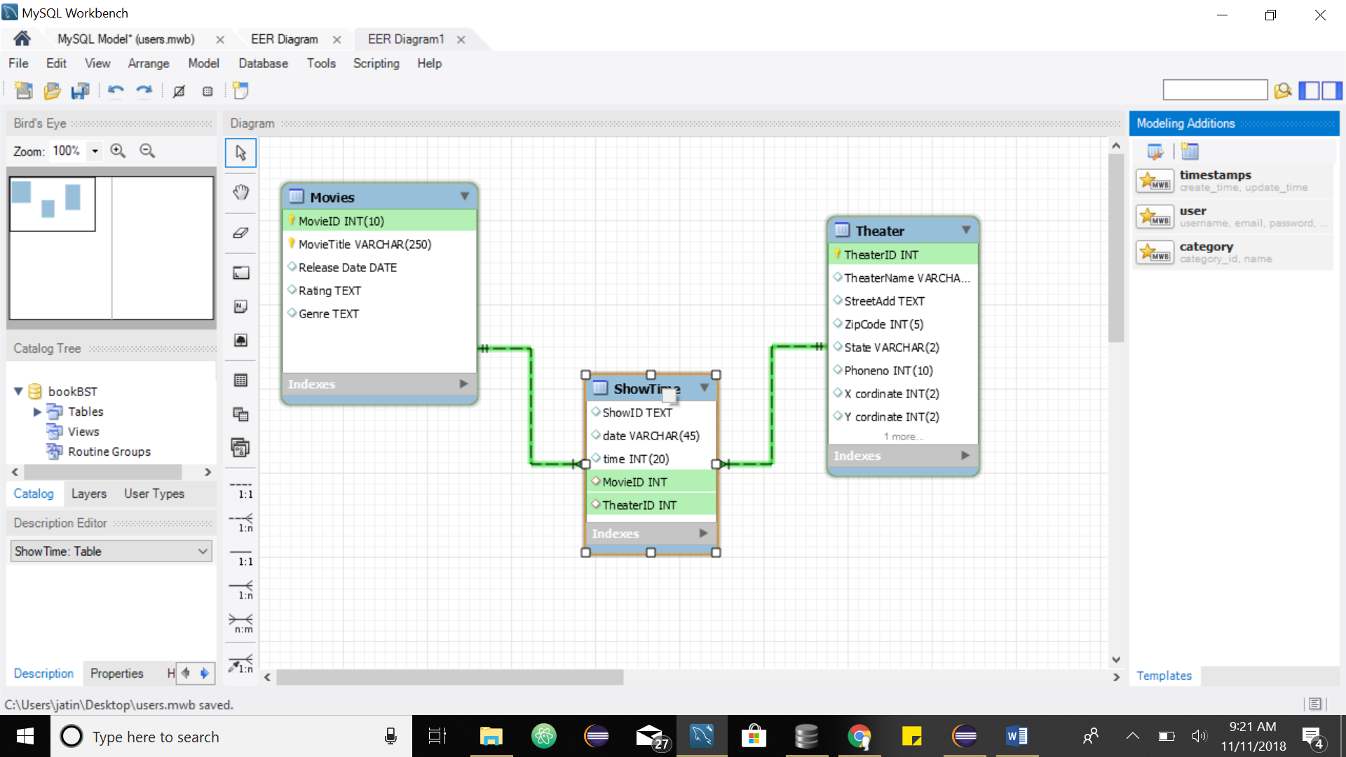

The database contains 3 tables. Connected to each other through the table named ShowTime. This way when admin enter a movie it goes into table Movies. But when admin enters showtime to movies it gets added into showtime table using the movie of the movie. This is references to movieID in the movie table, same way Theater is connected to showtime.

**Software:**

1. Eclipse(IDE) to write , debug and run codes.
2. Language: JAVA
3. GUI: created by window builder from Eclipse.
4. Database: SQLITE(local database)

**Gui:**

These are the lists of all the guis that we have designed.

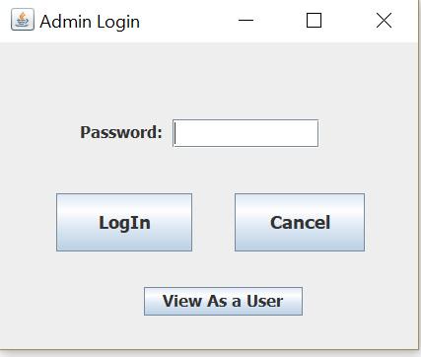1. This is a login screen for admin which is password protected. Only, admin will be able to login the users will use the button View As a User.

1. 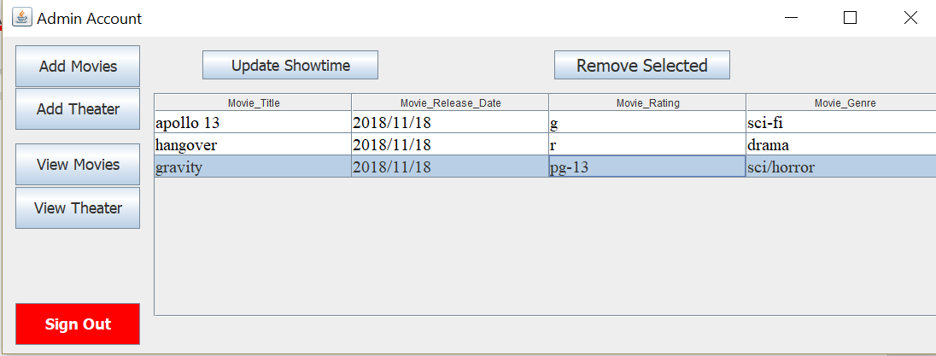 The GUI below is the main screen of admin, he can view movies, theater, add theater, add Movies, update showtime, remove by clicking the buttons.

This screen is the home screen, also admin will see this when he clicks view movies button.

1. 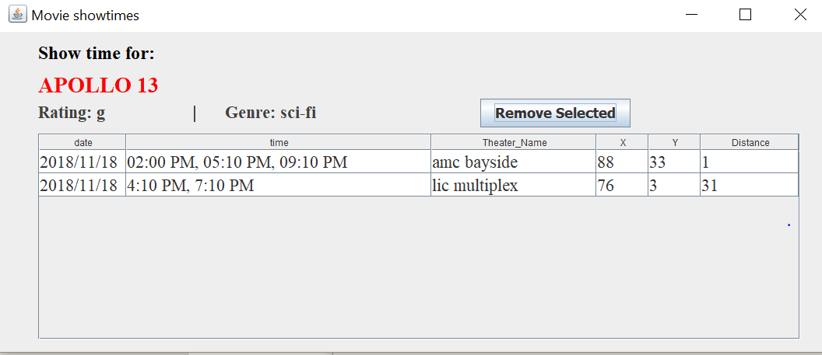 If admin clicks any of the movies on the 2nd gui above, admin can view the showtimes for that movie as shown in this gui. Admin can remove perticular show times as well by clicking Remove Selected button. In addition, user will have the same type of gui, but user will not be able to remove anything( user will not see Remove selected button), but, user can enter his location to see which theater will be the closest to his location.
2. 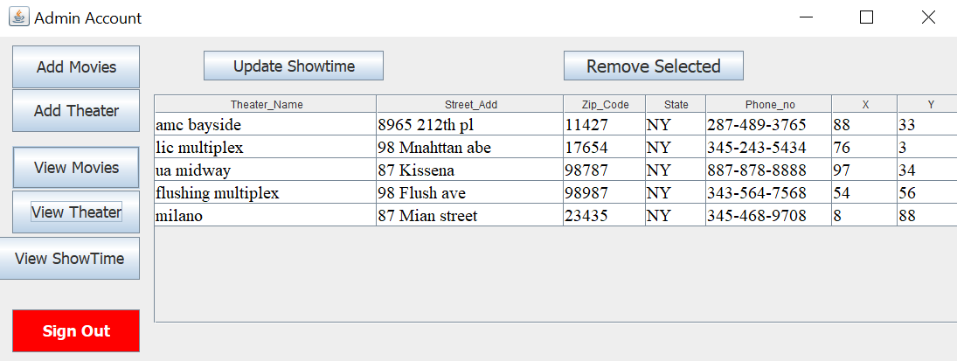 Admin will see this gui by clicking view Theater Button from gui no2 above. Admin can select any theater from the list or remove it.
3. 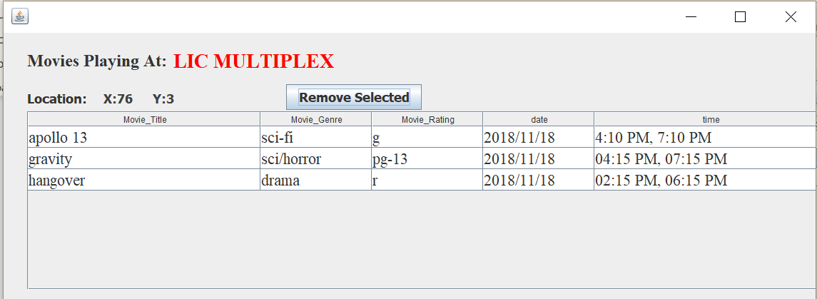 Admin will get to this screen by clicking on any theater from gui no4 above. This will show the list of all movies playing at that theater. Admin can remove movie with the use of a button. Normal users will also have the same gui with no remove selected buttons. So it will be a ready only gui for the normal users.
4. 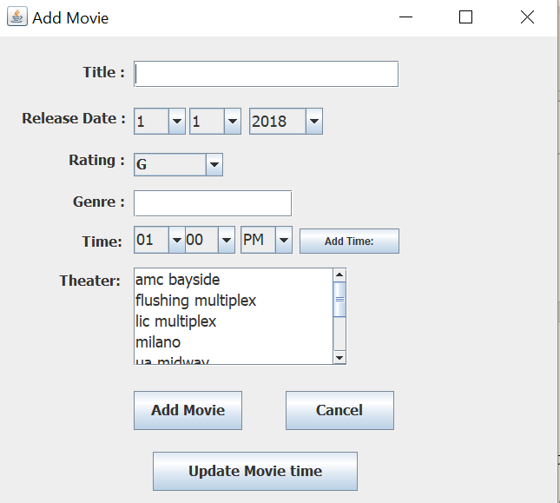 Admin will get to this screen by clicking add movie button from gui no. 2 above, this will allow admin to add new movies their showtime and their theaters.

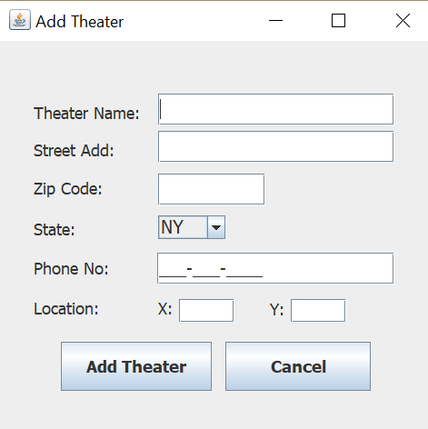7. Admin will get to this screen by clicking add Theater button from gui no2 above. Admin can add new theaters.

1. 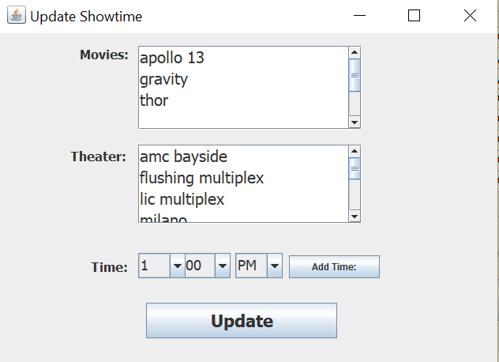 Admin will get to this screen by pressing Update showtime button from gui no 2 above.

Admin can update, add more showtimes for the existing movies.

Finally, user can sign out by clicking the button sign out from the gui no1.

Below are the guis for user, we have already described some guis for user above.

1. 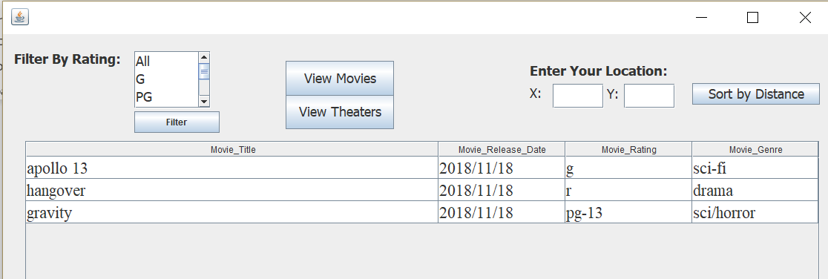 This is the home page of user. User can click on movie to see the list of theaters playing it. Also, user can use the filters by Rating. Sort by Distance will be use for theaters only. More on this in gui no 11. User can view theater or movies by clicking buttons.

1. 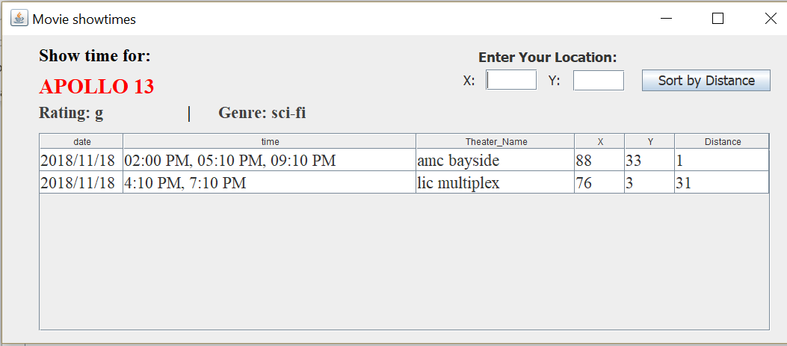 User will get this by clicking movie from the gui above. Here user can insert his location and sort by distance, clicking on the list will give the user an information about the showtime. Check the gui below.
2. 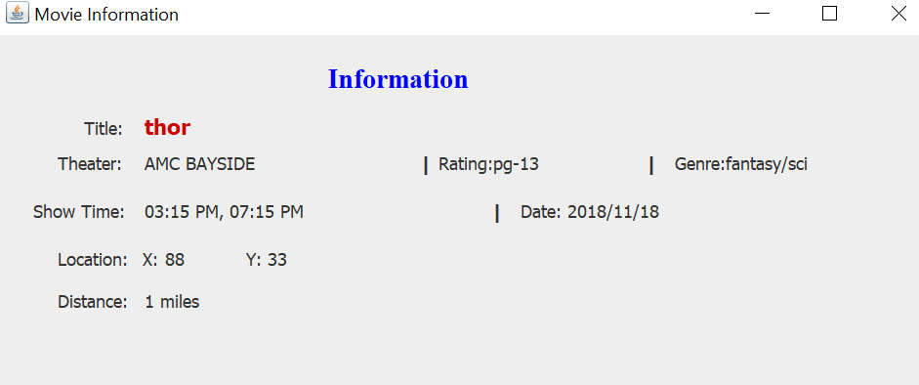

User will get to this screen by clicking on a showtime above, this will give the user clearer

information about the showtime, as shown above.

1. 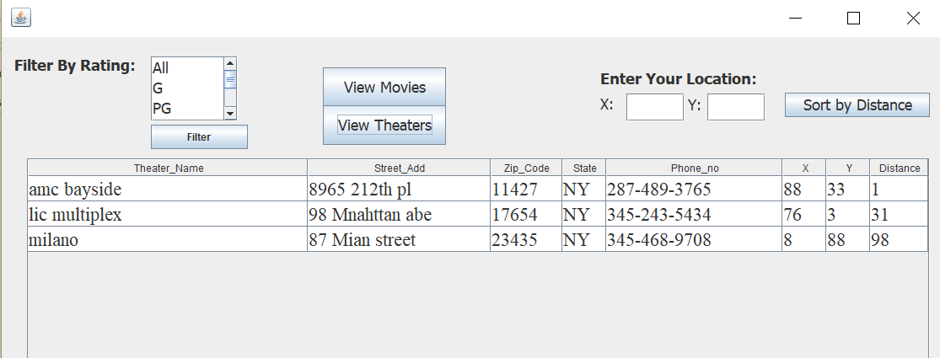

User will get this gui by clicking view theater button from Home Screen gui 9 above. User can enter coordinates to sort by distance and it will show the closest theater first then others in order. User can click on the theater and see what movies are playing at that theater,(check the gui below).

1. 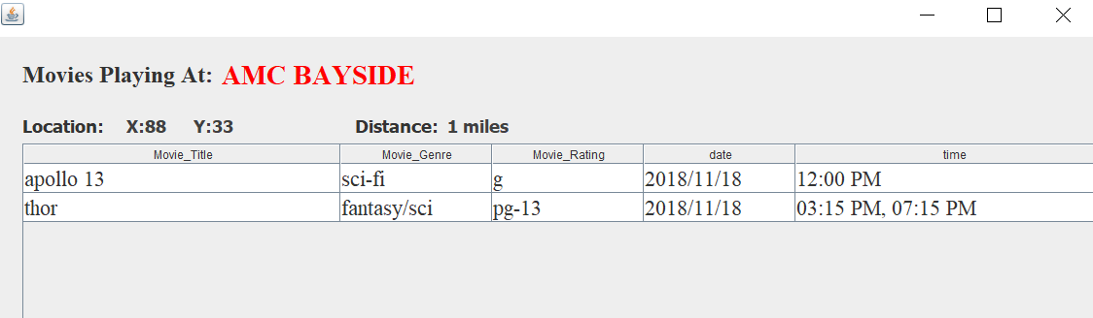User will get this gui from the gui above. This gui shows all the showtime for the movies at the theater selected in the gui no 12. Clicking on this will show user more information about showtime(see next gui).
2. User will get information about the movie and it’s showtime selected in previous gui.

Finally, these are all the guis we have designed for users and admin to get their work done easily and more comfortably. We have tried to keep it as simple as we can.