BusTrack — Testing Manual
Live URL: https://bus-track-gray.vercel.app

IMPORTANT — Always use full addresses When entering any location, always use the full address including city and state. Example: "Sector 18 Metro Station, Noida, Uttar Pradesh" not just "Sector 18". This ensures ORS geocodes correctly.

Recommended Test Routes
Route 1 — Noida
- Sector 18 Metro Station, Noida, Uttar Pradesh
- Atta Market, Sector 27, Noida, Uttar Pradesh
- Noida City Centre Metro Station, Sector 39, Noida, Uttar Pradesh
- Sector 62 Metro Station, Noida, Uttar Pradesh
Route 2 — Delhi
- Kashmere Gate Metro Station, Delhi
- Chandni Chowk Metro Station, Delhi
- New Delhi Railway Station, Delhi
- Connaught Place, New Delhi, Delhi

Step 1 — Admin Setup
Login at the live URL with:
- Username: admin
- Password: admin301
- Note: It may take sometime to start as render server goes inactive after sometime of inactivity.
- 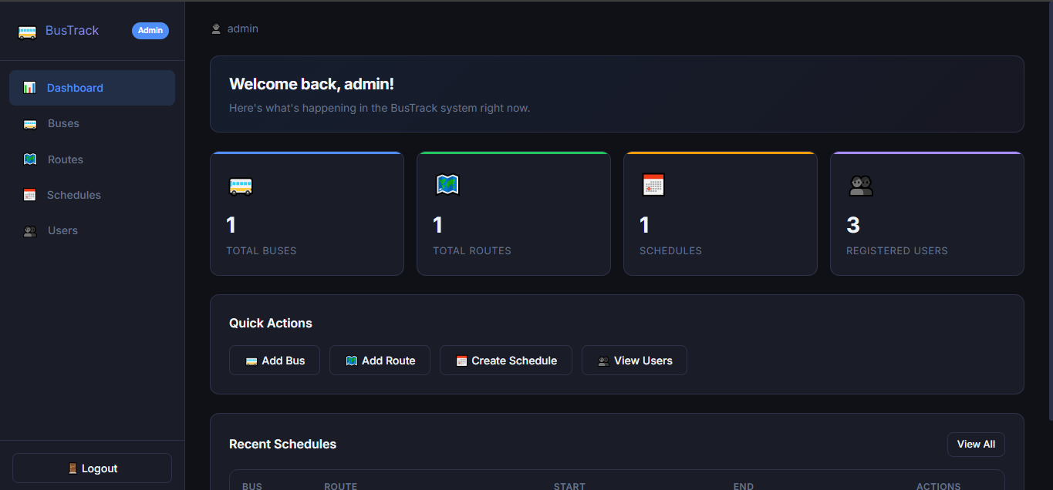
Create Stops Go to Admin → Stops → Create Stop. Enter each stop name and its full address. Create all stops for your chosen route one by one.

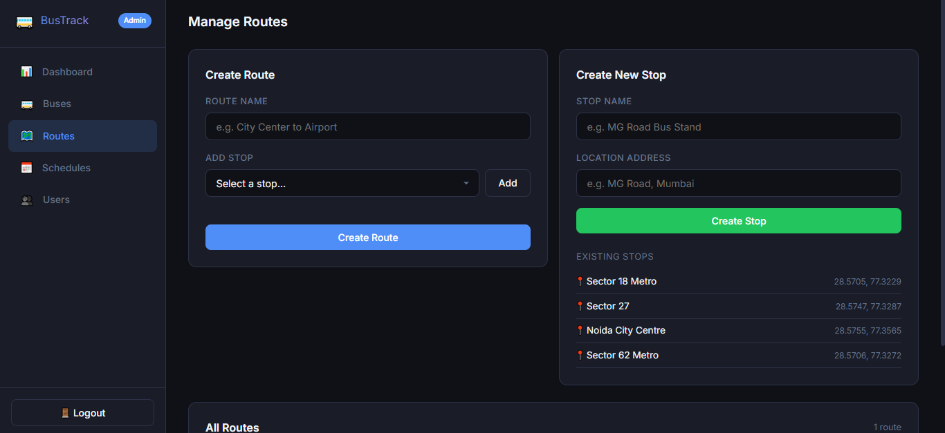
Create Route Go to Admin → Routes → Add Route. Enter a route name and select stops in order from start to end.
Add Bus Go to Admin → Buses → Add Bus. Enter a bus code (e.g. UP-32-BT-001) and average speed (recommended: 20 km/h for realistic ETA).
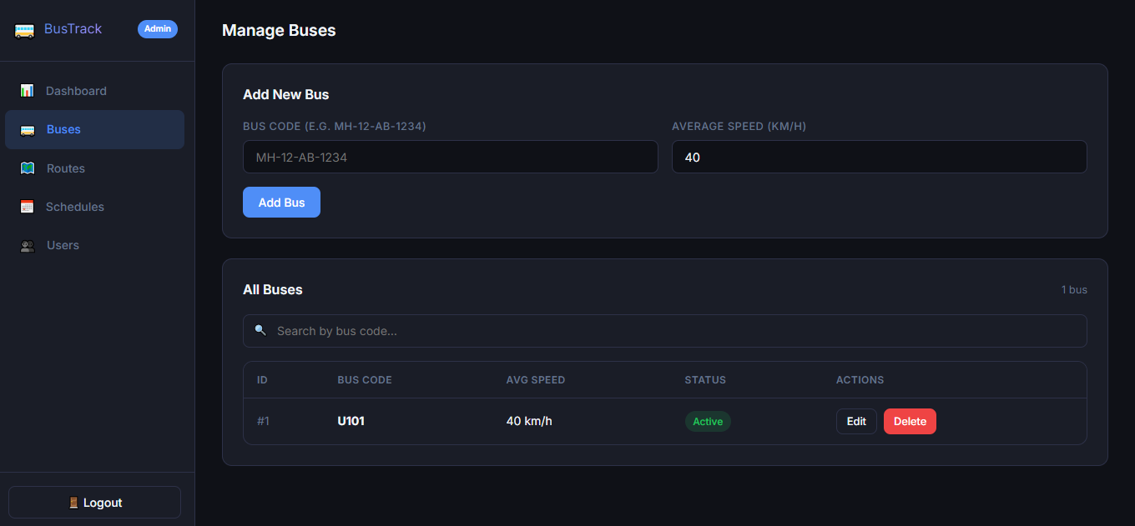
Create Driver Account Go to Admin → Users — register a new user with role "driver". Example: username driver1, password driver123.
Create Schedule Go to Admin → Schedules → Create Schedule. Assign the bus and driver to the route. Set start and end time covering the current time.
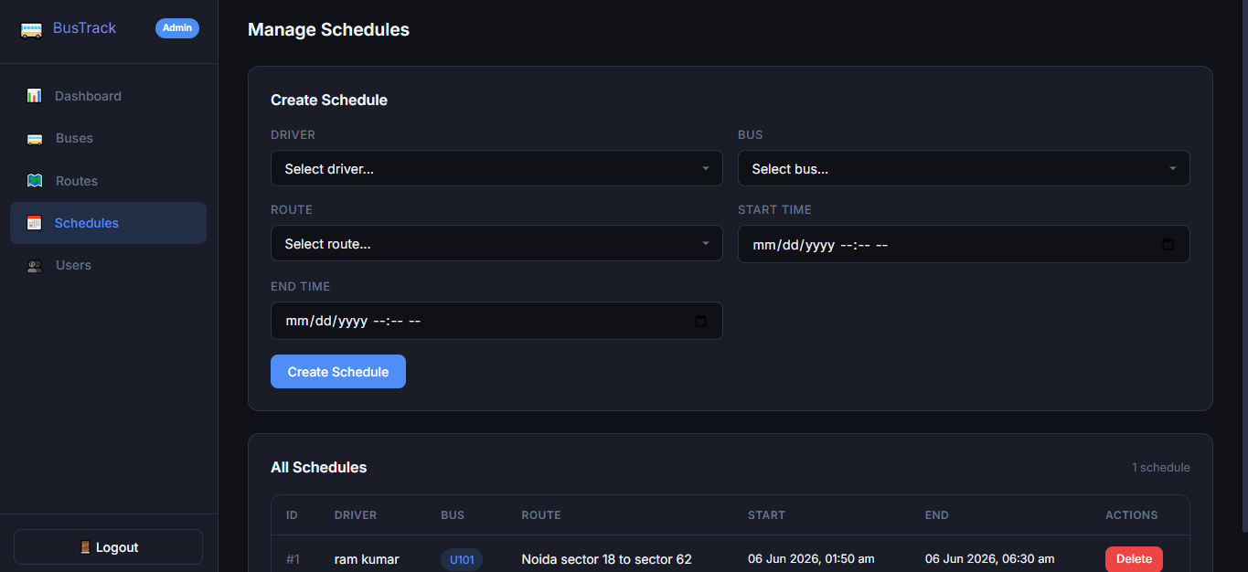

Step 2 — Driver
Logout from admin. Login with driver credentials (driver1 / driver123).
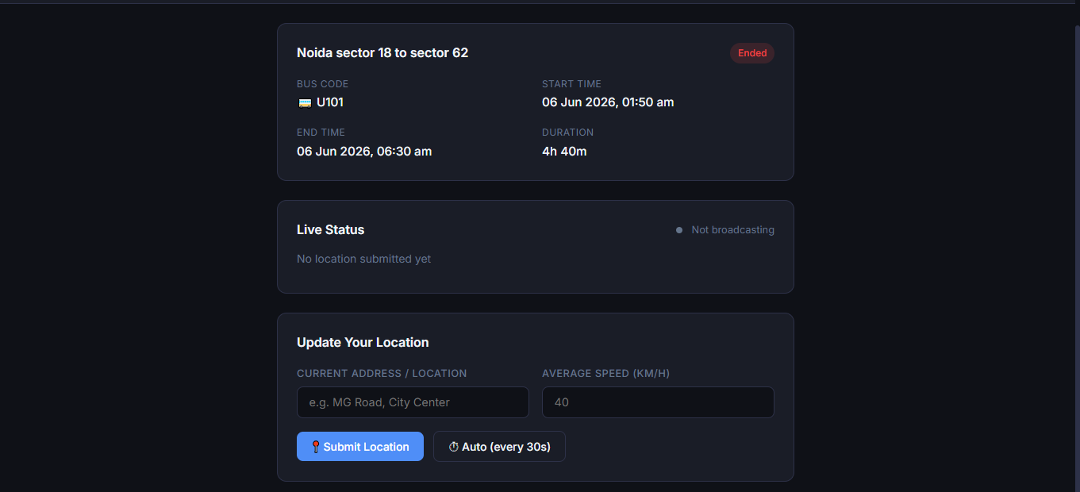
Go to Driver Dashboard → Update Location. Enter your current location as a full address — use a stop near the start of the route. Example: "Sector 18 Metro Station, Noida, Uttar Pradesh". Submit.
This tells the system where the bus currently is. Update this periodically to simulate the bus moving.

Step 3 — Passenger
Register a new passenger account from the login page. Role: passenger.
Login and go to Passenger Dashboard → Routes. Select the route you created.
Click Track. Enter your location as a full address — use a stop that is ahead of where the driver currently is on the route. Example if driver is at Sector 18, enter "Noida City Centre Metro Station, Sector 39, Noida, Uttar Pradesh".
The system will show ETA in minutes. Every 10 seconds it polls the backend and updates automatically.
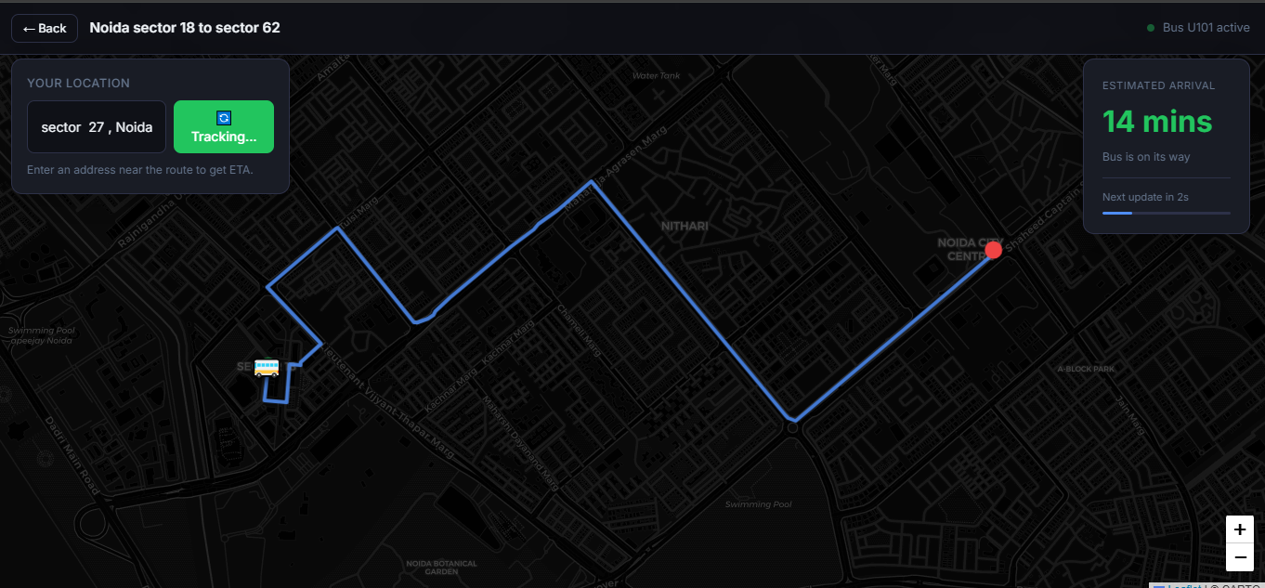
To see the bus marker move: Go back to the driver tab, update location to the next stop, then return to the passenger tab. Within 10 seconds the bus marker on the map will jump to the new position and ETA will recalculate.
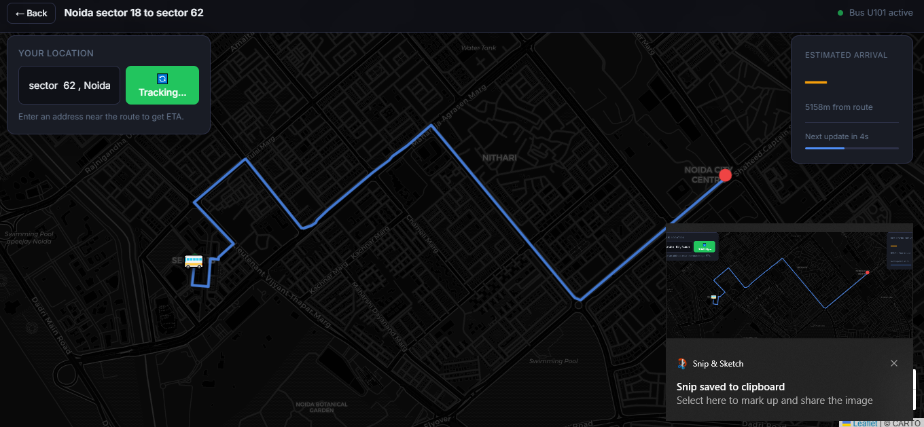

Expected Behavior
- If your location is more than 500m from the route, you'll see a "X metres from route" warning instead of ETA
- If the bus has already passed your stop, you'll see "Bus has already passed your stop"
- ETA decreases as you update driver location closer to the passenger stop
- Bus marker on map moves when driver updates location

Test Credentials
- Admin: admin / admin301
- Create driver and passenger yourself via registration

