Test Plan

|  |  |  |
| --- | --- | --- |
| **\Functionality** | **Test Scenario** | **Result (Pass /Fail)** |
| Adding Movies | * *Add a Movie and check if it adds to the database and shows in the Data-grid* * *The user should not be able to add the same movie twice, the system should give appropriate error message* * *The system should not store a Blank Movie* * *Movie Genre should have proper value* | Pass  Pass  Pass  Pass |
| Adding Customers | * *Add a customer and check if it adds to the database and shows in the data-grid* * *The system should not store a blank customer name* * *Customer name should not accept special characters or numbers* | Pass  Pass  Pass |
| Search Movies / Customer | * *Search by Movie name / Customer name* * *Search should give out all results that matches the search criteria* | Pass  Pass |
| Update Movies / Customer | * *Should update details of the respective movie and customer only* | Pass |
| Delete Movies | * *Should not be able to delete a movie that is rented out* | Pass |
| Delete Customer | * *Should not be able to delete a customer that has rented out a movie* | Pass |
| Issue Movie | * *Issue a movie to a customer and check if it adds a record in the Rented movies table, Date rented should be the current system date* * *System should not issue a movie that is already been rented out* * *Give an error message if there are no copies of the movies* * *Cannot issue more than two movies to the same customer* | Pass  Pass  Pass  Pass |
| Return Movie | * *Return movie should update the Rented Movies Table* * *Cannot return a movie that has not been rented out* * *Date returned should reflect the current system date in the Rented movies table* | Pass  Pass  Pass |

Login form

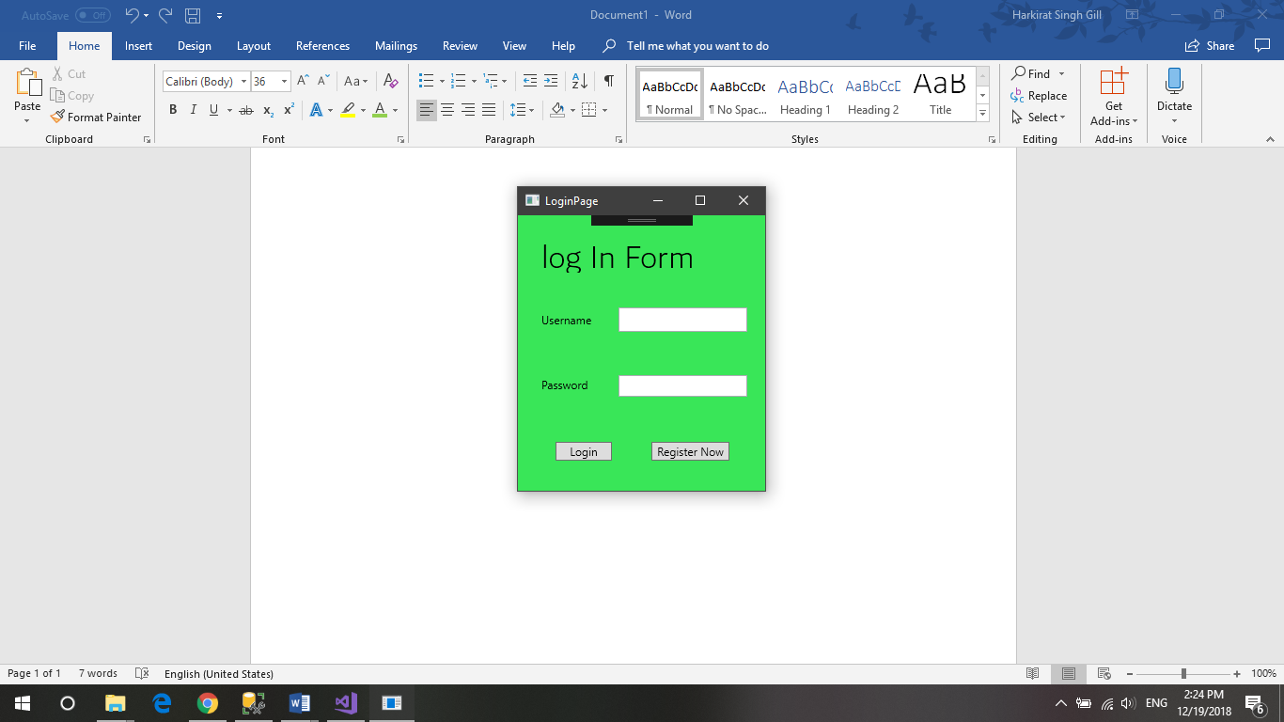

Working

Registration Form

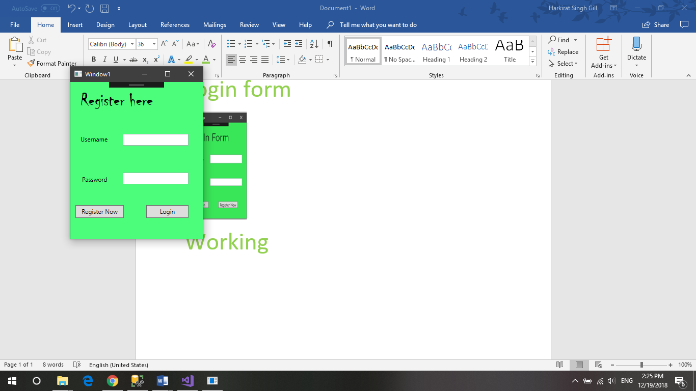

Working

Customer:

Add,Delete,Update

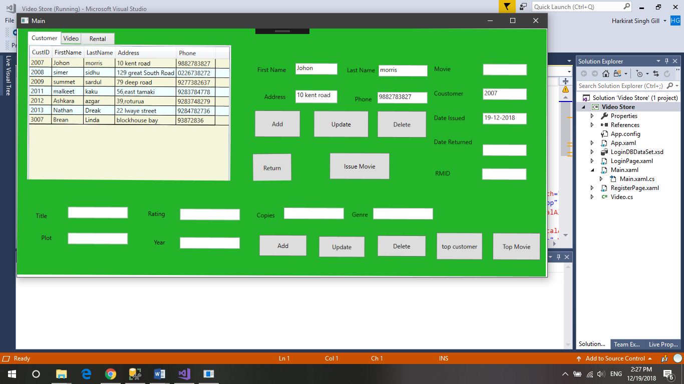

Working

Video:

Add,Update,Delete

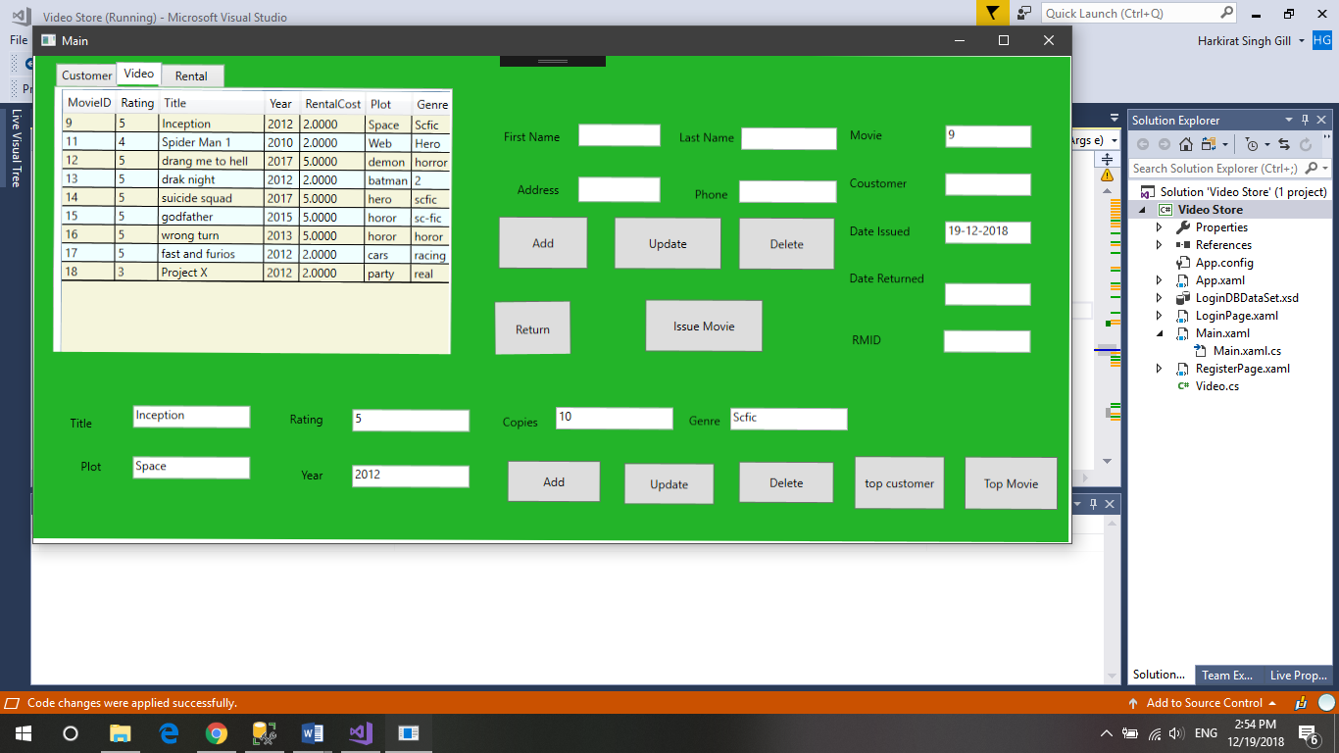

Working