A/B testing Carried out for displaying Banner of advertisement of food beverages at the top of website for GLOBOX E-Commerce

Background:

Globox is online e-commerce business. Globox is known among customers for boutique fashion item and high end decor product. but their food and beverage offering have grown tremendously in last few months. so the company want to awareness to this product category to increase revenue.

The Growth team decides to run an A/B test that highlights key products in the food and drink category as a banner at the top of the website.

a) The control group does not see the banner, and

b) the test group which sees the changes

* Designing of A/B experiment:
* **Formulating the hypothesis for testing:**

We don't know that Displaying Banner at top of website will lead to conversion or not. so we will choose the two tail test.

we are doing two different significant test for selected variable. here so we define two hypothesis for each test variable.

General Hypothesis is:

H0 = There is no difference between control and experimental group

H1 = There is difference between control and experiment group

confidence level = 95 %

significant level ( = 0.05

(alpha value is the threshold that we set for this testing.)

The probality of oberserved result(p-value) is lower than 0.05 then We reject Null hypothesis.

* **Choosing Variables:**

Control - There is No banner at top of website

Experiment - There is banner at top of website

Control and Test group is our independent variable.

(**Note**: there are many other varibles that can effect to our base conversion rate for example, Seasonality,should take into account before calculating it)

But, here we assume that test is carried out considering all thing is neutral.

our dependant variable(what is trying to measure ) is:

A) Average purchase amount (t-statistical test)

B) Conversion rate. (binary variable) (Normal Distributuion (z) test)

for conversion rate:

0 - user did not buy any product during this experiment

1 - user bought the product during this experiment

**Choosing the sample size:**

It is important to note that we won't test the whole user base (our population).

Number of user or people, we decide to capture in each group will have effect on precision of our estimated conversion rate. The more sample, more precise the estimated conversion rate.(smaller the confidence interval) so higher chance to detect difference if present.

Sample size is estimated through power analysis.

Power of test: 1 -  (80 %)

alpha = 0.05

effect size = how big of a difference we expect

Base line conversion rate = 13 %

Expected conversion rate = 15 %

Diff = 2 % (mde- minimal detecttable effect)

The required sample size is 4720 atleast for each variation or/ group

(for the calculation, refer Notebook_A/B_testing)

**Collecting and preparation of Dataset:**

Based on sample size, we have collected sample from our whole all user randomly.

**Checking Inferencial Condition that our sample met or Not:**

Random condition:

A/B test is carried out on randomly selected users and they were assigned control and experiment group randomly.

Normal condition:

Sample size > 30 so we can say it is normally distributed.

Independent condition:

Sampling is done with replacement so we can say, it is independent sample.

1. **Checking difference in average amount spent per user between control and experiment group(t-test)**

our sample met all inferece condition, so we will do t-statistical test to check significance diifference in avearge amount spent betweeen two groups.

confidence level is 95%

significal level(assumed) alpha = 0.05

We assume:

Null hypothesis : H0 = There is no significant difference between mean of purchaseamount between control and experiment group                        u0 - u1 =0

Alternative Hypothesis: H1 = There is difference between mean of purchase amount between control and experiment group

u0 is not equal to u1

* Visualization of Basic statistics for average amount spent per user for both group

|  |  |  |  |
| --- | --- | --- | --- |
| **Test Group** | **Average_spent** | **Std Deviation** | **Std Error** |
| **A (Control)** | 3.375 | 25.94 | 0.17 |
| **B (Experimental)** | 3.391 | 25.41 | 0.16 |

* Visulization plot (bar chart of average spent per user for each group)

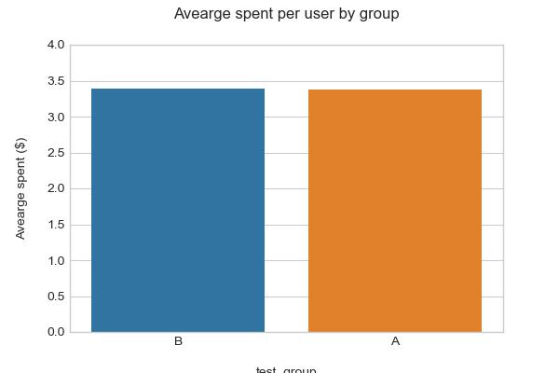

**T-test Results (two tail):**

T-statistics for difference in avearge spent per user between two group is: 0.07

T-critical Value at 95 % is: 1.96

p - value for difference in mean of average spent per user is: 0.944

95 % confidence interval for control group is : 3.049 to 3.700

95 % confidence interval for experimental group is : 3.073 to 3.708

**Evaluation of Test results:**

At 5 % significance level, Assuming the Null Hyothesis is True, The probability of difference in mean for both Group is 0.944 Which is higher than our significance level (alpha=0.05). So we fail to reject our Null Hypothesis.

1. **Checking difference in mean of conversion rate between control and experiment group(z -test and unpooled proportion are used.)**

Null Hypothesis:

H0 = There is no difference in user conversion rate between control and experimental group

        p = p0

Alternative Hypothesis:

H1 = There is difference in user conversion rate between control and experimental group

    p  =/ p0

|  |  |  |  |
| --- | --- | --- | --- |
| **Test Group** | **conversion_rate** | **Std Deviation** | **Std Error** |
| **A (Control)** | 0.0392 | 0.1941 | 0.0012 |
| **B (Experimental)** | 0.0463 | 0.2101 | 0.0013 |

Conversion rate for control group is: 3.92 %

Conversion rate for experimental group is: 4.63 %

Visualisation of conversion rate:

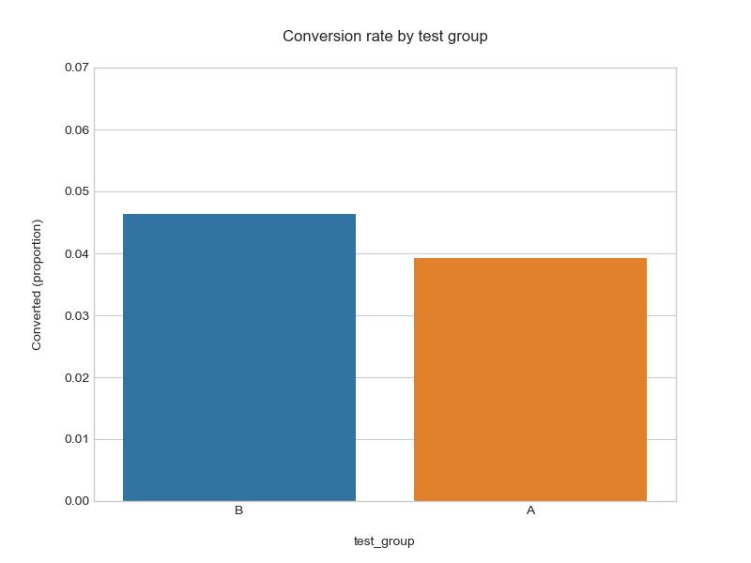

Test Results(Z-test):

The difference in mean of conversion rate of control and experimental group is : 0.0071

z statistic: -3.86

p-value: 0.0001

ci 95% for control group: [0.0368, 0.0417]

ci 95% for experiment group: [0.0437, 0.0489]

Critical Z value is: 1.96

Recommendation: