<https://www.youtube.com/watch?v=0KWQLFI8mFE> ([Awais Mirza](https://www.youtube.com/channel/UCIKbbV7ae7LAWa8cGnvjSPA))

1. 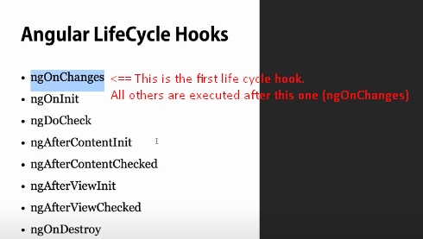

ngOnChanges

1. This is the first one that gets executed.
2. Called whenever any **data-bound** **property** of a directive changes.
3. We need to create parent and child component because this is where we can utilize this life cycle hook.
4. ‘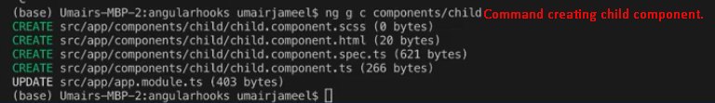  
   **Parent Component**. app.component.ts
5. Child must have @Input property and parent would set its value. Then, ngOnChange(SimpleChanges) would be called each time. 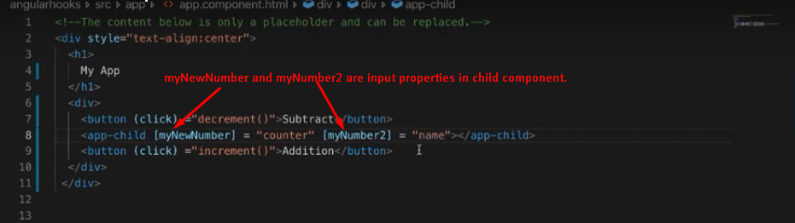
6. 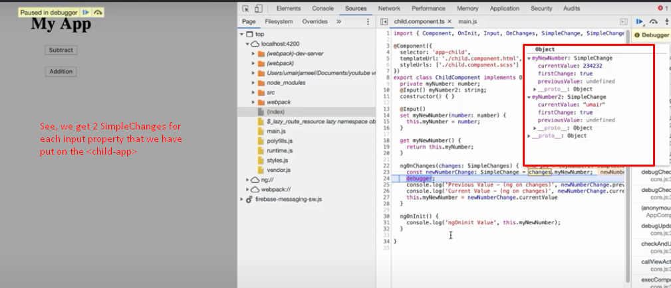

DoCheck interface

1. From @angular/core.
2. Method ngDoCheck().