Index.html

1. 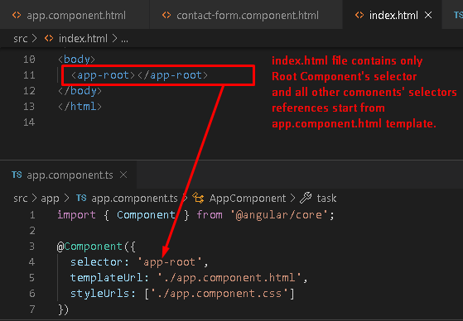
2. All the CLI angular projects, all the app related content go into app folder as subfolder.  
   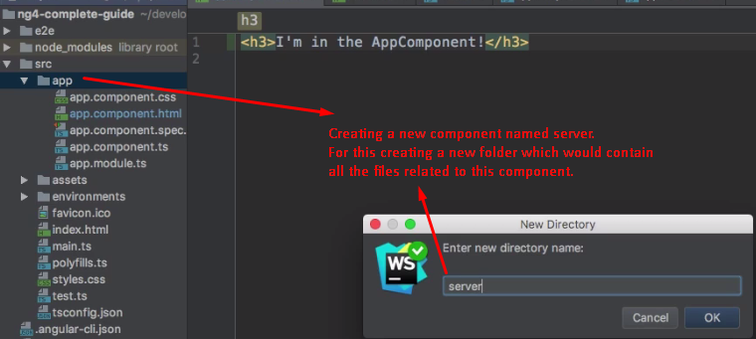  
   **NOTE**: There is no hard-rule to have a separate folder for each component but makes sense.  
   **NOTE**: Component name is server so folder name is also server making sense.
3. Component: Why do we export component class in app.component.ts? 🡺 As we use it outside in another component such as app component.