1. **Types of Candlesticks** 🡺 Bull, Bear & Doji Candle.  
   A diagram of candlesticks with red and black text

   Description automatically generated
2. **Market Players** (Participants = Creatures) 🡺 Bulls, Bears.
3. **Security**: Tradable Financial Asset which can be bought /sold.
4. **Price Action**: The movement of a security’s price plotted over time.
5. **Sentiments**:
   1. Bullish, Bearish, Neutral-Bullish, Neutral-Bearish.
6. A diagram of a body part

   Description automatically generated
7. **Reward to Risk Ratio** = Reward : Risk = 2.5 : 1
8. **Account Size**: The amount we want to trade with.
9. **Stop Loss**: The price at which we want to get out of the market.
10. Hammers, Normal Hammers (with a small upper wick), Classical Hammers (With no Upper Wick).
11. 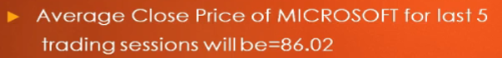
12. Price Chart.
13. **Whipsaw**: When prices move b/w two price points where neither bulls or bears make profits.
14. **Trending Market**: when market doesn’t move sideways.

Intraday Tools/Techniques

1. EMA follows price more closely than the SMA.  
   50Days Double EMA, Triple EMA.  
   Recommended: Jatin 😊 Timeframe 5Min, Triple EMA, Input 10, 10.