1. Spring Data MongoDB is one of the **Spring projects** fro **intergrating** **Spring Framework** with most widely used **NoSQL database MongoDb**.
2. 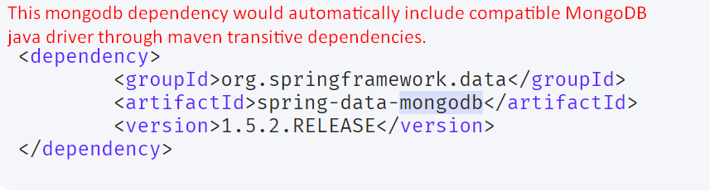
3. Model Bean
4. 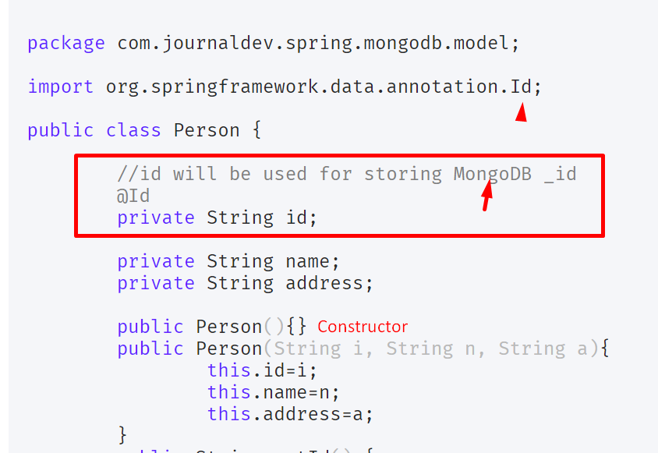
5. 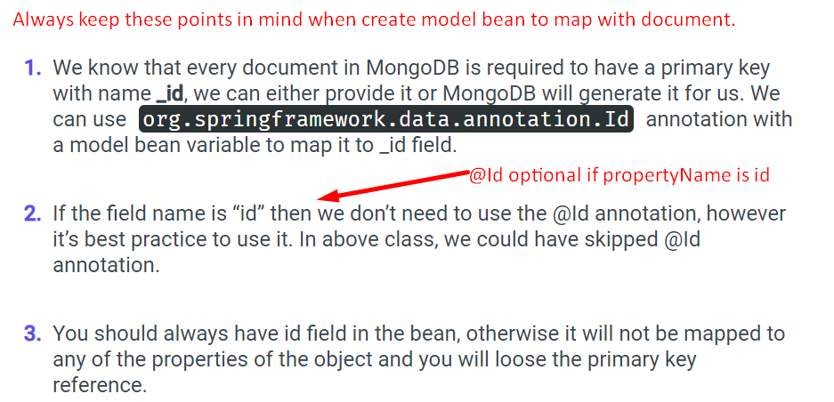
6. Let’s talk about the **components** from Spring Data MongoDb project:  
   **NOTE**: Spring Data MongoDB provides wrappers over the MongoDB java driver internally, it’s using MongoDB java driver to perform database operations.  
    Spirng Data MongoDB itself does marshalling and un-marshalling from java bean into JSON and vice versa.
   1. **MongoOperations**: Declares a lot of methods for different operations.
   2. **MongoTemplate**: Implementation class for **MongoOperations**.
   3. **MongoClient extends Mongo**: Used to create and manage connections. With internal connection pooling. For most app, one **MongoClient** per JVM. Mongo is deprecated and its methods which are not deprecated would be moved into MongoClient.
   4. Org.springframework.data.authentication.**UserCredentials**: If DB password protected, we can use to pass the authentication username and password details.
   5. Org.springframework.data.mongodb.core.query.**Query**  
      Org.springframework.data.mongodb.core.query.**Criteria**: Used to define the query used to find particular record or records.
7. Configuration for Spring Data MongoDB can be provided in
   1. XML
   2. Annotations
   3. Java Config
8. 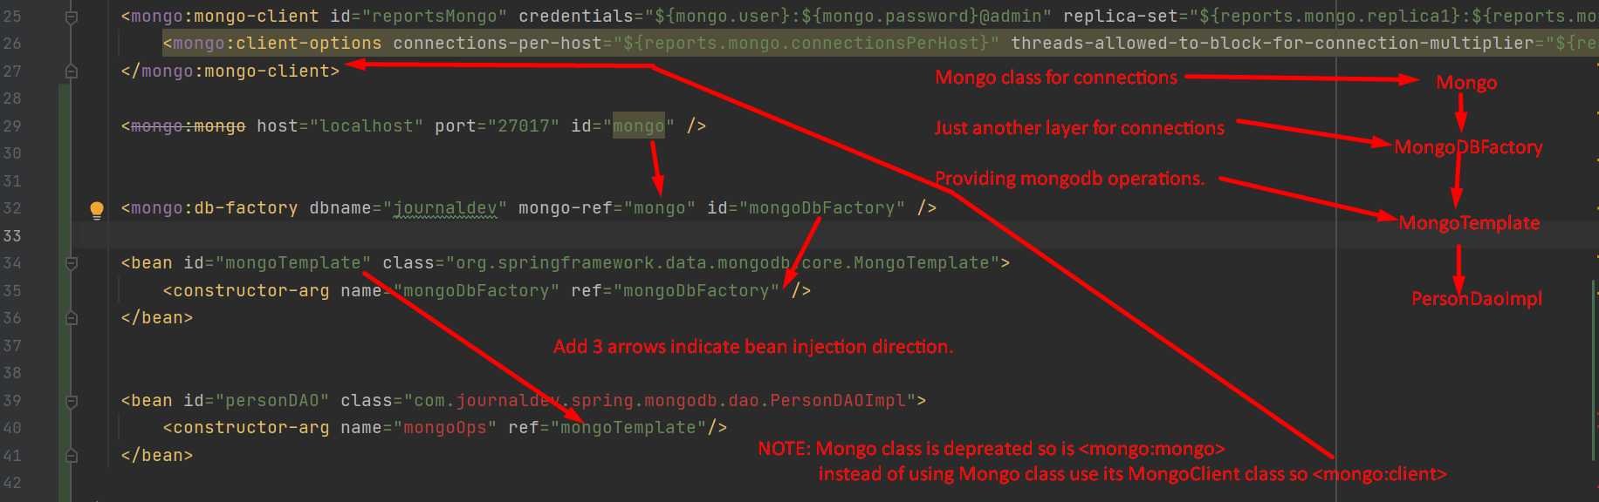  
   NOTE: MongoDbFactory takes MongoClient ( responsible for connections) and this factory is dedicated to a db. Actually we encapsulate db name and connection and then we give this factory to MongoTemplate and using this we perform mongo db operations.
9. 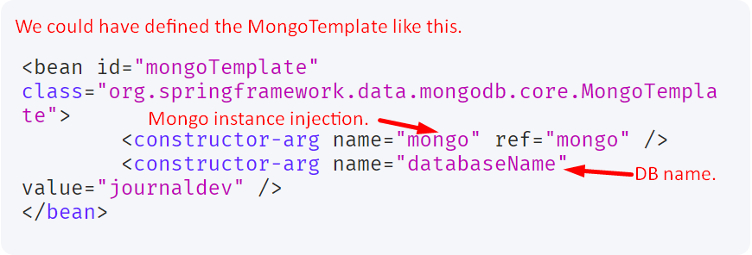
10. 
11. We can use the following annotation above the model class to make it with a particular collection.  
    

Spring Data MongoDB Annotation Based Configuration.

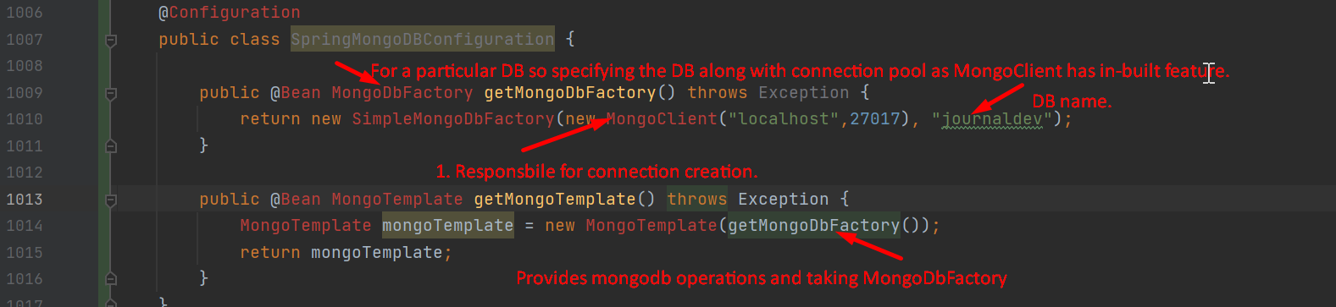

Using MongoOptions for MongoDB Options

