1. <https://www.youtube.com/watch?v=YUdxKYHmaCM>
2. 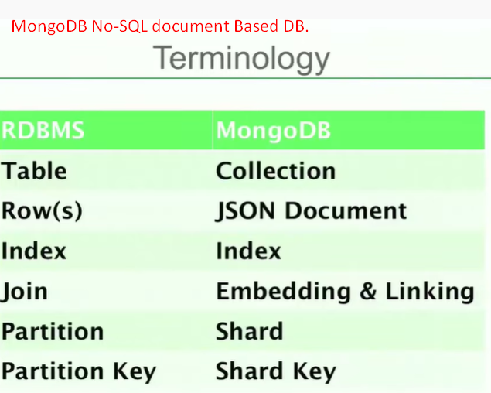
3. 
4. 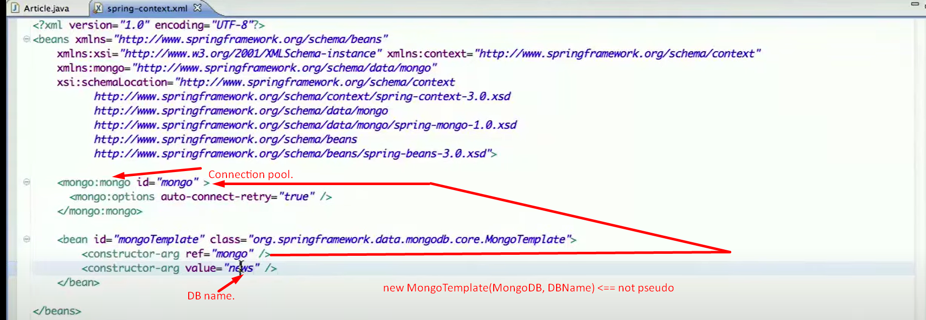
5. **To save Document**🡺 mongoTemplate.insert(documentObject);
6. **To get a Document**🡺  
   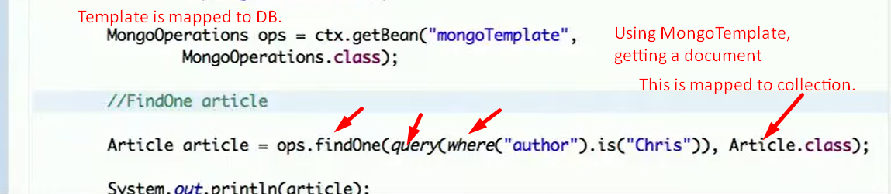
7. **Pushing and popping**:  
   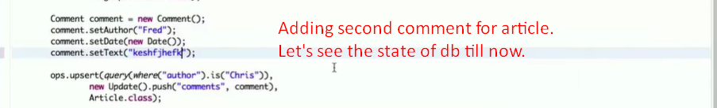
8. 