1. <https://www.youtube.com/watch?v=YUdxKYHmaCM>
2. 
3. 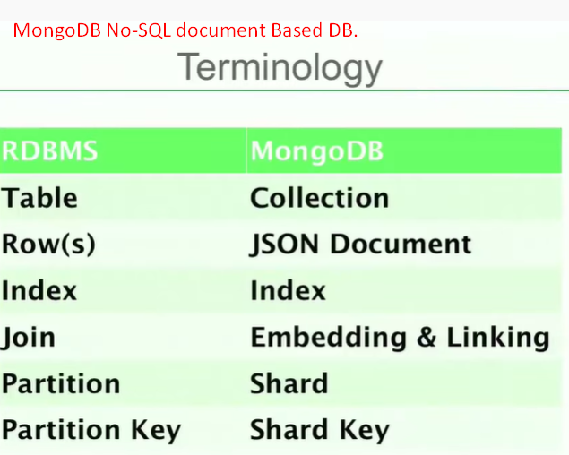
4. We can index any property in JSON document.
5. 
6. 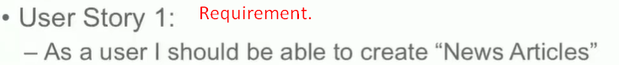
7. 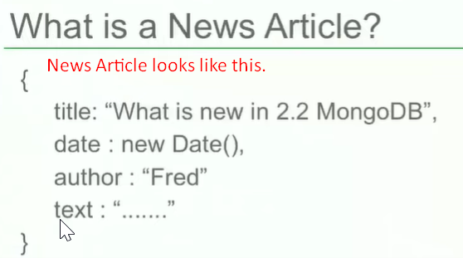
8. 
9. 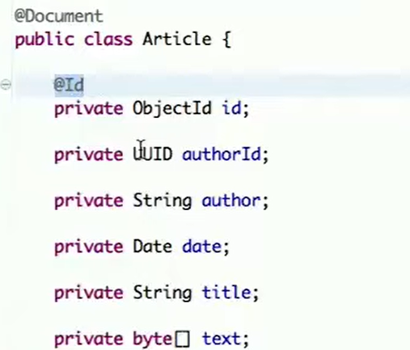Connection configuration.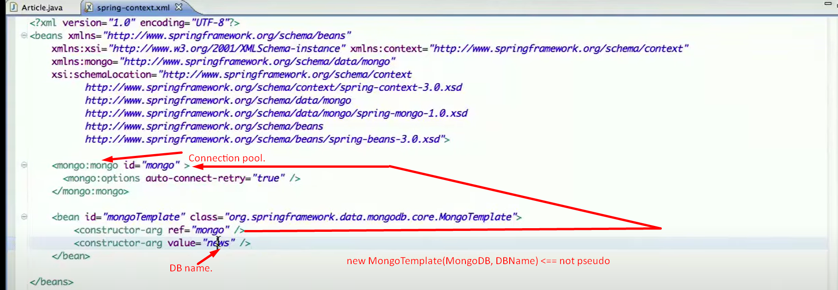 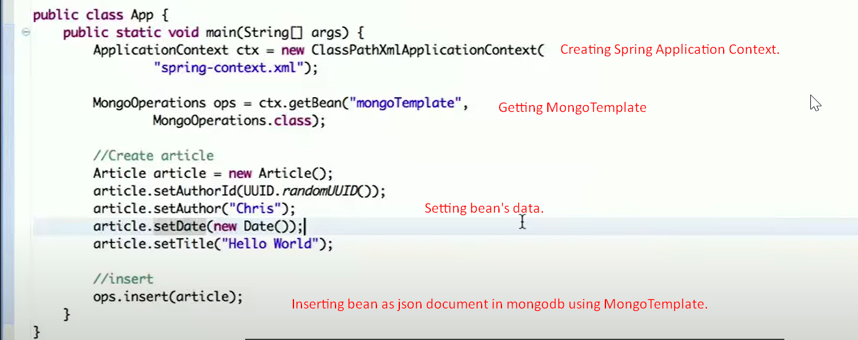  
   Let’s see the output in mongodb.  
   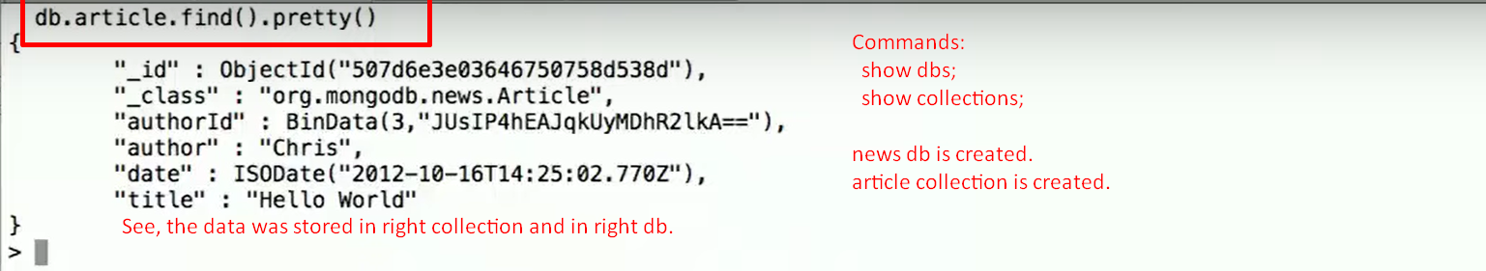
10. How to find a document.  
    
11. 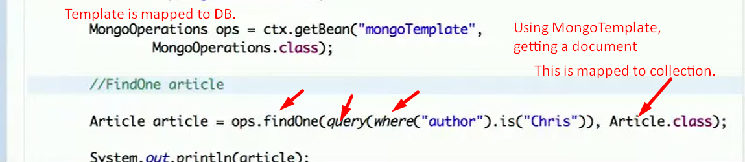
12. 
13. 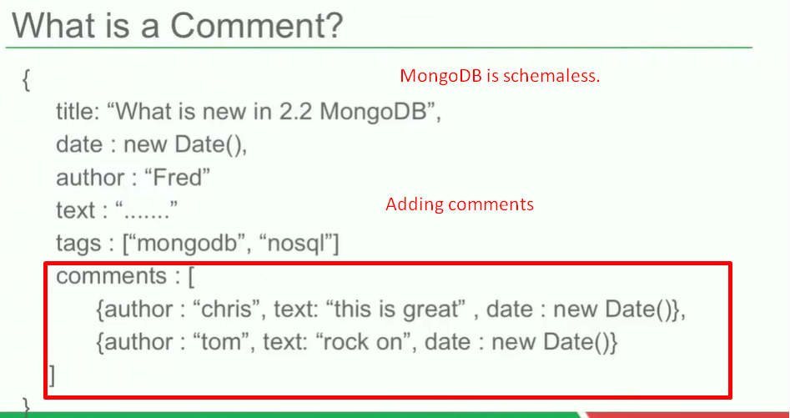
14. 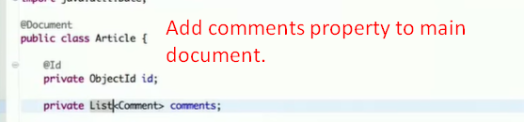
15. 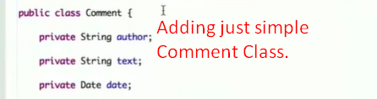
16. **The following would be performed in one transaction which is at document level**.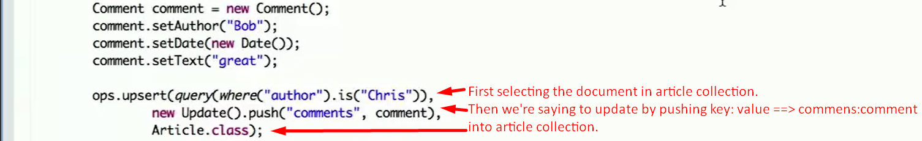
17. 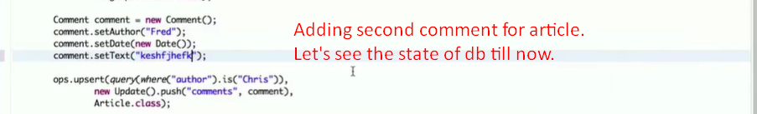
18. 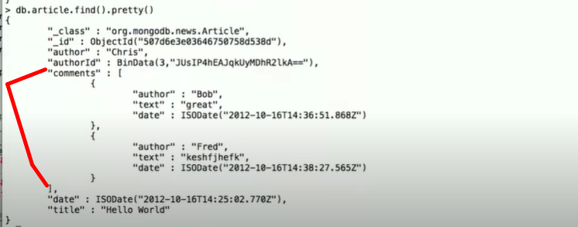
19. 
20.   
    **Output**:  
    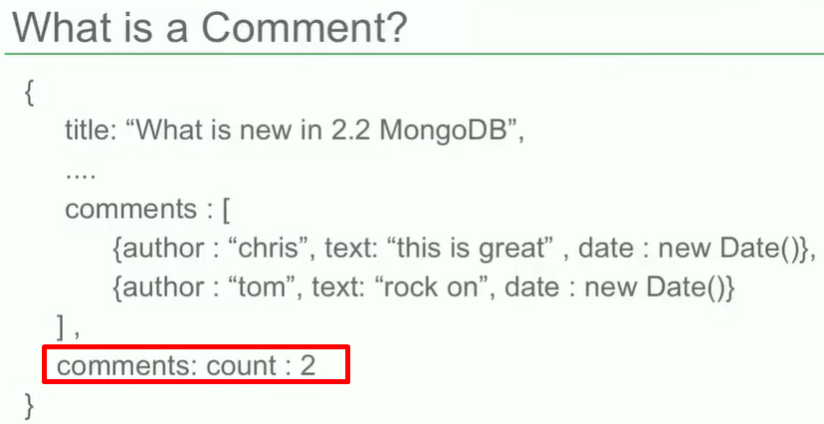
21. 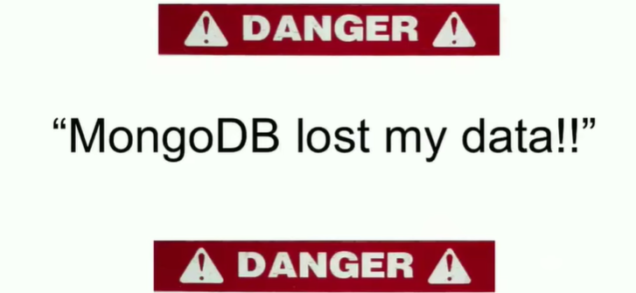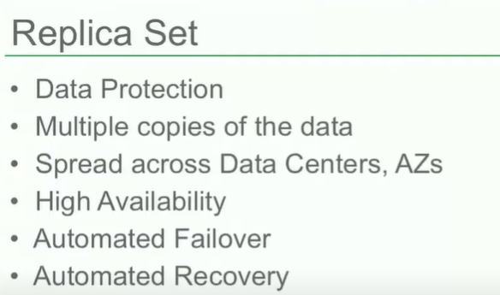
22. Write:
23. 