1. <https://www.youtube.com/watch?v=8r_IMTerZSY>
2. 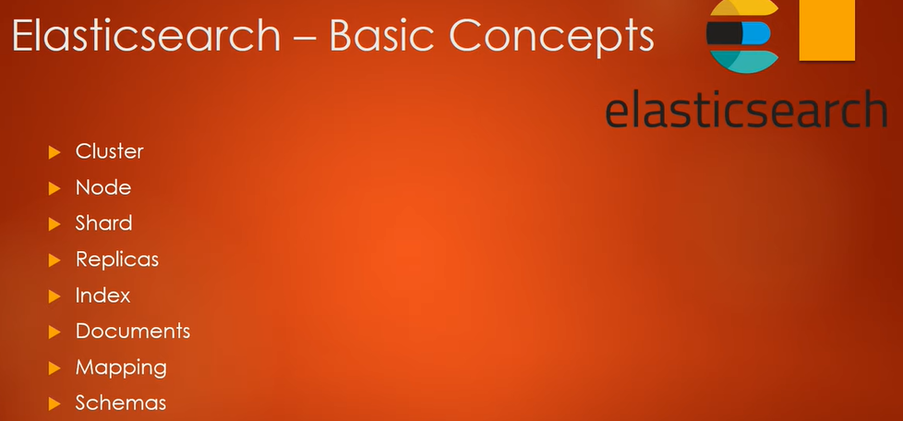
3. What is Elasticsearch?
   1. Fully distributed enterprise search and analytics engine.
4. When to use elasticsearch.
   1. When we want to create our own search engine.
   2. When we want to analyse data such as transactional data or log data and we want to extract some useful info out of it.
   3. When we want to implement centralized logging system where we will be capturing logs from all different kinds of servers posted on different locations. We want to store and see logs from one place.
5. Comparing the data when stored in elasticsearch and RDBMS.  
   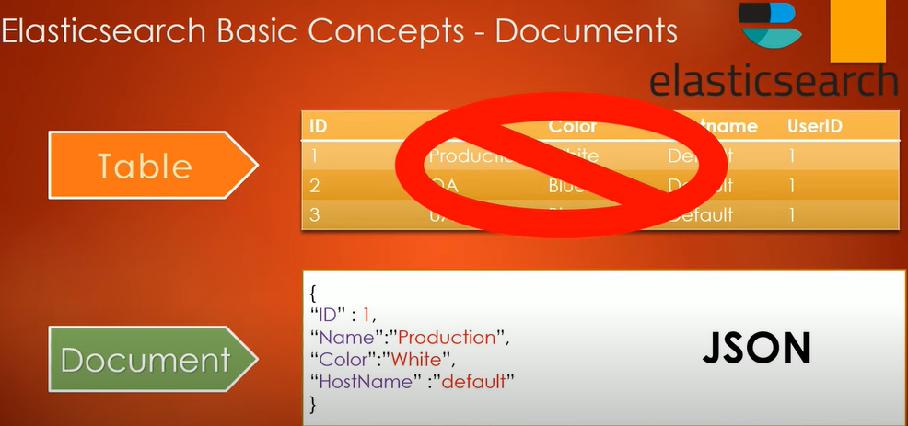
6. 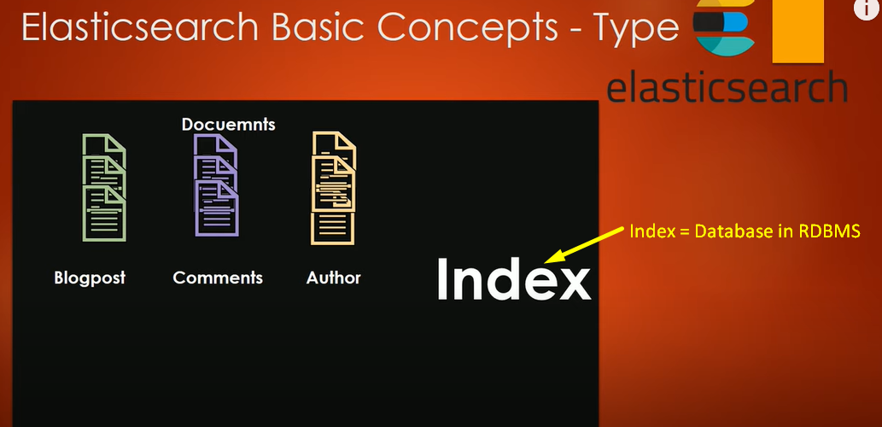
7. **Shards**: Index is divided into chunks. Logical division of all data so that storing, searching and querying can be done easily.
8. **Cluster**: Collection of shards.
9. **Replica**: Copy of shard.   
   Benefit: If shard is down, replica can be used. So that cluster is available.

<https://www.youtube.com/watch?v=PpX7J-G2PEo>

1. 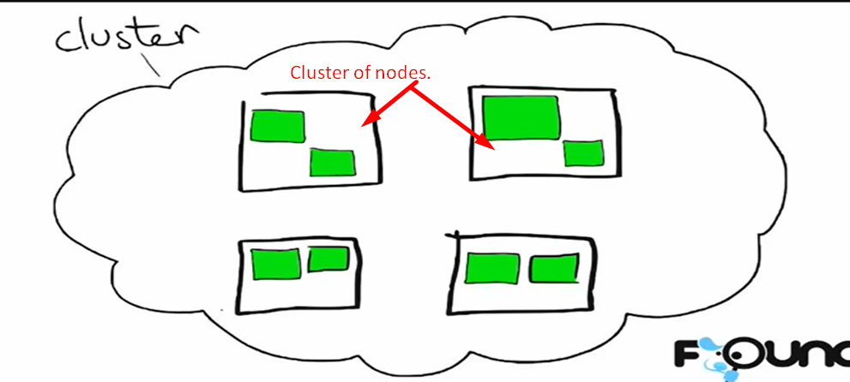
2. 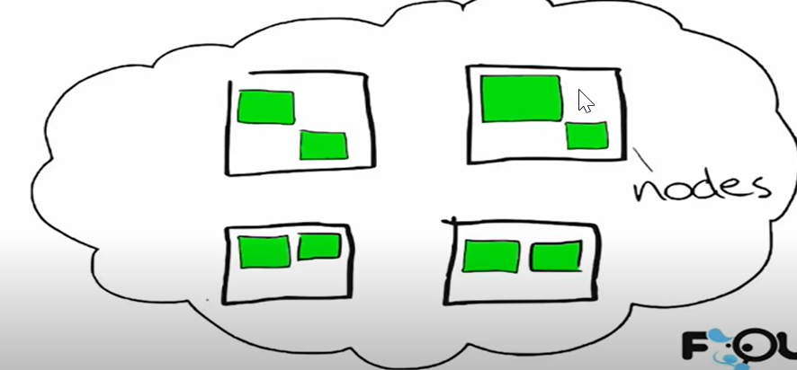
3. 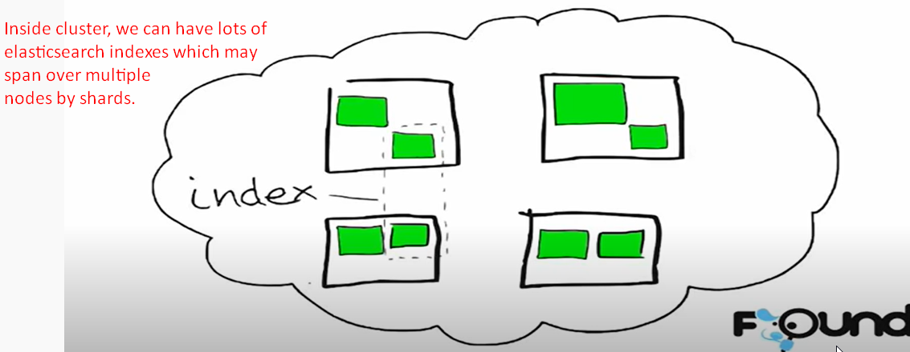

**NOTE**: Above, the two green boxes inside the dashed rectangle is a complete index which is divided into multiple shards where each green box is a shard. Thus, index is spanning over multiple nodes.

1. 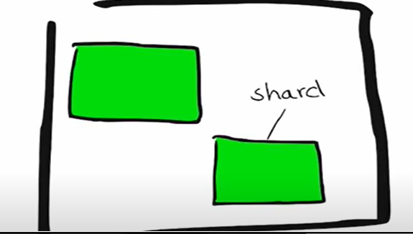
2. Lucene is full-text search library, elasticsearch is built on.
3. 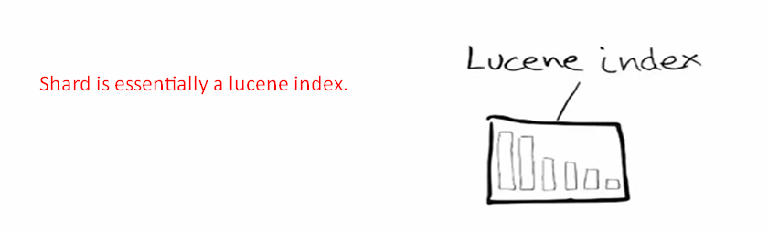
4. Within lucene index, we have segments which are sort of like mini indexes and within segment we have certain data structure like
   1. an inverted index: Key data structure when we have to understand search.
   2. stored fields,
   3. document values,
   4. and so on.
5. **Inverted Index**:
   1. It consists of two parts.
      1. Sorted Dictionary: Containing index terms (search terms)
      2. Posting List: For each index term, there is posting list of documents ids containing the index term.

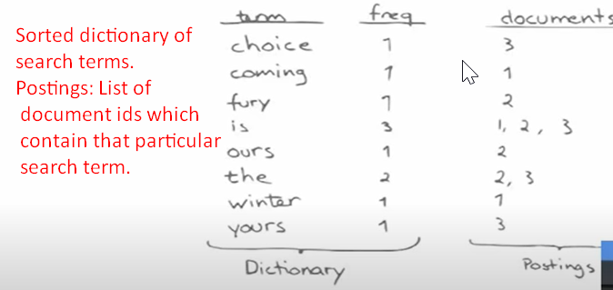

1. How to do index a document.  
   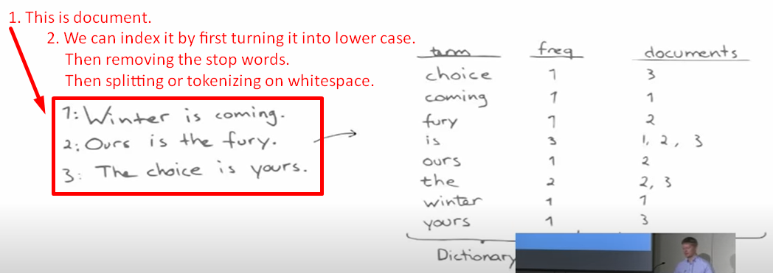
2. 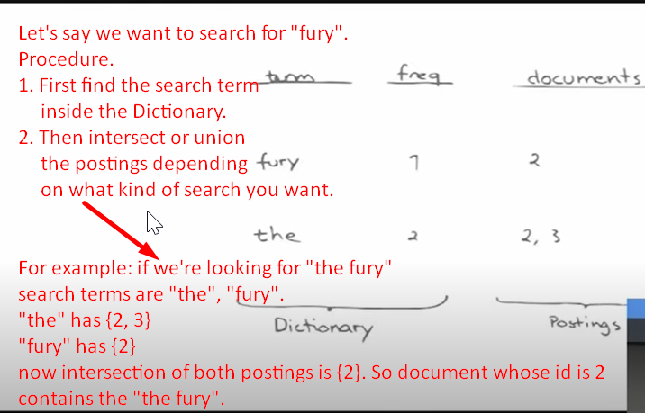  
   Resume the lecture from this time <https://youtu.be/PpX7J-G2PEo?t=312>