|  |  |
| --- | --- |
| **Four kinds of object managed by Git to Keep track of files and changes** | |
| **Object Type** | **Description** |
| **Blob** | **Any kind of File** is stored as **blob**.  Blob File contains = File Size + File Type + Content itself. |
| **Tree** | Dir is stored as a **Tree.** |
| **Commit** | To store different versions of our project. |
| **Annotated Text** | Text pointing to other commit. |

1. Structure of Git DB is similar to JSON.  
   **KEY**: The hash code of the file which is calculated based on the contents of the file. So, in git, we can’t store same file two times.  
   **VALUE**: The file itself.
2. Git uses **SHA1** Hash Function/Algo. 160Bits, 40 Hexadecimal Characters.
3. Total Different files that can be stored under same Repo= 2160
4. Blob = Size + Type (Blob)+ Content  
   Diagram

   Description automatically generated  
   Graphical user interface, text, application

   Description automatically generated  
   **NOTE**: In the above slide, see the structure. The structure is passed to “git hash-object” to calculate Hashcode and the same structure we’re passing as content to shasum to calculate Hashcode. That is why Hashcode is same by both utilities.   
   Graphical user interface, text

   Description automatically generated
5. Tree represents a Directory. All kinds of git objects have same structure.

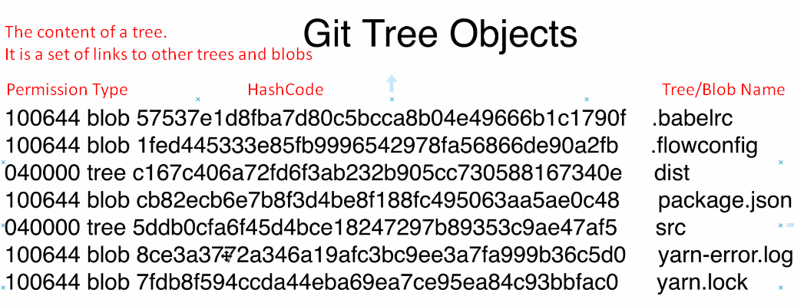

1. d

|  |  |  |
| --- | --- | --- |
|  | **git hash-object** | **shasum** |
| **Calculates SHA1 Hashcode based on** | File Size + File Type + File Contents | File Contents only. |
| **NOTE**: That is why Hashcode is different by both utilities. | | |