Assertion 🡺 1.4v

# Agenda

1. Introduction🡸 Very Important
2. Assert as keyword and identifier.
3. Types of assert statements
4. Various possible Runtime flags
5. Appropriate & Inappropriate Use of assertions
6. AssertionError

Introduction

1. Very rarely our program compiles successfully in first go but compiler gives us hint.   
   Very rarely our program runs successfully. For this, we have to **debug  
   How to debug?**
   1. **Using print-like statement ☺**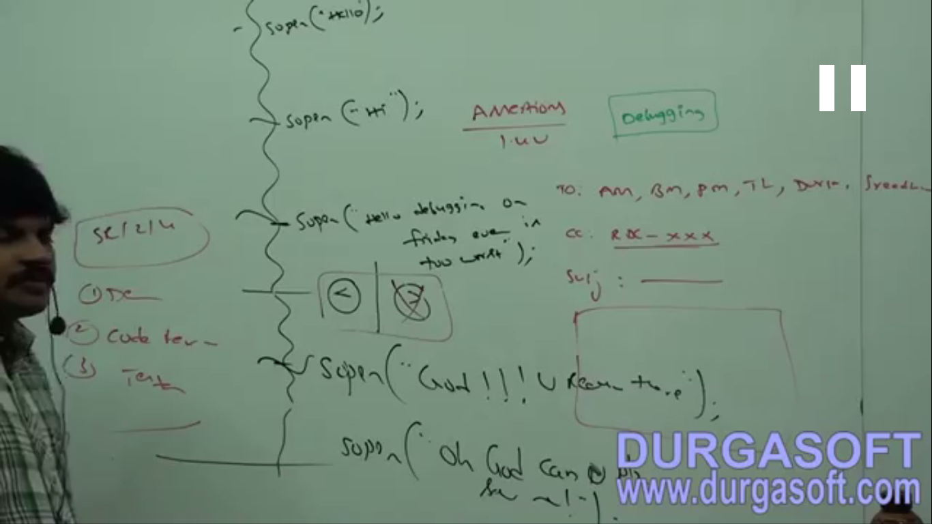

Instead of using <, by mistake, I used >

1. **Problems with print-like statements for debugging**?

If we don’t remove those statements by mistake, those statements would run in production too.

* 1. Performance Problem.
  2. Server-side logging is disturbed with those non-sense statements.

1. **Solution:** Sun people introduced **Assertion concept** in **1.4v**
2. The main **advantage** of assertion when compared with sop is that after fixing the bug, we are not required to remove assert statements because they won’t be execute by default at runtime. Based on our requirement, we can enable and disable assertion and by-**default assertions are disabled.**Hence, the main **objective of assertion** is to perform debugging.
3. **Environment:  
   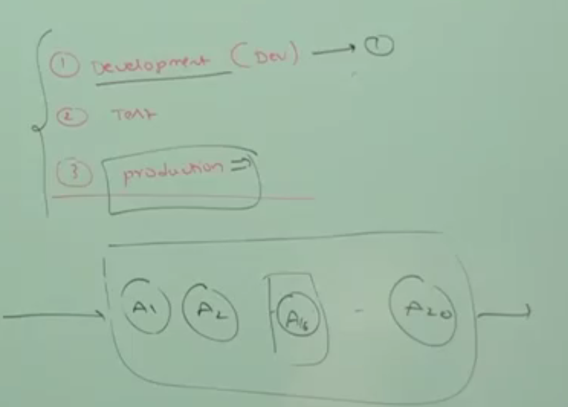**
4. Usually, we can perform debugging in **development and testing environment** but in **production environment**. Assertion concept applicable for development and test environment but not production environment.

assert as keyword & identifier

1. assert introduced in 1.4v. Hence, From 1.4v onwards, we can’t use assert as identifier otherwise we will get compile time error.
2. If assert related questions are asked anywhere (interview, SCJP) but version of JDK is not mentioned then consider the current version of JDK in market.
3. **When running a code having assert as identifier with different version what happens?**
   1. **When with 1.6v  
      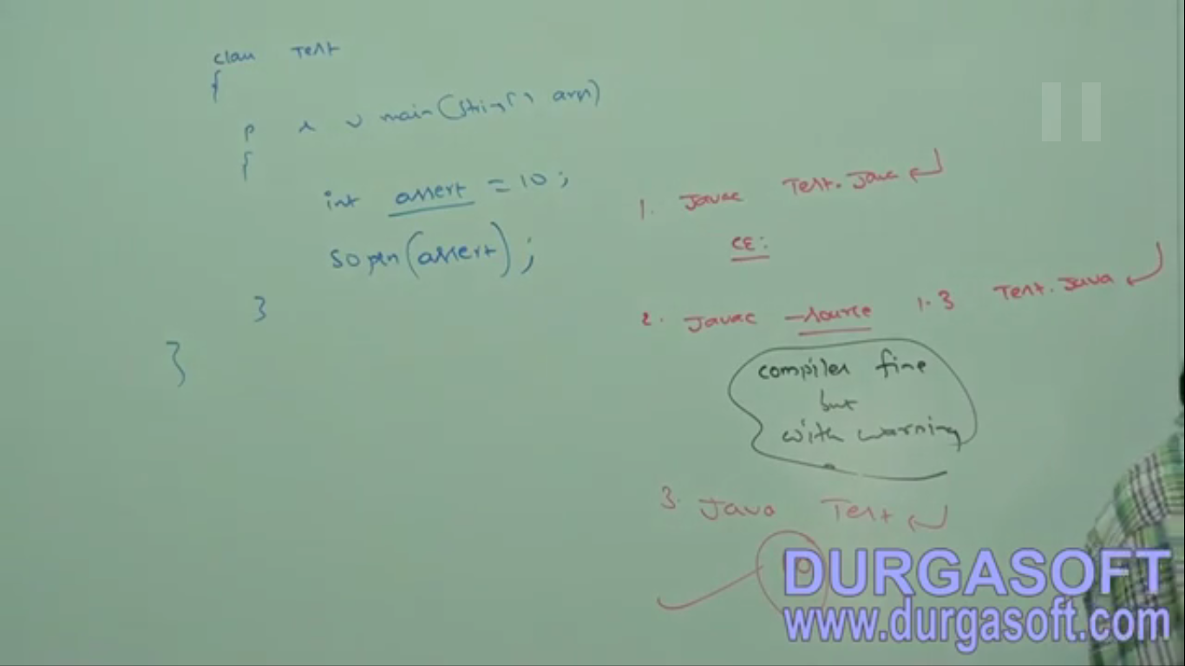  
      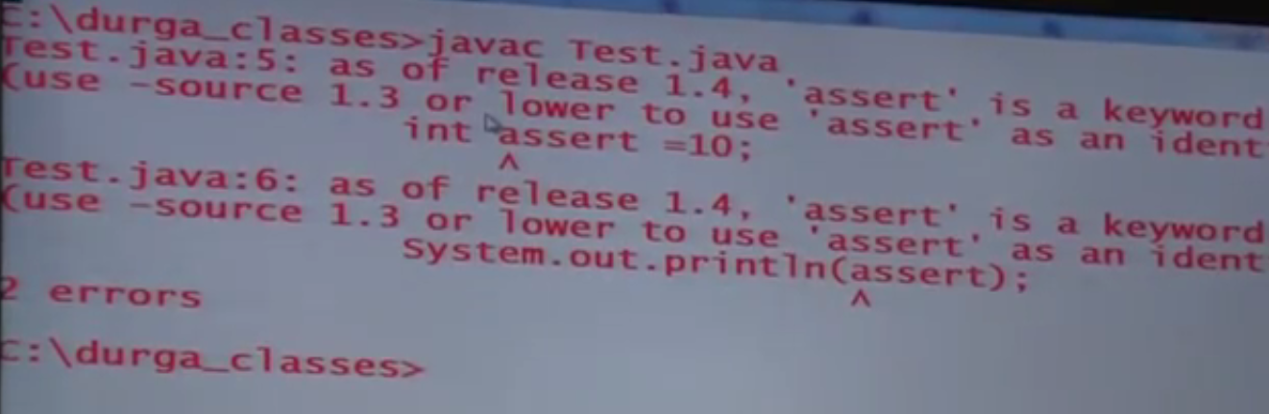**
   2. **If we compile with 1.3 or lower but the installed one is 1.4 or higher, then the compiler will compile the program but with a warning as the 1.4 or higher versions are aware of assert as keyword.   
      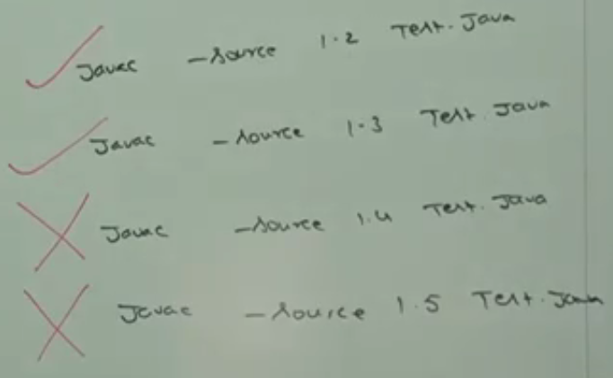**
4. d
5. d