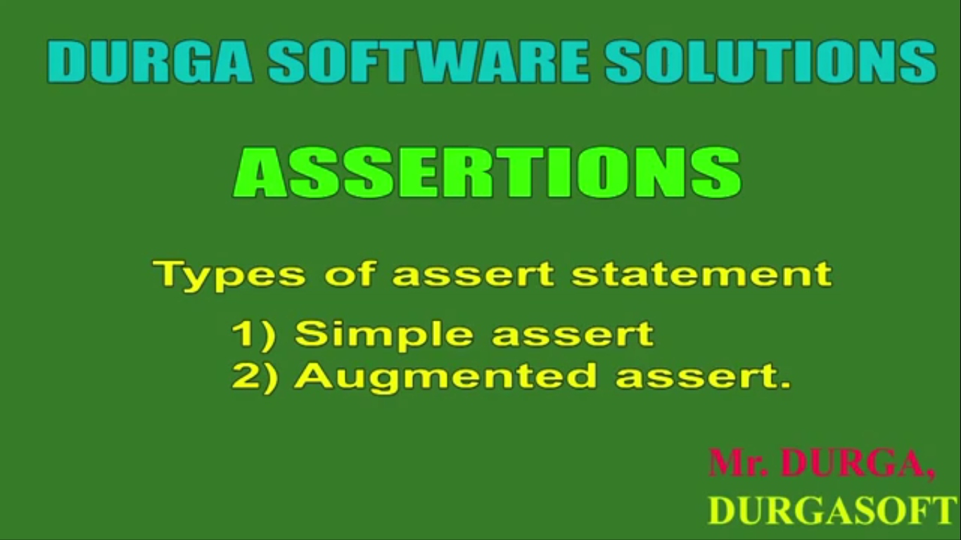

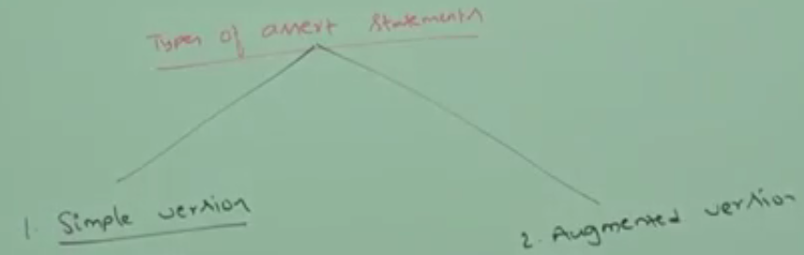

Simple Assert Statement

1. **syntax**:
   1. **assert(boolean b)**
2. **if the b value is false then it means our program will terminate abnormally by raising exception error. Once we get asser**tion error, then by analyzing the error, we can fix the error.
3. How to enable assert?
   1. java -ea Test // ea 🡺 **E**nable **A**ssert
4. **Error**:
5. 

Augumented Version of Assert Statement

1. We can augment some description with assert error by using augmented version of assert statement.
2. **Syntax:**
   1. assert(b):e;
   2. b 🡺boolean
   3. e🡺Any Type but most times 🡺 String Type 🡺 actually e is expression so it can be method call returning value.
      1. Primitive Types
      2. Secondary Types
3. How to read assert(b):e 🡺 if b is false then evaluate e and print the result on screen.

Loop Holes in Augmented Version

1. assert(b):e 🡺 e will be executed if and only if the first argument is false. If the first is true then second argument will not be evaluated or executed.   
   **When assert is true**;  
   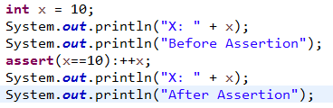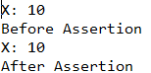  
   **When assert is false**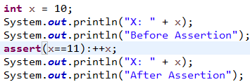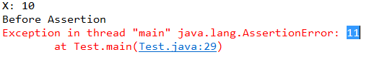
2. assert(b):method(); if method() call doesn’t return anything, we will get compile time error.   
   For the second argument, we can take method call but void return type method call is now allowed otherwise we will get compile time error.   
   