# Write a program to insert String objects into TreeSet where all elements should be inserted according to reverse of alphabetical order.

If we are depending on Default Natural Sorting Order, then objects should be

* Homogeneous
* Comparable

Otherwise we will get ClassCastException

If we are defining our own sorting by Comparator then objects need not be Comparable and Homogeneous. That is, we can add heterogeneous objects also.

# Write a program to insert String and StringBuffer objects into TreeSet where Sorting Order is increasing length order.

# Tips: 🡺 Use toString() method inside compare(Object, Object) to convert the received objects into String objects. All the classes can be divided into following 3 groups. Write a program to insert Employee Objects into TreeSet

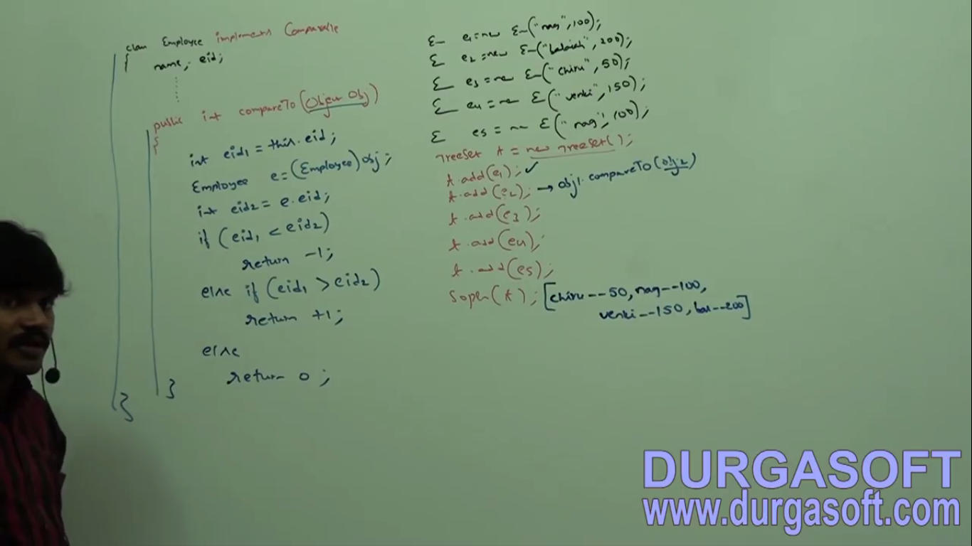

As per employee ids

Default Natural Sorting Order

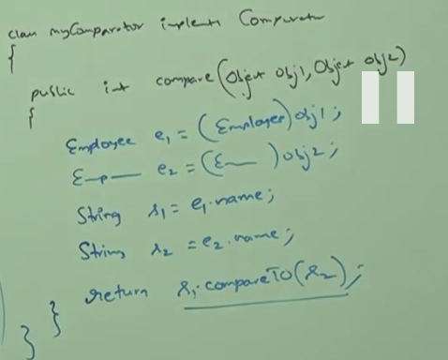

Customized Sorting Order for Employee as per names

|  |  |
| --- | --- |
| Comparable | Comparator |
| Default Natural Sorting Order | Customized Sorting Order |
| java.lang | java.util |
| Only one method 🡺 compareTo(Object) | 2 Methods   * compare(Object, Object) * equals(Object) |
| Ex🡺String and all wrappers | Ex🡺Collator, RuleBasedCollator |

