SortedMap(I)

1. It’s child interface of map.
2. If we want to represent a group of key, value pairs according to some sorting order of keys, then we should go for SortedMap.  
   NOTE: Sorting is based on the Keys.
3. **SortedMap defines the following specific methods same as SortedSet(I)  
   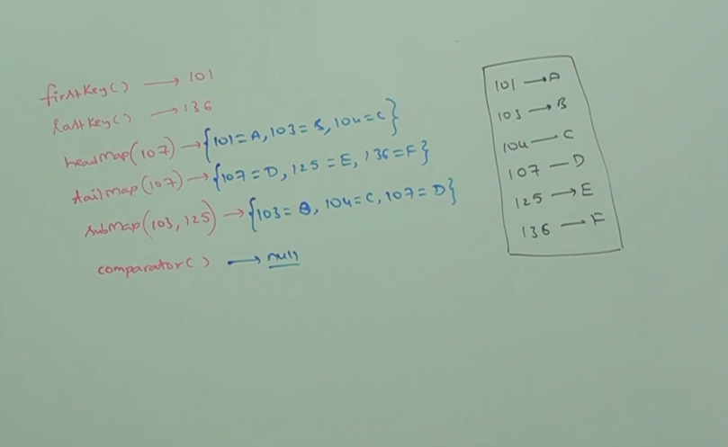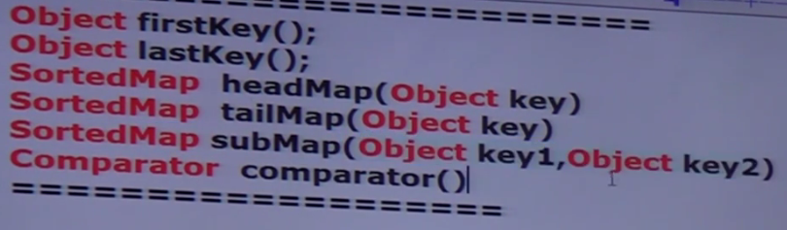**

if default natural sorting order

TreeMap

1. **Characteristics**:
   1. Underlying datastructure🡪 Red-Black
   2. Insertion Order is not preserved.
   3. Sorting is based on Keys.
   4. Duplicate keys not allowed but values
   5. key type:
      1. If we depend on default natural sorting order, then keys should be homogeneous and Comparable otherwise no need for homogeneous and Comparable.
   6. null insertion: no possible in 1.7 and upwards otherwise we can insert only once as first entry.
2. **Constructor:**  4 Constructors
   1. TreeMap()
   2. TreeMap(Comparator)
   3. TreeMap(SortedSet)
   4. TreeMap(Map) 