Hashtable

1. NOTE: Hash Table is standard non-java Data Structure from Data Structure Concept.
2. **Features**:
   1. Java Hashtable(C) is based on standard data structure🡪 Hash Table.
   2. Insertion order is not preserved.
   3. Duplicate keys are not allowed but values
   4. Heterogeneous keys and values allowed.
   5. null insertion not for key and value.
   6. implements Serializable(I) and Cloneable(I) but RandomAccess(I)
   7. Thread-Safe
   8. Best for Search Operation.
3. **Constructors**:
   1. HashMap()
      1. initial Capacity🡪 11 where 12🡪 HashSet, HashMap
      2. fill Ratio🡪 .75
   2. HashMap(Int initialCapacity)
   3. HashMap(Int initialCapacity, float loadFactor)
   4. HashMap(Map map)
4. **Time**

How Hash Code works?

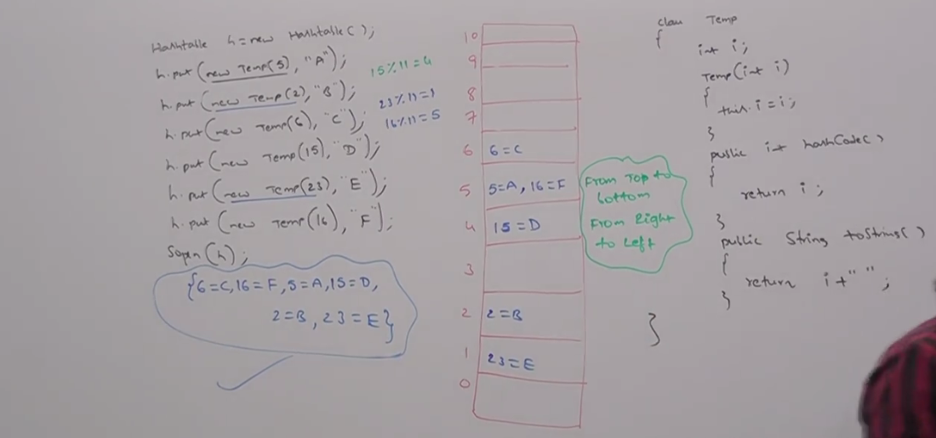

when printing

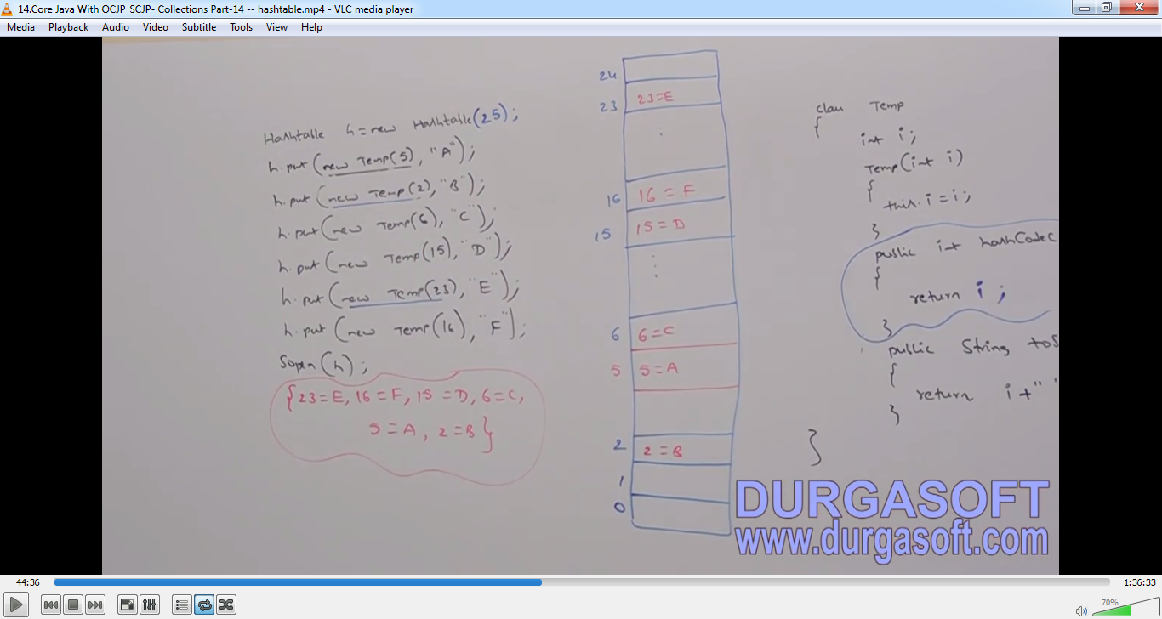

Properties

1. In our program, if anything which changes frequently like username, password, mail –id, mobile no etc are not recommended to hard code in java program because if there is any change, to reflect that change, we need to do the followings
   1. Recompilation
   2. Re-build (ear, war, jar)
   3. Re-deployment
   4. Restart (sometimes)

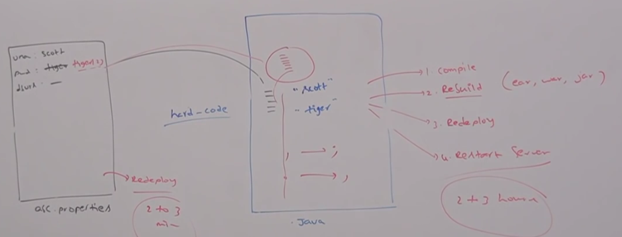

Which creates a big business impact to the client.

1. **Solution**: We can overcome this problem by using properties file. Such type of variable things, we have to configure in the properties file. From that properties, we have to read into java program and we can use those properties.
2. **Advantage**:
   1. If there is change in properties file, to reflect that change, just redeployment is enough which will not create any business impact to the client.
3. We can use java Properties object to hold properties which are coming from properties file.
4. In normal map (HashMap, Hashtable, TreeMap etc), key and value can be of any type but in the case of Properties(C), key and value should be of String type.
5. **Constructor**:
   1. Properties()
6. **Method**:
   1. String getProperty(String propertyName)
   2. String setProperty(String key, String value)
   3. Enumeration propertyNames()

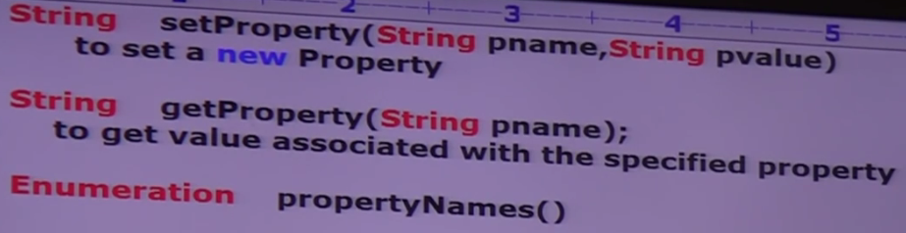

**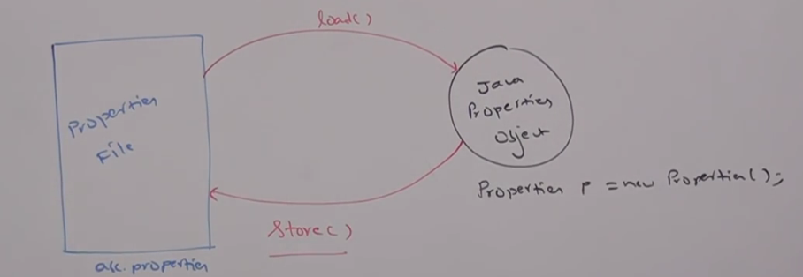  
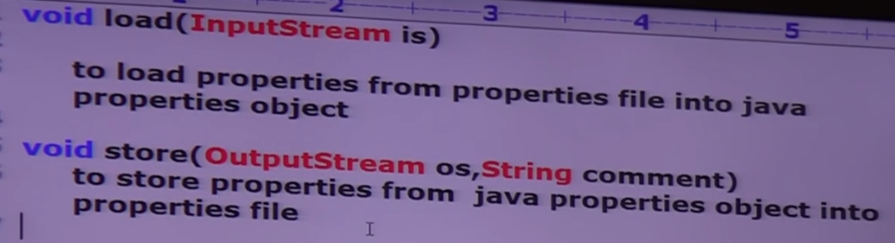**

1. **Demo  
   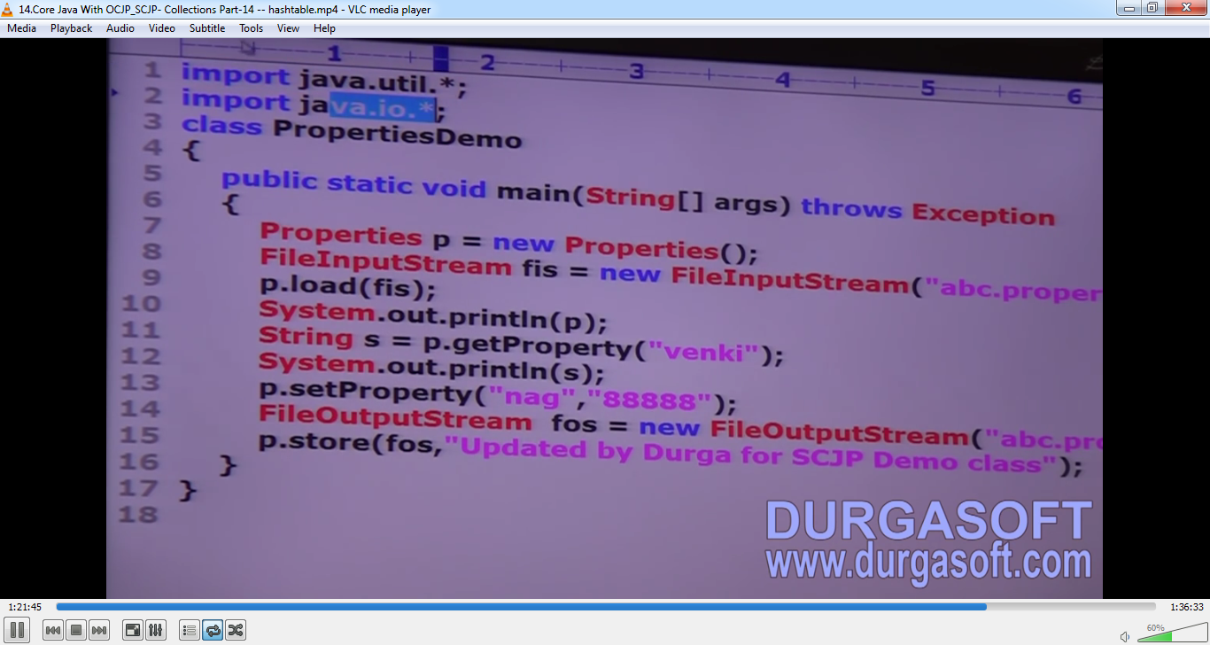  
   Output  
   