# Searching elements of list using Collections Utility Class

1. Collections class defines the following binary search methods
   1. If list is sorted according to Default Natural Sorting Order then use this method
   2. 

We have to use this method if list is sorted according to customized sorting order.

**Conclusion**: The above search method internally will use binary search algorithm.   
Successful search returns **index**.  
Unsuccessful search returns **insertion point**.  
Insertion point: Location where we can place the target element in the sorted list.  
**\*\*\*NOTE**: Before calling binarySearch (), compulsory the list should be sorted otherwise we will get **unpredictable result**.

If the list is sorted according to comparator, at the time search operation also, we have to pass same comparator object otherwise we will get **unpredictable result.**

1. Demo to binary search   
   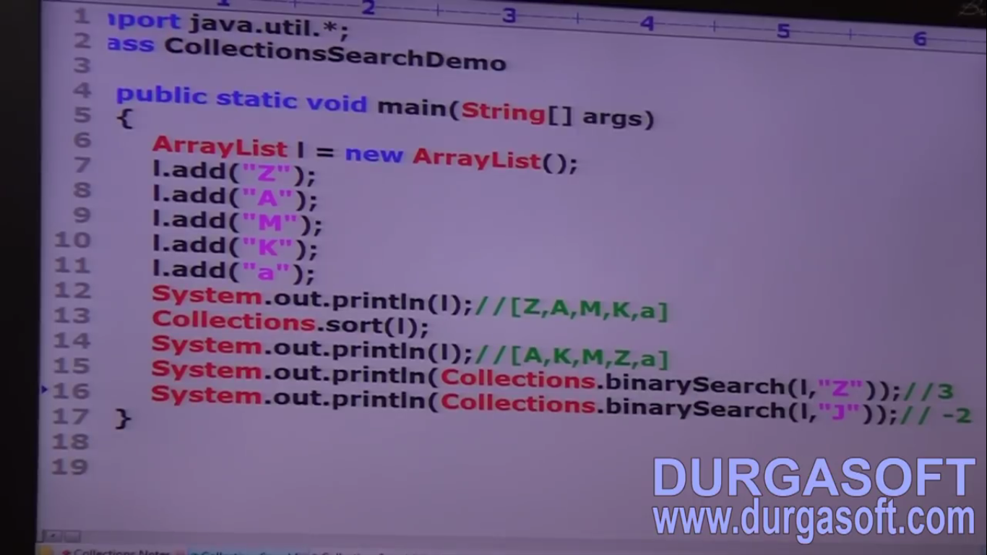  
   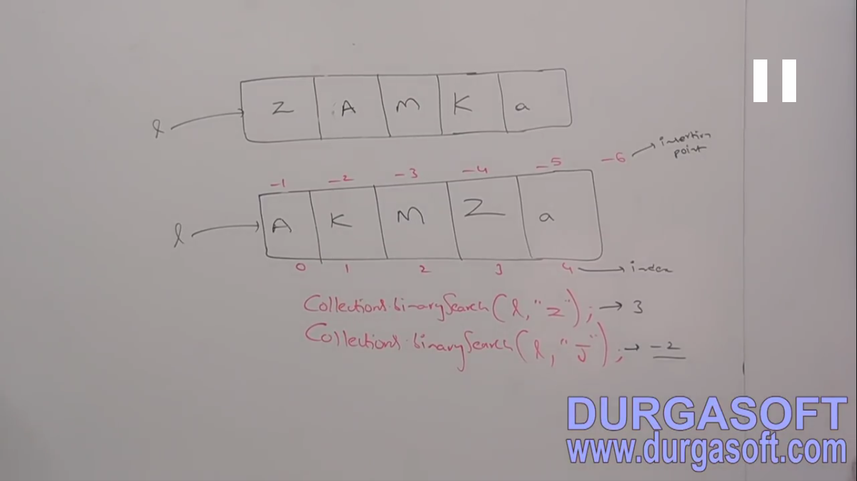
2. Demo to binary search  
   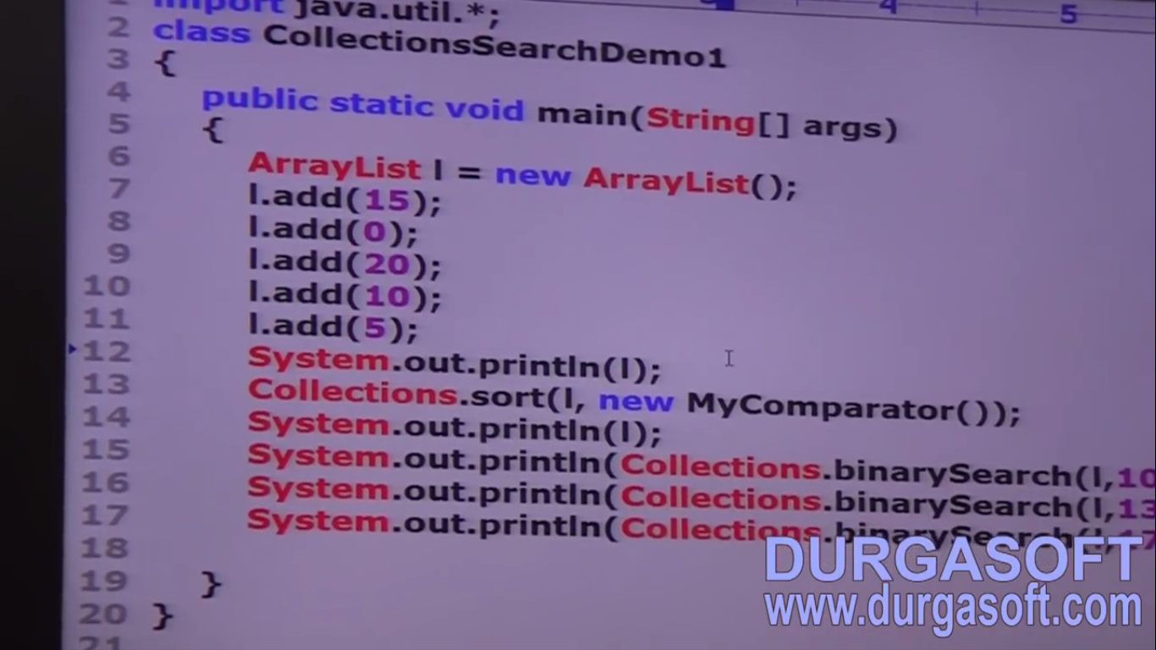 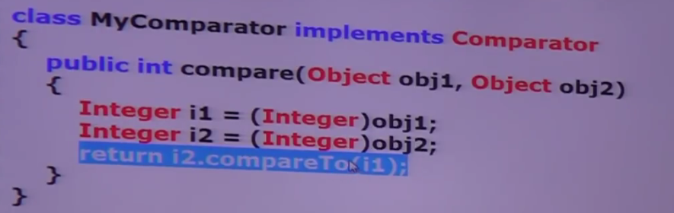  
   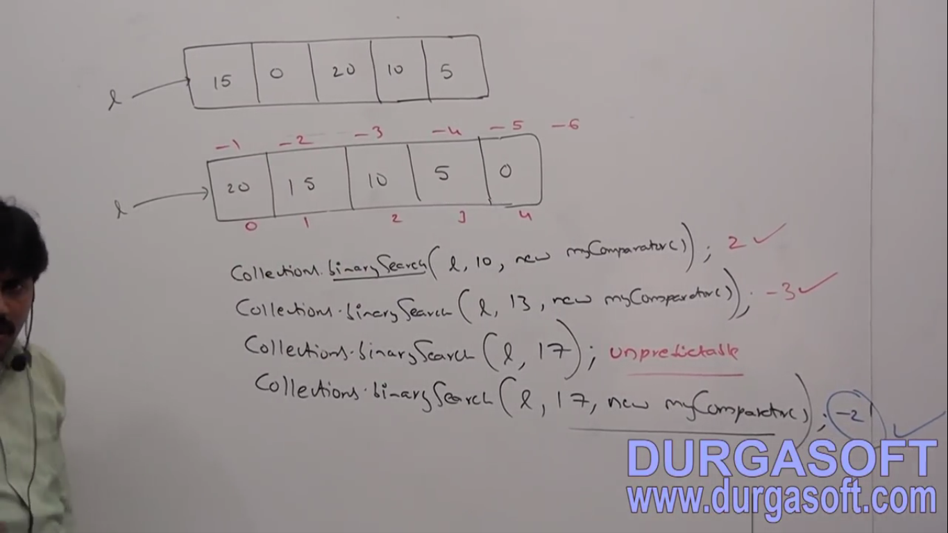
3. 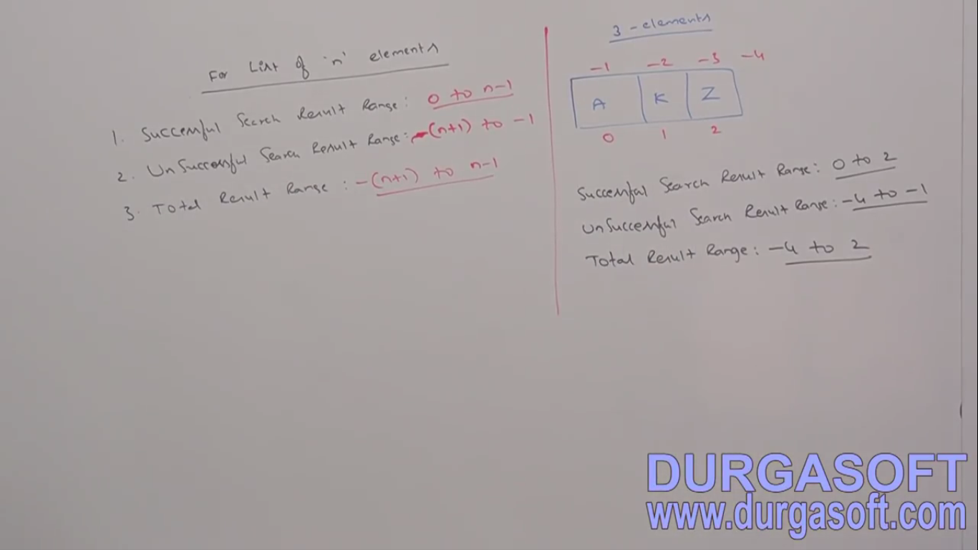
4. f

Collections reverse()

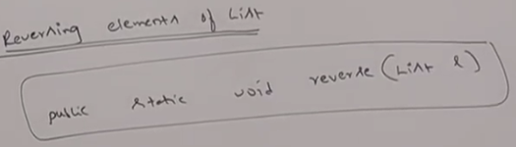

The above reverse() is used to reverse the elements of List.

**Example**:  
