Arrays(C)

1. Arrays class is a utility class to define several utility methods for array/array objects.
2. Arrays class defines the following 3 sort methods to sort elements primitive and object type of arrays.
   1. 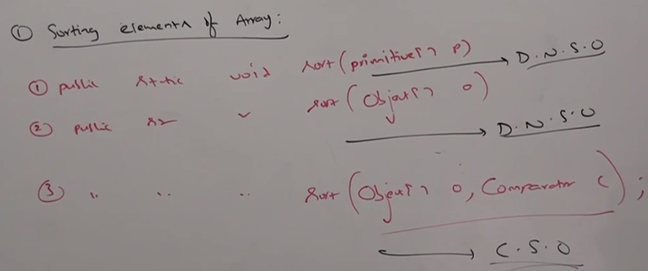  
      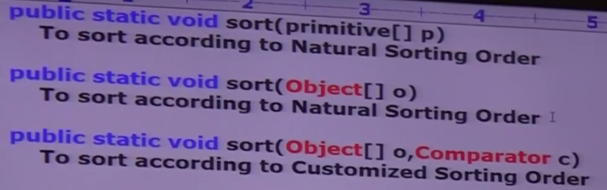  
      **NOTE**: We can sort primitive arrays only based on **Default Natural Sorting Order** whereas we can sort Object arrays either based on **Default Natural Sorting Order** or **Customized Sorting Order**.

# Searching an elements of an array

1. Arrays class defines the following binary search methods.
   1. 
   2. **NOTE**: All rules of Arrays class binarySearch () is exactly same as those for Collections class binarySearch ().
2. **Example**:  
   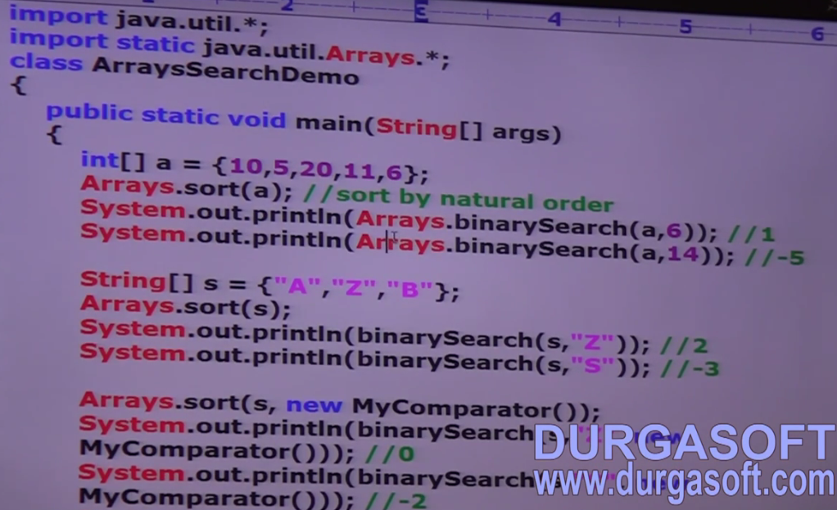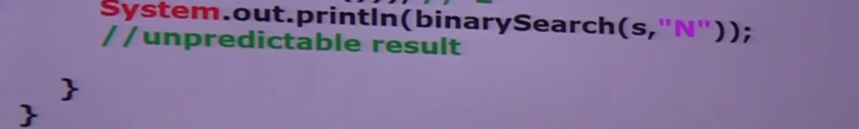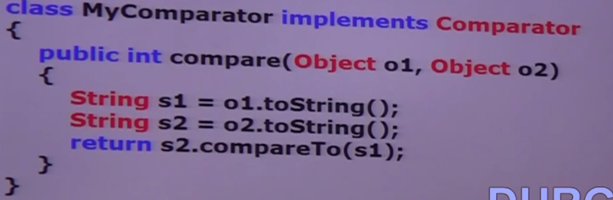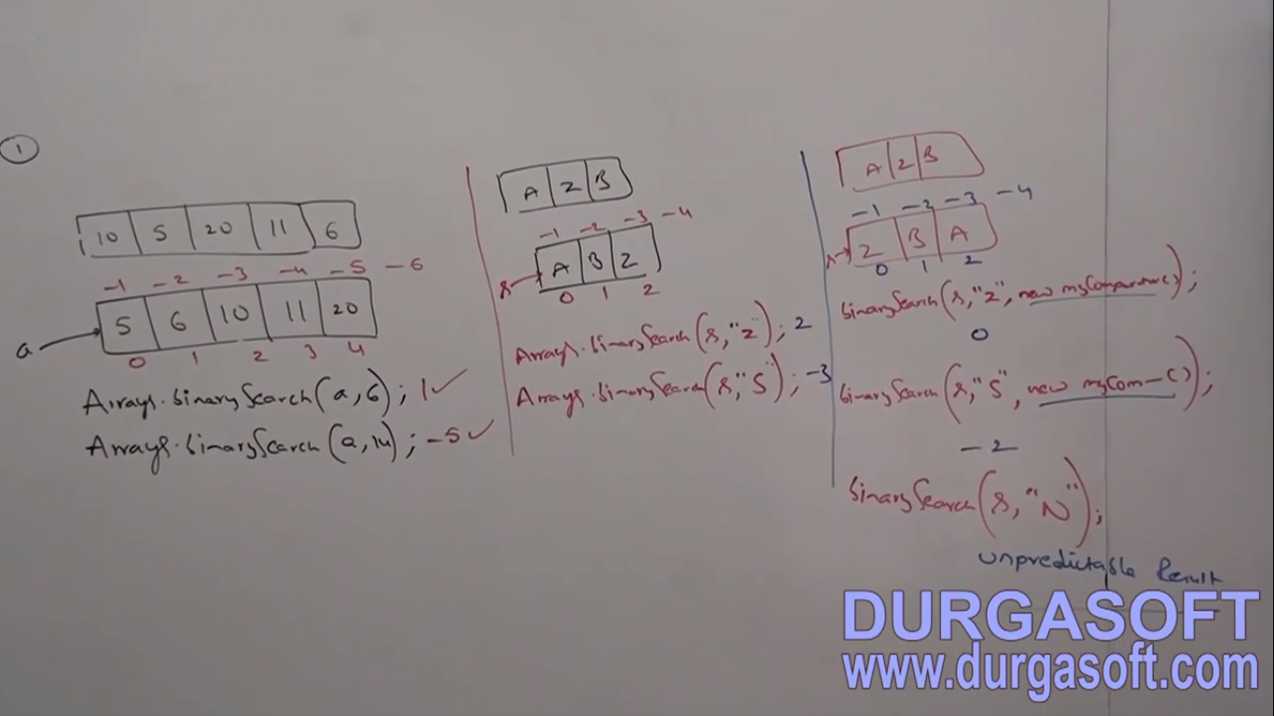
3. **d**

Conversion of arrays to List

1. 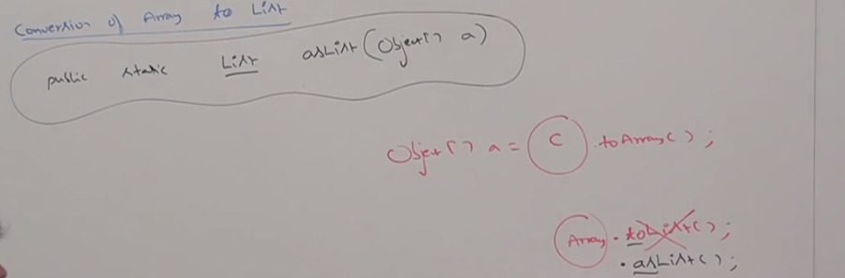  
   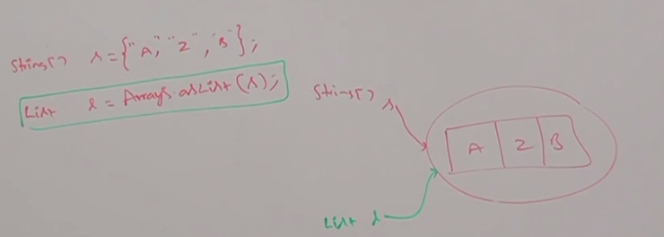  
   Strictly speaking, this method will not create an independent List object for the existing array, we are getting “List View”.   
   **NOTE**: By using array reference, if we perform any change, automatically that change will be reflected to the List, similarly, by using List reference, if we perform any change, that change will be reflected automatically to the array.  
   **NOTE**: If by using List reference, we try to make any kind of operations which change the size(Not the capacity) of the underlying array you would get exception 🡪 UnsupportedOperationException  
   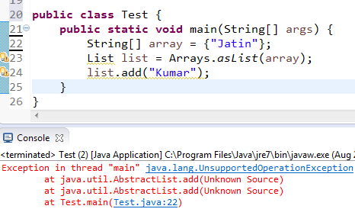

remove() also changes the size of list/array so this would also throw \