fail-fast & fail-safe

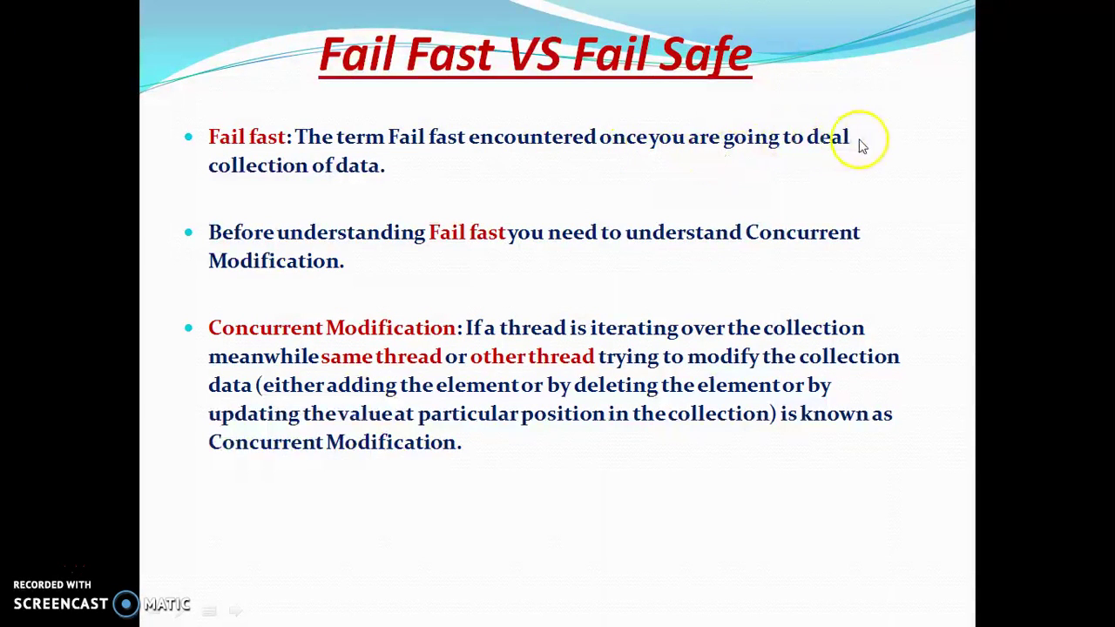 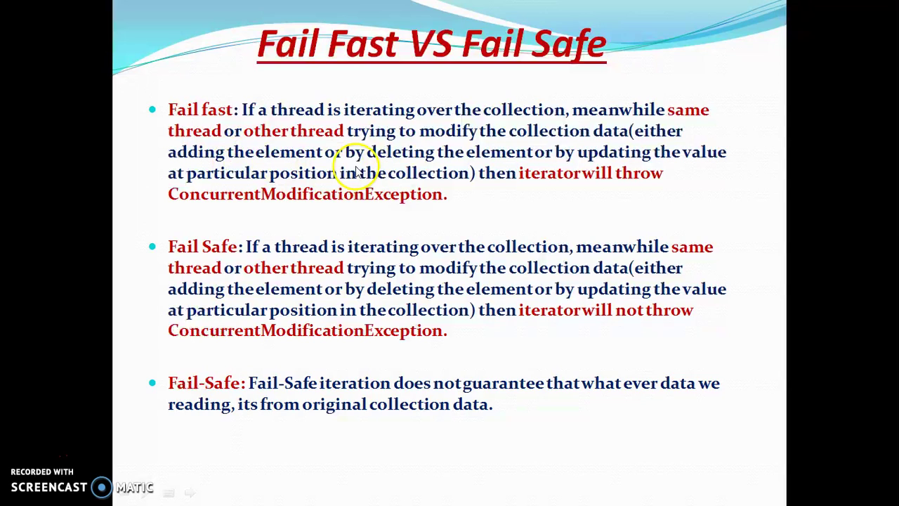

# Who throws the ConcurrentModificationException?

Iterator implementation class.

# What is the exact point when ConcurrentModificationException is thrown?

Follow the steps in the slide: 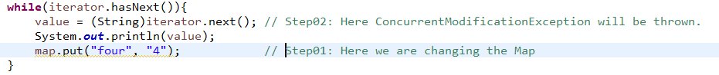

ConcurrentModificationException is thrown when we call iterator.next() after changing the collection to which the iterator belongs. ☺  
NOTE: No Map has any iterator. Only Collection part has iterator. In case of Map, we first get all keys as collection then we get its iterator. ☺