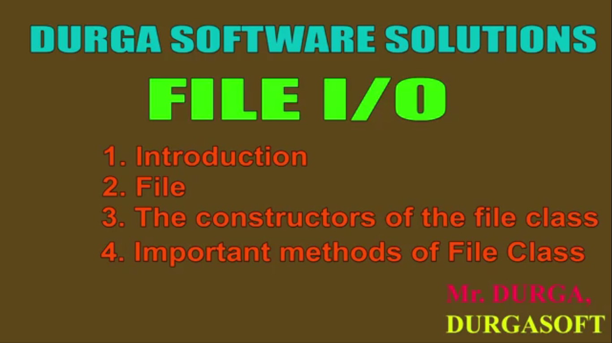

File Related SCJP History

1. Java 1.0v came in 1995. At that time, DB was not that popular. DB got popularity in around 2004.Till that, there were 1.0, 1.2, 1.3, 1.4v in the market. So SCJP exam for those versions was full of file related question up to 7-8 questions. But suddenly, near about 2004, when db got popularity, The File concept got failed because people liked to go for DB instead of file to store data. So SCJP exam cut off the file related questions outside. But again suddenly, file questions were again on exam in SCJP 1.5, 1.6v as it was considered that to store small amount of data, to go for db is not good.   
   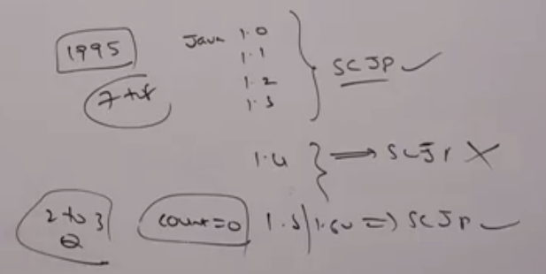

Syllabus

1. File
2. FileWriter
3. FileReader
4. BufferedWriter
5. BufferedReader
6. PrintWriter

**NOTE**: These 6 classes, we will discuss

File(c)

1.   
   This line will not create any physical file. First, It would check is there any physical file named “abc.txt” available or not. If it’s available, then file simply refers that file. It’s not available, then we are just creating java file object to represent the name “abc.txt”
2. We can use Java File object to represent directory also.   
   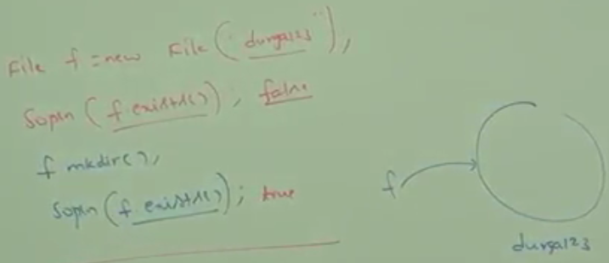
3. **NOTE**: In UNIX, everything is treated as file. Java File IO concept is implemented based on UNIX Operating System. Hence, Java File can be used to represent both **files & directories**.
4. **File Class Constructors:**
   1.   
      Creates a Java File object to **represent name of the file or directory** in current working directory.
   2.   
      Creates a Java File object to **represent name of the file or directory** present in specified subdirectory.

filename 🡺 “hello.txt”  
DirName🡺 “xyz”, “xyz\mno”  
“Combination” 🡪 “xyz\hello.txt”  
NOTE: don’t use driveName🡺 “E:\\hello”

“DriveName”🡪 E:\, F:\  
“DirName” 🡪 “xyz”, “xyz\mno” (in Current Working Dir),  
“Combination” 🡪 “E:\\xyz”

* 1. 

1. **Example 01:** Write code to create a file named with “abc.txt” in current working directory.  
   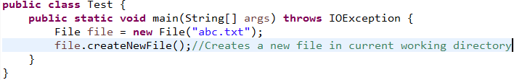
2. **Example02:** Write code to create directory named “” in current working directory and create a file named “Demo.txt” in that directory.  
   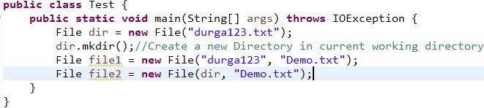
3. **Example03**: Write code to create a file named “abc.txt” in e:\xyz folder.  
   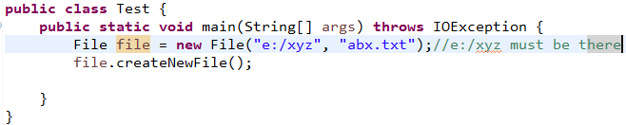
4. **d**

Important Methods in File

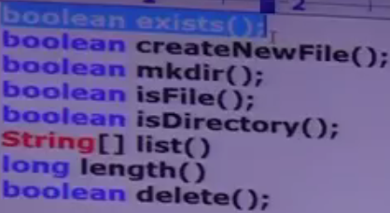

**createNewFile();** first it checks whether the specified file is already available or not. If it is already available then this method returns false without creating a new physical file. If the file is not already available, then this method creates a new file and returns true.   
**String[] list()**:This method returns the names of all files and directories present in specified directory but not subdirectories.   
**long length()**: Returns # of characters present in specified file. This method works for only file. For directory, it returns 0.  
**boolean delete()**: if you try to delete a folder not empty then it will not delete the folder and returns false.

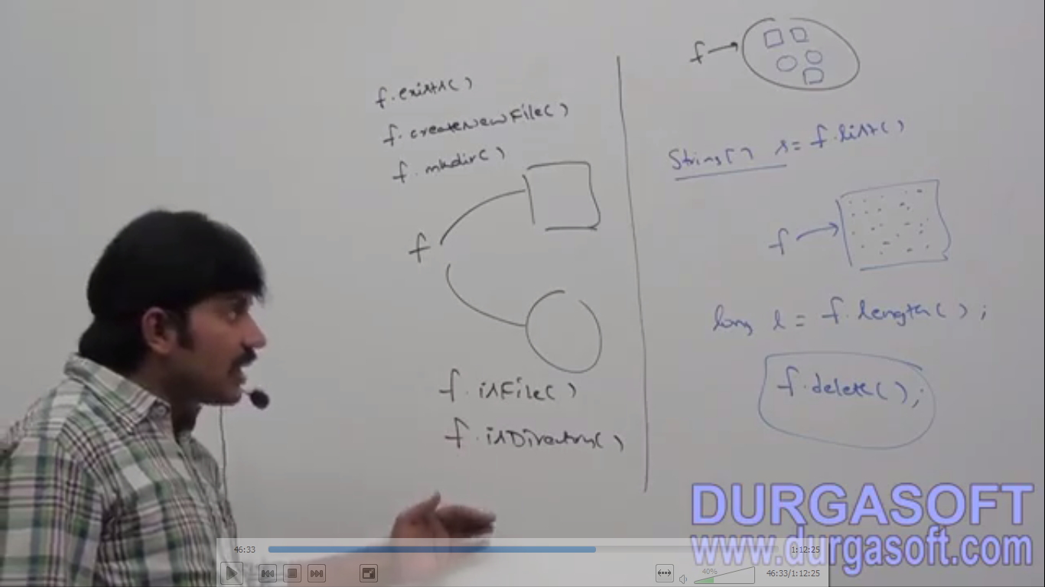

# Write a program to print all the files and folder names on screen along with number about total number of files and folders. Displaying only file names

