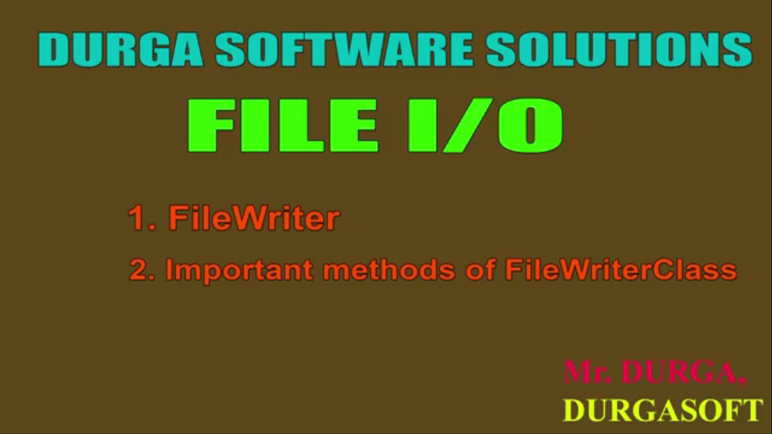

FileWriter

1. We can use FileWriter to write character data to file.
2. **Constructors**:
   1.   
      The above FileWriter(s) are meant for overriding the existing data. Instead of overriding, if we want to perform append operations, and then we have to create FileWriter by using the following constructors.  
      **NOTE**: If the specified file doesn’t exist, then all the above constructor the file.   
      Suppose, I have 2 students whom I asked to write a message to bulletin board. One comes back and says that there is no white paper on the board so I can’t write but the second one put on the white board and writes the message on there. The 2nd one is better option. Same is with all FileWriter Constructor.   
      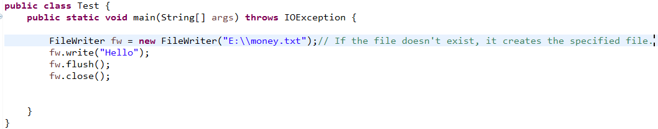
   2. d

# FileWriter Methods

1. 3 write() methods are there  
   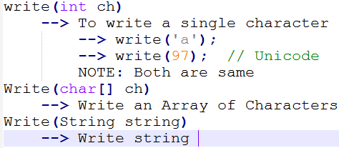

FileWriter, BufferedWriter,   
PrintWriter all have these 3 write()…

1.  To give the guarantee that total data including the last character is written to the file.   
   Writer is something like pipe.   
   **Scenario**: A bag of rice to transfer the rice into a drum. First we carry **small amount of rice**. When we are confident we take the whole bag and turn down-side up over the drum and **shakes the bag so** that every bit of rice is into the drum.   
   Similar case is with FileWriter when transfer the data into file. and for shaking purpose, we have flush()
2. : To close the FileWriter.

# Let’s write a demo program to study the whole above methods.

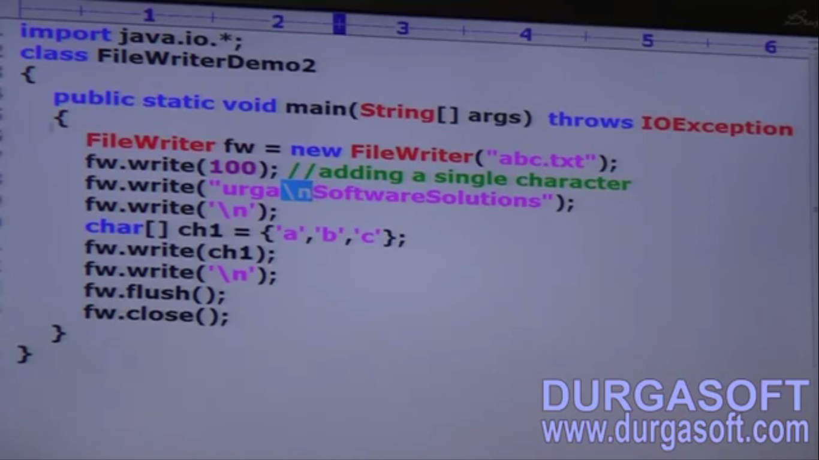

# Problem with \n in case of FileWriter

**NOTE**: The main **problem** with FileWriter is that we have to insert line separator “\n” manually which varies from system to system. This is the difficulty to the programmer. We can **solve** this problem by using **BufferedWriter** and **PrintWriter** classes.